Title-Comaprison between XGBoost and Decision tree

- Abstract
XGBoost is one of the most popular machine learning algorithm these days. Regardless of the type of prediction task at hand; regression or classification.
XGBoost is well known to provide better solutions than other machine learning algorithms. In fact, since its inception, it has become the "state-of-the-art” machine learning algorithm to deal with structured data.

- Introduction
What makes XGBoost so popular?
- Speed and performance : Originally written in C++, it is comparatively faster than other ensemble classifiers.
  - Core algorithm is parallelizable : Because the core XGBoost algorithm is parallelizable it can harness the power of multi-core computers. It is also parallelizable onto GPU’s and across networks of computers making it feasible to train on very large datasets as well.
  - Consistently outperforms other algorithm methods : It has shown better performance on a variety of machine learning benchmark datasets.
  - Wide variety of tuning parameters : XGBoost internally has parameters for cross-validation, regularization, user-defined objective functions, missing values, tree parameters, scikit-learn compatible API etc.

XGBoost (Extreme Gradient Boosting) belongs to a family of boosting algorithms and uses the gradient boosting (GBM) framework at its core.

- Methodology
Boosting is a sequential technique which works on the principle of an ensemble. It combines a set of weak learners and delivers improved prediction accuracy. At any instant t, the model outcomes are weighed based on the outcomes of previous instant t-1. The outcomes predicted correctly are given a lower weight and the ones miss-classified are weighted higher. Note that a weak learner is one which is slightly better than random guessing. For example, a decision tree whose predictions are slightly better than 50%. Let's understand boosting in general with a simple illustration.
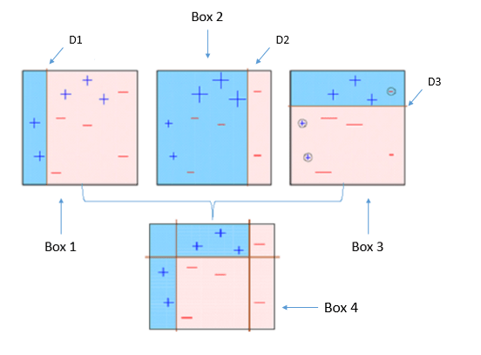
Four classifiers (in 4 boxes), shown above, are trying to classify + and - classes as homogeneously as possible.
1. Box 1: The first classifier (usually a decision stump) creates a vertical line (split) at D1. It says anything to the left of D1 is + and anything to the right of D1 is -. However, this classifier misclassifies three + points.
Note a Decision Stump is a Decision Tree model that only splits off at one level, therefore the final prediction is based on only one feature.
2. Box 2: The second classifier gives more weight to the three + misclassified points (see the bigger size of +) and creates a vertical line at D2. Again it says, anything to the right of D2 is - and left is +. Still, it makes mistakes by incorrectly classifying three - points.
3. Box 3: Again, the third classifier gives more weight to the three - misclassified points and creates a horizontal line at D3. Still, this classifier fails to classify the points (in the circles) correctly.
4. Box 4: This is a weighted combination of the weak classifiers (Box 1,2 and 3). As you can see, it does a good job at classifying all the points correctly.
That's the basic idea behind boosting algorithms is building a weak model, making conclusions about the various feature importance and parameters, and then using those conclusions to build a new, stronger model and capitalize on the misclassification error of the previous model and try to reduce it. Now, let's come to XGBoost.
If you check the image in Tree Ensemble section, you will notice each tree gives a different prediction score depending on the data it sees and the scores of each individual tree are summed up to get the final score.

- Dataset
iris dataset
1. sepal length in cm
2. sepal width in cm
3. petal length in cm
4. petal width in cm
5. class:
-- Iris Setosa
-- Iris Versicolour
-- Iris Virginica
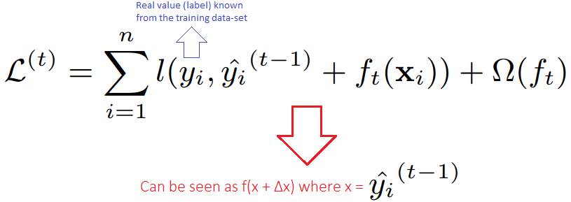
- Algorit

5.Screenshots:

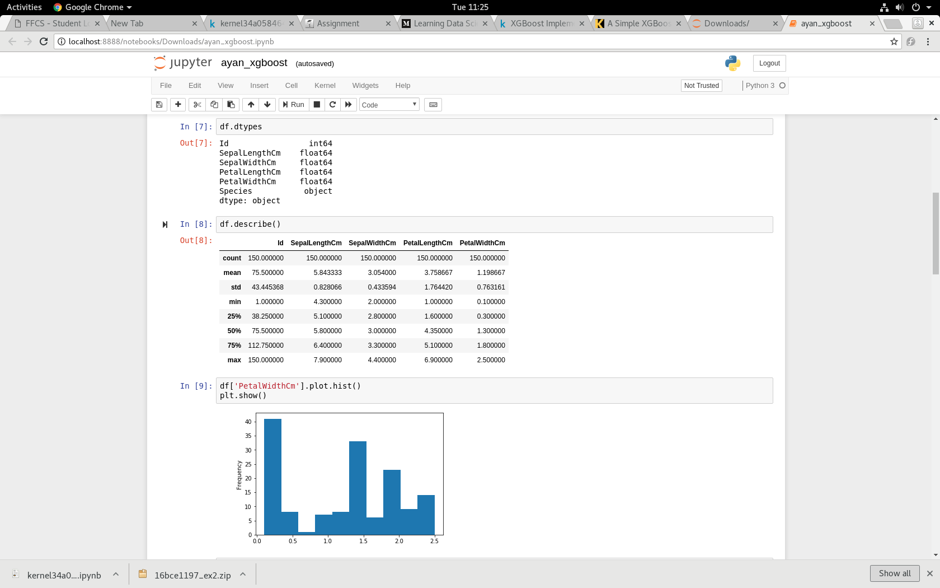
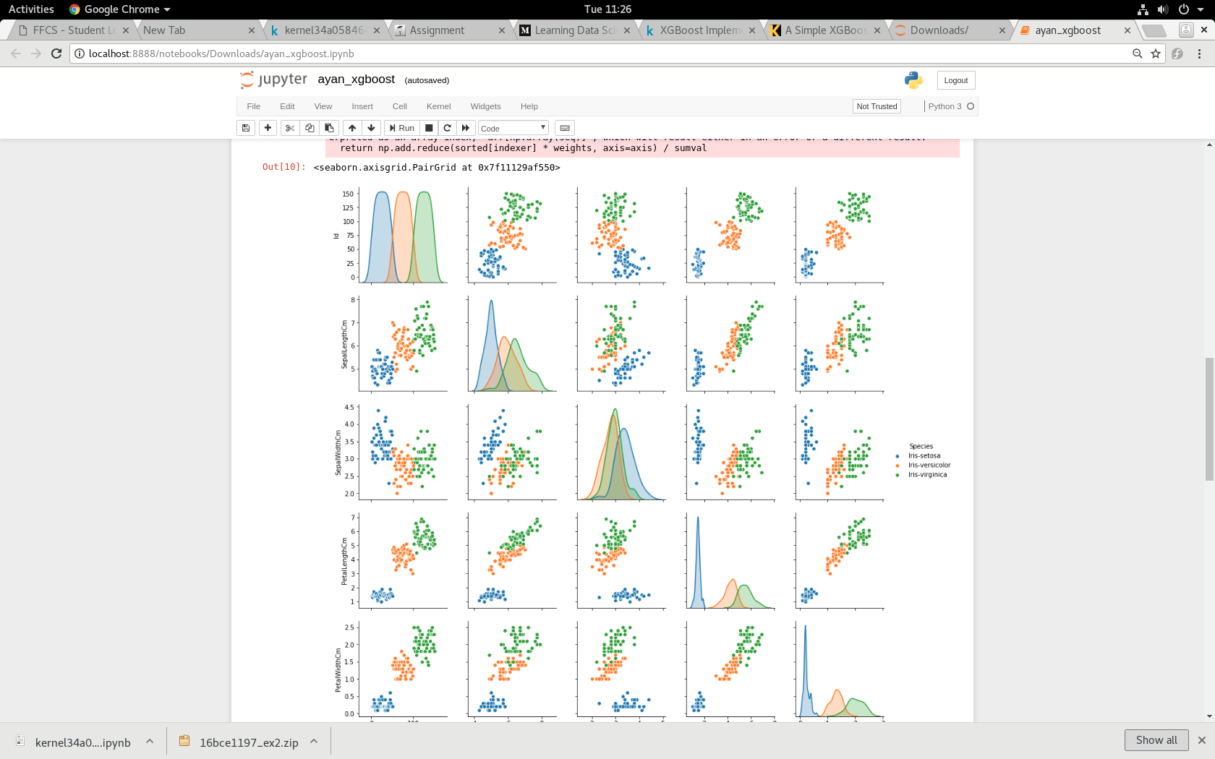
Decision tree provides an accuracy of 95%

Now applying Xgboost

Decision tree provides an acuuracy of 95%.

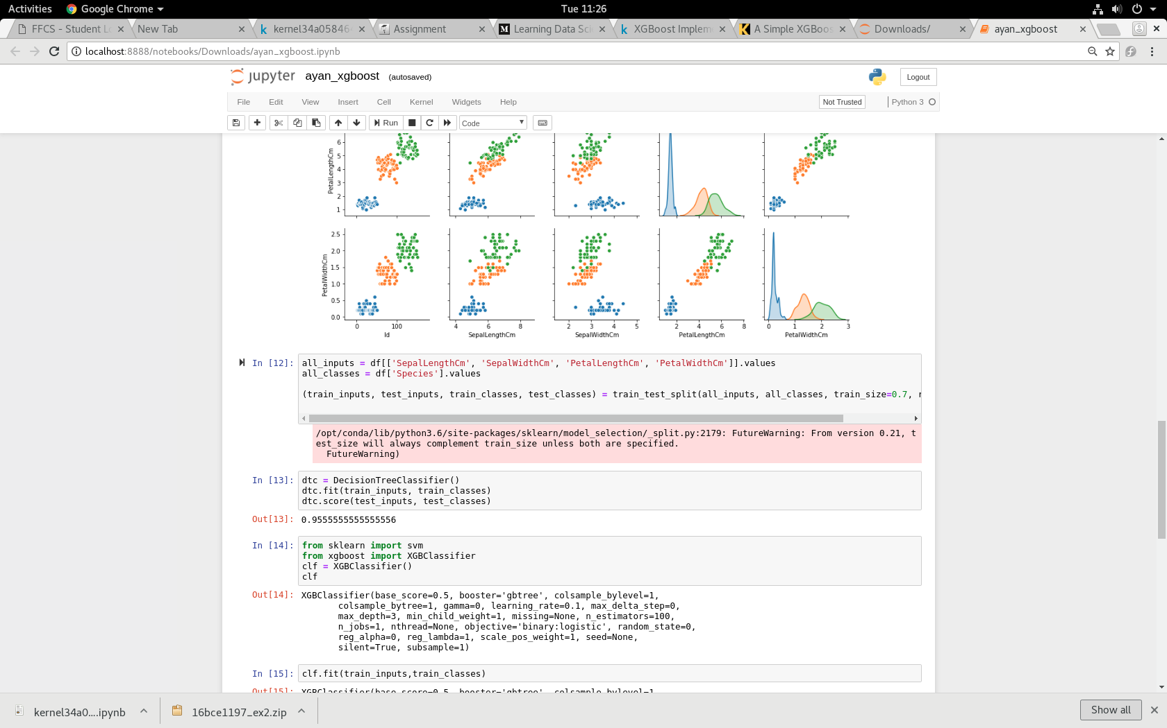

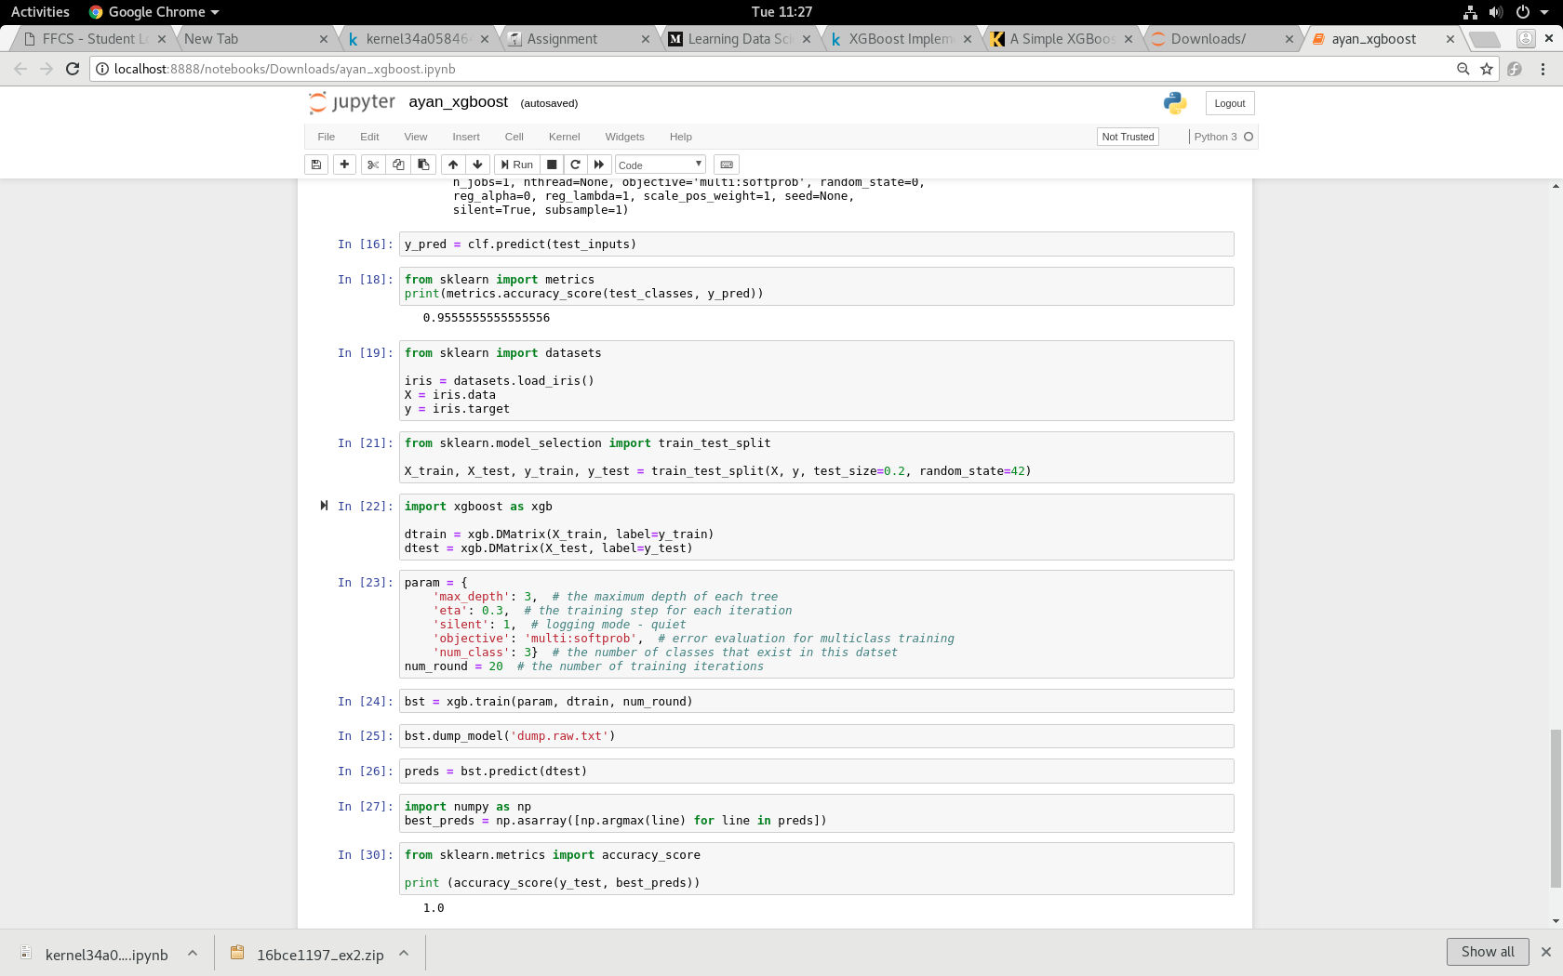

Xgboost provides an accuracy of 100%.

Conclusion:

Thus XG Boost provides a boost in the accuracy by 5%. Thus it is better than decision tree classifier.

