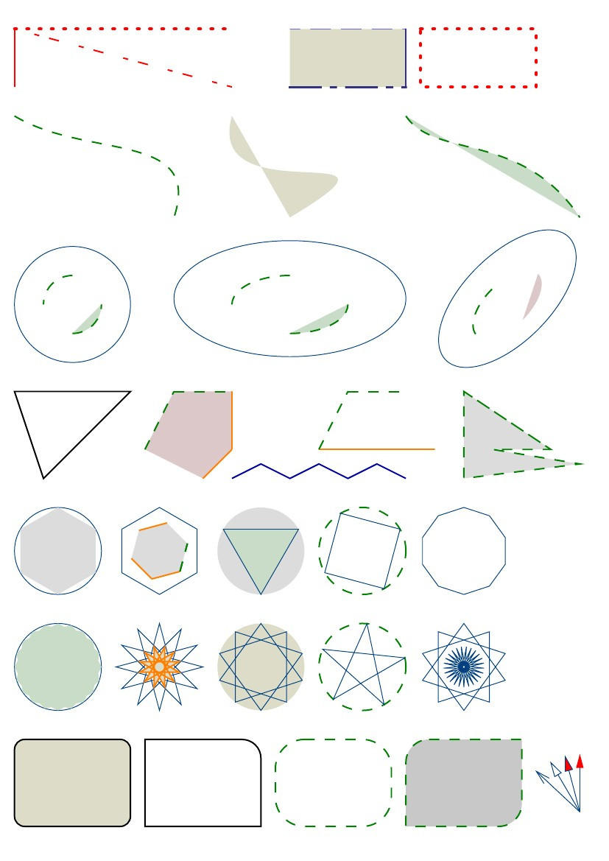

Line examples
Rectangle examples
Curve examples
Circle and ellipse examples
Polygon examples
Regular polygon examples
Star polygon examples
Rounded rectangle examples
Arrows
Arc of Ellipse
Powered by TCPDF (www.tcpdf.org)

