UNIFIED MODELING LANGUAGE DIAGRAMS - UML DIAGRAMS

A UML DIAGRAM is a standard way to visually design and represent software systems using diagrams.
The main purpose is to have a common visual language that shows -
how classes, objects, relationships and interactions work in a system.

This makes it easier for developers and teams to -
understand, discuss and plan the system before writing actual code.

UML Diagram Importance -

1. Visualization -
They act as a blue print.
This makes it much easier to understand
how different parts of the system are structured,
how they connect and
how they work together.

2. Documentation -
They act as detailed documentation of your system design.
This is very helpful when you need to maintain the code later or when the system needs to grow.

3. Communication -
They create a common language that designers, developers, and teams can all understand.
Everyone can look at the same diagram and discuss the design clearly without confusion.

4. Standardization -
Since UML is a universally accepted standard, everyone in the software industry reads and understands these diagrams the same way.
No matter where you work, UML will be the same.

BASIC ELEMENTS -

1. Class -
A blueprint / template for creating objects.
It has a name, properties(attributes), and actions(methods) that objects can perform.

class User:
def __init__(self, name, age):
self.name = name
self.age = age

def login(self):
pass

2. Interface -
In Python, we use Abstract Classes to define WHICH METHODS a class MUST have.
It tells what a class should do, NOT HOW TO DO IT.

from abc import ABC, abstracmethod
class Loginable(ABC):
@abstracmethod
def login(self):
pass

3. Object -
A real working copy of a class created when the program runs.
If class is a blueprint then object is the actual house built from the blueprint.
Ex - user1 = User("Pritam",27)

4. Association -
A connection between 2 classes showing how their objects interact or relate to each other.

5. Inheritance -
An "IS - A" relationship where a child class inherits properties and methods from a parent class.
Ex - class Dog(Animal) , Dog IS-A Animal

Composition -
A strong relationship where 1 object is made up of another object and cannot work without it.
Ex - A Car "has-an" Engine - if the Car is Destroyed, the Engine is also Destroyed.

Aggregation -
A weaker relationship where 1 object contains another object, but both can exist independently.
Ex - A classroom "has" Students - if the classroom closes, Students still exist.

CLASS DIAGRAMS -

Shows blueprint of your system like what classes you have,
- their properties (attributes),
- their actions (methods) and
- how these classes are connected to each other (like inheritance, association, etc)
Let’s say class Student has -
3 Private Attributes - name, roll_no, cgpa
2 Public Methods - attend_class(), submit_assignment()
- = Private + = Public

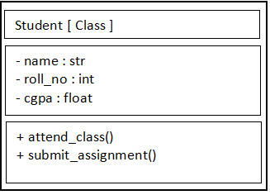

ASSOCIATION -
Association is a connection between 2 or more classes that shows how their objects are related to each other. When 1 class’s object uses or interacts with another class’s object, that’s association.
Simple Terms - “Class A knows about Class B and can use it”

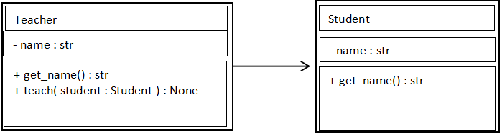
AGGREGATION -

Aggregation is a weak “has-a” relationship where 1 class contains objects of another class,
But the contained objects can survive independently EVEN IF the container is destroyed.
Simple Terms - “Class A has Class B, but B can exist without A”

