
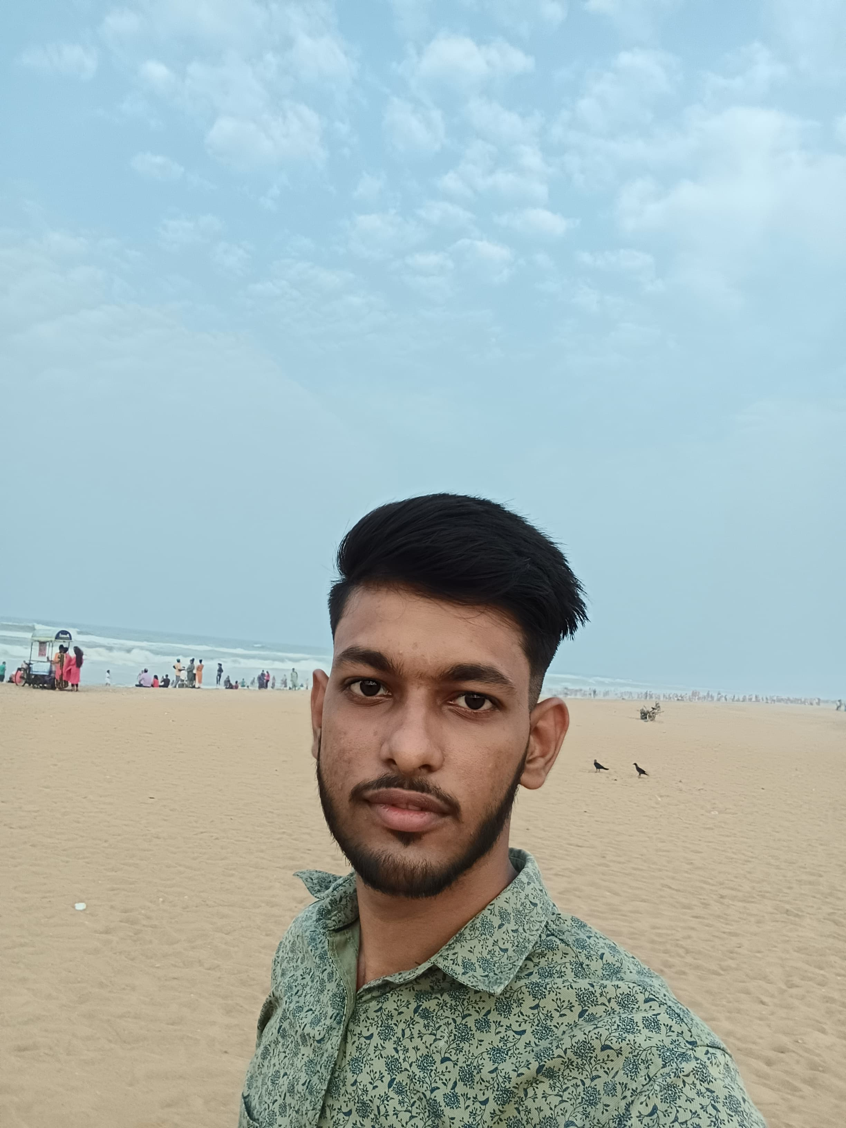
RESUME

PRITAM KUMAR DASH
S/o- Pradyumna dash
At-Ambapada, Po-Karamul ,Ps-Gondia
Dist-Dhenkanal Pin-759014, Odisha
Mob-9938054831
Adhaarcard No-5548 5425 7037
Email ID –pritamkumardash15@gmail.com

OBJECTIVE:
Intend to build my career at an esteemed organization which would tell my knowledge, help to achieve my goals and to move ahead in this competitive world while being resourceful, innovative and flexible.

EDUCATIONAL QUALIFICATION :
- persuing B.tech in Gandhi Institute of Excellent Technocrats in Bhubaneswar.
- Passed +2 Science from S.R.H. College Dhenkanal in the year 2023
- Passed H.S.C from Panchayat Nodal High School, Karamul in the year 2021

COMPUTER SKILLS :
- Well versed with MS Word, Excel, Power Point, Outlook and Windows 2007 .
- Completed core Java , HTML , CSS , Java script , react , C , DSA , mysql .
PERSONAL TRAITS :

- Self motivated with a positive attitude.
- The ability to work in a team.
- Adaptable to the changes in my surroundings.
- I take initiative to improving the things and convince others to join me.
- Interested in exploiting my theoretical knowledge as practical.

EXPERIENCE :
- Lab Assistance in Ambapada Computer Care,
- Making salesforce UI using HTML,CSS ,JAVASCRIPT
- Making tic tac game JAVA with DSA

PERSONAL DETAILS :
Name : Pritam kumar Dash
Father’s Name : Pradyumna Dash
Date of Birth : 09.05.2005
Marital Status : Unmarried
Languages Known : Oriya, Hindi & English,
Nationality : Indian
Religion : Hindu
Gender : Male

DECLARATION :
I consider myself fit and efficient for all type of situations and conditions. I am also confident of my ability to work in a team as I have proved it in my school, college and work field.

I hereby declare that the information furnished above is true to the best of my knowledge.

Place: Ambapada

Pritam kumar Dash

