1. Valid login.

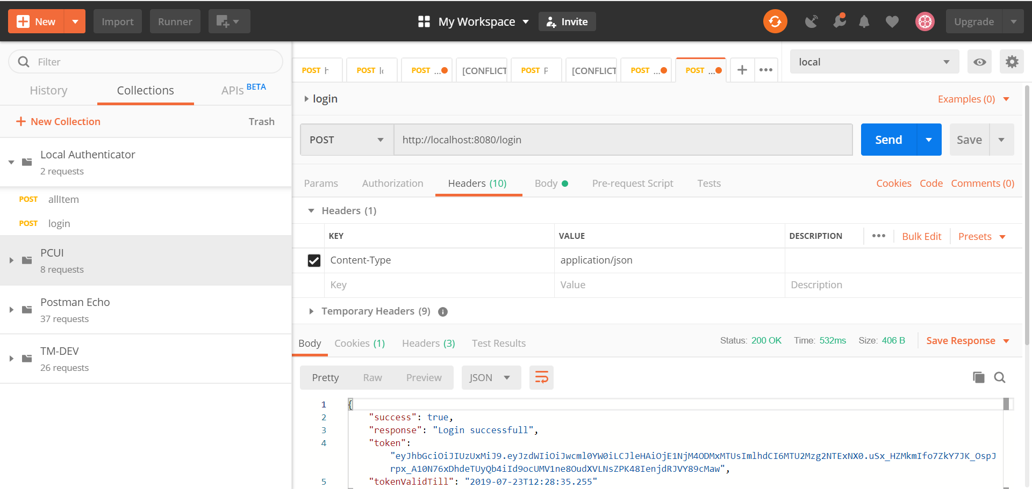

See the token in response , you can generate your token by giving correct user name and password which you user table may have.

In my case I have set it as pritam/panhale

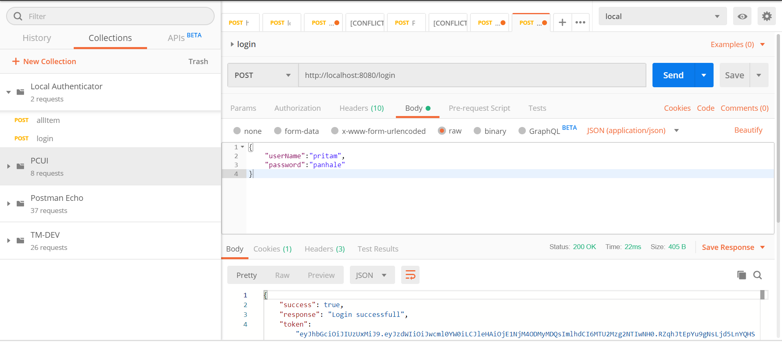

1. Invalid username and password.

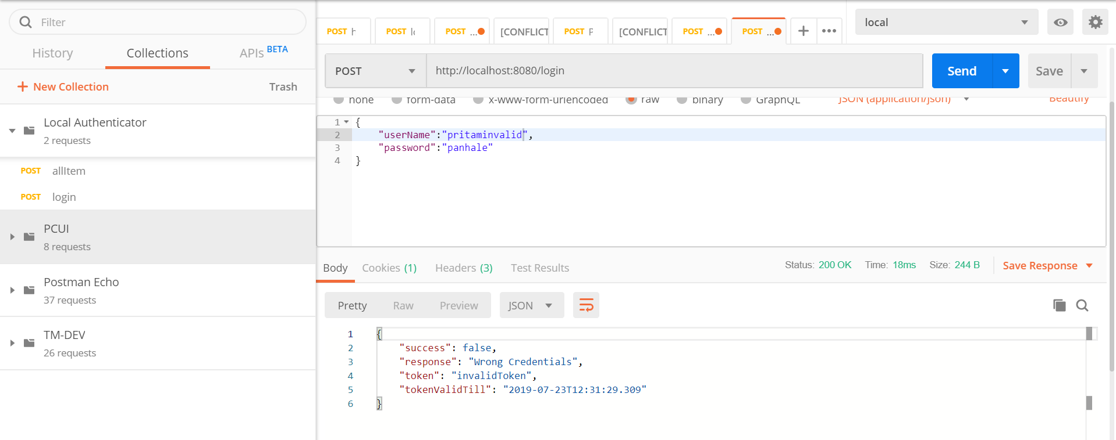

1. Get the correct token and request a resource. Put the token in header as below

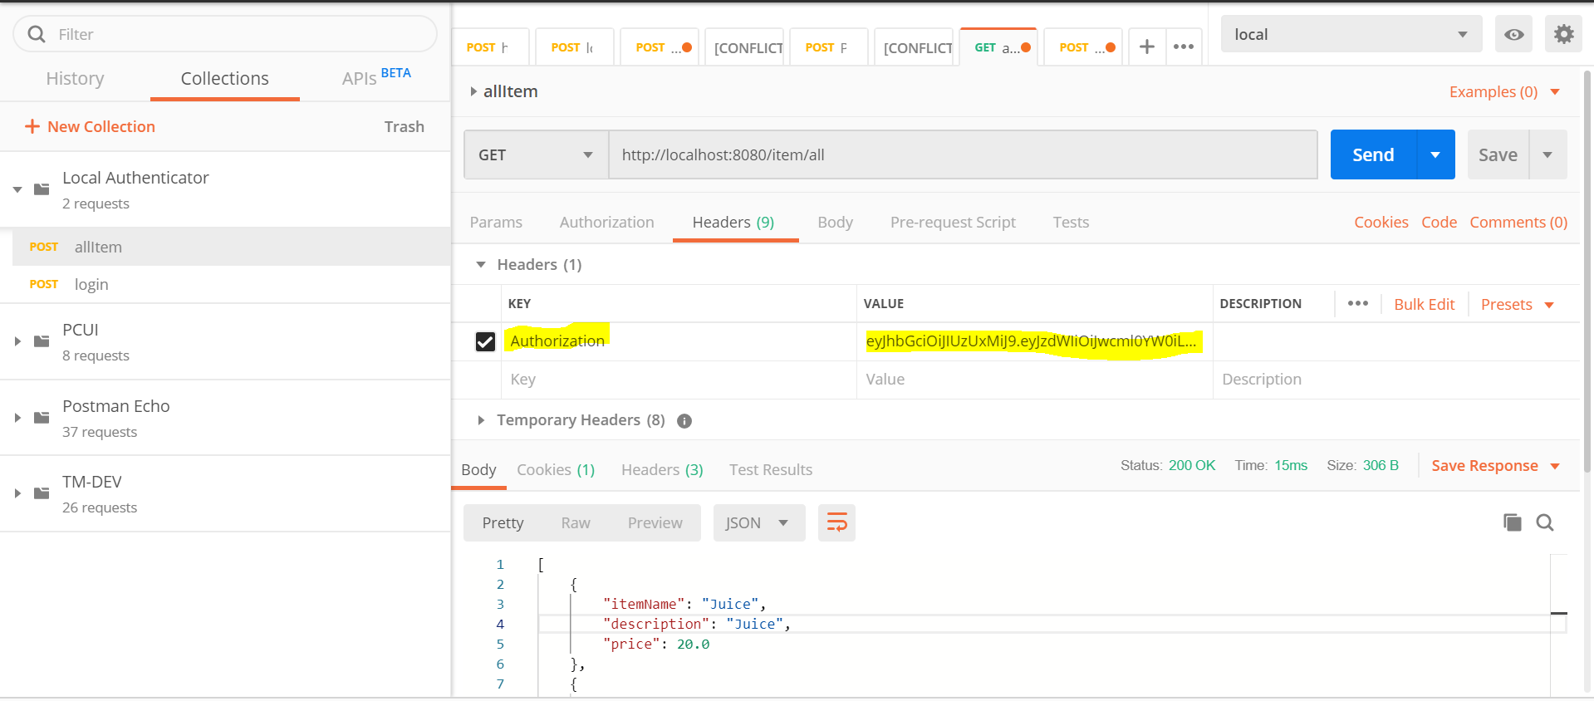

1. Tamper a token to check that without valid token you are not able to see the request‘s output.

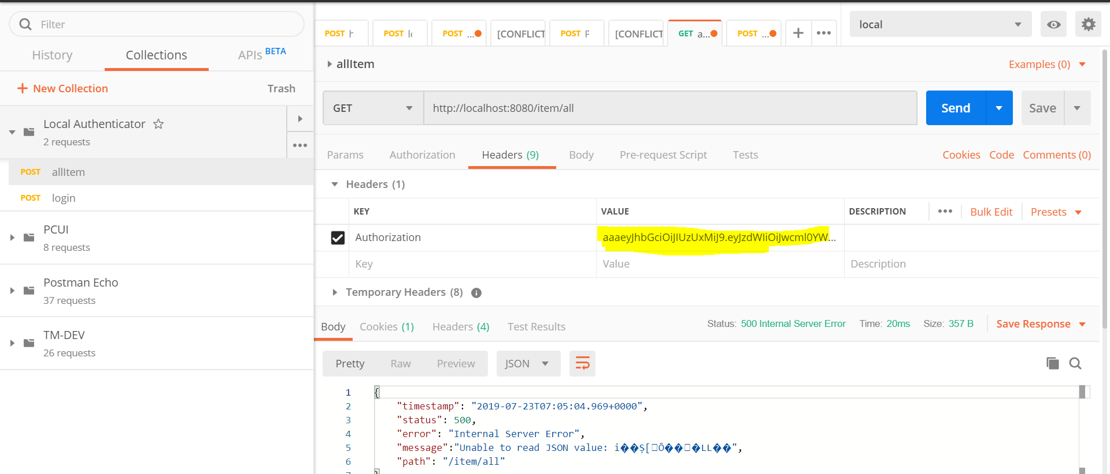

Definity there would be a better response for both rest resources but my intention was just to illustrate the JWT token functionality.