DBSPEND360 – Product Release Document
Release Version: v1.0
Release Date: February 23, 2026
Cloud Support (Phase 1): Azure
Upcoming Support: AWS (Phase 2), GCP (Phase 3), Storage Costs, Network Costs

1. Overview
DBSPEND360 is a Databricks-native solution that provides clear job-level visibility into cloud and DBU spends for Databricks workloads on Azure.
- Tracks end-to-end cost at job, run, and cluster level for Databricks jobs.
- Combines cloud VM cost from the cloud cost explorer with Databricks DBU cost from system billing tables.
- Produces a consolidated dbspend360_total_job_spends table as the single source of truth for job-level cost.
- Includes audit and error logging to support incremental loads, monitoring, and reconciliation.
- Powers the DBSPEND360 Databricks App, which provides dashboards and AI-driven cost and performance recommendations.

2. Architecture

2.1 Logical Architecture Diagram (Conceptual)

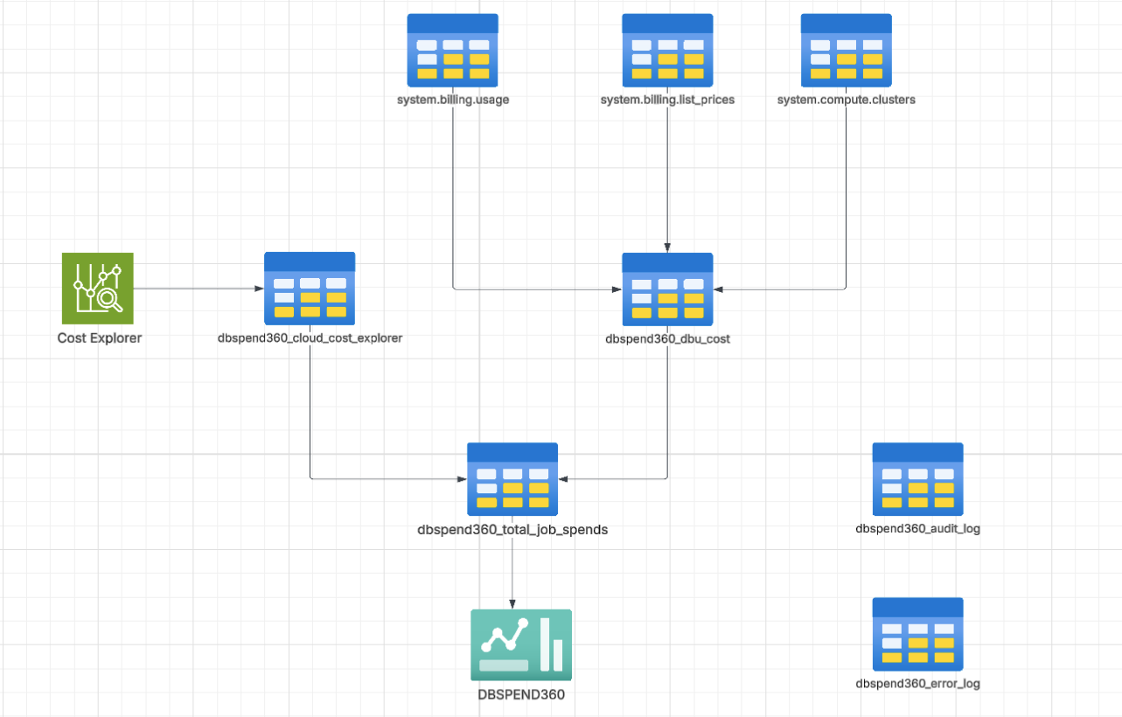

Cloud Provider (Azure)
↓
Task 1: cloud_cost_explorer_task
↓
Table: dbspend360_cloud_cost_explorer
↓
Task 2: dbspend360_dbu_cost_task
↓
Table: dbspend360_dbu_cost
↓
Task 3: databricks_job_spends_task
↓
Table: dbspend360_total_job_spends
↓
DBSpend360 Databricks App
• Interactive cost analytics and visualizations
• AI-powered recommendations
Supporting Tables:
• dbspend360_audit_log — Success/failure tracking for batch and incremental loads
• dbspend360_error_log — Records mismatches between cloud and DBU data

2.2 High-Level Implementation Detail
The DBSPEND360 job is made up of three main tasks, followed by the Databricks app.​
- cloud_cost_explorer_task – Fetches Azure cloud cost per cluster and writes to dbspend360_cloud_cost_explorer.​

- dbspend360_dbu_cost_task – Reads Databricks system tables, computes DBU cost per job/run, and writes to dbspend360_dbu_cost.​

- databricks_job_spends_task – Joins cloud and DBU cost, writes final job-level cost into dbspend360_total_job_spends, and logs audit/error records in dbspend360_audit_log and dbspend360_error_log.​

DBSPEND360 Databricks App – Uses dbspend360_total_job_spends as its source for dashboards and AI-driven cost/performance insights.​

3. Implementation Logic

3.1 Cloud Cost Explorer Task (cloud_cost_explorer_app)
Key Features:
- Date Chunking: Splits large date ranges into 10-day chunks to
prevent API timeouts
- Calls Azure Cost Management APIs, grouping cost daily by cluster tag
- Aggregates cost per cluster_id, currency, and cost_incurred_date, then merges into dbspend360_cloud_cost_explorer (upsert semantics).
- Rate Limit Handling:
  - Detects HTTP 429 responses
  - Parses Azure-specific retry headers (x-ms-ratelimit-*)
  - Implements exponential backoff with configurable retries
(default: 3 attempts)
- Pagination Support: Automatically follows nextLink URLs for
large result sets
- Incremental Processing: Uses watermark from
dbspend360_audit_log to determine date windows
- Overlap Days: Configurable overlap (default: 3 days) ensures
cost convergence for late-arriving data
- Writes a SUCCESS or FAILED entry into dbspend360_audit_log with the processed date range and row count.

Important Notes:
- Long-Running Jobs: Jobs spanning multiple days produce multiple cost records (one per date)
- Currency: Costs are returned in the subscription's billing currency

Required widgets:
- catalog – catalog name
- schema – schema name
- overlap_days – number of overlap days (default "3" )​
- subscription_id – Azure subscription ID
- scope – Databricks secret scope containing Azure SPN secrets

3.2 DBU Cost Task (dbspend360_dbu_cost_app)

Key Features:
- Derives the processing window from dbspend360_audit_log, again using an overlapping date range.
- System Tables Integration: Reads from system.billing.usage, system.billing.list_prices, and system.compute.clusters to compute DBU cost per job, run, date, and workspace.
- Calculation: Joins system.billing.usage with system.billing.list_prices using time-based matching
- Workspace Filtering: Optional comma-separated workspace_ids parameter for multi-workspace deployments
- Job Cluster Filtering: Only processes clusters with cluster_source = 'JOB'
- Upserts results into dbspend360_dbu_cost and logs the run in dbspend360_audit_log.

Cost Calculation Logic:
databricks_cost = SUM(usage_quantity × list_price_default)
Grouped by: cluster_id, job_id, run_id, usage_date, workspace_id

Required Widgets:
- catalog – catalog name
- schema – schema name​
- overlap_days – number of overlap days (default "3" )​
- workspace_ids – optional comma‑separated workspace IDs; empty means “all workspaces”.

3.3 Total Spend Calculation Task (databricks_job_spends_app)

Key Features:
- Computes its own date window from dbspend360_audit_log, using overlap for consistency with upstream tasks.
- Reads dbspend360_cloud_cost_explorer and dbspend360_dbu_cost for that window and joins them on cluster_id and date (usage_date = cost_incurred_date).
- Produces final rows with cloud_cost, databricks_cost, and total_cost, and merges them into dbspend360_total_job_spends.
- Error Logging:
  - DBU-only records: DBU costs without matching cloud costs (logged as NO_MATCH_CLOUD_COST)
  - Cloud-only records: Cloud costs without matching DBU costs (logged as NO_MATCH_DBR_DBU)
- Records the run in dbspend360_audit_log.

Required Widgets:

- catalog – catalog name
- schema – schema name​
- overlap_days – number of overlap days (default "3" )​

4. Required Tables

4.1 dbspend360_cloud_cost_explorer

CREATE TABLE IF NOT EXISTS ${catalog}.${schema}.dbspend360_cloud_cost_explorer (
cluster_id STRING,
cloud_cost DOUBLE,
currency STRING,
created_at TIMESTAMP,
updated_at TIMESTAMP,
cost_incurred_date DATE
)
CLUSTER BY AUTO

4.2 dbspend360_dbu_cost

%sql
CREATE TABLE IF NOT EXISTS ${catalog}.${schema}.dbspend360_dbu_cost (
cluster_id STRING,
job_id STRING,
run_id STRING,
usage_date DATE,
databricks_cost DOUBLE,
currency STRING,
sku_name STRING,
workspace_id STRING,
created_at TIMESTAMP,
updated_at TIMESTAMP
)
CLUSTER BY AUTO

4.3 dbspend360_total_job_spends

%sql
CREATE TABLE IF NOT EXISTS ${catalog}.${schema}.dbspend360_total_job_spends (
cluster_id STRING,
job_id STRING,
run_id STRING,
usage_date DATE,
cloud_cost DOUBLE,
databricks_cost DOUBLE,
currency STRING,
total_cost DOUBLE,
created_at TIMESTAMP,
updated_at TIMESTAMP
)
CLUSTER BY AUTO;

4.4 dbspend360_audit_log
Tracks ingestion status and incremental loads for watermarking and auditing purposes.
%sql
CREATE TABLE IF NOT EXISTS ${catalog}.${schema}.dbspend360_audit_log (
table_name STRING, -- e.g. 'azure_cost_explorer'
start_date DATE, -- start_dt used in the API call
end_date DATE, -- end_dt used in the API call
status STRING, -- 'SUCCESS', 'FAILED', 'SKIPPED'
row_count LONG, -- rows merged into target (optional)
message STRING, -- optional notes / error summary
created_at TIMESTAMP -- log insertion time
)
CLUSTERED BY AUTO

4.5 dbspend360_error_log
Captures mismatches and processing errors.
%sql
CREATE TABLE IF NOT EXISTS ${catalog}.${schema}.dbspend360_error_log (
source_system STRING, -- 'AZURE_COST' or 'DBR_DBU'
error_type STRING, -- e.g., 'NO_MATCH_DBR_DBU', 'NO_MATCH_AZURE_COST'
cluster_id STRING,
job_id STRING,
run_id STRING,
usage_date DATE,
currency STRING,
error_detail STRING, -- free-text description
raw_record STRING, -- JSON serialization of the problematic row
created_at TIMESTAMP
)
CLUSTERED BY AUTO

5. Pre-Requisites

5.1 Azure Service Principal Requirements (Phase 1)
For detailed step-by-step instructions on creating Azure Service Principal, obtaining credentials, and assigning required roles, refer to the Azure Credentials and Permissions Setup Guide.

Summary of Required Components:
- Azure Subscription ID
- Tenant ID
- Client ID (Application ID)
- Client Secret
- Azure Role: Cost Management Reader (assigned at Subscription level)

5.2 Databricks Secret Configuration
Store Azure credentials securely using Databricks secrets:

5.2.1 Create Secret Scope
databricks secrets create-scope azure-key-vault

5.2.2 Add Secrets
databricks secrets put-secret --json '{
"scope": "azure-key-vault",
"key": "client-id",
"string_value": "your-client-id-here"
}'

databricks secrets put-secret --json '{
"scope": "azure-key-vault",
"key": "client-secret",
"string_value": "your-client-secret-here"
}'

databricks secrets put-secret --json '{
"scope": "azure-key-vault",
"key": "tenant-id",
"string_value": "your-tenant-id-here"
}'

⚠️ Security Note: Ensure the scope name matches the scope widget parameter in the cloud cost explorer notebook.

5.3. Databricks Permissions
Managed Principal (DBSPEND360 Job)
Grant the following permissions:
Table Permissions
- READ + WRITE access to:
  - dbspend360_cloud_cost_explorer
  - dbspend360_dbu_cost
  - dbspend360_total_job_spends
  - dbspend360_audit_log
  - dbspend360_error_log
Secret Scope Permission
- Read access to: azure-key-vault

5.4 Databricks App SPN
Must have:
- Read access to: dbspend360_total_job_spends
- CAN USE PERMISSION for a sql warehouse to execute the required queries

6. App Details (DBSPEND360)

6.1 Data Source
App reads from: dbspend360_total_job_spends

6.2 Metrics Available
- Job-level cost
- Cloud cost
- Databricks (DBU) cost
- Total cost
- Analysis on cluster usage and recommendations for performance/cost Improvements using databricks hosted foundation models

6.3 Refresh Mechanism
Data is refreshed via scheduled DBSPEND360 job execution.

7. Release Plan
Phase | Cloud | Status
Phase 1 | Azure | ✅ Release v1
Phase 2 | AWS | Planned
Phase 3 | GCP | Next Quarter

8. Key Design Considerations
- Supports job level cost aggregation
- Watermark-driven incremental ingestion
- Error logging for reconciliation gaps
- Cloud-agnostic architecture (extensible)
- Secure credential management via Secret Scope
- AI Powered Cost Analysis and Cost + Performance Recommendations

9. Usage
- Download the DBSPEND360 databricks app repo from https://github.com/pritampaul-db/DBSpend360.
- Jobs folder contains all the DDL, Notebooks , and resource template for DBSPEND360 Job.
- release folder contains the product release doc and the azure SPN setup guide needed for the data ingestion from cost explorer.
- readme.md contains all the usage related description as mentioned below:

- Setup your local databrickscfg file with DATABRICKS_HOST and DATABRICKS_TOKEN details. Update config file from config-> app.dev.config , this will be used to deploy the app.
- Step by step setup:
  - Change directory to DBSpend360 in your cloned git golder using
cd DBSpend360
  - In the config folder change the values in app.dev.config for:
    - Warehouse_id
    - Table_name (catalog.schema.table)
    - Schema_name (catalog.schema)
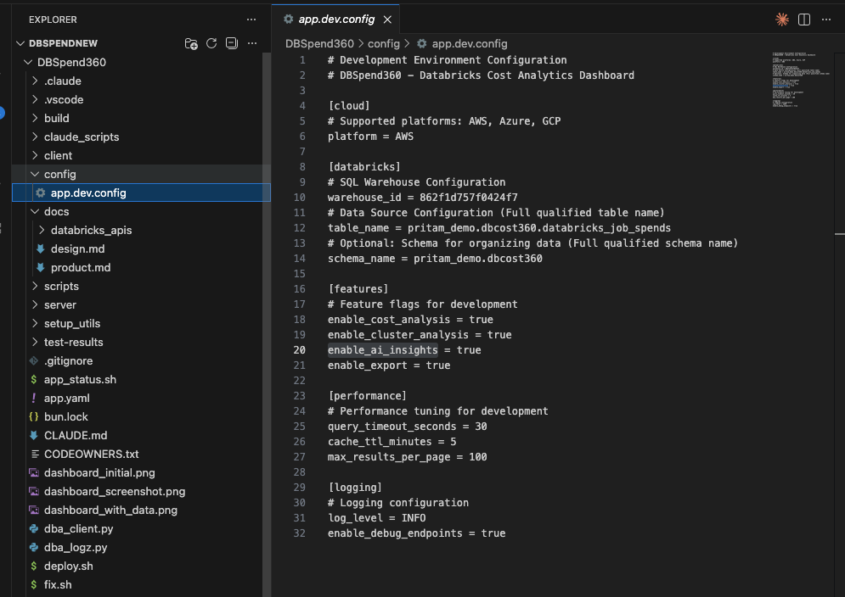

- Run setup.sh and follow the below steps:
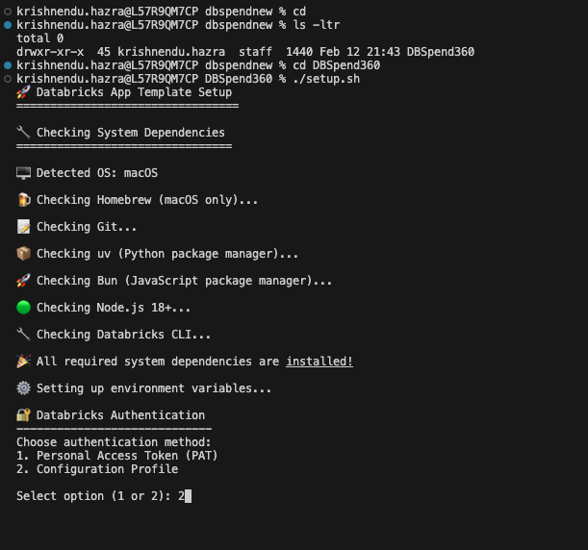

- Choose the Authentication type
- Choose the databricks configuration profile you want to use to deploy the app
- Give an app name: App name should not have cap letters or numbers
- Give the source code path to store all the app related code/assets
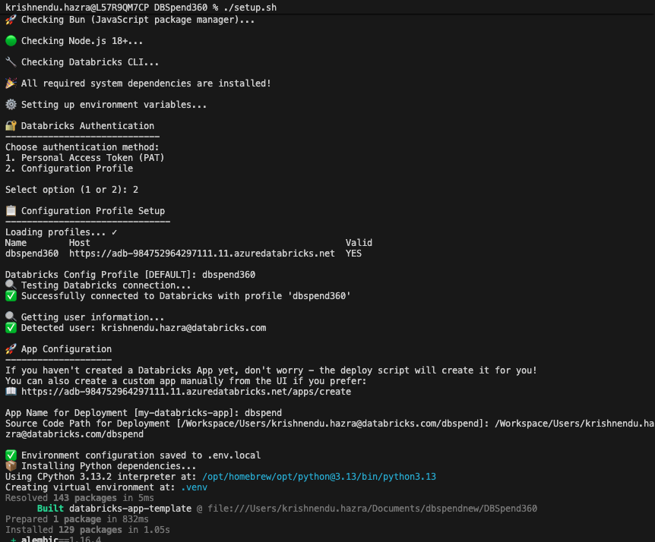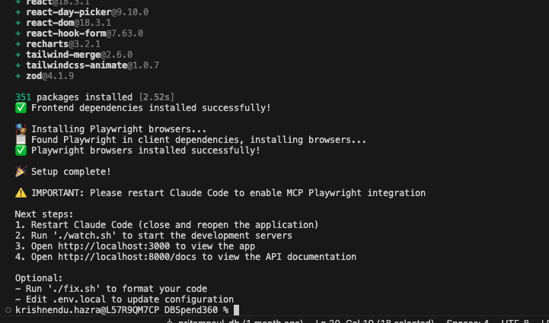

- Run the deploy command : ./deploy.sh --verbose --create (This creates and deploys the app)
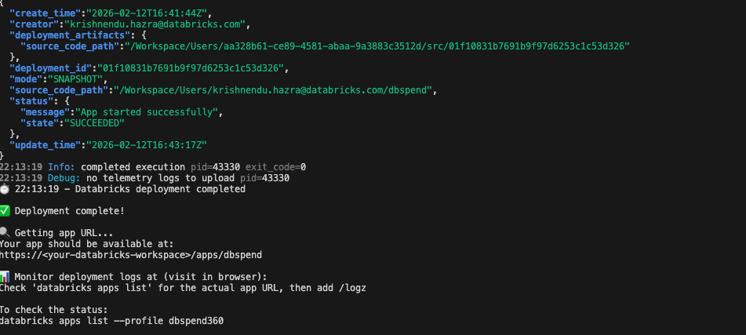

- App SPN should have below permissions:
a) CAN USE for the sql warehouse mentioned in the app config file.
b) USE CATALOG, USE SCHEMA, SELECT permissions on the catalog, schema, table name used for sourcing the data of the databricks app from dbspend360_total_job_spends.
c) App uses databricks-claude-sonnet-4 as foundation model to generate insights for cost/performance improvements.
