Ashbourne Industries, Inc.
2024 Monthly Trial Balance – Audit Report
Audit work
Submitted By: Pritam Saha

1. Purpose and scope
This report tests whether Ashbourne Industries' 2024 monthly trial balance is complete and balanced. It covers 473 general ledger accounts for January to December. Debits are shown as positive and credits as negative.

2. Conclusion
The trial balance balances from January to November, within $1 to $8 a month (rounding). December does not balance: it is out of balance by (97,403,376).
The December difference equals the year's net income of 97,403,378. Net income was already booked to Retained Earnings (account 29205) while the revenue and expense accounts were left open, so it is counted twice. If the revenue and expense accounts were closed to zero, December would be out by only $2.

3. Year-end summary (December)
Code | Description | Total
10000 | Assets | 1,263,879,322
20000 | Liabilities & Equity | (1,263,879,320)
30000 | Revenue | (988,385,863)
40000 to 80000 | Expenses | 890,982,485
 | Net (should be 0) | (97,403,376)
Revenue and expense balances are cumulative for the year, so the December column is the full-year figure.

4. Monthly balance test
Month | Net debits less credits | Result
JAN | -1 | Rounding
FEB | -4 | Rounding
MARCH | 6 | Rounding
APRIL | 5 | Rounding
MAY | 8 | Rounding
JUNE | 4 | Rounding
JULY | -1 | Rounding
AUG | 5 | Rounding
SEPT | 2 | Rounding
OCT | -2 | Rounding
NOV | -1 | Rounding
DEC | (97,403,376) | Out of balance
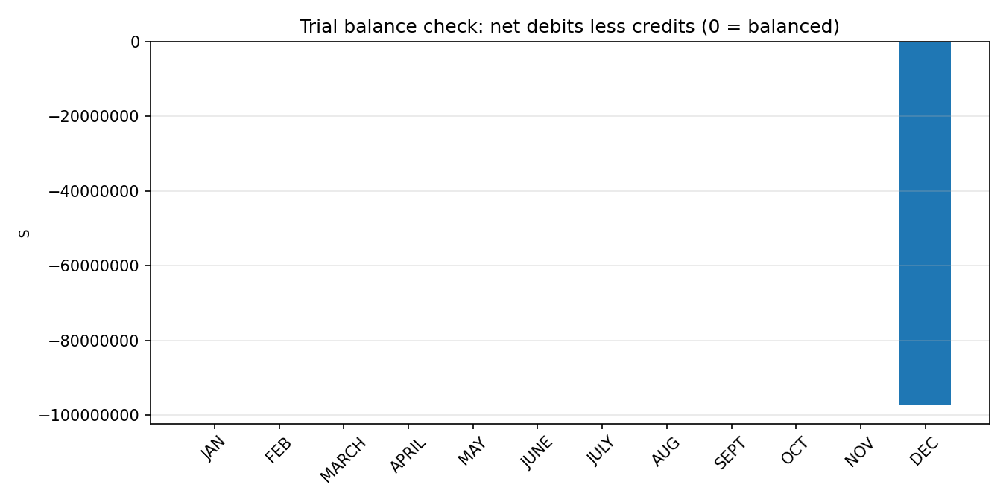

5. December reconciliation
Item | Amount
Year-to-date net income (revenue and expense accounts) | 97,403,378
Retained Earnings (29205), November | 220,435,578
Retained Earnings (29205), December | 123,032,200
Movement in Retained Earnings | (97,403,378)
December imbalance as reported | (97,403,376)
Imbalance if revenue and expense accounts were closed | 2
The movement in Retained Earnings matches net income exactly, which confirms the cause.

6. Income statement and balance sheet
Net income builds steadily through the year. Monthly figures are derived from the cumulative balances. October is low at 3.4 million, and December shows (20.3 million) because the cumulative net income falls from 117.7 million in November to 97.4 million.
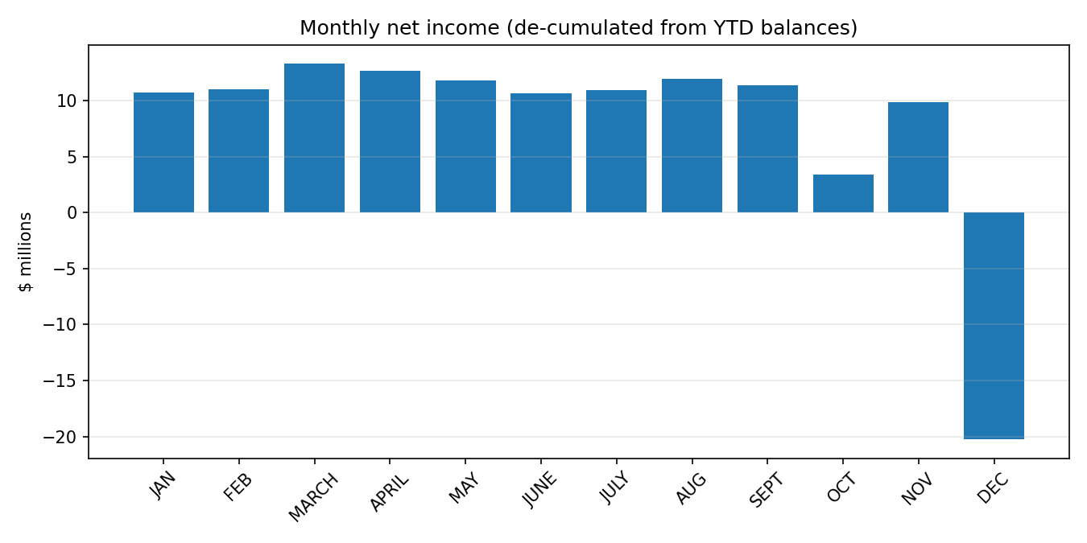
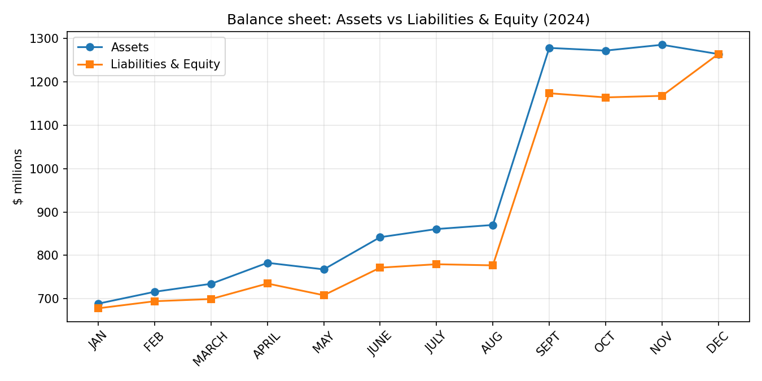
Assets and Liabilities & Equity move together all year, with a large step in September. The two lines meet in December.

7. Unusual balance sheet movements
Period | Account | Description | Change
AUG–SEPT | 23121 | Long-term portion (new account) | (880,575,000)
AUG–SEPT | 23120 | Long-term portion | 514,510,000
AUG–SEPT | 15160 | Prepaid acquisition | 326,688,109
NOV–DEC | 15160 | Prepaid acquisition | (327,528,296)
NOV–DEC | 16050 | Machinery & equipment | 133,064,916
NOV–DEC | 29205 | Retained earnings | (97,403,378)
The prepaid acquisition balance appears in September and clears in December while fixed assets increase. This points to an acquisition that was reclassified at year end and should be supported with documents.

8. Data-quality observations
The review raised 121 flags (full list in data_quality_issues.csv). Main points:
- 22 accounts have no balance after November and 21 accounts first appear in December.
- 10 liability accounts carry a debit balance in December, including Accrued Trade (22100) at 8,647,577 and Accrued Federal Income Tax (22710) at 5,095,457.
- 7 asset accounts carry a credit balance in December, including Finished Goods (14314) at (94,284,618).
- Account names in the workbook are cut off at about 13 characters, so use account codes to identify accounts.

9. Recommendations
- Close the revenue and expense accounts to Retained Earnings, or reverse the Retained Earnings entry, so December balances.
- Obtain support for the September debt reclassification and the prepaid acquisition cleared in December.
- Review the debit-balance liabilities and credit-balance assets for misposting or reclassification.
- Confirm the source period of the workbook: its figures are identical to an earlier template labelled 2022.

