**Software Engineering Assignment**

**MODULE: 1**

**SE – Overview of IT Industry**

1. **What is software? What is software engineering?**

* **Software is a set of instructions, data or programs used to operate computers and execute specific tasks.**
* **Software Engineering is the process of designing, developing, testing, and maintaining software. It is a systematic and disciplined approach to software development that aims to create high-quality, reliable, and maintainable software.**

1. **Explain types of software.**

* **System software :-**
* **System software is a type of software that controls a computers hardware and applications that provides a platform for other software to run on.**
* **It manages a computers resources, such as memory, processors, and devices.**
* **It is like an interface between hardware and user applications that helps to communicate with each other because hardware understands binary language ( 1 or 0).**
* **User applications are work in human-readable languages like English, Gujarati and others. so system software converts the human-readable language into binary language.**
* **After the hardware completes the task, the system software translates the results back into human-readable form.**
* **System software helps to generate the user interface and allows the operating system to interact with the computer hardware.**
* **Features of system software:-**
* **It is smaller in size.**
* **It is very difficult to design system software.**
* **System Software is difficult to understand.**
* **System software is responsible to directly connect the computer with hardware that enables the computer to run.**
* **Types of system software :-**

1. **Operating System :-**

* **An Operating System is the most basic type of System Software that helps to manage computer hardware and software.**
* **An Operating system primarily operates your computer when computer is start.**
* **It controls all input and output devices such as monitors, keyboards, microphones, and scanners.**
* **It enables you to access the network on your system.**
* **It helps to link different parts of your system.**
* **It facilitates users to access and use application software.**
* **Ex-** **Windows, macOS, Linux, Android, iOS.**

1. **Device driver :-**

* **Device drivers is one type of programs that allow the operating system to communicate with hardware devices.**
* **The operating system contains a number of device drivers to drive the hardware components like mouse, keyboards are already installed in the computer system by the computer manufacturing companies.**
* **Ex- Printer driver,graphics card driver**

1. **Utility software :-**

* **Utility software works as an interface between system software and application software.**
* **It helps to reduce disk size such as WinRAR, WinZip.**
* **It works as a Windows Disk Management service and helps in a disk partition.**
* **It facilitates users to back up the old data and enhance the security of the system.**
* **It helps to recover the lost data.**
* **Ex-** **WinRAR, Backup utilities.**

1. **Firmware software :-**

* **Firmware is a type of low-level software that is embedded into hardware components to control their functions.**
* **It resides in non-volatile memory like ROM, EPROM, or flash memory.**
* **Low-level software embedded in hardware to control its functions, like booting the system.**
* **Ex- BIOS, router firmware.**

1. **Language translator :-**

* **Language translators is a programs that convert programming code written by users into machine code that can be executed by the CPU.**
* **Compilers: Convert code into machine language before execution.**
* **Interpreters: Convert code line by line**
* **Assemblers: Convert assembly language into machine code.**
* **GCC (GNU Compiler Collection), Python Interpreter, Turbo Assembler.**
* **Application software :-**
* **Application software is designed to perform a specific task and solve problem.**
* **Application software is a type of computer program designed to help users perform tasks such as creating documents, managing databases, or playing games.**
* **High-level languages like C, Java, are used to build application software.**
* **Features of application software :-**
* **An important feature of application software is it performs more specialized tasks like word processing, spreadsheets, email, etc.**
* **Mostly, the size of the software is big, so it requires big storage space.**
* **Application software is more interactive for the users, so it is easy to use and design.**
* **The application software is easy to design and understand.**
* **Application software is written in a high-level language in general.**
* **Types of application software :-**

1. **General-Purpose Application Software :-**

* **General-purpose application software is designed for everyday tasks**
* **It includes software used for creating documents, calculations, and presentations.**
* **Ex- MS-Word, MS-Excel, MS-Powerpoint**

1. **What is SDLC? Explain each phase of SDLC.**

* **Software development life cycle is a process which is used to design, develop and test good quality of software.**

**Stage-1: Planning and Requirement Analysis:**

* **The requirement is the first stage of SDLC process.**
* **It is conduct by senior team member.**
* **In this phase all information are collected from customer after the develop software as per customer requirement.**
* **The customer tells the developer that I need such a requirement to develop the software.**
* **In this stage customer and developer are discussed about software.**
* **The main aim of this phase to collect details of each requirement of customer.**
* **Stage-2: Feasibility study:**
* **Requirement analysis phase is completed the next SDLC step is to define and documentation of software.**
* **In this phase in which an organization dicuss about the cost and benefit of software.**
* **It is very important phase because profit from the software plays an important role like if the cost is very high for developing software the the company can loss.**
* **This process is conducted with help of “Software requirement specification”document is called SRS document.**
* **Stage-3: System Design:**
* **In this phase architects will start working on logical designing of software.**
* **This phase is conducted by Designing team.**
* **In this phase SRS document is created in which all logical details like how the software will look, which language is used, database design, module design.**
* **In this phase we use many designing language like HTML, CSS, javascript**
* **Stage-4 Implementation:**
* **In this phase developer can start and build the system by writing code using choose programming language like C, C++, Python, PHP**
* **In this phase works are divided into module and assign to the many developers.**
* **In this phase developer can follow pre-define coding rules.**
* **It is also used programming tools like Complier, debugger, interpreater to implementation cod eand shows output.**
* **This phase is very long.**
* **Stage-5 Testing:**
* **In this phase software development is complete after it is sent to sftware testing team.**
* **The testing team can start software test overall system is checked.**
* **In this phase the software is checked for bugs and errors.**
* **The software testing team checks the software can show any type of error then It will return to Coding team after solve the error before software can rechecking by software testing team and this software are properly works.**
* **Stage-6 Development/Maintenance:**
* **Software testing phase over and no bugs and errors in the system then software publish in market.**
* **Maintenance means updating software to fix problems and keep it running smoothly.**

**4.** **What is DFD? Create a DFD diagram on Flipkart.**

* **Data flow diagram(DFD) is a graphical representation of flow of data through information system.**

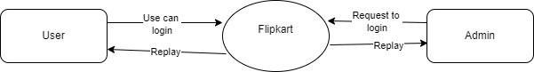

**0 – Level DFD**

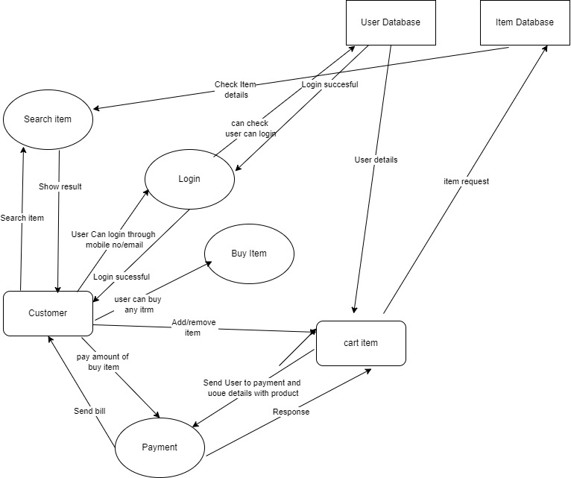

**1 – Level DFD**

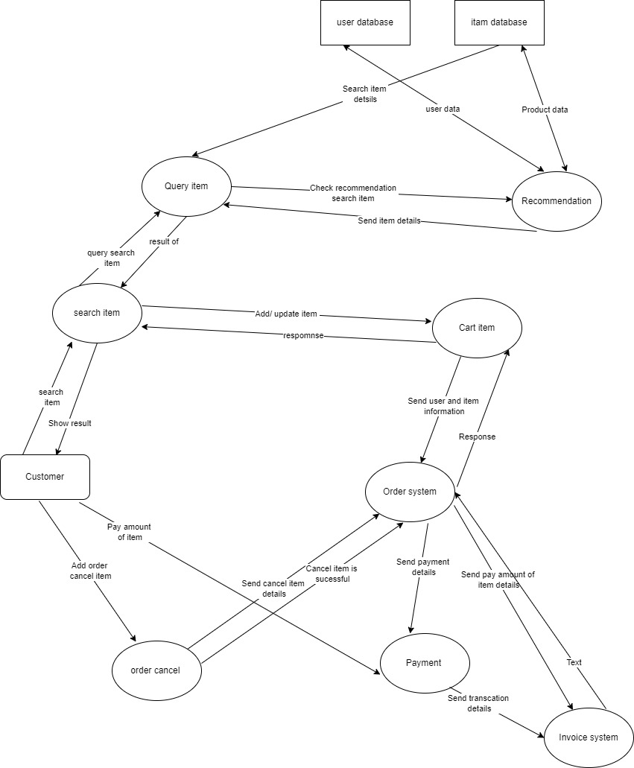

**2 – Level DFD**

5. What is Flow chart? Create a flowchart to make addition of two numbers.

* Flow chart is a graphical representation of an algorithm with the help of different symbols, shapes and arrows to demonstrat a process or program.

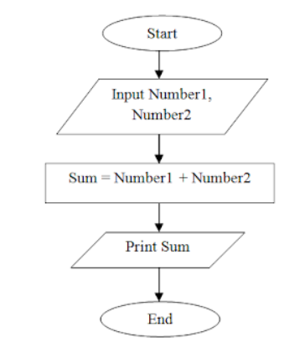

6. What is Use case Diagram? Create a use-case on bill payment on paytm.

* A use case diagram is a visual representation used in software engineering to show the interactions between users and system.

