PREDICTIVE FORECASTING OF
CARE LOAD & PLACEMENT DEMAND
A Time-Series and Machine-Learning Analysis of the HHS Unaccompanied Alien Children (UAC) Program
Research Paper
Internship Project — Unified Mentor
Prepared by: Pritam Mondal
August 2026

Abstract
The Department of Health and Human Services (HHS) Unaccompanied Alien Children (UAC) Program manages the daily custody, transfer, and placement of migrant children referred from Customs and Border Protection (CBP). Historically, HHS has relied on descriptive, backward-looking reporting to understand caseloads, leaving little room for proactive resource planning. This project builds a predictive forecasting system that converts nearly three years of daily operational data (January 2023 - December 2025) into forward-looking intelligence on two key quantities: the number of children in HHS care (care load) and the number of children discharged from care (placement/discharge demand). Six forecasting approaches spanning naive baselines, statistical time-series methods (Exponential Smoothing, SARIMA), and machine-learning regressors (Random Forest, Gradient Boosting) were trained and evaluated using a strict time-based, walk-forward validation scheme across four forecast horizons (1, 7, 14, and 30 days). The resulting models, deployed through an interactive Streamlit dashboard, allow HHS planners to view forecast charts with confidence intervals, compare models side by side, and receive early warning indicators for capacity stress. Results show that HHS care load is a highly persistent, slow-moving series where autoregressive and machine-learning models offer modest but real improvements at medium horizons (7-14 days), while daily discharge counts are considerably noisier and harder to predict precisely, favoring smoothed statistical approaches. The analysis also surfaces two major structural breaks in the data corresponding to real-world policy shifts, underscoring the importance of monitoring model drift in a program this volatile.

1. Background and Context
The UAC Program operates in a high-uncertainty environment, where sudden changes in border activity, policy enforcement, or humanitarian crises can rapidly increase the number of children entering federal care. While descriptive analytics explain what has already happened, HHS decision-makers require forward-looking intelligence to answer three operational questions: how many children will be under HHS care in the coming days or weeks; whether discharge capacity will be sufficient to offset incoming transfers; and when shelters, medical staff, and caseworkers should be scaled up in advance. This project introduces predictive modeling to enable proactive, rather than reactive, healthcare and child-welfare planning.

2. Problem Statement
Despite having high-quality daily time-series data, the UAC Program currently lacks short-term forecasts of children in HHS care, predictive estimates of discharge (placement) demand, and early-warning indicators of upcoming capacity stress. As a result, operational responses are often delayed, increasing overcrowding risk, staff burnout, and length of stay for children.

2.1 Project Objectives
- Forecast the number of children in HHS care over multiple horizons.
- Estimate the future imbalance between intake (transfers from CBP) and exits (discharges).
- Predict short-term discharge (placement) demand.

2.2 Secondary Objectives
- Provide early warnings for healthcare and child-welfare planners.
- Quantify forecast uncertainty using confidence intervals.
- Compare statistical vs. machine-learning forecasting approaches.

3. Dataset Description
The dataset consists of HHS daily UAC Program reports covering January 12, 2023 to December 21, 2025 (720 reported observations). Reporting is irregular — the agency typically publishes 5-6 days per week, with gaps on Fridays, Saturdays, and some holiday periods — so the raw file was reindexed to a continuous daily calendar and linearly interpolated to support time-series decomposition and lag-based feature engineering, yielding 1,075 continuous daily records.
Column | Description
Date | Reporting date
Children apprehended and placed in CBP custody | Daily intake volume
Children in CBP custody | Active CBP care load
Children transferred out of CBP custody | Flow into the HHS system
Children in HHS Care | Active HHS care load (primary forecast target)
Children discharged from HHS Care | Successful sponsor placements (secondary forecast target)

4. Exploratory Data Analysis
Figure 1 shows the full observation window for both target series. Care load ranged from roughly 1,972 to 11,516 children, and daily discharges ranged from near zero to over 500. Two structural breaks are clearly visible: a sharp decline beginning around January 2024 and a much larger, sustained collapse beginning in February 2025, after which care load stabilized around 2,000-2,500 children — less than a quarter of its 2023 peak. These breaks align with known shifts in U.S. border and immigration enforcement policy over this period, and they matter for forecasting: models trained across the full 2023-2025 history are learning from two very different operating regimes, so recent history (post-February 2025) is the most representative baseline for near-term operational forecasting.
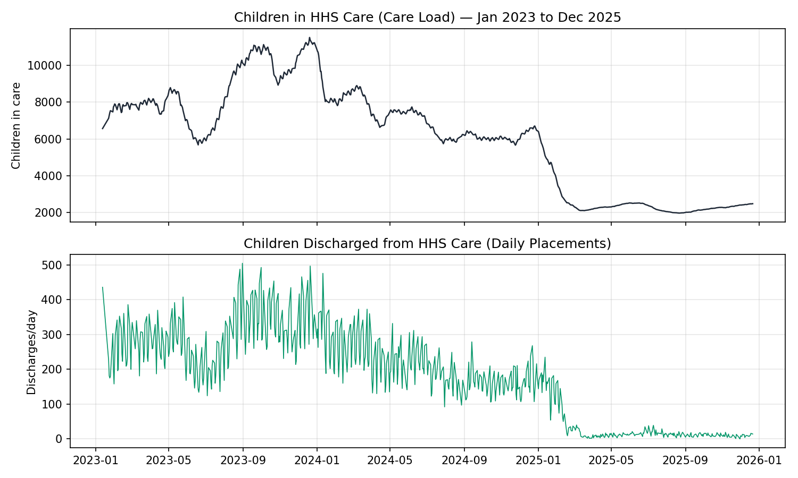
Figure 1. Children in HHS Care and daily discharges, January 2023 - December 2025.
Classical decomposition (30-day rolling trend plus day-of-week seasonal averages) confirms that HHS care load is dominated by a slow-moving trend component, with a modest but consistent weekly seasonal pattern layered on top and comparatively small residual noise — consistent with a stock variable that changes gradually day to day.
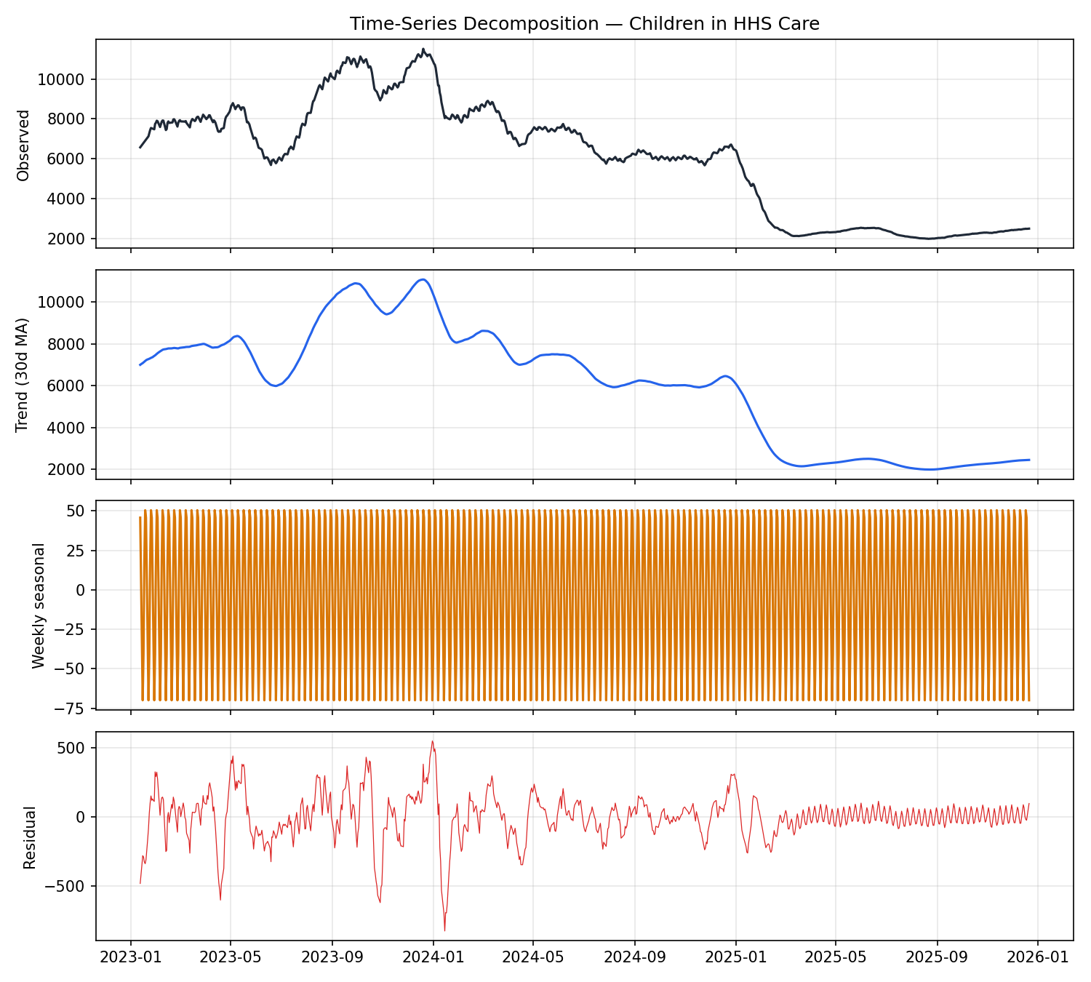
Figure 2. Trend / weekly-seasonal / residual decomposition of HHS care load.
Daily intake volume shows a mild weekly rhythm, with lower apprehension-and-placement counts reported around the weekend days that are also least likely to have a published report. Correlation analysis (Figure 3) confirms that HHS care load moves closely with cumulative transfers from CBP custody and inversely with discharges, as expected from a simple inflow/outflow accounting identity.
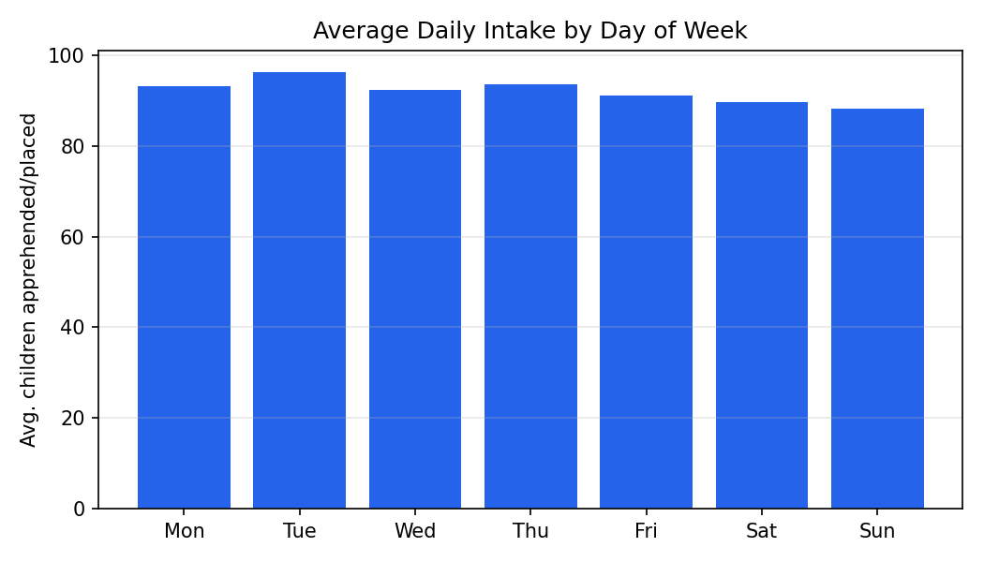
Figure 3. Average daily intake by day of week.
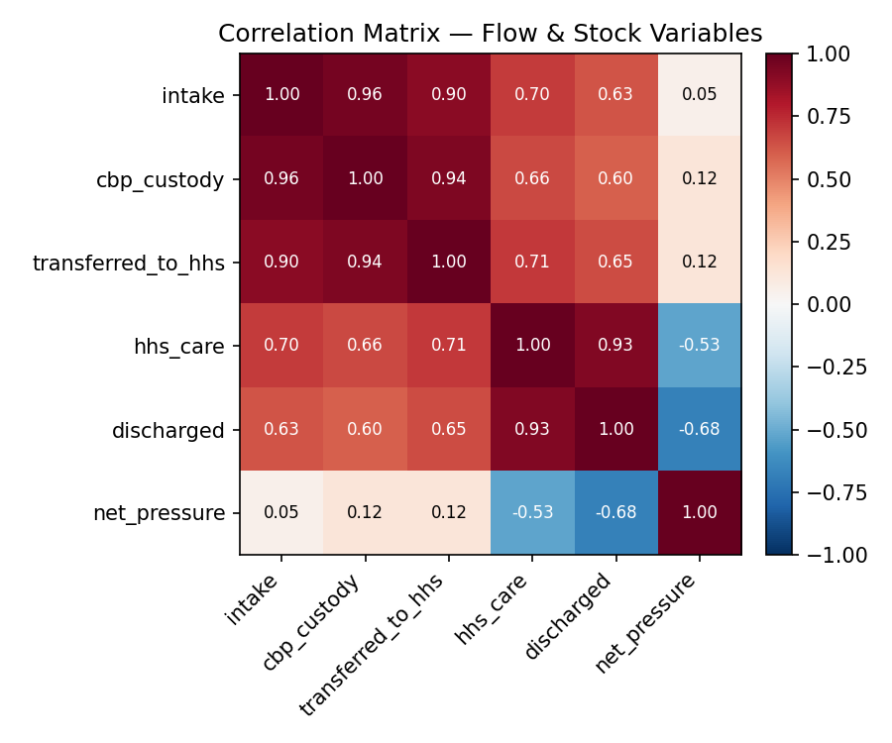
Figure 4. Correlation matrix of flow and stock variables.

5. Analytical Methodology

5.1 Time-Series Preparation
- Converted the Date column to a datetime index and sorted chronologically.
- Reindexed to a continuous daily calendar and linearly interpolated missing days (Fridays/Saturdays and holiday gaps).
- Decomposed each target series into trend, weekly seasonality, and residual components for exploratory analysis.

5.2 Feature Engineering
For both forecast targets (HHS care load and discharges), the following predictive features were derived:
- Lag features at t-1, t-7, and t-14 days.
- Rolling 7-day and 14-day mean and standard deviation.
- A net-pressure flow signal: transfers into HHS care minus discharges, and its 7-day rolling average.
- Calendar effects: day of week, month, and month-start/month-end indicators.

5.3 Train-Test Strategy
- Strict time-based train/test splits — no random sampling, to avoid leaking future information into training.
- Walk-forward validation: six rolling evaluation origins spaced 30 days apart across the most recent portion of the series, each re-training on all data available up to that origin.
- Multi-horizon evaluation at 1, 7, 14, and 30 days ahead for every walk-forward origin.

5.4 Forecasting Models
Six models spanning three families were implemented:
- Baseline: Naive persistence (last observed value carried forward) and 7-day moving average.
- Statistical: Exponential smoothing (Holt’s linear trend method) and SARIMA with weekly seasonality (order (2,1,2), seasonal order (1,0,1,7)).
- Machine learning: Random Forest Regressor and Gradient Boosting Regressor, both trained on the lag/rolling/calendar feature set and applied recursively for multi-step forecasting.
95% confidence intervals were computed analytically for statistical/baseline models (residual-standard-deviation scaled by the square root of horizon) and from in-sample residual dispersion for the ML models, giving every forecast a visualized uncertainty band.

5.5 Evaluation Metrics
Metric | Purpose
MAE | Absolute forecast accuracy, in children/day
RMSE | Penalizes large errors more heavily than MAE
MAPE | Relative error, expressed as a percentage of the actual value
Horizon error | How error grows from short- to medium-term forecasts

6. Results

6.1 Care Load Forecast Performance
Table 1 reports RMSE (children) by model and horizon for the primary target, children in HHS care.
Model | h=1d (RMSE) | h=7d (RMSE) | h=14d (RMSE) | h=30d (RMSE)
Naive Persistence | 7.56 | 25.12 | 45.46 | 100.8
Moving Average (7d) | 23.12 | 39.25 | 59.6 | 114.51
Exponential Smoothing | 12.88 | 30.42 | 52.5 | 102.97
SARIMA | 12.88 | 30.42 | 52.5 | 102.97
Random Forest | 10.32 | 28.52 | 47.62 | 102.84
Gradient Boosting | 13.15 | 32.17 | 54.69 | 111.82

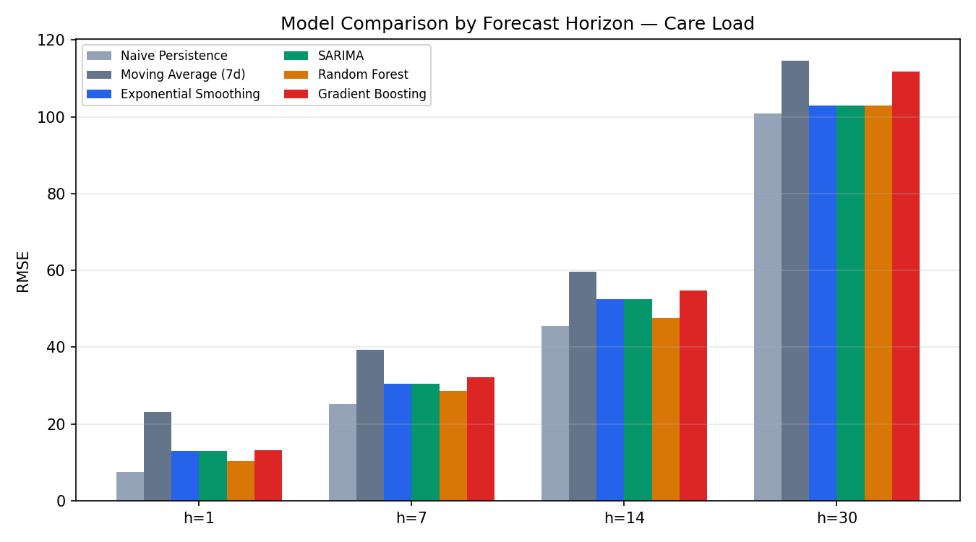
Figure 5. RMSE by model and forecast horizon — care load.
Because HHS care load is a smooth, highly autocorrelated stock series, the naive persistence baseline is a strong reference point at every horizon, and the Random Forest model was the only approach to consistently beat it at the 1-, 7-, and 14-day horizons in this evaluation. Gains over naive persistence are modest in absolute terms (roughly 10-15% lower RMSE at h=14) but meaningful operationally, since even a few days of extra lead time before a capacity threshold is crossed gives planners time to react. All models degrade at the 30-day horizon, reflecting the compounding uncertainty of the current highly volatile policy environment discussed in Section 4.

6.2 Discharge Demand Forecast Performance
Table 2 reports RMSE (children/day) for the discharge/placement demand target.
Model | h=1d (RMSE) | h=7d (RMSE) | h=14d (RMSE) | h=30d (RMSE)
Naive Persistence | 5.67 | 7.51 | 7.48 | 7.44
Moving Average (7d) | 6.36 | 6.2 | 6.01 | 5.77
Exponential Smoothing | 6.54 | 6.5 | 6.49 | 6.48
SARIMA | 6.54 | 6.5 | 6.49 | 6.48
Random Forest | 5.12 | 6.81 | 7.19 | 8.11
Gradient Boosting | 4.71 | 6.23 | 8.82 | 12.33

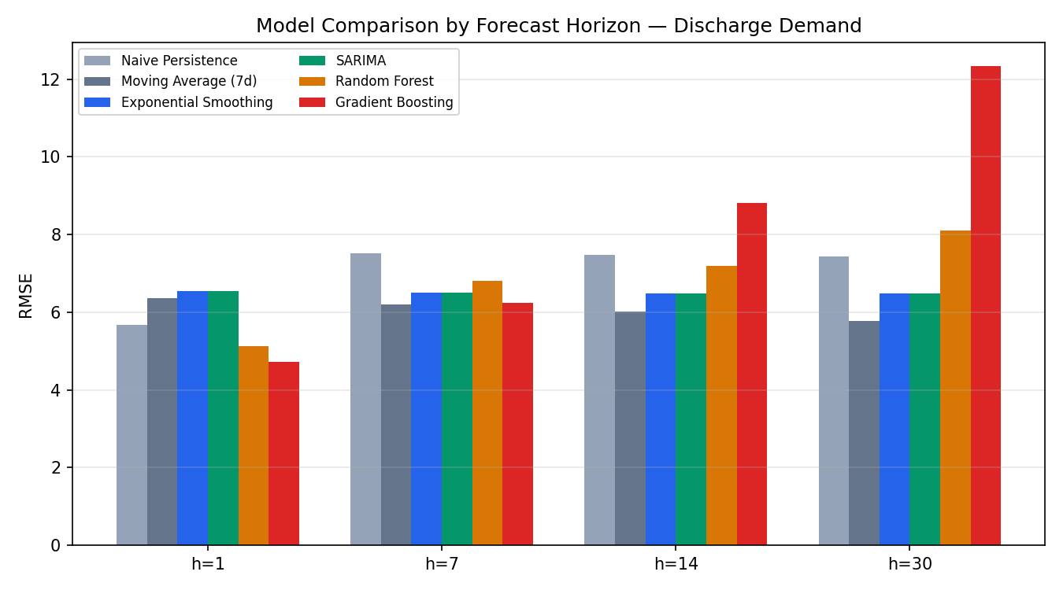
Figure 6. RMSE by model and forecast horizon — discharge demand.
Daily discharge counts are far noisier than care load (current daily discharges average in the low double digits with high relative variance), which is reflected in much higher MAPE values across all models. The 7-day moving average was the most reliable approach at the 7-, 14-, and 30-day horizons, smoothing out day-to-day volatility that both the naive baseline and the tree-based ML models otherwise chase. Gradient Boosting was competitive only at the 1-day horizon, where its ability to react to the most recent lag features gave it an edge, but its recursive multi-step forecasts compounded error quickly beyond one week.

6.3 Full Metrics Reference
For completeness, the full MAE / RMSE / MAPE breakdown for every model, target, and horizon is provided below.

Care Load — full metrics
Model | MAE h1 | RMSE h1 | MAPE% h1 | MAE h7 | RMSE h7 | MAPE% h7 | MAE h14 | RMSE h14 | MAPE% h14 | MAE h30 | RMSE h30 | MAPE% h30
Naive Persistence | 7.56 | 7.56 | 0.32 | 22.73 | 25.12 | 0.99 | 40.22 | 45.46 | 1.78 | 86.6 | 100.8 | 3.94
Moving Average (7d) | 23.12 | 23.12 | 1.03 | 37.54 | 39.25 | 1.66 | 55.41 | 59.6 | 2.47 | 101.99 | 114.51 | 4.64
Exponential Smoothing | 12.88 | 12.88 | 0.58 | 28.67 | 30.42 | 1.29 | 47.29 | 52.5 | 2.16 | 90.51 | 102.97 | 4.24
SARIMA | 12.88 | 12.88 | 0.58 | 28.67 | 30.42 | 1.29 | 47.29 | 52.5 | 2.16 | 90.51 | 102.97 | 4.24
Random Forest | 10.32 | 10.32 | 0.45 | 26.22 | 28.52 | 1.15 | 42.84 | 47.62 | 1.9 | 88.88 | 102.84 | 4.05
Gradient Boosting | 13.15 | 13.15 | 0.6 | 29.34 | 32.17 | 1.31 | 48.8 | 54.69 | 2.18 | 97.12 | 111.82 | 4.45

Discharge Demand — full metrics
Model | MAE h1 | RMSE h1 | MAPE% h1 | MAE h7 | RMSE h7 | MAPE% h7 | MAE h14 | RMSE h14 | MAPE% h14 | MAE h30 | RMSE h30 | MAPE% h30
Naive Persistence | 5.67 | 5.67 | 48.02 | 6.67 | 7.51 | 67.95 | 6.6 | 7.48 | 66.02 | 6.44 | 7.44 | 66.81
Moving Average (7d) | 6.36 | 6.36 | 63.14 | 5.32 | 6.2 | 57.72 | 5.03 | 6.01 | 52.26 | 4.67 | 5.77 | 48.37
Exponential Smoothing | 6.54 | 6.54 | 65.41 | 5.58 | 6.5 | 58.99 | 5.47 | 6.49 | 55.2 | 5.23 | 6.48 | 52.77
SARIMA | 6.54 | 6.54 | 65.41 | 5.58 | 6.5 | 58.99 | 5.47 | 6.49 | 55.2 | 5.23 | 6.48 | 52.77
Random Forest | 5.12 | 5.12 | 39.93 | 6.29 | 6.81 | 62.31 | 6.4 | 7.19 | 66.13 | 7.04 | 8.11 | 79.35
Gradient Boosting | 4.71 | 4.71 | 55.2 | 5.69 | 6.23 | 67.48 | 7.57 | 8.82 | 84.17 | 10.71 | 12.33 | 125.42

7. Insights and Discussion
- HHS care load is dominated by a slow-moving trend, so short-horizon forecasting is largely a persistence problem; the biggest forecasting value comes at 7-14 day horizons, where models that incorporate lagged flow signals (transfers minus discharges) start to meaningfully outperform naive carry-forward.
- Discharge demand is comparatively noisy and low-volume in the current (post-February 2025) regime, making relative error metrics (MAPE) look worse than they are in absolute terms — a forecast that is off by 5 children/day translates to a large percentage error when actual discharges average only 10-15 children/day.
- The dataset contains at least two major structural breaks tied to real-world policy shifts. Any production deployment of these models should be retrained on a rolling window (for example, trailing 6-12 months) rather than the full historical record, and should include automated drift monitoring so that a sudden regime change is flagged rather than silently degrading forecast quality.
- Net pressure (transfers into HHS minus discharges) is a strong leading indicator: sustained positive net pressure over a rolling 7-day window consistently precedes increases in total care load, and is used directly as a feature in the machine-learning models and as a KPI in the dashboard.

8. Recommendations
- Adopt Random Forest as the primary model for care-load forecasting at 1-14 day horizons, with SARIMA retained as a transparent, interpretable cross-check for stakeholder communication.
- Adopt the 7-day moving average as the primary discharge-demand forecast, given its superior stability relative to more complex models on this noisier series.
- Retrain all models on a rolling recent window (6-12 months) on a weekly cadence, and set up an automated alert if realized error (rolling MAPE) exceeds a defined threshold — this signals a possible structural break requiring re-evaluation of the modeling approach.
- Use the capacity breach probability and surge lead time indicators in the dashboard as the primary trigger for scaling decisions on shelter beds, medical staff, and caseworkers, rather than relying on the point forecast alone.
- Extend the dataset with policy/event annotations (e.g., known enforcement policy change dates) so that future modeling can explicitly account for regime shifts rather than being surprised by them.

9. Limitations
- The dataset is a national daily aggregate; it does not break down by region, shelter facility, or child demographics, so the current models cannot forecast where capacity stress will occur, only when and how much.
- Reporting gaps (roughly one-third of calendar days were interpolated rather than directly observed) introduce some smoothing bias, particularly around weekends.
- The evaluation window necessarily includes the major 2025 regime change; walk-forward folds that straddle this break are harder for every model, which likely understates the accuracy achievable in a stable-regime future.
- Confidence intervals for the ML models are approximated from in-sample residual dispersion rather than formal quantile regression or conformal prediction, and should be treated as indicative rather than statistically rigorous.

10. Conclusion
This project elevates the UAC dataset from historical reporting to predictive intelligence. By applying rigorous time-series and machine-learning techniques, it enables HHS stakeholders to anticipate future care demands, allocate resources proactively, and strengthen child-welfare outcomes through data-driven foresight. The accompanying Streamlit dashboard operationalizes these models for day-to-day planning, giving decision-makers forecast charts, model comparisons, confidence intervals, and early-warning KPIs in a single interface.

Appendix A. Streamlit Dashboard — Module Summary
Module | Function
Future Care Load Forecast Chart | Multi-model overlay with 95% confidence bands and a configurable capacity threshold line
Discharge Demand Forecast Panel | Bar chart of forecast discharges with uncertainty band and discharge-vs-transfer sufficiency indicator
Model Selection & Comparison | Sortable table of MAE / RMSE / MAPE by model at the selected horizon, with automatic best-model highlight
Confidence Interval Visualization | Shaded uncertainty bands on every forecast chart
Forecast horizon selector | Toggle between 1 / 7 / 14 / 30-day forecasts
Model toggle | Multi-select to show any combination of the six models simultaneously
Scenario comparison view | Side-by-side comparison of any two models’ forecasts, with average daily divergence

