CMPEN/EE454: Computer Vision

Computer Project # 2:

Region Properties, Shape Recognition, and Image Filtering

Zhenning Zhao, Kyle McCormick, Michael Mikulski

Date: 09/28/2012

    - Objectives
The second CMPEN 454 project was intended to use methods used in project one to analyze and manipulate a set of images. This project specifically aims to get students to recognize model regions and perform image filtering techniques using MatLab.
    - Methods
Provide a flow chart or algorithmic description to show the flow of the project. Similarly, you could alternately discuss the structure of your code; i.e., give a breakdown of your *.m files, such as the main.m file and supplemental function.m files, and how to run them. A good approach is to give a flow chart or some skeletal psuedocode, such as I did on page 3-9 of the class notes for computing a histogram. EVERY tiny detail isn’t needed – the goal is to summarize the ``big picture” of your code.
Briefly describe your algorithms and any other relevant implementation details, including mathematical details.
Give references to any analytical derivations. For example, you could say: “We applied equation (2.5) of Jain, Kasturi, and Schunck to compute the size of the labeled region.”

    - Results
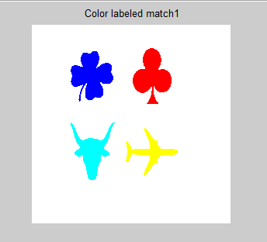
Figure 1. Labeled model image match1.gif with color. (Clover: blue; Steer: cyan; Airplane: yellow; Spade: red)

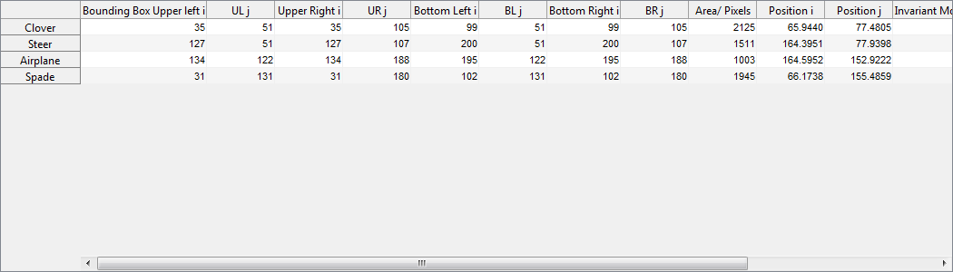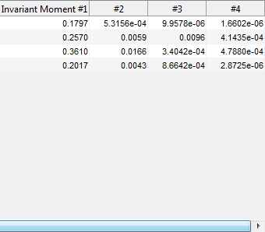

Figure 2. Database table of model image match1.gif

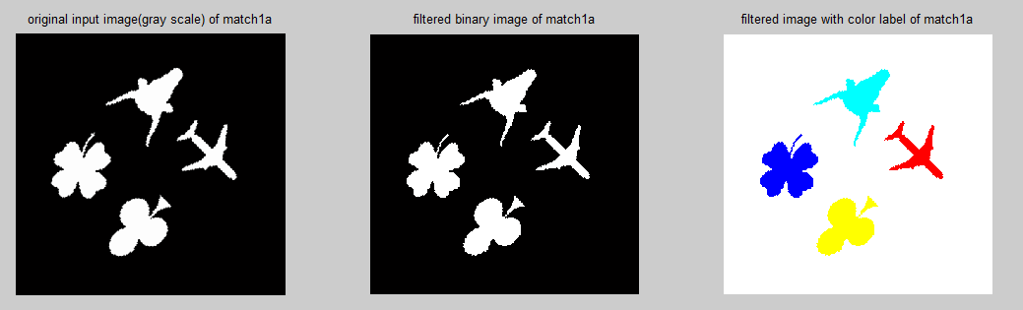

Figure3. Original input image, filtered binary image and filtered image with color label of test image match1a.

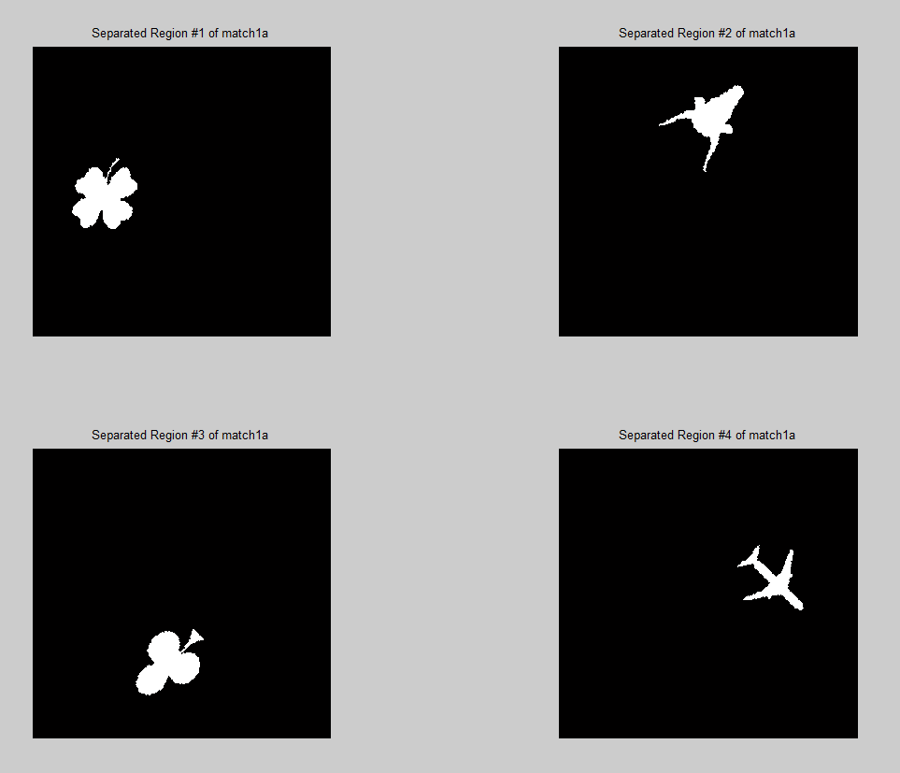

Figure 4. Four Separated ROIs of test image match1a.

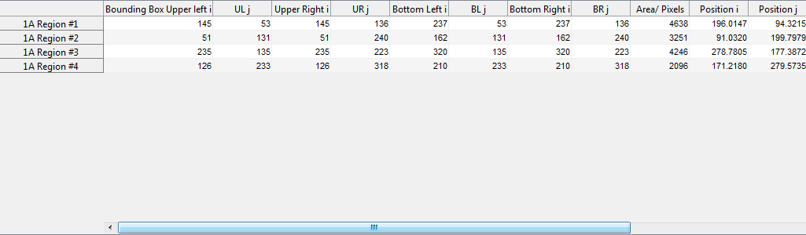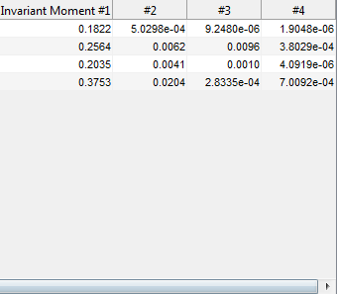
Figure 5. Database table of test image match1a

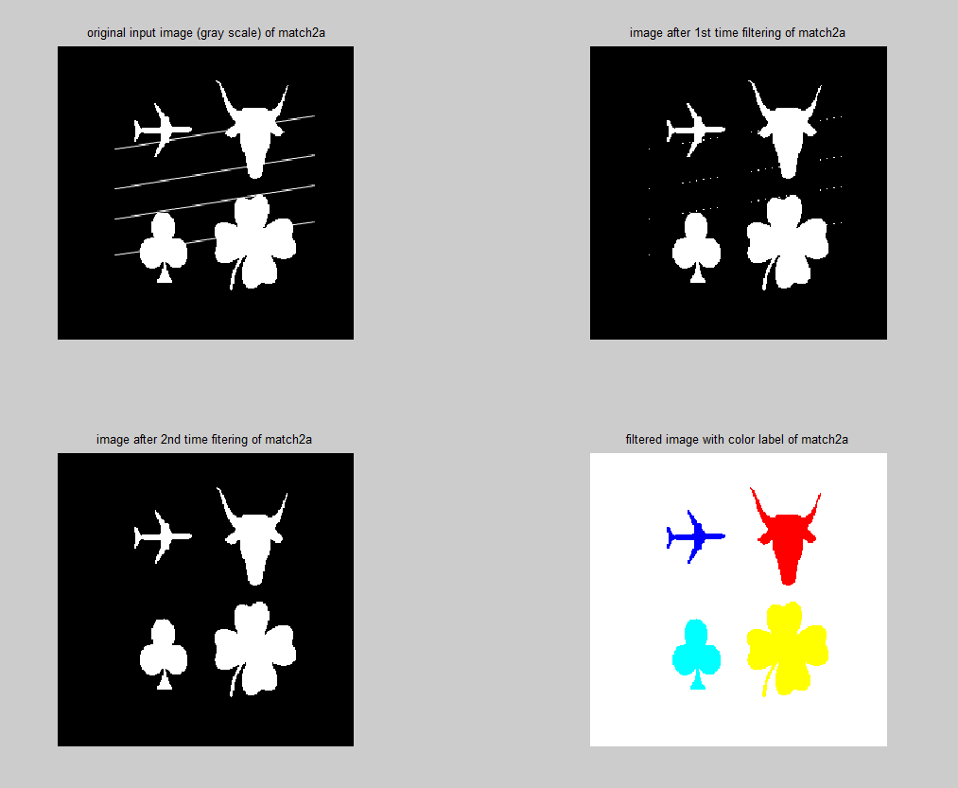

Figure 6. Original input image, 2 filtered image and finally filtered image with color label of test image match2a.

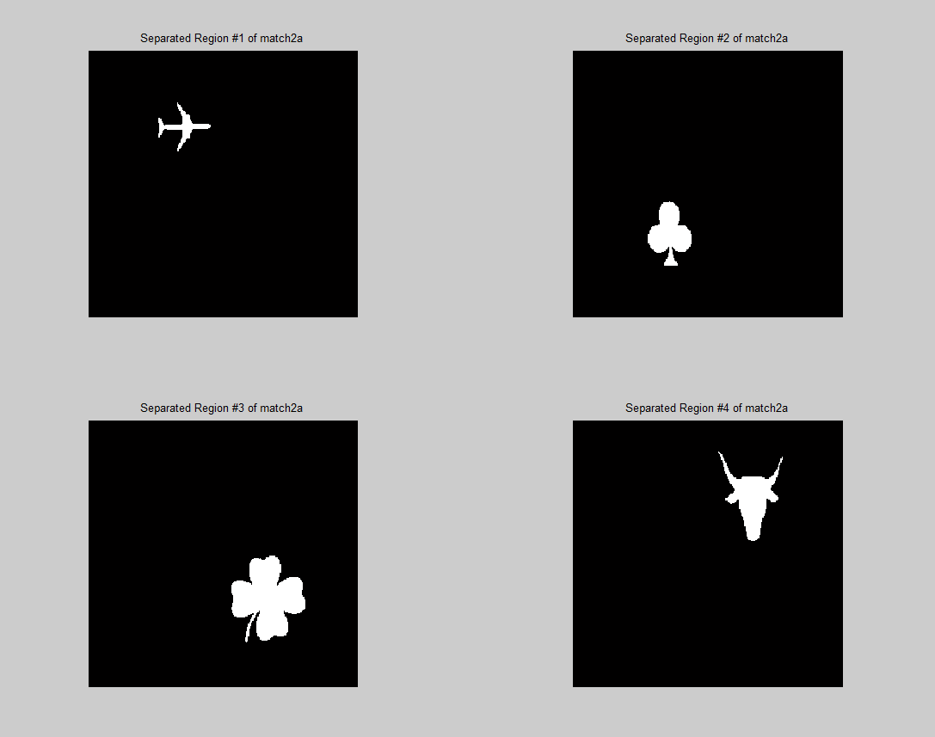

Figure7. Four Separated ROIs of test image match2a

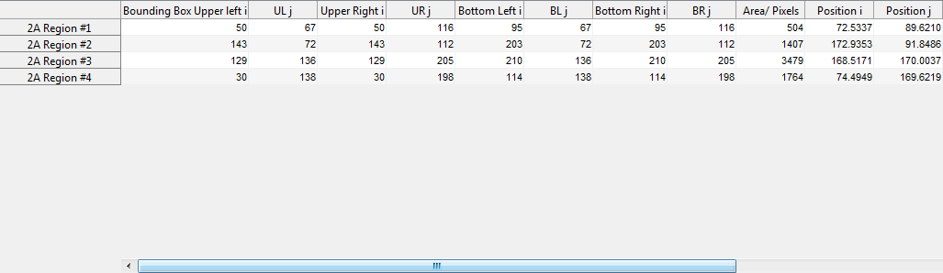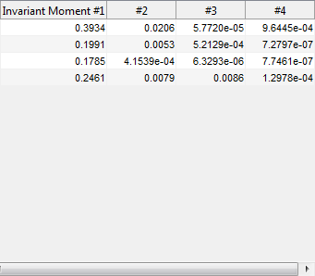

Figure 8. Database table of test image match3a

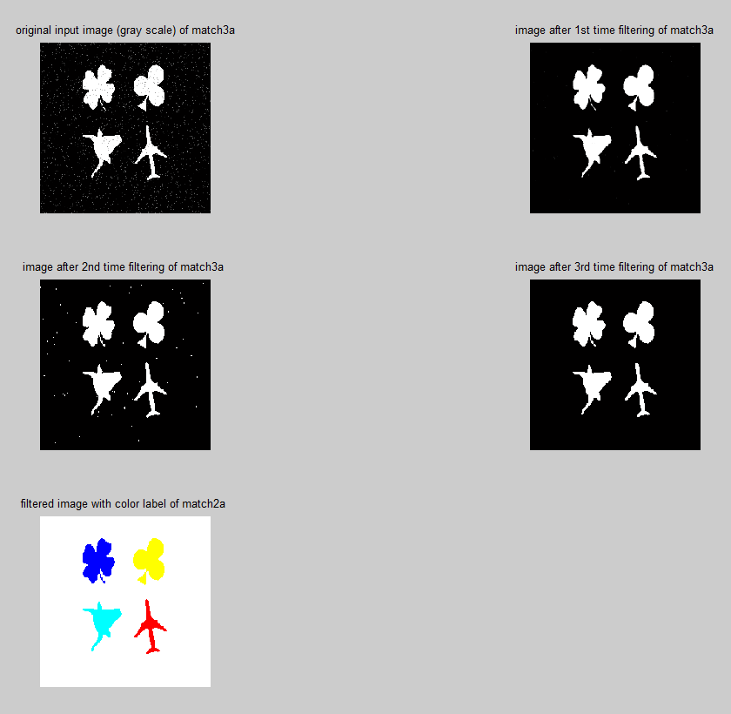

Figure 9. Original input image, 3 filtered image and finally filtered image with color label of test image match3a.

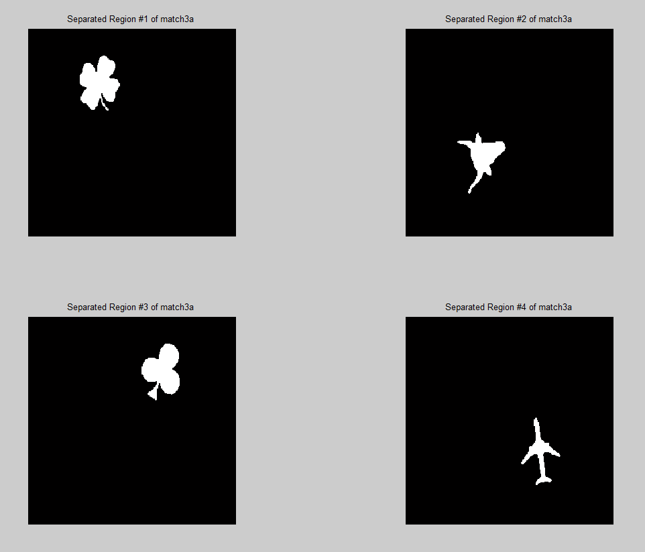

Figure 10. Four Separated ROIs of test image match3a

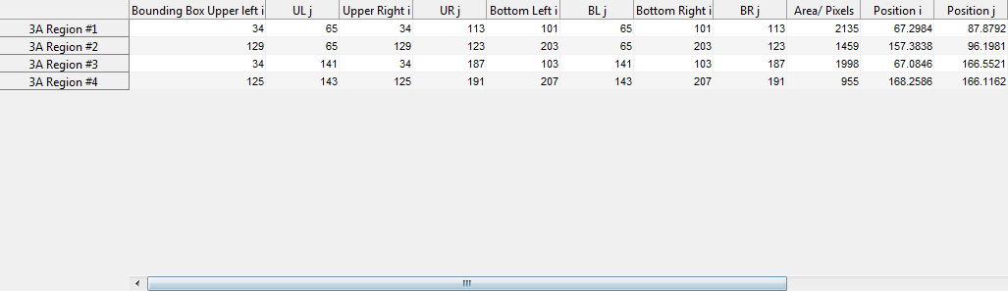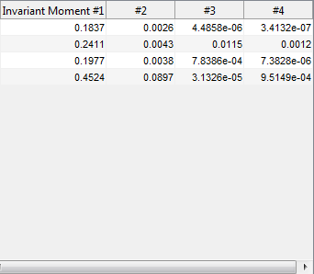

Figure 11. Database table of test image match3a

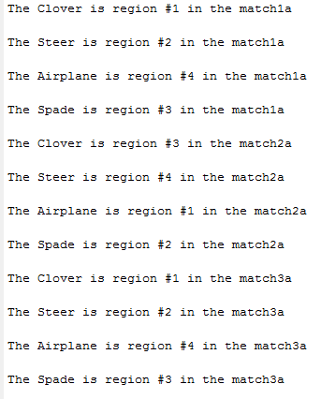

Figure 13. Conclusion for shape recognition

Give detailed observations and/or analysis of all results.
Also, ask yourself the following general questions:
- Are the results what you were expecting they would be? If not, why not?
- Do you think it's because the algorithm is not the appropriate one, or because your implementation has a bug?
Be sure to answer any questions the project write-up may pose! I often pose such questions to probe you on certain project knowledge.
It is important that you realize when your results are wrong – this means that you understood the theory behind the project. In some cases, credit is given for incorrect results when the error is pointed out and thorough explanations are given for the incorrect results, along with possible corrections or solutions.
    - Conclusions

