Selenium testing

* We have so many tools available in the market where some are open-source and paid tools.
* The significant difference between open-source and the paid tool is that the open-source tools have limited features, whereas paid tool or commercial tools have no limitation for the features. The selection of tools depends on the user's requirements, whether it is paid or free.

What is selenium ?

* Selenium is an open-source tool that automates web browsers. It provides a single interface that lets you write test scripts in programming languages like Ruby, Java, NodeJS, PHP, Perl, Python, and C#, among others. Selenium is automation testing tool.

What is automation testing tool ?

* This type of tool is used to enhance the productivity of the product and improve the accuracy. We can reduce the time and cost of the application by writing some test scripts in any programming language.

Selenium WebDriver

Also known as Selenium 2.0, [WebDriver](https://www.browserstack.com/guide/selenium-webdriver-tutorial) executes test scripts through browser-specific drivers. It consists of:

**API**

Application Programming Interface. Ports test scripts you write in Ruby, Java, Python, or C# to Selenese (Selenium’s own scripting language), through bindings.

**Library**

Houses the API and language-specific bindings. Although plenty of third-party bindings exist to support different programming languages, the core client-side bindings supported by the main project are: Selenium Java (as selenium jar files), Selenium Ruby, Selenium dotnet (or Selenium C#, available as .dll files), Selenium Python, and Selenium JavaScript (Node).

**Driver**

Executable module that opens up a browser instance and runs the test script. Browser-specific—for instance, Google develops and maintains Chromedriver for Selenium to support automation on Chromium/Chrome.

**Framework**

Support libraries for integration with natural or programming language test frameworks, like Selenium with Cucumber or Selenium with TestNG.

Selenium Grid

The Grid can minimize test runtime—by executing multiple test scripts on any number of remote devices at once. This is called parallel testing.

Selenium Grid is a smart server that routes test commands to browser instances on remote devices.

Selenium IDE

Selenium IDE is a Chrome and Firefox plugin that can log ‘natural’ interactions in the browser and generate its code in programming languages like C#, Java, Python, and Ruby, as well as Selenese (Selenium’s own scripting language).

Testers can enable ‘recording’ within the IDE and ‘play out’ the test scenario on the browser. The IDE can then replay those interactions and highlight any errors (during replay) in red.

Advantages of selenium :-

→ Open Source: -

it is an open-source tool, anyone can download and use the source code. It can also be refactored based on project requirements. This improves the functionality of predefined functions and classes.

→ Multi Language Support

esters normally use the most common languages for writing Selenium test automation code: C #, Java, PHP, Perl, Python, and Ruby.

→ Multi Browser Support

Chrome, Firefox, Safari, Internet Explorer, Opera, and Edge are the most commonly used browsers worldwide and are compatible with Selenium test automation scripts. One can create Test scripts and execute them in these browsers without any changes in the script. That means it is not required to rewrite the scripts for every browser, just one script for all browsers, with the help of browser drivers.

→ Platform Support

Once we create test scripts on any operating system, they can be executed on any other operating system.

→ Framework availability

There are a wide variety of frameworks that supports Selenium test automation when compared to other test automation tools in the same class.

→ Reusability

As we know, Selenium test automation scripts can be executed in multiple browsers and operating systems. Moreover, tests written in Selenium reduce the manual effort required to run them repeatably.

Disadvantages of selenium :-

* Selenium can only test web applications. It can not test software applications and other desktop applicati ons.
* Selenium can not access web elements outside the web applications that are under test.
* Selenium independently does not support image testing.

1. First search selenium IDE for chrome

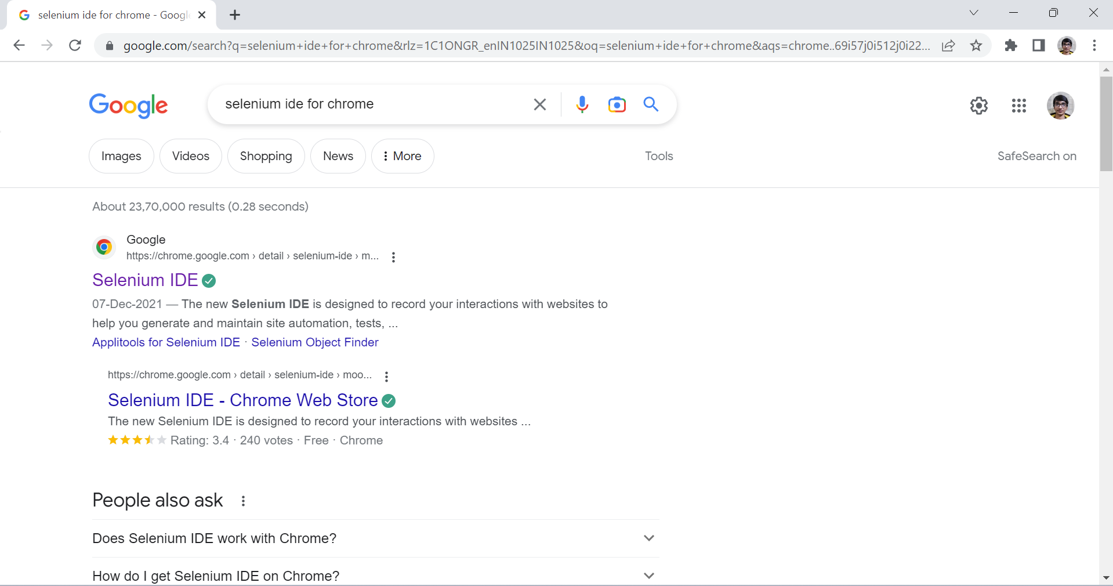

1. Choose add to chrome option

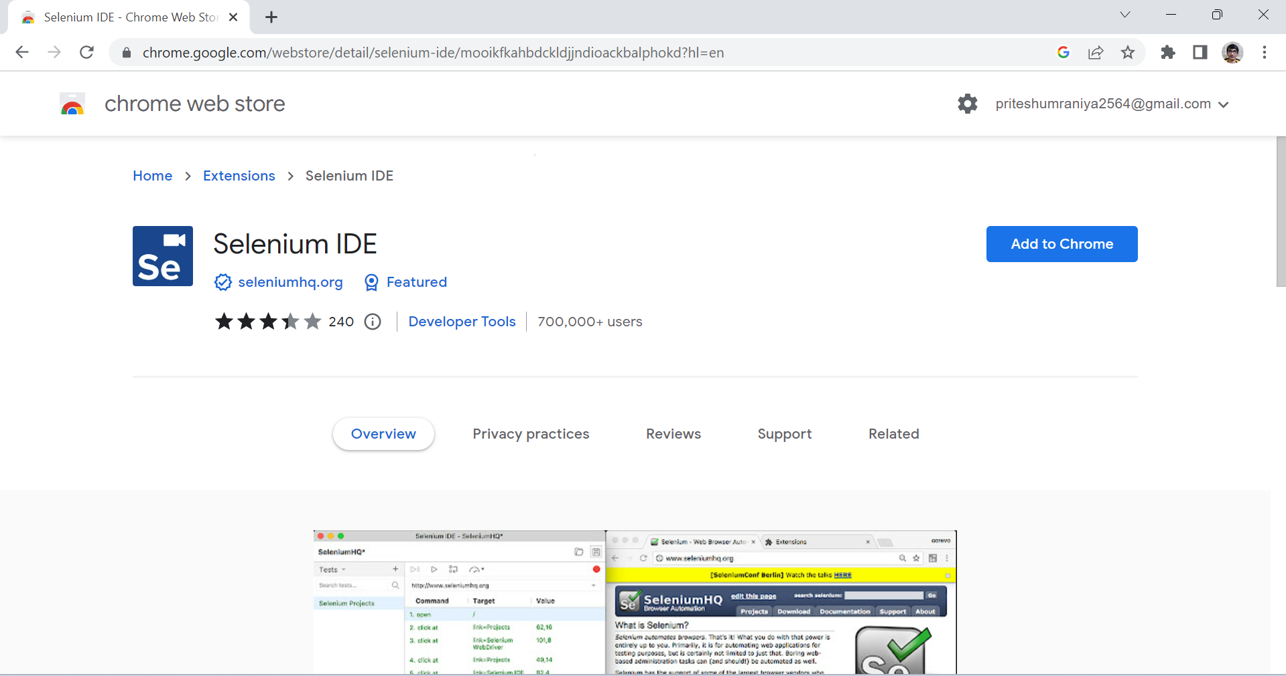

1. Click on add Extension option

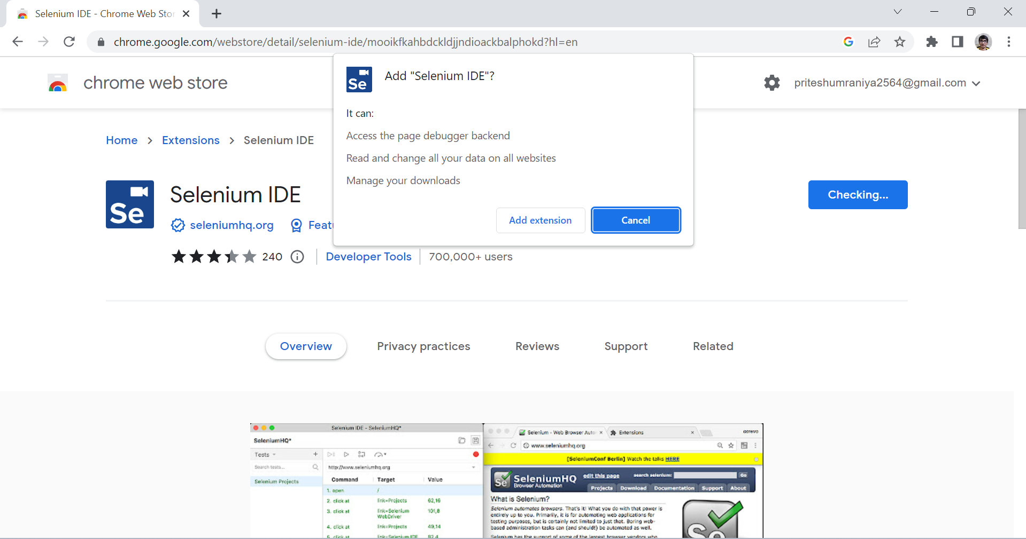

1. Choose option Record a new test in a new project and then give the project name you want. In our case project name is ‘pritesh’ and I want to test the login page of my system which is made using Django framework.

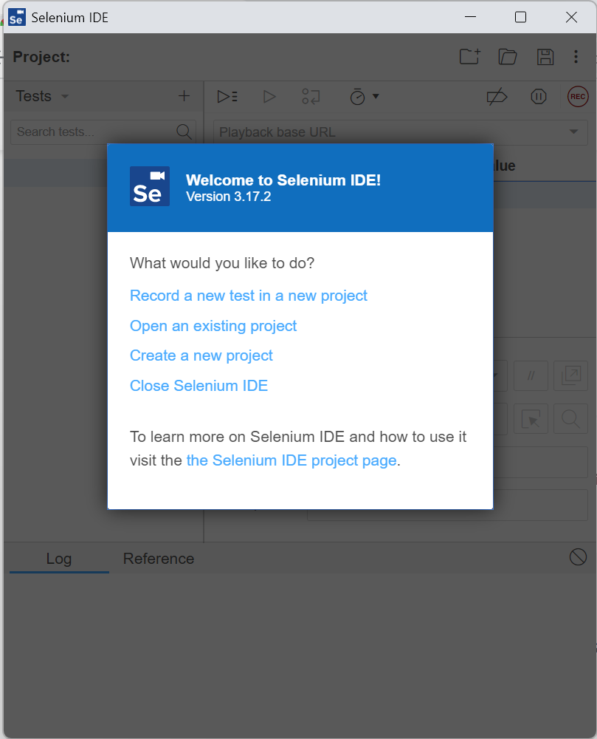

1. Select link of login page

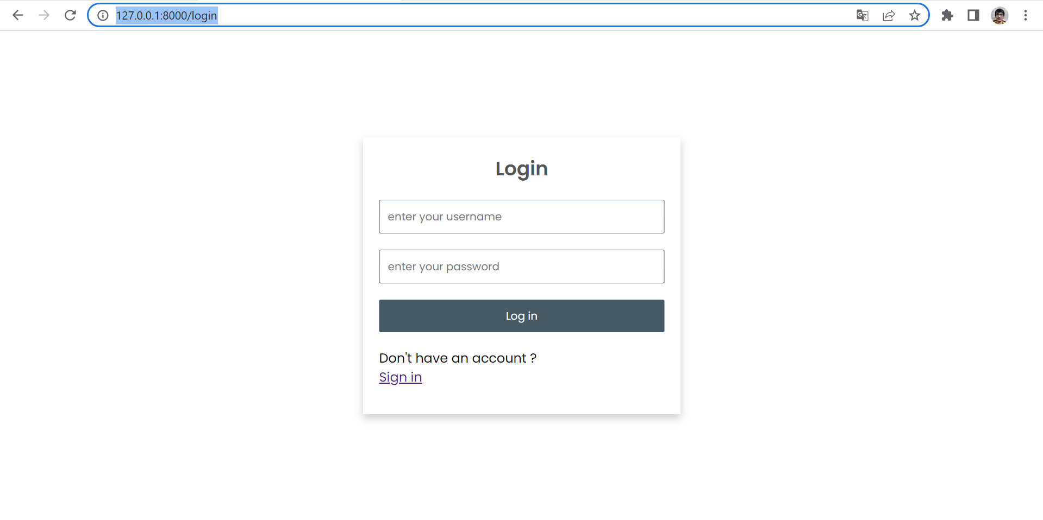

1. Paste that URL as project URL and then click on start recording

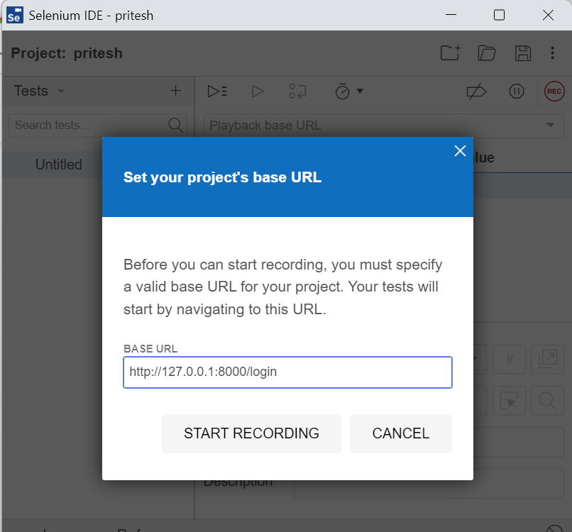

1. Selenium will start recording and here I’m entering correct username and password

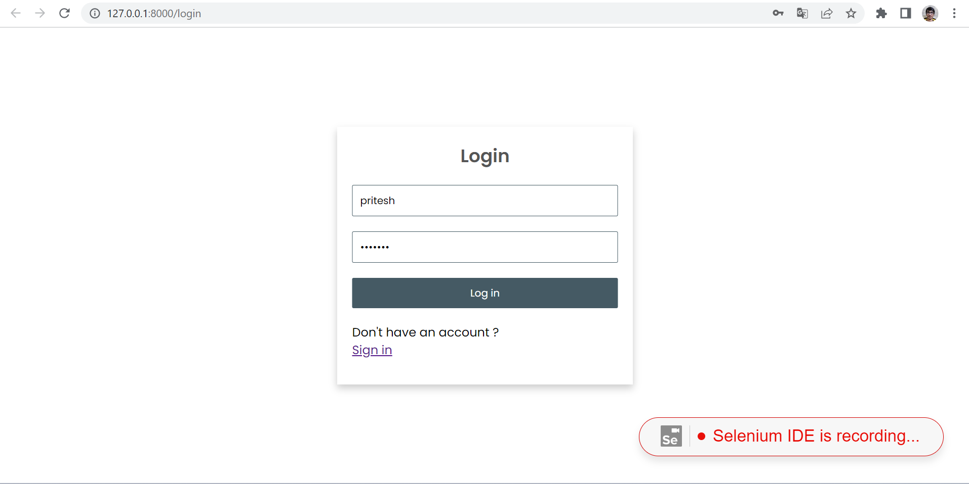

1. It will redirected to the home page of the system

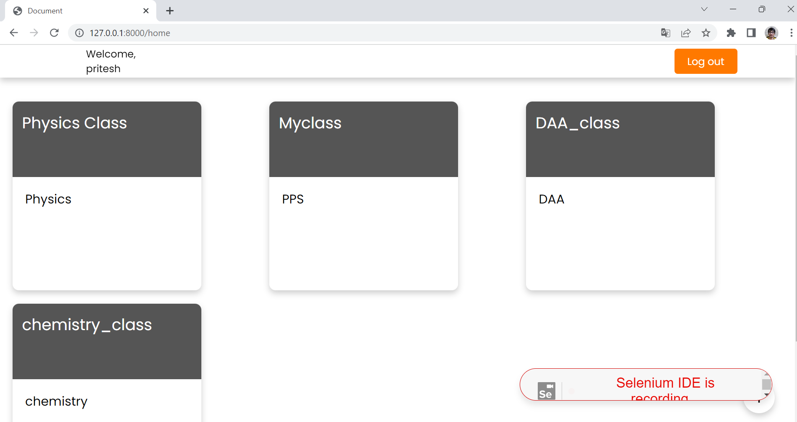

1. If I enter incorrect password then it will displays the error message and redirected to the same login page

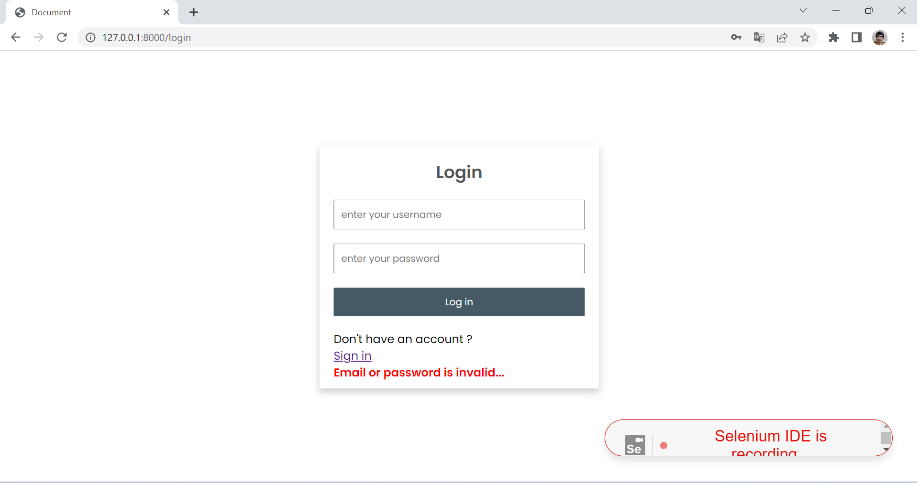

1. Save the test file. Here I am giving ‘login_testing’.

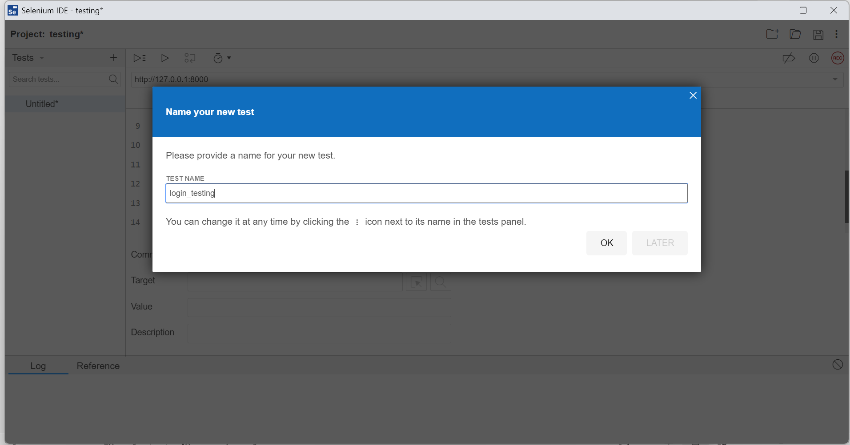

1. Below picture is the successful test of my login system.

