**CSCI 56500 – Fall 2017**

**Quiz 14**

**Name : Pritesh Ratnappagol**

1. **Length of the list**

The program can be used to compute the length of the given list of various sizes.

Program also checks if there are no elements in the list then returns “ 0 ” (i.e. zero) else calculates the length of the list accordingly and returns the value.

To implement this I am first checking if it is a list or not, if not I am printing a error message; If no elements it will return zero else it will calculate the length of the list by recursively performing addition operation on the tail of the list.

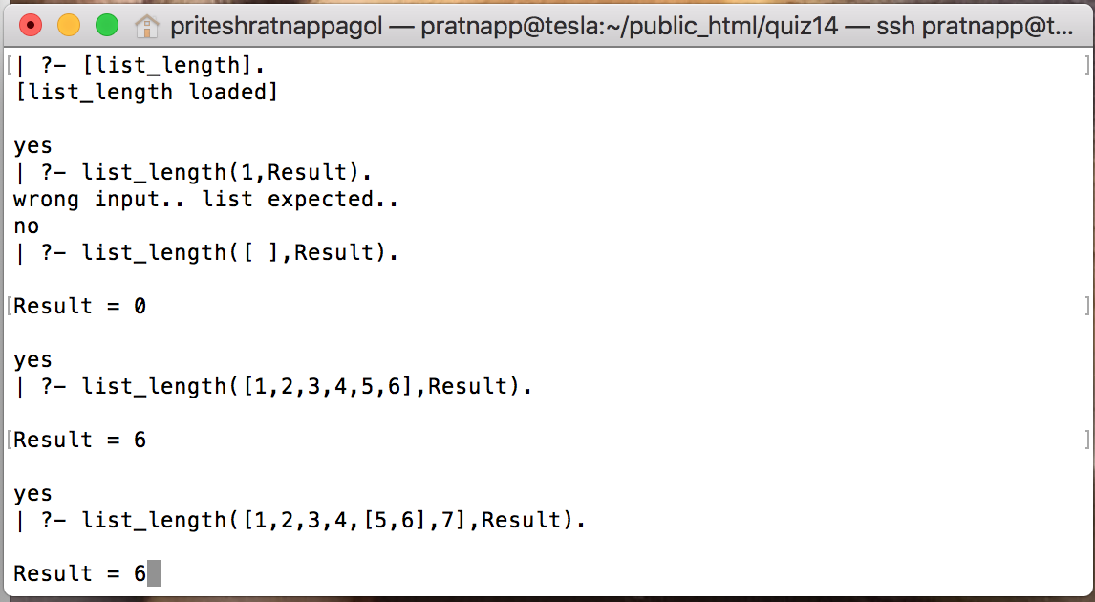

Screenshot 1. Instance of finding length of the list

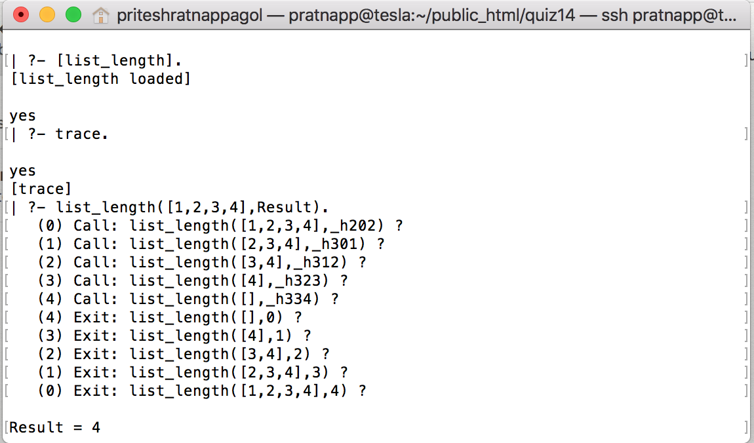

Screenshot 2. Trace of finding length of the list

1. **Finding the second last element**

I have implemented it using four conditions:

1. Program first checks if the input is list or not.
2. Program checks if list is empty and if so it returns the statement “List is empty” and exits the program
3. If list is not empty and contains only one atom in it, it returns “List has only one item” and exits the program
4. If list is not empty and contains two element, it returns the second last element by simply using the car function for the given list.
5. If list is not empty and contains more than two elements it recursively performs the above steps on tail of the list till it is reaches the step 4 and returns the second last element in the list.

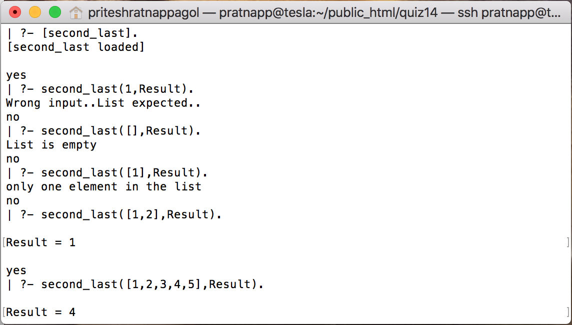

Screenshot 3. Instance of finding second last element

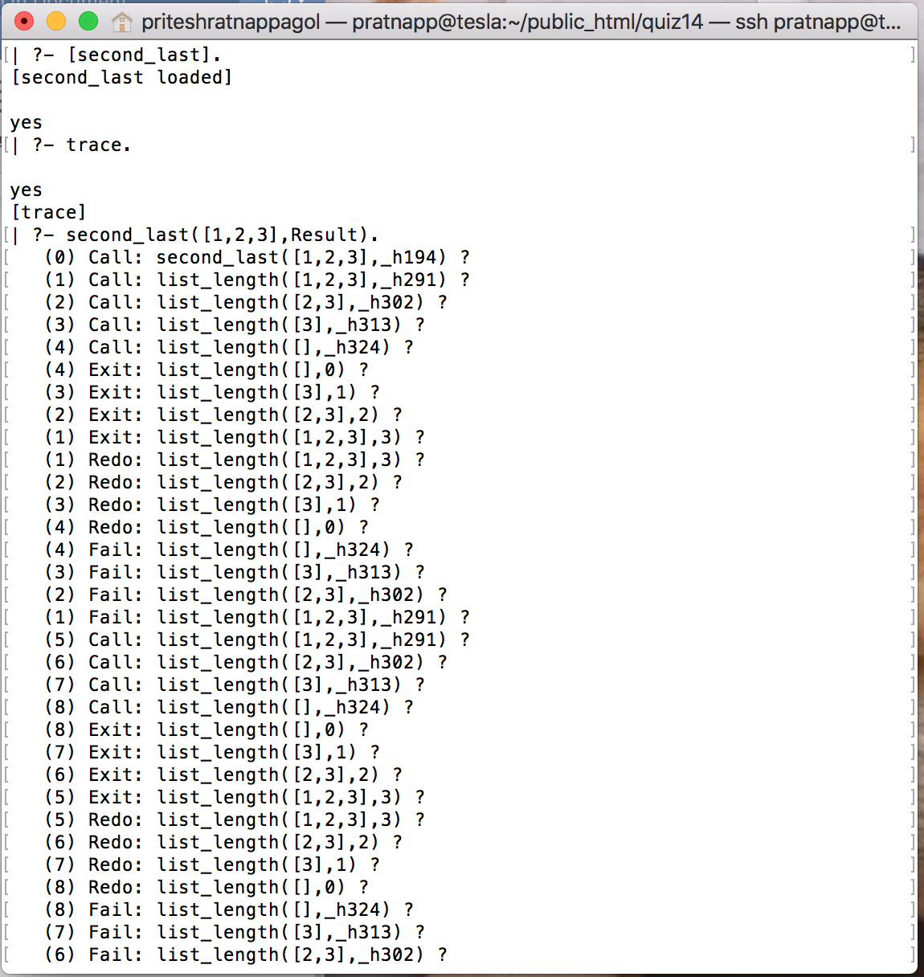

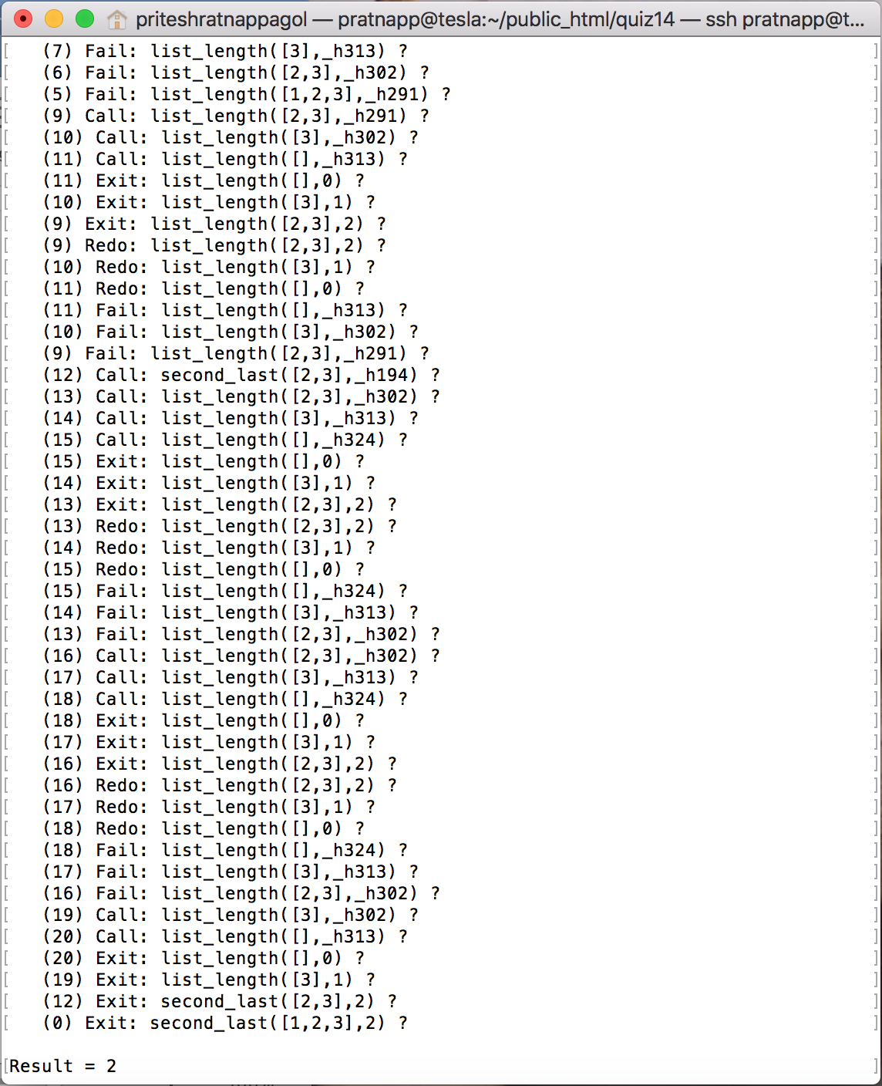

Screenshot 4. Trace of finding second last element

1. **Merging the two lists.**

To implement this function I am taking two lists of equal length from the user and checking the condition if length of the two list is equal or not and creating a new list by using by getting the first element from both the lists and recursively calling merging the two lists.

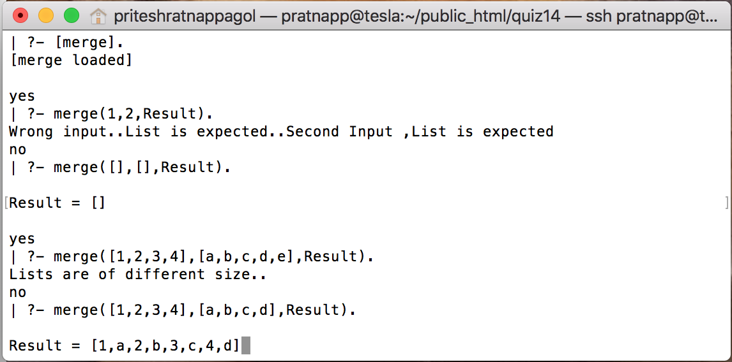

Screenshot 5. Instance of merging the list

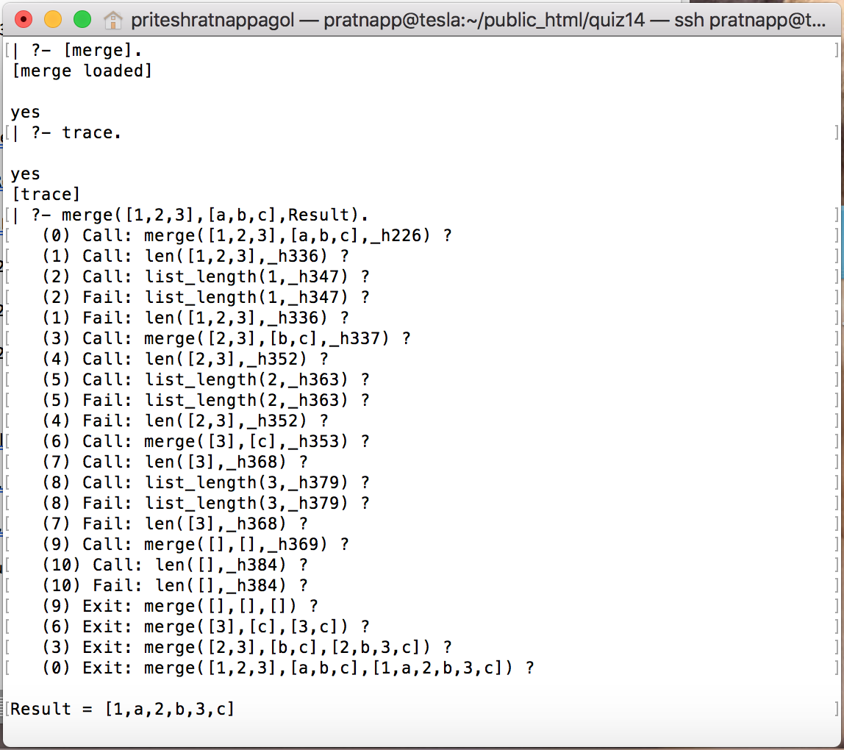

Screenshot 6. Trace of merging the list

1. **Comparison between clisp and prolog.**

* Prolog is a declarative language, while CLISP is a functional language.
* Prolog is used most for logic and reasoning problems, while CLISP is used for problems with rapid prototyping needs.
* Prolog is smaller language and easier to learn , while CLISP handles variety of tasks and easier to use.
* Prolog is an interpreter and LISP is a compiler as prolog compiles the program line by line and LISP compiles the whole program at a time.
* Arithmetic and logical operations in Lisp and prolog.

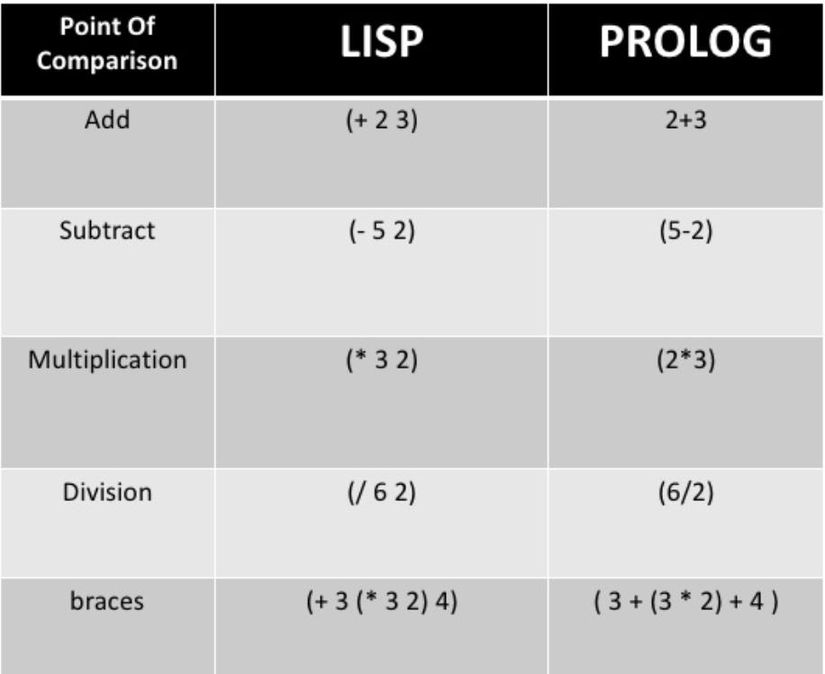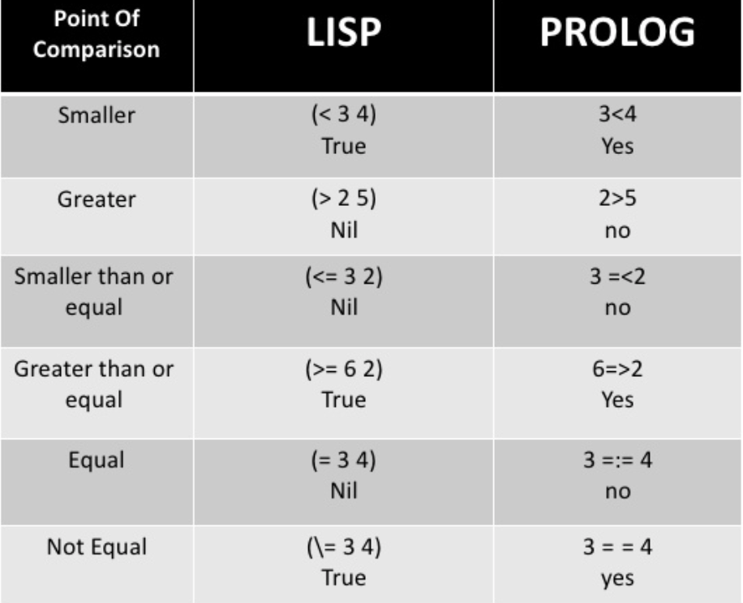

**Finding the head and tail in prolog. Finding the head and tail in Clisp.**

[X|Y] denotes a list with head X and tail Y. head (called car) and the tail (called cdr)

| - used to create a list or dismantle a list.

Example: Example:

[H|T] = [a, b, c]. car((A.B))=A , car((A.B) .C)) = (A.B)

H= a, T = [b, c] cdr((A.B)) = B , cdr(((C.B).D)) is D

[a|T] = [H, b, c].

H= a, T = [b, c]