
CIP Wayfinder
AI-Native NERC Compliance Intelligence
Week 3 Project Submission | Updated September 17 2026 | Python, LangGraph, and Streamlit

Executive summary
CIP Wayfinder is a learning-first compliance review application that helps an analyst move from an authorized public NERC CIP standard to a traceable draft review package. The application presents concise, plain-language requirement summaries with source locations, draft controls, remediation steps, and a human decision in one understandable Streamlit experience.
The project is deliberately more than a document lookup. A separately tested LangGraph workflow coordinates specialist roles, carries typed state across steps, handles empty results and tool failures, and pauses at a human approval interrupt. The product interface focuses on the useful review experience while the graph and branch tests provide the agentic-system evidence required by the assignment.
Project one-liner
My agent helps utility compliance analysts turn a public NERC CIP standard into a source-linked draft review package, replacing manual cross-referencing across documents. It retrieves and drafts autonomously, recovers within strict limits, and hands off before package delivery. Success means a reviewer can reach a usable, traceable draft and choose direct download or separately authorized email without the system claiming compliance or touching live IT/OT assets.

Submission item | Status
Project documentation | SME revision update; tested locally, not yet published
Video demo | Existing recording: ElevenLabs.mov (Drive link below). Accessible; content and duration review pending.
Code base | https://github.com/priteshbhoite-bot/cip-wayfinder  Published baseline 0981beb Open link
Existing video link | https://drive.google.com/file/d/1LBrPT0LFz-n4r8UJg99BQxy7cHizHDAA/view Open link

System architecture
I designed the solution as two complementary layers. The Streamlit layer is the experience an analyst uses. The LangGraph layer is the stateful orchestration model used to prove routing, recovery, checkpointing, and human handoff behavior in code and tests.
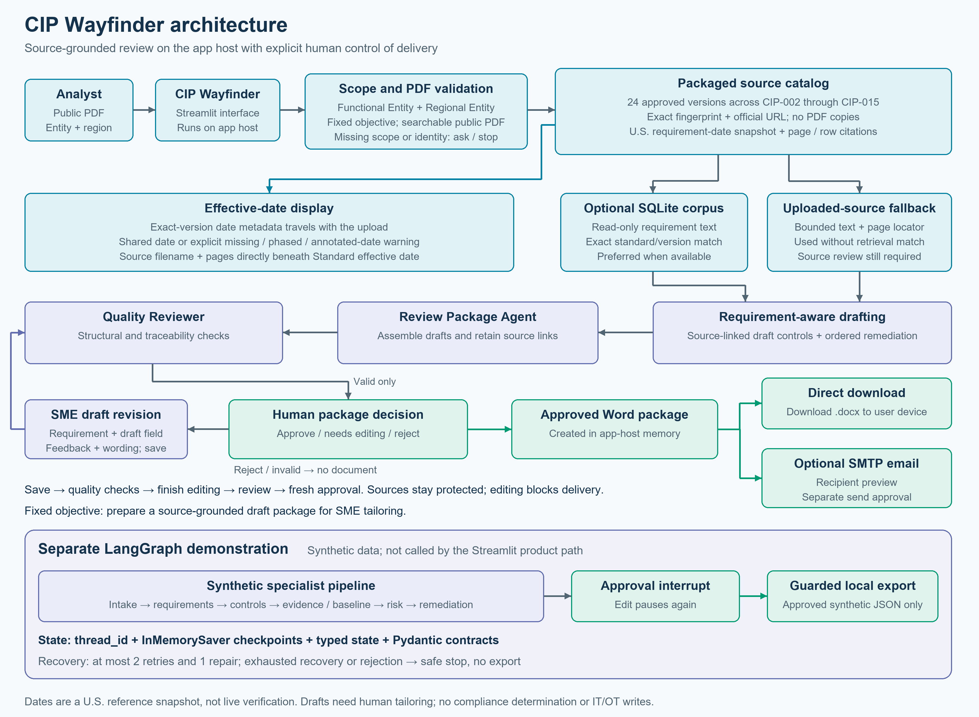
Figure 1. The product includes an SME revision loop before fresh approval. Source recognition, date metadata and the separate synthetic LangGraph path remain distinct.
Current delivery options
After package approval, the app creates a Word document in memory. The reviewer can download it directly or provide a recipient and separately authorize an SMTP send. Package approval alone never sends email.

Important implementation truth
The product screen and the testable LangGraph path are intentionally separated in this MVP. The interface does not pretend that a diagram is a production workflow engine; the graph behavior is demonstrated through code, checkpoints, branch tests, and offline evaluations.

Agent roster
The roster groups seven specialist roles and an independent quality check. The current release uses deterministic Python and graph nodes, not paid model calls. The product package assembler and synthetic graph are separate execution paths.
Role | Primary job | Output / handoff
Intake and Scope | Product: entity and region. Graph: synthetic case scope. Objective is fixed in the UI. | Validated scope or a focused question.
Requirement and Citation | Recognize approved fingerprints; prefer version-matched retrieval or validated upload text. | Requirement mapping plus citation metadata.
Control Drafting | Create draft controls and remediation anchored to retrieved IDs. | Traceable draft package.
Review Package | Assemble grounded knowledge, controls, remediation and sources without rewriting them. | Strict package for quality review; flags missing corpus support.
Evidence Insight | Extract facts and gaps from synthetic, untrusted evidence. | Observations, confidence, and SME questions.
Risk and Remediation | Form potential findings and an explainable draft plan. | Draft risk label and ordered actions.
Human Handoff | Pause, present choices, and guard any write-classified action. | Approve, revise with feedback, reject, or safe stop.
Quality Reviewer | Check citations and cross-artifact control links before handoff. | Structural result; invalid product packages cannot be approved.

7 grouped specialist roles + independent quality check | 9 typed graph tools | retries: 2 | graph repairs: 1 | 15 offline evaluations

Why not one general agent?
One large agent would have to retrieve sources, interpret evidence, draft controls, score risk, recover from failures, and make workflow decisions at the same time. Separating responsibilities makes failures easier to locate, prompts and contracts easier to reason about, and approvals harder to bypass.

How the agents communicate
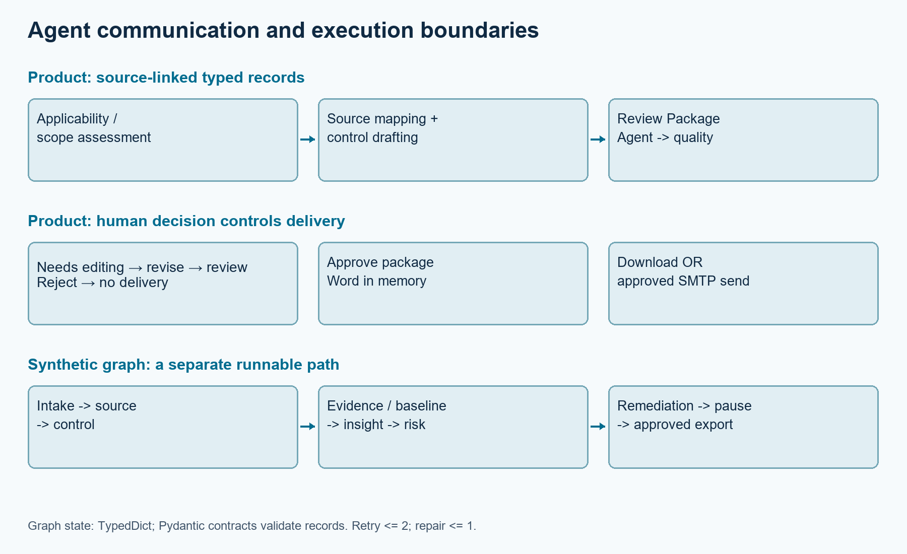
Figure 2. Typed handoffs move the review forward; the approved Word package can be downloaded or separately authorized for email delivery.
LangGraph carries a typed dictionary as shared state. Pydantic models validate structured records at tool and agent boundaries; nodes return state updates. The product Review Package Agent separately assembles strict Pydantic package items for quality review.
Synthetic graph routing: normal tool results advance; errors retry at most twice; empty retrieval gets one repair attempt. Missing scope, exhausted recovery or rejection stops safely. Approval alone permits the synthetic local export. Product quality review is separate.

Agent deep dives: scope, sources, and controls

Intake and Scope Agent
The product asks for Functional Entity and Regional Entity selections, then detects standard/version from the authorized PDF. Its objective is fixed: prepare a source-grounded draft package for SME tailoring. Missing scope prompts a question. The synthetic graph separately validates its case and asset identifiers.
Boundary
It never decides whether a real organization is subject to a NERC requirement. It validates the review scope only.

Requirement and Citation Agent
The product recognizes approved PDFs by exact SHA-256 fingerprint, then prefers version-matched requirements from an optional read-only SQLite index. Without a retrieval match, it uses bounded text from the validated upload. Recognition and retrieval are separate checks. Users can expand summaries, official wording and page citations; unmatched retrieval still prompts source review.
Product: matched corpus or validated upload source -> drafting -> package assembly -> quality review. Synthetic graph: empty retrieval -> one repair -> approval or safe stop.

Control Drafting Agent
This role turns retrieved text into a practical draft control: objective, owner, trigger or frequency, procedure, expected evidence, exceptions, test steps, assumptions, and tailoring questions. Every meaningful field retains the supporting requirement ID.
Draft means draft
Generated language is a starting point for organization-specific SME review. The app does not label the organization compliant and does not authorize implementation.

Evidence, risk, and human handoff

Evidence Insight Agent
The learning workflow uses fictional evidence only. The agent extracts allowlisted facts, support signals, missing fields, conflicts, and SME questions. Document text is treated as untrusted data, so instruction-like lines embedded inside evidence are ignored.

Risk and Remediation Agent
This role compares the sourced requirement, draft control, synthetic evidence, and simulated baseline observation. It creates an explainable potential finding, a simple High/Medium/Low learning label, and ordered remediation actions with owners, decisions, and expected end states.
Boundary
A risk label is a demonstration rubric, not an audit conclusion. The app cannot close a gap, accept evidence, or approve remediation on behalf of an organization.

Quality Reviewer
In the product, the Review Package Agent assembles the grounded drafts, then the Quality Reviewer checks source and control links. Invalid packages cannot be approved. This reviewer does not perform the graph repair: the separate LangGraph validation_repair node permits one bounded attempt.

Human Handoff Agent
Needs editing opens a session-only editor. The SME selects a requirement and existing draft field, enters revised wording and feedback, then saves. Each save preserves sources and reruns structural checks. Finish editing returns to review; fresh approval is required before Word download or separately authorized email. Rejection creates no attachment.
Human control
Approval of the package is not a declaration of compliance. Downloading or authorizing email delivery is not approval to implement a control. Those meanings remain deliberately separate.

Tools and data used
The assignment asks what the system can actually do. I classified every tool as read, compute, interrupt, or write so the approval boundary is visible in code.
Tool group | Examples | Safety behavior
Retrieve | requirement_lookup, evidence_retriever, asset_baseline_reader | Local approved or synthetic records only.
Analyze | control_drafter, evidence_insight_analyzer, gap_and_risk_assessor, remediation_planner | Deterministic typed outputs; no operational change.
Interrupt | approval_gate | Requires explicit approve, edit, or reject input.
Write | simulated_workflow_store | Checks approval again and writes only synthetic local output.
Delivery | Word renderer and configurable SMTP transport | In-memory document; direct download or separate destination review and email-send approval.

Datasets and source material
- A packaged catalog recognizes 24 approved public standard-version PDFs spanning CIP-002 through CIP-015 without the Windows corpus folder. It carries fingerprints and official URLs, not PDF copies. This does not cover every CIP version; content-marker fallback is heuristic, not proof of publisher identity.
- Exact-version U.S. date schedules come from CIP us-effective-date-status-functional-applicability.pdf: 596 rows across 29 versions, with 481 rows attached to the 24 catalog versions. Metadata preserves requirement and part dates, status, notes, source pages, row IDs and the reference fingerprint. Optional SQLite still supplies requirement text and citations.
- A static local catalog of public NERC Functional Model and Regional Entity names for intake guidance.
- Fictional Northstar Grid Services case data, synthetic evidence, and simulated asset-baseline records for safe testing.
- Deterministic fake model and tool fixtures used by unit tests so tests require no API key or network connection.
Data rule
No confidential evidence, production configuration, real IT/OT asset export, credential, or customer record belongs in this prototype.

Application experience
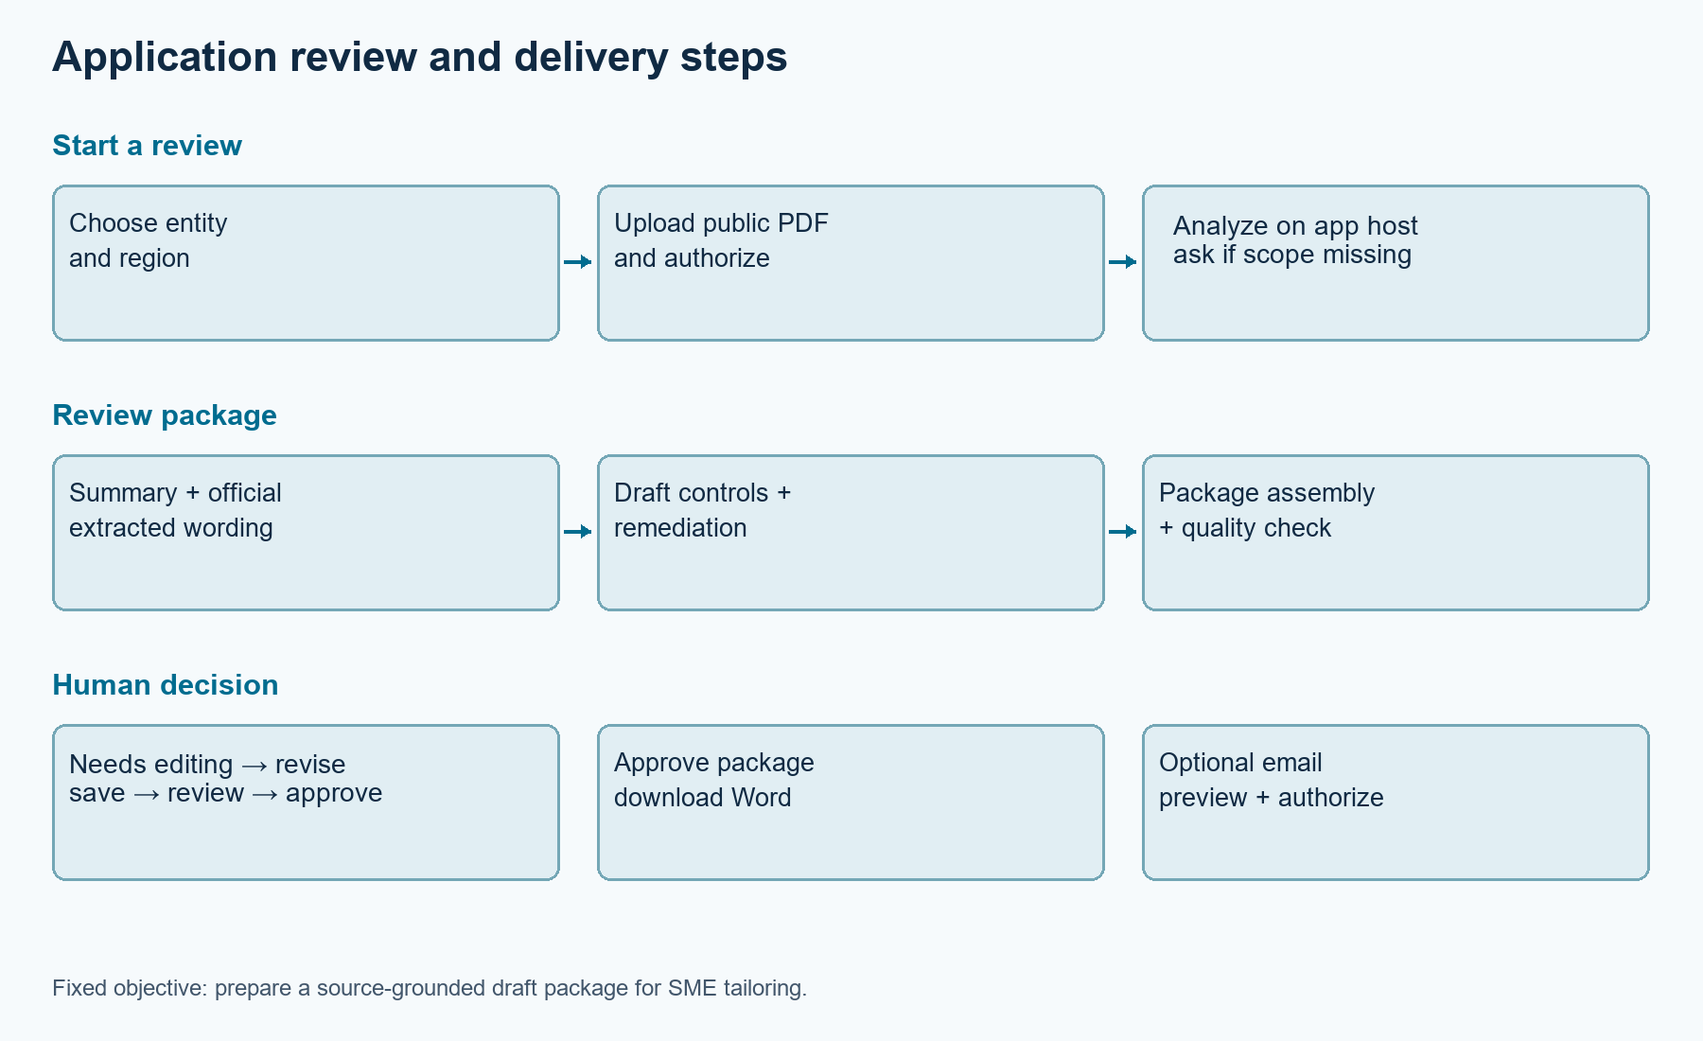
Figure 3. The analyst moves from an authorized public PDF to summarized requirement guidance, an approved Word package, and a choice of download or email delivery.
- Upload one authorized, searchable public NERC standards-related PDF and confirm authorization.
- Choose one or more Functional Entities and Regional Entities. No asset-scope or review-objective selection is required; the package objective is fixed.
- Check Standard effective date and its source filename and pages directly beneath it. Then open Requirements and sources for each requirement summary, full extracted wording and date citation. Different, missing or annotated dates are flagged; no separate effective-date section is needed.
- Open Draft controls and remediation to inspect the proposed owner, timing, evidence, and ordered actions for each requirement.
- In Human decision, approve, reject or choose Needs editing. To revise, select a requirement and draft field, enter feedback and revised text, Save revision, then Finish editing and review. Review the updated package before a new approval.
- If approved, download the Word package directly or review the email recipient and attachment summary before explicitly authorizing the SMTP send.
Why this interface is intentionally simple
The user sees two workspaces: Start a review and Review package. Review sections and requirement details start collapsed so the analyst can open only what is needed. Internal graph diagnostics and a fake Visio-style demo panel were removed because they distracted from the real job: verifying sources, evaluating drafts, and making a controlled decision.

State, control flow, and recovery

What the system remembers
- Server-side session: public PDF, scope, revised package, before/after feedback history and approval. Edits never enter the shared cache or a model. Clearing or replacing the upload, or changing scope, discards revisions. Cloud processing occurs on the hosting server.
- LangGraph state: review identifiers, standard/version, retrieved records, drafts, tool history, route history, retry counts, validation repair count, decision, and error status.
- Workflow continuity: a thread_id with InMemorySaver supports pause and resume during the running process.
- Optional local persistence: typed synthetic cases can be saved to ignored SQLite only after separate save approval.

Control flow
Product: validate upload/scope -> retrieve or retain source -> draft -> assemble package -> structural quality review -> human decision -> Word download / separately approved email
Synthetic graph: intake -> requirement -> control -> evidence/baseline -> insight -> risk -> remediation -> interrupt -> approve / edit / reject -> guarded local export

What happens when something breaks
Condition | System response | Limit
Missing scope | Ask for the missing field or stop safely. | No downstream call
Temporary tool error | Retry the failed tool. | At most 2 retries
Empty or invalid result | Enter validation repair. | At most 1 repair
Repair still fails | Record a safe error and stop. | No write
Edit decision | Product: save draft changes and review again. Synthetic graph: return to its draft plan. | Fresh approval before delivery
Reject decision | Close without delivery or workflow write. | Terminal safe stop

Caching and delivery

Bounded application caching
The product builds drafts from matched local corpus content or bounded source text in a validated upload. Its derived-package cache is limited to 32 entries. Document identity, profile, requirements, corpus revision and policy version invalidate the cache. External model exercises remain disconnected from the product page.
Cache boundary
The shared cache stores only derived public-source review data. It never stores raw uploaded PDF bytes, credentials, approval state, confidential evidence, email recipients, or operational data.

Recommended MVP cache policy
- Cache public-source-derived packages with a bounded Streamlit data cache.
- Invalidate when the document hash, parsed requirements, corpus revision, or cache-policy version changes.
- Limit the derived review-package cache to 32 entries and keep its invalidation rules explicit and testable.
- Do not place raw PDF bytes, credentials, approval state, evidence, or operational data in the shared cache.
- Avoid semantic caching because similar compliance questions may require materially different answers.

Approval-gated Word download and optional SMTP email
Package approval creates a Word document in memory for direct download. Optional email requires a recipient, attachment preview and separate send authorization. SMTP is configurable; Resend is one possible provider, not a required dependency. Automated tests use fake transports. This revision makes no claim of a newly verified live email delivery.
Two distinct approvals
1) approval of the reviewed package for Word creation and direct download; 2) separate permission to email that document to the displayed recipient. Neither decision means compliance approval, legal advice, or authorization to implement a control.

How I used Codex to learn and build
I approached the code track as a guided learning project rather than asking an AI tool to create one large solution in a single pass. Each milestone introduced one concept, added tests, and updated the decision record before the next feature was started.

Representative vibe-coding prompts
Focus | Prompt used or closely paraphrased
Planning | Create a beginner-friendly code-path plan aligned to the earlier NERC CIP assistant and teach me while we build.
Architecture | Use all Week 3 agentic concepts: tools, state, control flow, retries, checkpoints, human handoff, and evaluations.
Product value | Turn the review into draft controls and real-world workflow guidance rather than a simple standards chatbot.
Efficiency | Add a bounded MVP cache so Streamlit reruns do not rebuild the same source-derived review package.
Approval | Make approval useful by generating a Word package with requirements, sources, draft controls, and remediation.
Delivery | Provide both direct Word download and optional email delivery, with a separate approval for the external send.
Simplification | Remove interface options and demo details that do not add value for the reviewer.

Iteration pattern
- Ask Codex to explain the concept in plain language.
- Inspect the proposed files and safety boundary before allowing changes.
- Implement one small milestone with typed models and fake data.
- Run targeted tests, then the full regression suite.
- Use the app, identify what feels confusing or low-value, and revise the product experience.
- Record why the decision changed so the learning remains visible.

Testing and evaluation
The local SME revision build passed 221 tests and 15 of 15 offline evaluations. GitHub baseline 0981beb does not yet include this editor. Tests cover source protection, session isolation, approval invalidation and revised Word output. These verify software behavior, not regulatory accuracy or SME acceptance.
Test area | What it proves
Schemas and contracts | Invalid state is rejected early; tools and agents exchange predictable objects.
Graph routes | Approve, edit, reject, retry, repair, empty retrieval, and safe-stop branches behave as intended.
Source traceability | Exact-version fingerprints, citations and date metadata are tested; missing, phased and annotated dates are flagged.
Human approval | Editing clears prior approval, attachment and email consent; revised Word content requires fresh approval.
Caching | Changes to the public document identity, parsed requirements, corpus revision, or cache-policy version generate a new key.
Word and email | DOCX content and approval guards are tested. Fake SMTP transports verify recipient and attachment handling; no fresh live email delivery is claimed.
Streamlit | The two-workspace product contract and startup health remain intact.

Offline evaluation result
15 of 15 deterministic evaluations passed
Coverage includes valid intake, unsupported versions, retrieval, missing requirements, draft labeling, evidence insight, baseline variance, risk rubric, remediation completeness, bounded retry, approval interrupt, rejection safety, approved-boundary enforcement, checkpoint-style resume, and citation/data guardrails.

Success measure
Success means completing the source-to-draft workflow without bypassing human approval, with passing tests and offline evaluations. Production accuracy and real-world compliance effectiveness require separate validation.

Architecture decisions
The choices below reflect both the assignment goals and what I learned by testing the application as a first-time builder.
Decision | Why I made it
LangGraph for orchestration | Its explicit nodes, routes, checkpointing, and interrupts make state and failure behavior visible and testable.
Deterministic agents first | Fake providers let me learn the system mechanics without cost, flaky outputs, or hidden API behavior.
Portable catalog and optional corpus | Fingerprints recognize approved PDFs without local files. Optional SQLite supplies text; date schedules remain version-scoped snapshots.
Pydantic at every boundary | Typed inputs and outputs turn vague handoffs into contracts that fail early and clearly.
Separate product UI from graph demo | The analyst sees useful review work; assignment mechanics remain provable in code and tests without cluttering the interface.
Bounded retry and repair | Infinite recovery loops hide errors and waste resources. Small limits make failure predictable.
Human approval before consequence | Reads and draft computations can run locally, but package creation, workflow writes, and email delivery remain behind explicit human decisions.
Bounded derived-data caching | It avoids repeated deterministic package work while invalidating on exact document, requirement, corpus, and policy changes.
Word package download and email | Approval now produces a useful review artifact that can be downloaded directly, while any email destination and send action remain under separate human control.

Learnings, limitations, and next steps

What I learned
- Agentic development is mostly about state, routing, failure handling, and boundaries, rather than writing a clever prompt.
- Typed data models made the unfamiliar code easier to understand because each object explained what information belonged at that step.
- A human approval button has value only when its meaning and downstream action are concrete.
- Deterministic tests made it safe to improve the interface repeatedly without losing core behavior.
- Removing low-value options and visual demos was as important as adding features; the product became clearer when every element supported the analyst's task.

Current limitations
- The app is not a NERC compliance determination, legal opinion, audit conclusion, or engineering approval.
- Applicability remains a human decision. Dates are U.S. snapshots, not live regulatory verification. Missing, phased or annotated dates need review; Regional Entity selection does not establish Canadian applicability.
- Evidence and baseline remain synthetic graph/test components. The catalog covers approved PDF bytes, not all versions. Unfamiliar documents and drafts need SME review. Runtime retrieval does not crawl the web.
- Revision history is temporary, not a durable audit log. Checkpoints are in-memory. Cloud uploads reach the server; local-only UI wording needs correction before a pilot. SMTP requires credentials and separate approval. LangSmith remains disabled.

Practical next steps
- Review ElevenLabs.mov against the current app. Confirm live app use, explanation of AI coding-tool use, and a duration under five minutes.
- Publish the updated Google Doc and confirm access. Submit its URL with GitHub, a verified deployed-app URL and the reviewed video link.
- Validate retrieval and citations against a controlled set of authorized public standards and versions.
- Before any pilot, add authenticated roles, durable audit logging, secret management, governance-approved connectors, and SME acceptance testing.
Final reflection
CIP Wayfinder began as an idea for a modern NERC standards assistant. The Week 3 build turned it into a testable agentic prototype and, just as importantly, taught me how orchestration, state, recovery, evaluation, and human control fit together in working code.

