OUTPUT

- FIRSTLY, it’s detecting our location as soon as we run the code.

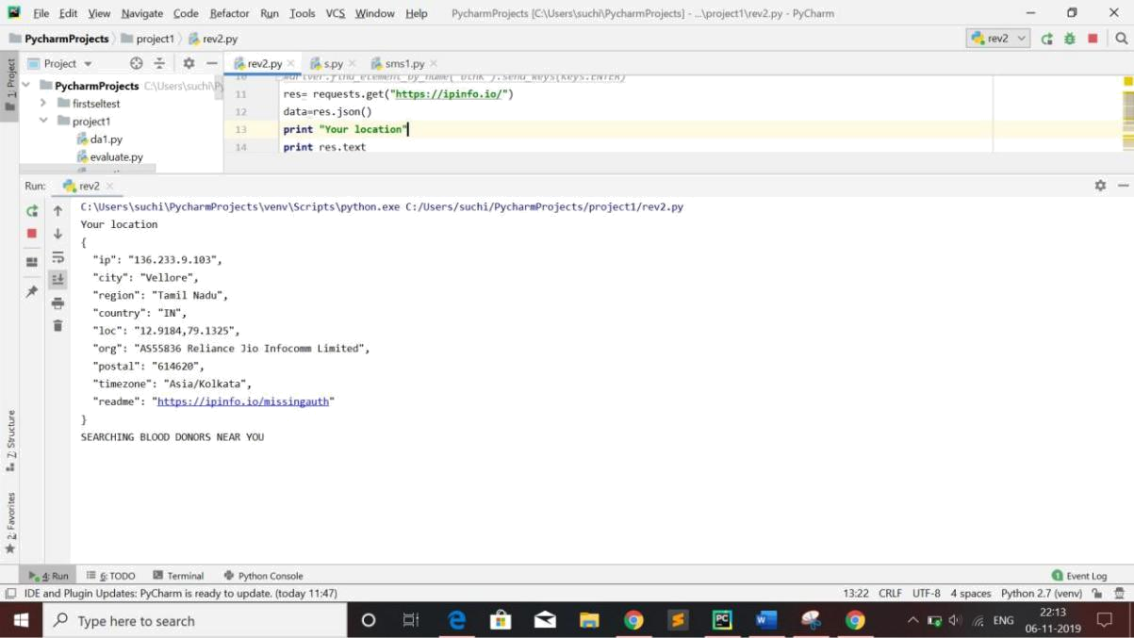

Then, to our location, it automatically checks the available blood donors in “https//bloodworld.in” website for O+ blood donors.

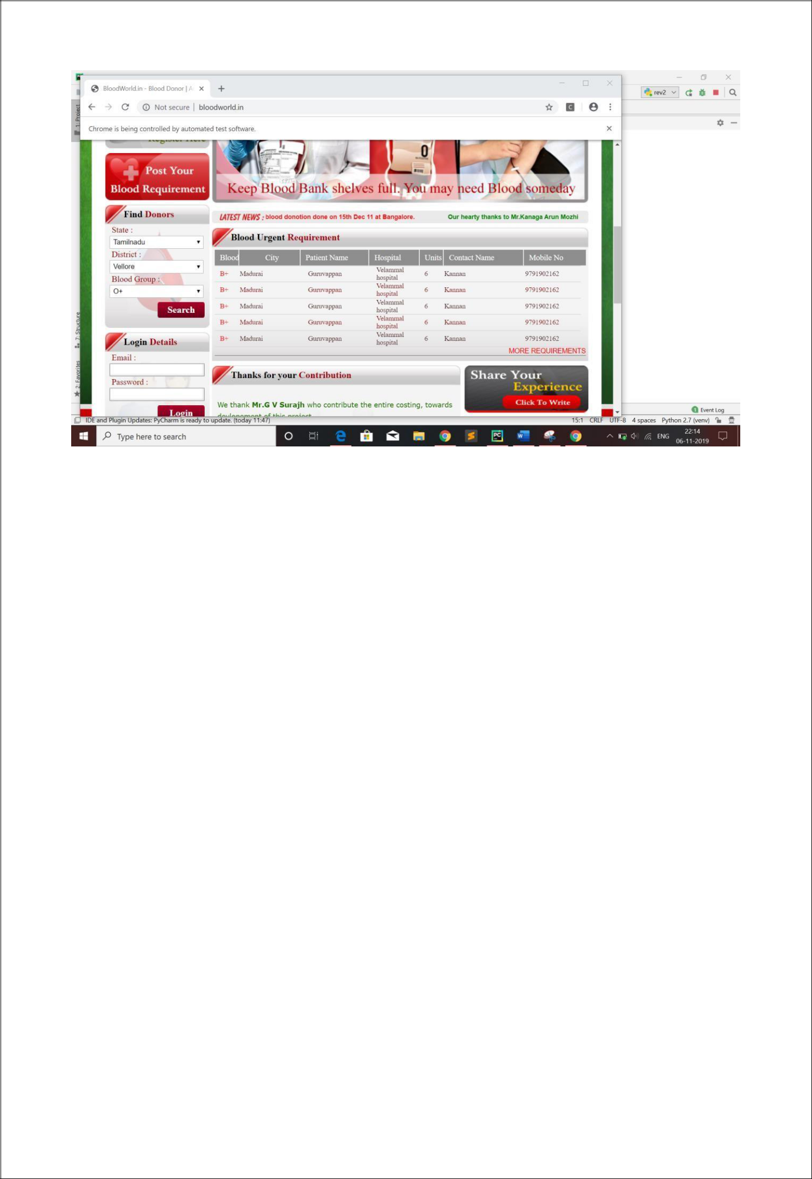

Right now, it has detected our location as Vellore and has searched for O+ donors in Vellore. We have these donors’ numbers in the website.

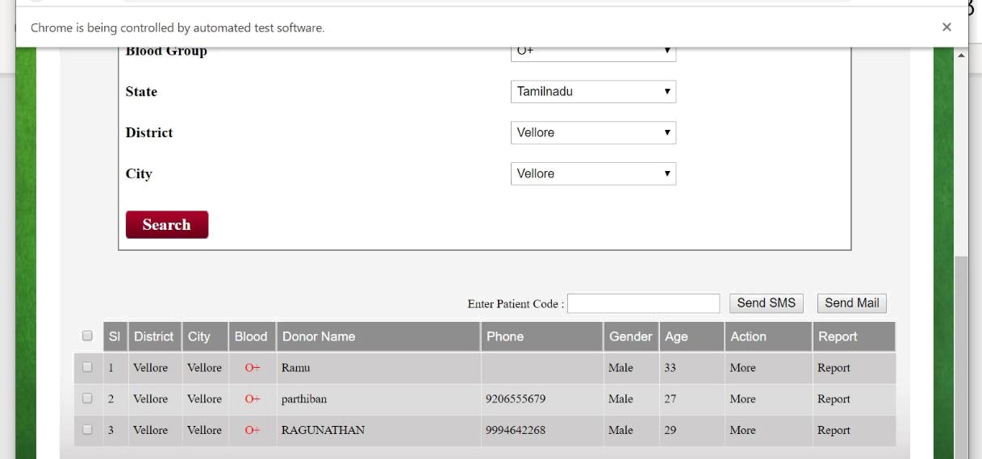

We have now successfully loaded the same numbers to our code:
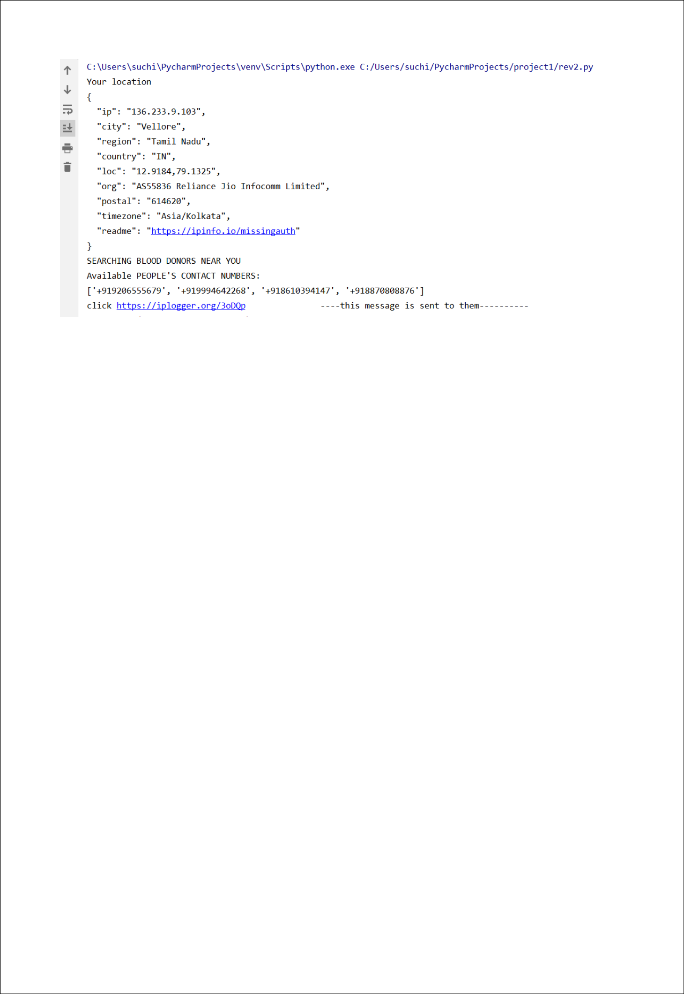

Now as we can see, this message has been sent to all the donors from that website to detect their location. To simply demonstrate this, we have added our numbers to the code (“+918610394147”-RK Sneha; “+918870808876”-S Prithesh)

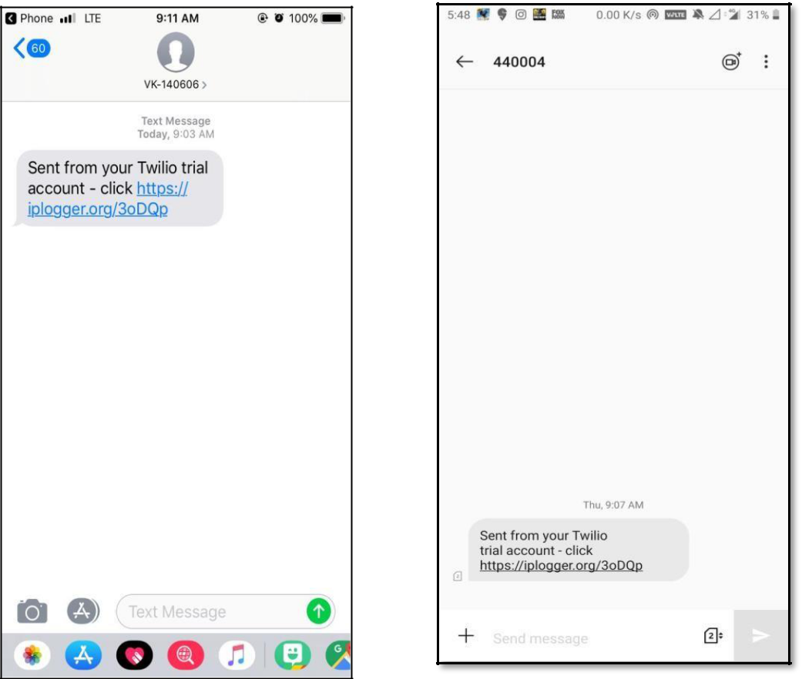

Mobile 1 Mobile 2

As we see, we have sent a normal link message to all the donors’ registered from that place.

This has simply been sent to detect their locations.

As soon as the message has been sent, our iplogger website gets updated with everyone’s ip address (to whomever the message has been sent)

Now, later we match these ip addresses and find their locations

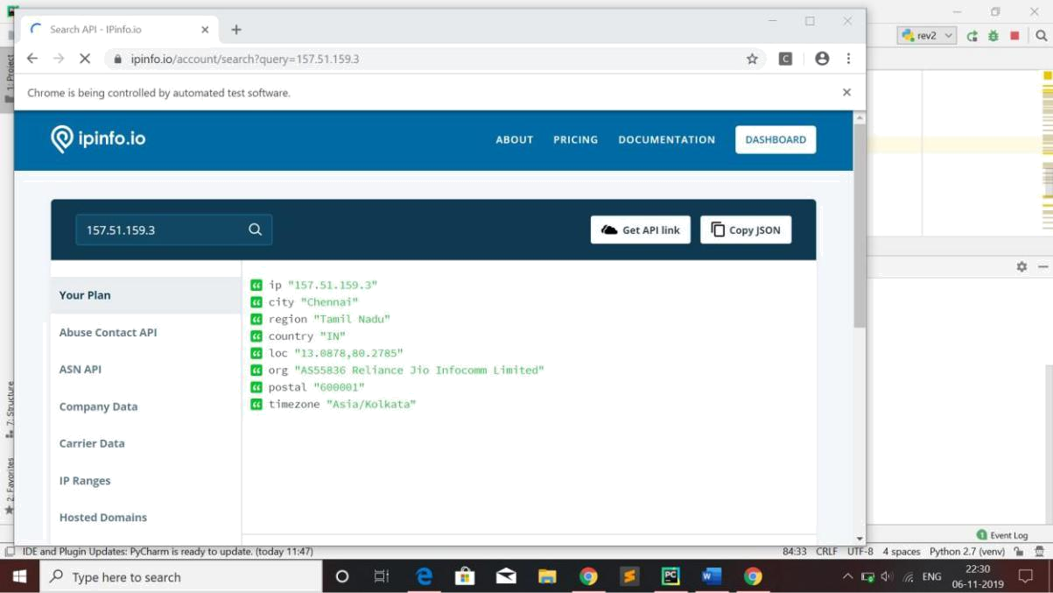
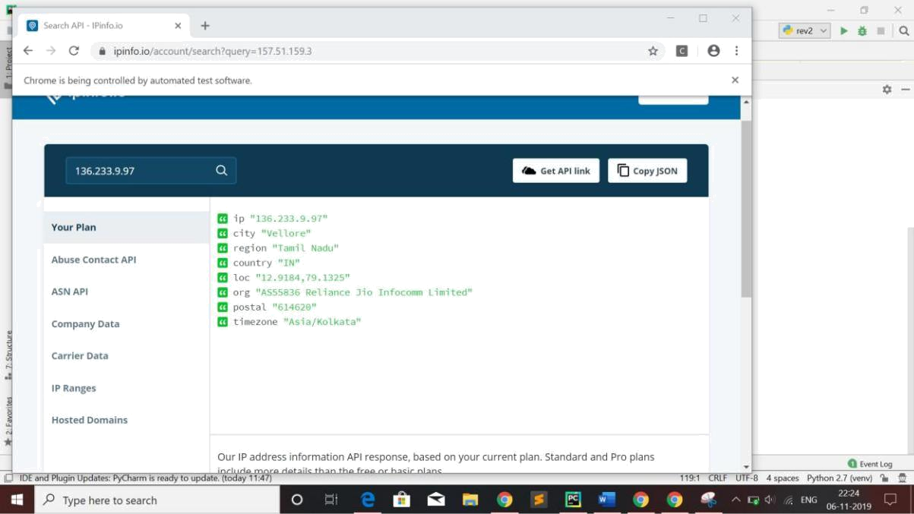


Now, we have received the location of all the people to whomever we have sent a dummy message.

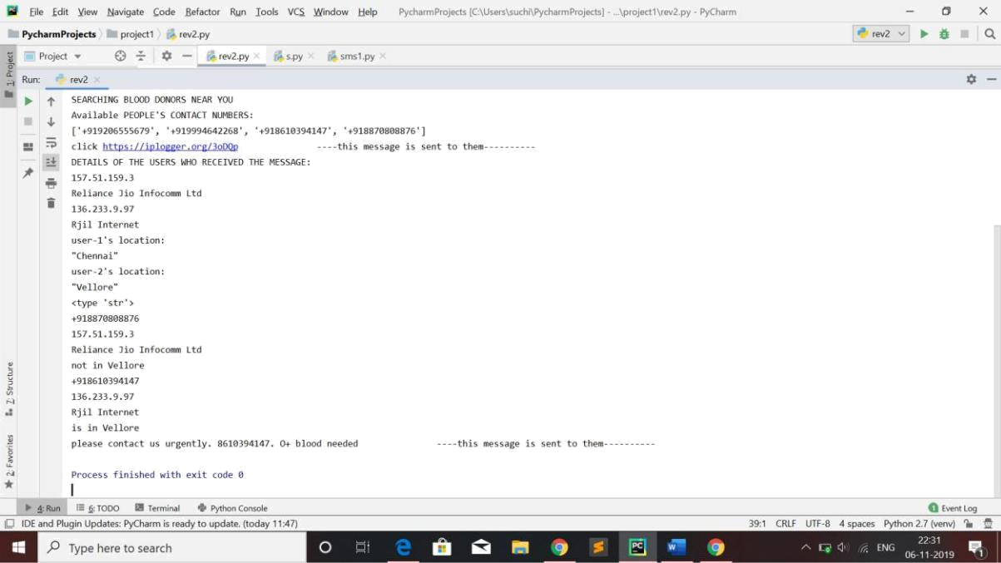

Here, we clearly got the details of the users who are in Vellore and we have sent a message to “contact us urgently and that we are in need of O+ blood”.

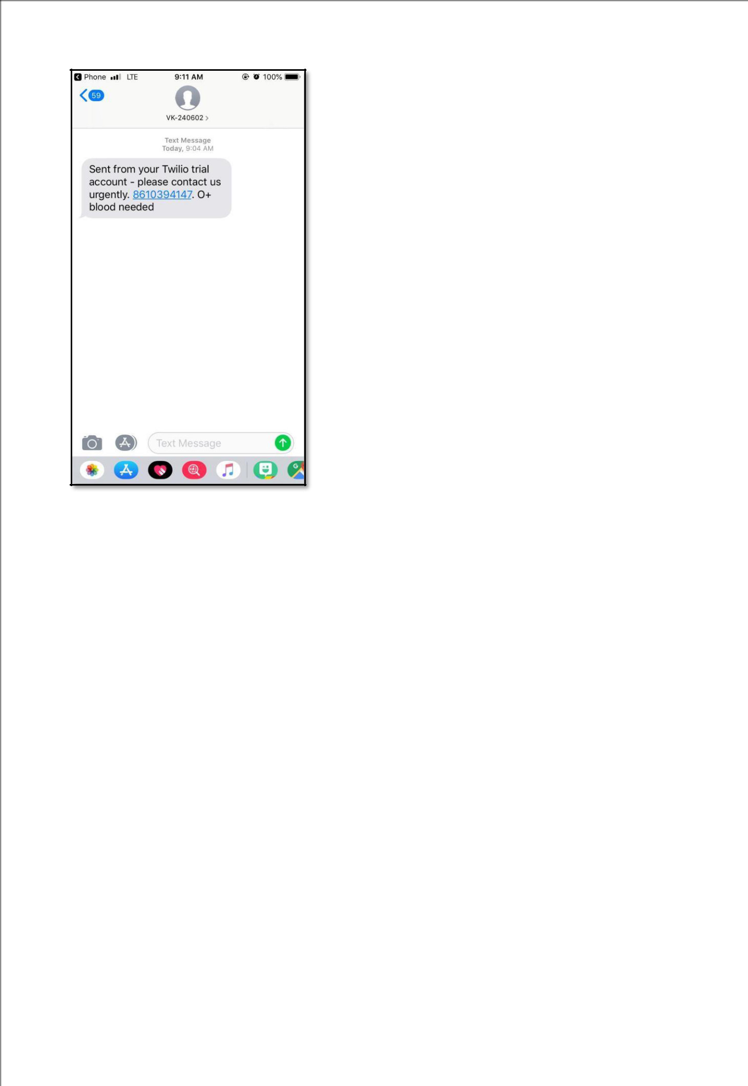

Mobile 1

Mobile 2

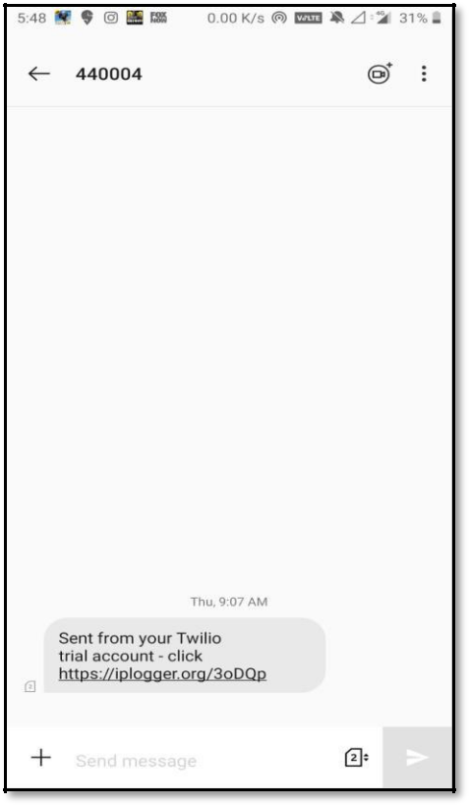

Received the Emergency Message



Received only one message

Along with the tracing message

We can see that only +8610394147 has received the message but the other number hasn’t received the message since they are not in Vellore.

This way we can smartly geotag people around us alone and text them or call them alone to ask for help. This saves much time for us and also helps us to know available people around us in a very short time. To do this manually might take a lot of time if we have 1000 registered donors and only if 5-10 are available in them (hypothetically). But this way, we save much time in case of emergencies

