# Result:

Here, a most powerful prediction algorithm called back propagation algorithm was used to predict and classify the weather forecast standard dataset. Furthermore, twenty training examples from 1995-2014 were used to predict weather features. The prediction was calculated for weather forecast basic factors like temperature of previous year’s data. A Multi-layered neural network is designed and trained with the existing dataset and obtained a relationship between the existing non-linear parameters of weather. The overall behavior of our model has been concluded is that by increasing the number of hidden layers, the trained neural network can classify and predict the weather variables with less error.

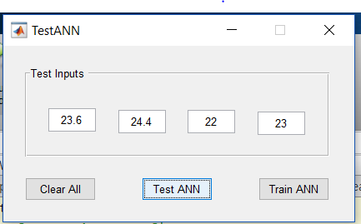

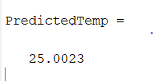

Thus back propagation algorithm is used to predict weather in our project.

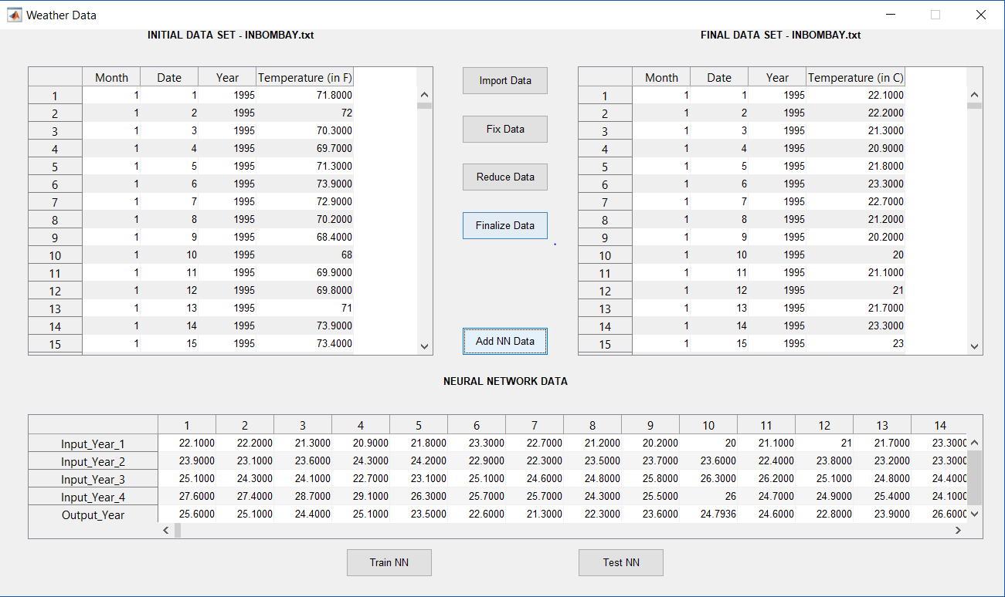

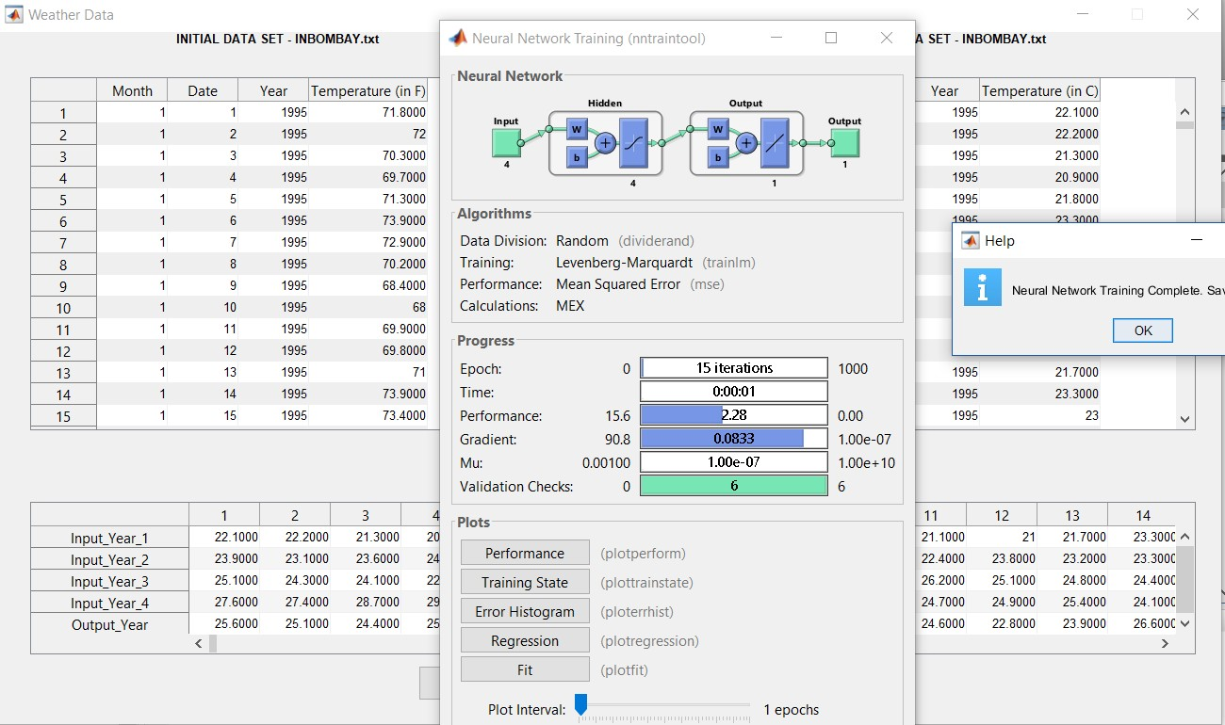

Here we can see the number of epochs performed is 15. The performance measure used is Mean Square error. The gradient descent from the result is 0.0833

Input year 1 has data’s of temperatures from years 1 to 16. Input year 2 has data’s of temperatures from years 2 to 17. Input year 3 has data’s of temperatures from years 3 to 18.

Input year 5 has data’s of temperatures from years 4 to 19. Thus all the years are taken as the inputs and done back propagation and the results are shown in output year

We have to enter the values of temperature in TestANN as test inputs as the temperature of a particular date in the previous four years of data in order to predict the weather of a particular day in the current year.

The performance plot is given below. It also tells at which epoch the performance is better in predicting the weather

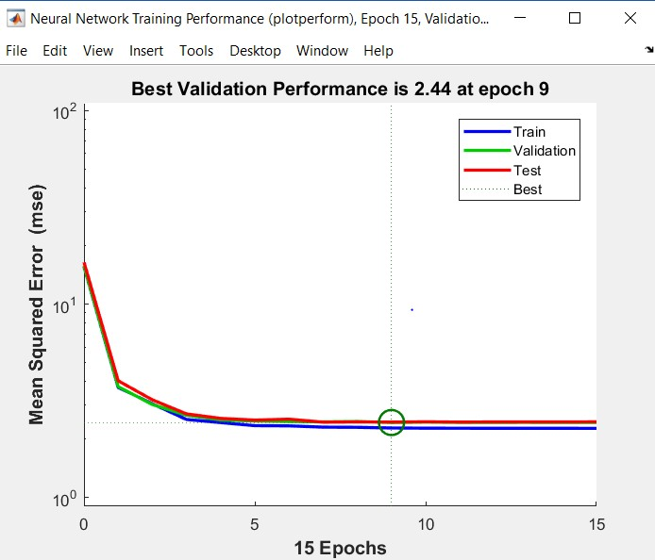

In the 15 epochs the training state plot is given below for gradient, mu and val fail

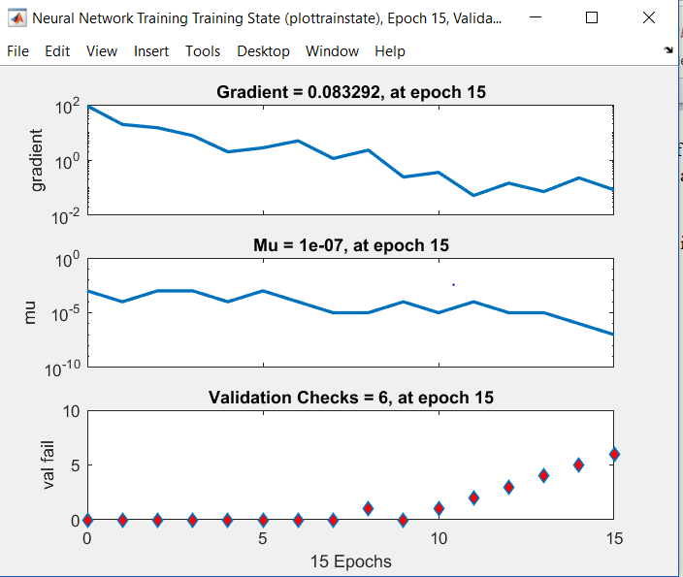

Error is generated based on 20 bins. The error histogram is given below

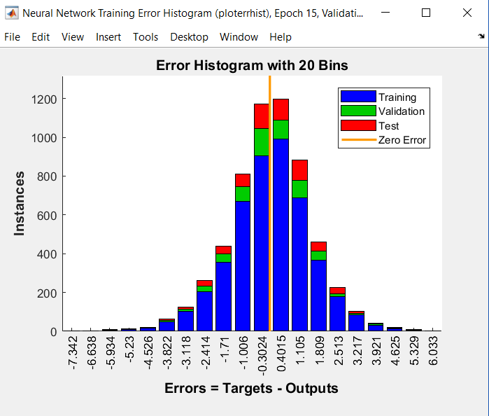

Regression is used for training, testing and validation. The regression plot is given below