AI Fit Buddy
AI-powered fitness companion for smarter daily workouts.
Introduction
Project Title: AI FIT BUDDY
Team ID: SWTID-2026-9852
Team Leader:
Prithika & prithika2528@gmail.com
Team Members:
Prithisha & prithishaprithisha734@gmail.com
Pavithra & aripavi2006@gmail.com
Poovizhi & poovizhiarjunan5109@gmail.com
Abstract:
AI Fit Buddy is a responsive, mobile-first web application for fitness in which an AI coach adjusts the daily workout plan to suit the user. The application presents a personalised home dashboard, a catalogue of workouts, a dedicated coach screen, and a progress screen that tracks workouts, calories, streaks and active minutes. The front end is built with React and Vite and follows a clean, card-based design system so that the app feels friendly, motivating and easy to use on both phones and desktop browsers.
Introduction:
Most people who start exercising lose motivation because a fixed workout plan does not change with their energy, time or progress. AI Fit Buddy addresses this by treating the workout plan as something that is adjusted every day. A user opens the app, sees a summary of today's goal, follows a short list of planned exercises, chats with the AI coach, and reviews weekly progress. This phase of the project delivers the complete front-end experience: four connected screens, reusable components and a consistent visual theme, ready to be connected to an AI service and a back-end API.
Objectives:
- To provide an attractive, responsive front end for a fitness application.
- To show the user's daily goal, calories, steps and active minutes at a glance.
- To display a day-wise workout plan with clear workout cards (type, duration, level).
- To provide a coach screen through which the AI coach can adjust the workout based on how the user is doing.
- To visualise progress through workouts completed, calories burned, day streak and active-minutes charts.
- To build reusable components and a shared design system so new screens can be added quickly.
Scope of the Project:
The application is designed for beginners and regular exercisers who want a simple, guided way to stay active. The scope of this phase covers the user interface and navigation of the four main screens (Home, Workouts, Coach and Progress), reusable UI components, and a responsive layout that works on mobile and desktop widths. The screens currently use sample data; integration of the AI model, user accounts and a database is planned as the next phase.
Modules:
- Home Module – Shows the headline, the daily goal progress ring, calories, steps and active minutes, and Today's Plan as a list of workout cards.
- Workouts Module – Lists available workouts using reusable workout cards showing the workout type, duration and difficulty level.
- AI Coach Module – Provides the coach screen where the AI coach interacts with the user and adjusts the daily workout.
- Progress Module – Displays summary cards for workouts, calories and day streak, and an Active Minutes bar chart for the week.
- Navigation Module – A top navigation bar with the app logo and profile button, and a bottom navigation bar with Home, Workouts, Coach and Progress tabs.
- UI Component Module – Reusable components: ProgressRing, WorkoutCard, TopNav and BottomNav.
System Requirements:
Hardware Requirements:
- Computer or Laptop
- Minimum 4 GB RAM
- Internet connection

Software Requirements:
- Operating System: Windows 10 or above
- Node.js runtime and npm
- React.js with Vite (development server on localhost:5173)
- React Router (react-router-dom) for page navigation
- Antigravity IDE (AI-assisted code editor)
- Web Browser (Chrome/Edge)
System Architecture:
The application is a single-page application (SPA) built with React. The entry point (main.jsx) loads App.jsx, which uses React Router to switch between the Home, Workouts, Coach and Progress pages while the TopNav and BottomNav components stay fixed. Each page is composed from small reusable components such as ProgressRing and WorkoutCard, and each has its own CSS file. A global stylesheet (index.css) defines the design tokens used everywhere. In the next phase, the pages will call a back-end REST API and an AI service to fetch personalised plans and coach responses.
Project Structure:
File / Folder | Purpose
src/main.jsx, App.jsx | Application entry point and route configuration
src/index.css | Global design tokens: colours, fonts, spacing, radii
src/pages/Home.jsx / .css | Home dashboard with daily goal and Today's Plan
src/pages/Workouts.jsx / .css | Workout library screen
src/pages/Coach.jsx / .css | AI coach screen
src/pages/Progress.jsx / .css | Progress statistics and Active Minutes chart
src/components/ProgressRing | Circular progress indicator for the daily goal
src/components/WorkoutCard | Card showing workout name, type, duration and level
src/components/TopNav, BottomNav | Header with logo/profile and bottom tab navigation

Design System:
A consistent design system was defined using CSS custom properties in index.css, so that every screen shares the same look and feel. Headings use the Bricolage Grotesque typeface and body text uses DM Sans, both loaded from Google Fonts.
Token | Value | Usage
--color-primary | #2B4BFF | Royal blue: logo accent, active tab, progress ring
--color-secondary | #FF6B2C | Orange: calories and energy highlights
--color-accent | #19C39A | Mint: achievements and streaks
--color-bg | #EEF1FB | Light page background
--color-surface | #FFFFFF | Cards and panels
--color-text | #141B3A | Dark navy body and heading text
--spacing-xs to 2xl | 0.25 to 3 rem | Consistent spacing scale
--radius-sm to full | 0.5 rem to 9999 px | Rounded corners for cards and pills

Implementation:
The front end is implemented with React functional components. The Home page imports the ProgressRing and WorkoutCard components, uses the useNavigate hook from React Router for navigation, and lays out the daily stats and workout plan using flexbox and CSS grid. The Progress page uses a responsive grid (repeat(auto-fit, minmax(100px, 1fr))) for its statistic cards, so the layout adapts automatically from mobile to desktop. All colours, spacing and radii come from the shared design tokens, which keeps the styling consistent and easy to change.
The project was scaffolded and developed with the help of AI code generation in the Antigravity IDE, and run locally using npm run dev.
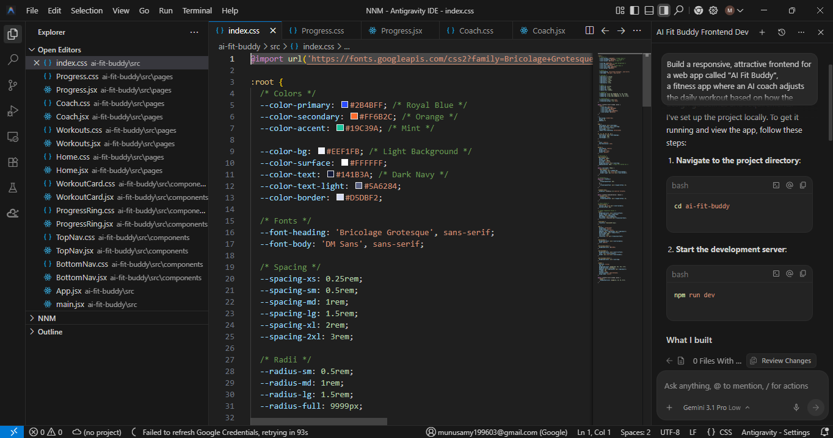
Figure: Global design tokens in index.css
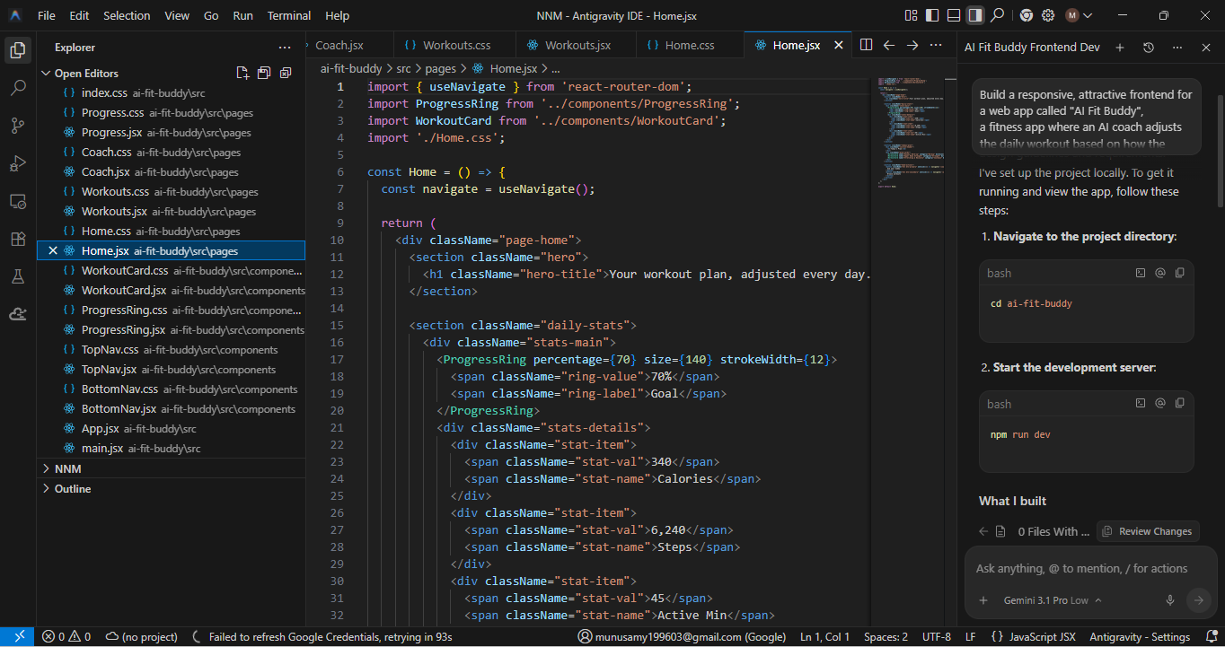
Figure: Home.jsx – Home page component
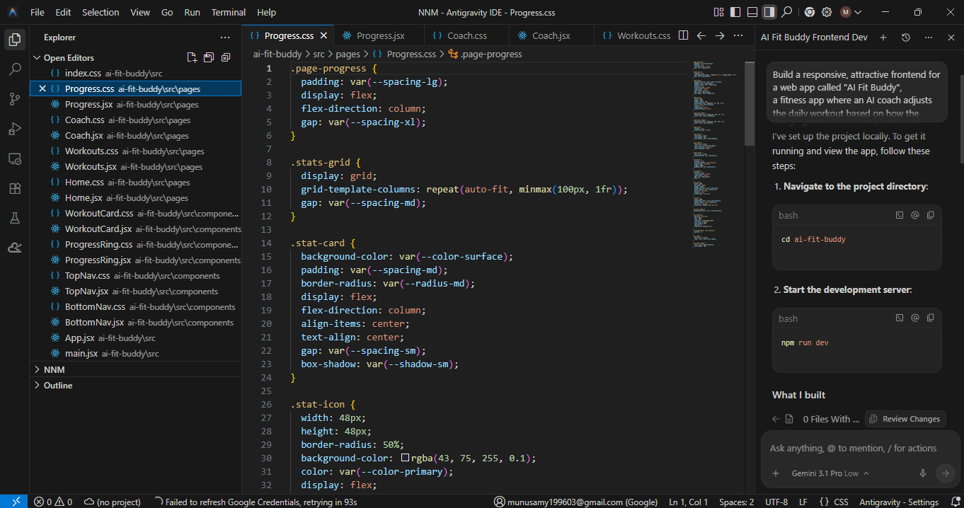
Figure: Progress.css – Progress page styling
Testing:
Testing was performed in the browser at localhost:5173 to verify that the screens render correctly, that navigation between the Home, Workouts, Coach and Progress tabs works, and that the layout stays usable at mobile and desktop widths.
Home Page Output:
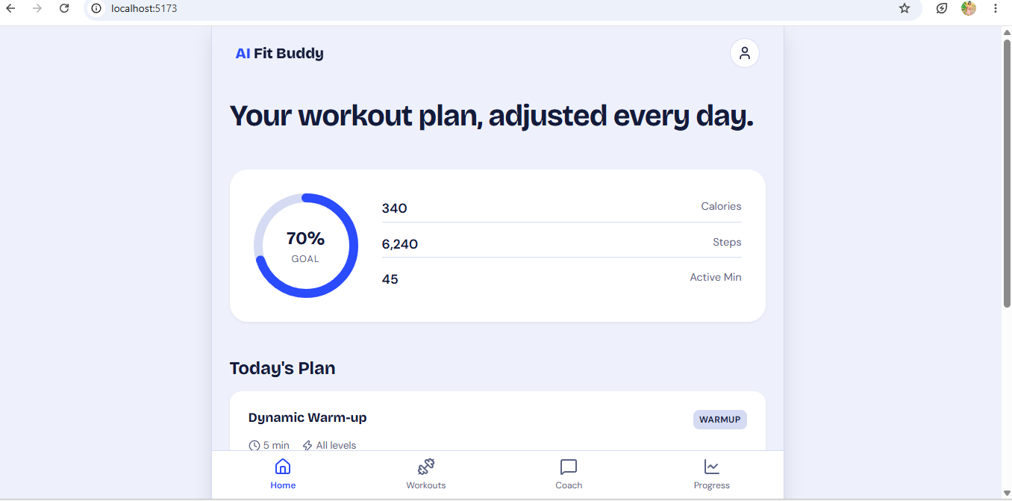
Figure: Home screen – daily goal ring, stats and Today's Plan
Progress Page Output:
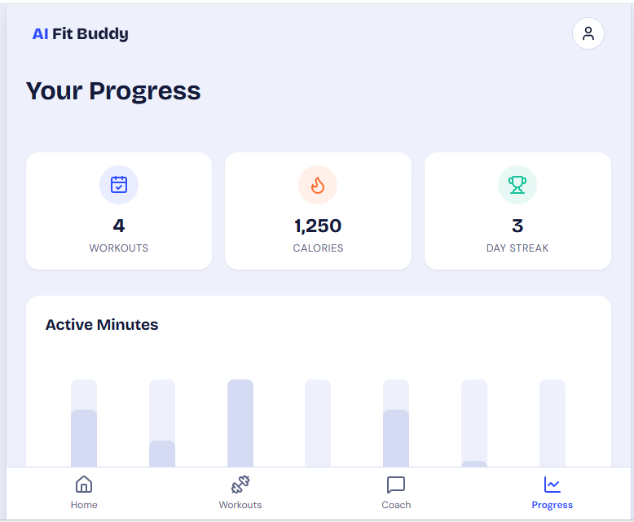
Figure: Progress screen – workouts, calories, day streak and Active Minutes
Conclusion:
AI Fit Buddy successfully demonstrates a clean, responsive and motivating front end for an AI-driven fitness application. The Home, Workouts, Coach and Progress screens work together through a shared navigation and design system, and testing in the browser confirms that the interface renders and navigates as expected. The project provides a solid foundation for connecting the AI coach and a back-end service in the next phase.
Future Enhancements:
- Integrate an AI model so the coach adjusts the daily workout in real time.
- Add user registration and login with a back-end API and database.
- Sync real step, calorie and heart-rate data from phones and wearables.

