Automatic Road Reflector Light

The Automatic Road Reflector is a simple but effective system will help us automate the traditional road reflectors.
A raised pavement marker is a safety device used on road to guide the vehicles along the path at the time of night. The Automatic Road Reflector system is designed to replace this currently being used safety device. The proposed system is designed to sense the intensity of ambient light and work accordingly. At the time of low light, the system senses the ambient light has been decreased and it lights up the reflector. On the other hand, the system will turn itself into power saving mode at the time of bright light and will save energy.
To sense the intensity of light, the system consists of a photoresistor or light-dependent resistor. The Light Dependent Resistor works on the basic principle of photoconductivity, making them useful in light sensing. The term photoconductivity stands for a phenomenon in which the conductivity of a substance increases while in contact with light. In general terms, the LDR is made up of substance who has a low conductivity in darkness, and whenever it comes in the contact with light the conductive property of the sensor increases. A typical light dependent resistor has a resistance in the darkness of 1MOhm and in the brightness a resistance of a couple of KOhm.
The Automatic Road Reflector can be very essential in leading the vehicles on their path at the time of night. The color of the LED can be rearranged in order to fulfill various requirements. They can be used to divide the road, show a curvature or an exit on the road. They can be very useful at the places like the airport and airport hangers where various colors of road reflectors are used to fulfill various purposes.

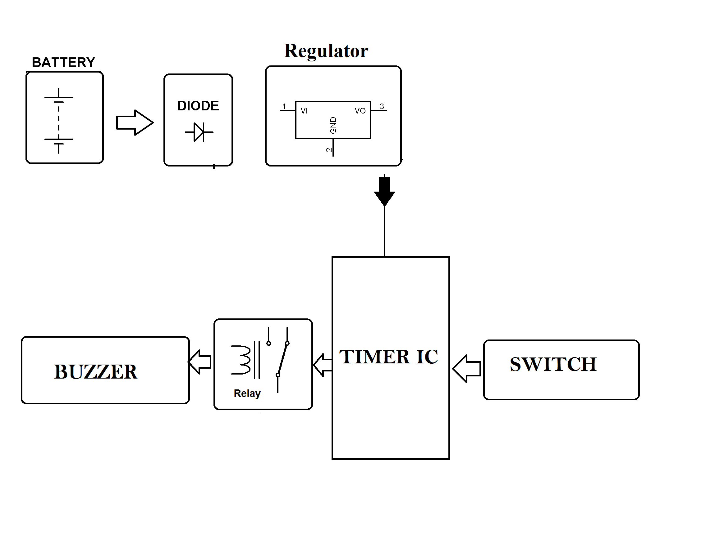

- Hardware Specifications

- IC

- IC Socket

- Relay

- Resistors

- Capacitors

- Transistors

- Cables & Connectors

- Diodes

- PCB

- LED’s

- Transformer/Adapter

- Push Button

- Switch

