EXP.NO: 5 | Write a Servlet to demonstrate the difference between HTTP GET and POST methods by creating a form and handling requests accordingly.
DATE:05/03/2025

AIM:
To demonstrate the difference between the HTTP GET and POST methods by creating a form in an HTML page and handling the form submissions using two different HTTP methods in a Java Servlet.

ALGORITHM:
1. Input:
- The user fills out a web form with their name and email.
- The form will use both GET and POST methods for data submission.

2. Steps for Creating and Handling the HTTP GET and POST Requests:
- Create an HTML Form:
  - Design an HTML form with two input fields: one for the name and one for the email.
  - Create two buttons to allow the user to submit the form using GET or POST methods.
  - Use the action attribute to define the Servlet URL and specify the form method (either GET or POST).
- Create the Servlet to Handle GET and POST Requests:
  - Write a Java Servlet class that will handle both GET and POST requests.
  - The servlet will have two methods:
    - doGet() to handle the GET requests.
    - doPost() to handle the POST requests.
  - In both methods, retrieve the form data using request.getParameter().
  - In the doGet() method, process and display the data in the URL.
  - In the doPost() method, process and display the data in the HTTP request body.
- Handle GET Requests in the Servlet:
  - In the doGet() method, use request.getParameter() to retrieve the name and email submitted via GET.
  - Output the data as a response, including the name and email in the URL (visible to the user).
- Handle POST Requests in the Servlet:
  - In the doPost() method, use request.getParameter() to retrieve the name and email submitted via POST.
  - Output the data as a response, displaying the name and email without exposing them in the URL (more secure).
- Return the Output:
  - The Servlet should return an HTML page displaying the name and email entered by the user.
  - For the GET method, the output should be visible in the URL.
  - For the POST method, the output should be visible in the response body, not the URL.
- Deploy and Test the Servlet:
  - Compile the Servlet class and deploy it to a Servlet container (like Apache Tomcat).
  - Test the form using GET and POST methods to see the difference in data submission.
- Observe and Compare GET and POST Results:
  - Test the GET method: The form data is sent in the URL.
  - Test the POST method: The form data is sent in the HTTP request body, not visible in the URL.
Code:
<!DOCTYPE html>
<html>
<head>
<title>Alumni GET vs POST</title>
</head>
<body>

<h2>GET Method Form</h2>
<form action="/alumnisystem/AlumniServlet" method="get">
Name: <input type="text" name="name"><br><br>
Email: <input type="email" name="email"><br><br>
<input type="submit" value="Submit using GET">
</form>

<hr>

<h2>POST Method Form</h2>
<form action="/alumnisystem/AlumniServlet" method="post">
Name: <input type="text" name="name"><br><br>
Email: <input type="email" name="email"><br><br>
<input type="submit" value="Submit using POST">
</form>

</body>
</html>

package com.alumni;

import java.io.*;
import javax.servlet.*;
import javax.servlet.http.*;
import javax.servlet.annotation.WebServlet;

@WebServlet("/AlumniServlet")
public class AlumniServlet extends HttpServlet {

// GET METHOD
protected void doGet(HttpServletRequest request, HttpServletResponse response)
throws ServletException, IOException {

response.setContentType("text/html");
PrintWriter out = response.getWriter();

String name = request.getParameter("name");
String email = request.getParameter("email");

out.println("<html><body>");
out.println("<h2>GET Method Used</h2>");
out.println("<p>Name: " + name + "</p>");
out.println("<p>Email: " + email + "</p>");
out.println("</body></html>");
}

// POST METHOD
protected void doPost(HttpServletRequest request, HttpServletResponse response)
throws ServletException, IOException {

response.setContentType("text/html");
PrintWriter out = response.getWriter();

String name = request.getParameter("name");
String email = request.getParameter("email");

out.println("<html><body>");
out.println("<h2>POST Method Used</h2>");
out.println("<p>Name: " + name + "</p>");
out.println("<p>Email: " + email + "</p>");
out.println("</body></html>");
}
}

Output:
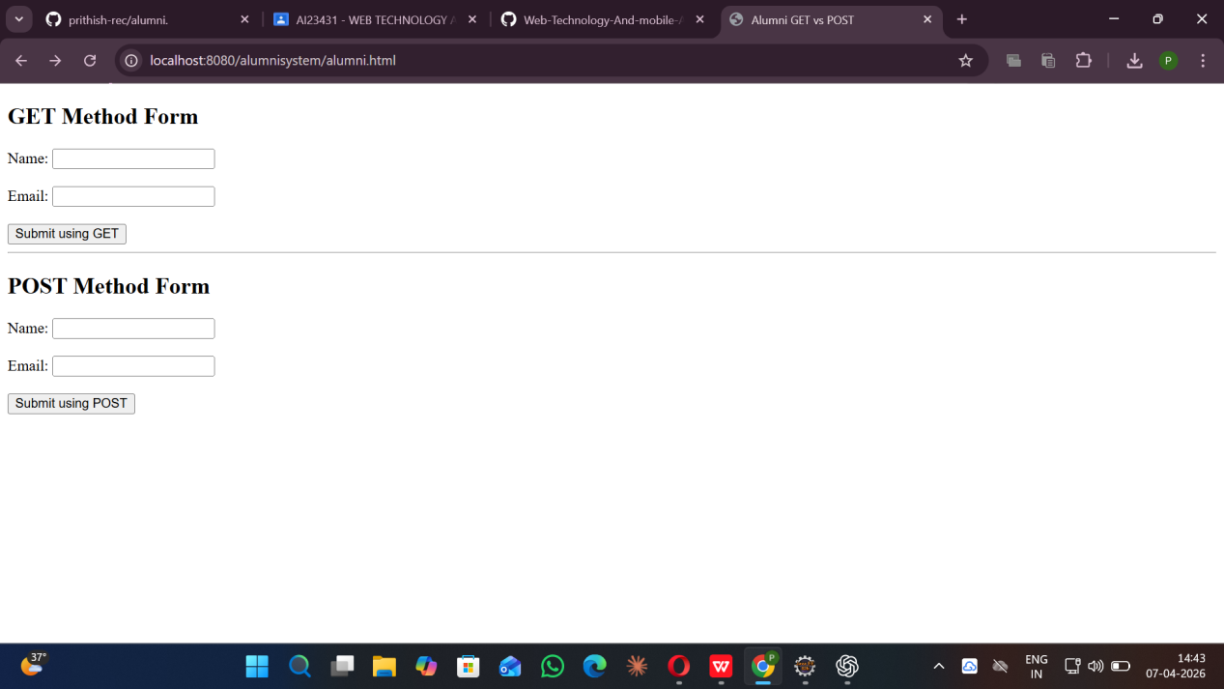

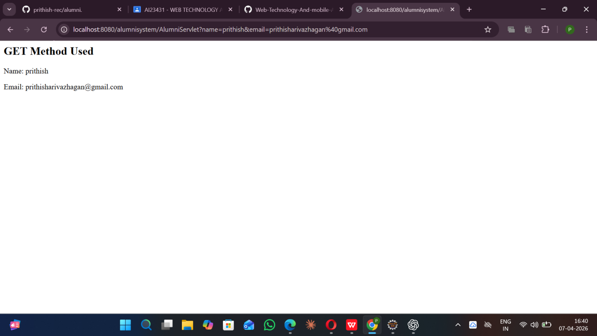

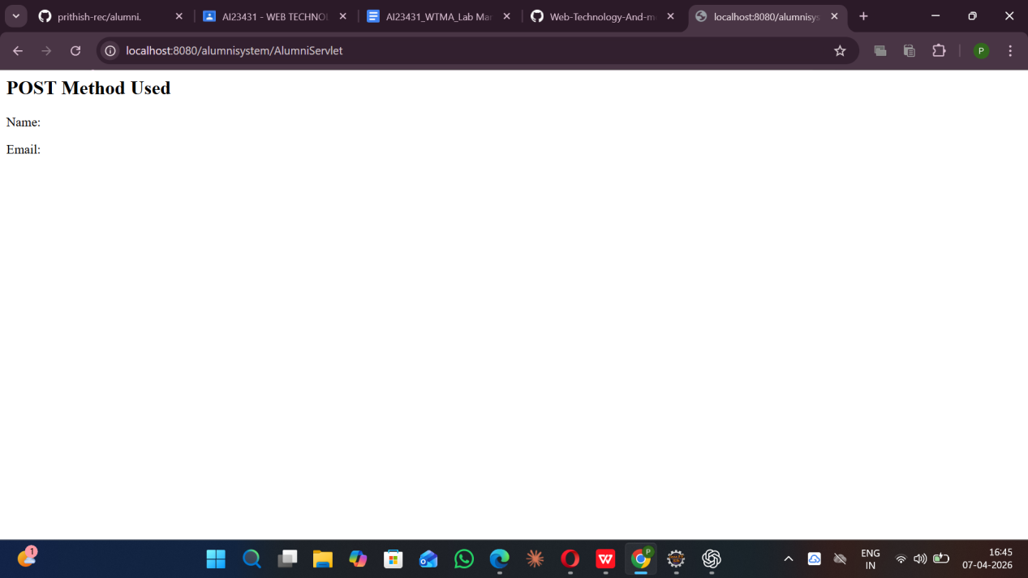

RESULT:
A Servlet is created to demonstrate the difference between HTTP GET and POST methods by creating a form and handling requests accordingly.

