EXP.NO: 2
DATE: 06/02/2025

AIM:
To write a JavaScript program to validate the fields of an HTML Registration Form. The program ensures that the user inputs meet specified validation criteria before submission, thereby maintaining data integrity and preventing invalid entries.

SOFTWARE REQUIREMENTS:
- Web Browser (Chrome / Edge / Firefox)
- Text Editor (VS Code / Notepad++)

ALGORITHM:
- Start the program.
- Create an HTML Registration Form with the following input fields:
  - First Name
  - Last Name
  - Password
  - E-mail ID
  - Mobile Number
  - Address
- Define a JavaScript function validateForm() that executes when the form is submitted.
- Validate First Name:
  - Check whether the First Name contains only alphabets using a regular expression.
  - Ensure that the length is at least 6 characters.
  - If validation fails, display an error message and prevent submission.
- Validate Password:
  - Check if the password length is at least 6 characters.
  - If not, display an error message.
- Validate E-mail ID:
  - Use a regular expression to verify that the email follows the pattern name@domain.com.
  - If invalid, display an error message.
- Validate Mobile Number:
  - Ensure the mobile number contains exactly 10 digits.
  - Verify that it contains only numeric values.
  - If invalid, display an error message.
- Validate Last Name:
  - Check whether the field is empty.
  - If empty, display an error message.
- Validate Address:
  - Check whether the field is empty.
  - If empty, display an error message.
- If all validations pass, allow the form submission and display a success message.
- Stop the program.

PROGRAM:
<!DOCTYPE html>
<html>
<head>
<title>Registration Form</title>

<script>
functionvalidateForm() {

letfname=document.getElementById("fname").value.trim();
letlname=document.getElementById("lname").value.trim();
letpassword=document.getElementById("password").value;
letemail=document.getElementById("email").value.trim();
letmobile=document.getElementById("mobile").value.trim();
letaddress=document.getElementById("address").value.trim();

letnamePattern=/^[A-Za-z]+$/;
if (!namePattern.test(fname)||fname.length<6) {
alert("First Name must contain only alphabets and minimum 6 characters.");
returnfalse;
}

if (password.length<6) {
alert("Password must be at least 6 characters long.");
returnfalse;
}

letemailPattern=/^[^\\s@]+@[^\\s@]+\\.[^\\s@]+$/;
if (!emailPattern.test(email)) {
alert("Invalid Email format.");
returnfalse;
}

letmobilePattern=/^[0-9]{10}$/;
if (!mobilePattern.test(mobile)) {
alert("Mobile number must contain exactly 10 digits.");
returnfalse;
}

if (lname==="") {
alert("Last Name should not be empty.");
returnfalse;
}

if (address==="") {
alert("Address should not be empty.");
returnfalse;
}

alert("Form validated successfully!");
returntrue;
}
</script>
</head>

<body>

<h2>Registration Form</h2>

<formonsubmit="return validateForm()">

First Name:<inputtype="text"id="fname"><br><br>
Last Name:<inputtype="text"id="lname"><br><br>
Password:<inputtype="password"id="password"><br><br>
Email:<inputtype="text"id="email"><br><br>
Mobile Number:<inputtype="text"id="mobile"><br><br>
Address:<textareaid="address"></textarea><br><br>

<inputtype="submit"value="Register">

</form>

</body>
</html>

OUTPUT:

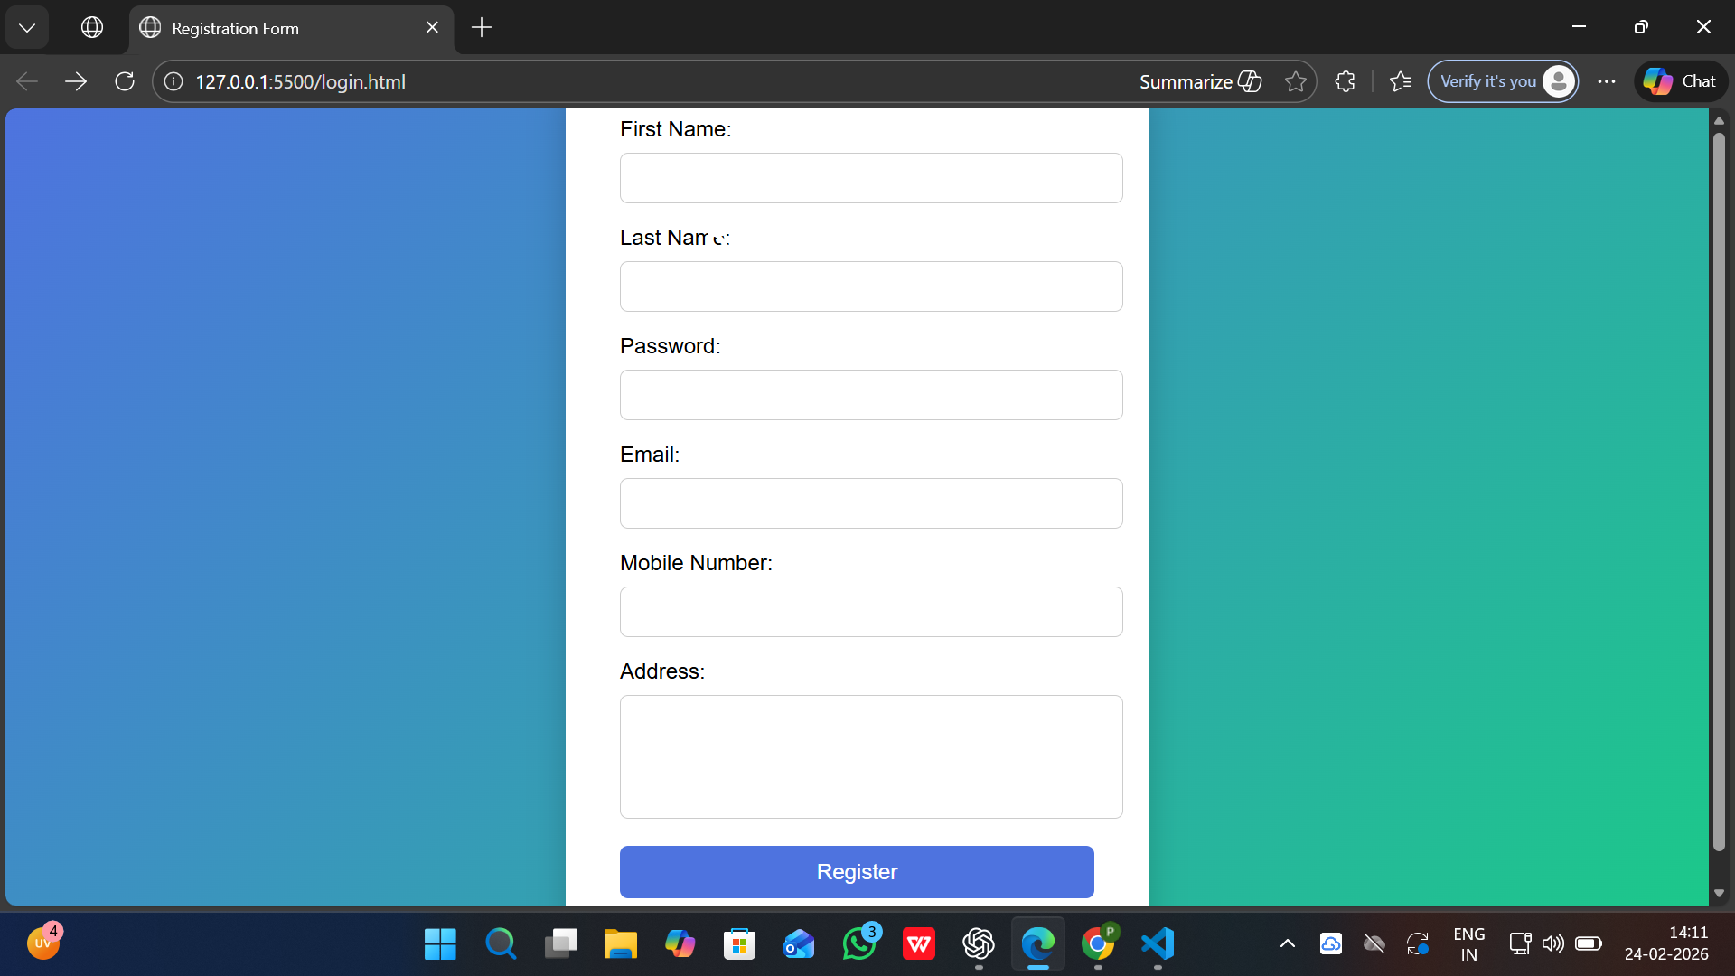



RESULT:
Thus, the HTML Registration page is created and validated successfully using JavaScript.

