EXP.NO: 11
SD Card Data Writing Application
AIM:
To develop a mobile application that writes user input data into the SD card storage of the Android device.
ALGORITHM:
• Start the application
• Display input field for user to enter text
• Display "Save" button
• User enters data in text field
• User clicks "Save" button
• App checks storage permission
• Create file in SD card storage
• Open file in write mode
• Write user entered text into file
• Close file
• Display success message "Data saved successfully"
• Stop the application
CODE:
activity_main.xml
<?xml version="1.0" encoding="utf-8"?>
<LinearLayout xmlns:android="http://schemas.android.com/apk/res/android"
android:orientation="vertical"
android:padding="20dp"
android:layout_width="match_parent"
android:layout_height="match_parent">

<EditText
android:id="@+id/editText"
android:hint="Enter data"
android:layout_width="match_parent"
android:layout_height="wrap_content"/>

<Button
android:id="@+id/saveBtn"
android:text="Save to SD Card"
android:layout_marginTop="20dp"
android:layout_width="match_parent"
android:layout_height="wrap_content"/>

</LinearLayout>
MainActivity.java
package com.example.sdcardwrite;

import android.os.Bundle;
import android.os.Environment;
import android.widget.Button;
import android.widget.EditText;
import android.widget.Toast;

import androidx.appcompat.app.AppCompatActivity;

import java.io.File;
import java.io.FileOutputStream;

public class MainActivity extends AppCompatActivity {

EditText editText;
Button saveBtn;

@Override
protected void onCreate(Bundle savedInstanceState) {
super.onCreate(savedInstanceState);
setContentView(R.layout.activity_main);

editText = findViewById(R.id.editText);
saveBtn = findViewById(R.id.saveBtn);

saveBtn.setOnClickListener(v -> saveToSDCard());
}

private void saveToSDCard() {
try {
String data = editText.getText().toString();

File path = Environment.getExternalStorageDirectory();
File file = new File(path, "MyData.txt");

FileOutputStream fos = new FileOutputStream(file);
fos.write(data.getBytes());
fos.close();

Toast.makeText(this, "Data saved to SD Card", Toast.LENGTH_LONG).show();

} catch (Exception e) {
e.printStackTrace();
Toast.makeText(this, "Error saving data", Toast.LENGTH_LONG).show();}
}}
OUTPUT:
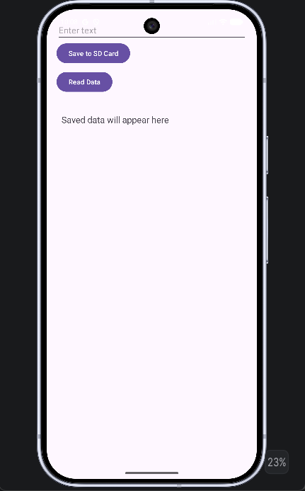

Result:
The application successfully writes the user-entered data into a file stored in the SD card. The saved file can be accessed later from the device storage.

