8. Consider a Library Management System. Develop a JavaScript
program that will validate the controls in the forms you have
created for the application. State the assumptions you make
(business logic you are taking into consideration).
Aim:
To develop a web-based Library Management System that validates user inputs
using JavaScript and connects to a database using Servlets and JSP, while also
demonstrating a simple Weather Information Webpage UI.
Procedure:
1. Create an HTML webpage for Library Management System.
2. Design a form to add books/users.
3. Apply JavaScript validation for all fields.
4. Create a JSP page to display data.
5. Develop a Servlet to handle form submission.
6. Connect the application to a MySQL database.
7. Insert validated data into the database.
8. Run the project on a server (e.g., Apache Tomcat).
9. Display success or error messages.
Code:

package com.example;

import java.io.IOException;
import java.sql.*;
import javax.servlet.ServletException;
import javax.servlet.annotation.WebServlet;
import javax.servlet.http.*;

@WebServlet("/library")
public class LibraryServlet extends HttpServlet {

protected void doPost(HttpServletRequest request, HttpServletResponse response)
throws ServletException, IOException {

String id = request.getParameter("id");
String name = request.getParameter("name");
String author = request.getParameter("author");
String quantity = request.getParameter("quantity");
String issue = request.getParameter("issue");
String ret = request.getParameter("return");

try {
Class.forName("com.mysql.cj.jdbc.Driver");

Connection con = DriverManager.getConnection(
"jdbc:mysql://localhost:3306/library_db", "root", "password");

PreparedStatement ps = con.prepareStatement(
"INSERT INTO books VALUES (?, ?, ?, ?, ?, ?)");

ps.setInt(1, Integer.parseInt(id));
ps.setString(2, name);
ps.setString(3, author);
ps.setInt(4, Integer.parseInt(quantity));
ps.setDate(5, Date.valueOf(issue));
ps.setDate(6, Date.valueOf(ret));

ps.executeUpdate();

request.setAttribute("msg", "Book added successfully");

} catch (Exception e) {
e.printStackTrace();
request.setAttribute("msg", "Error occurred");
}

request.getRequestDispatcher("result.jsp").forward(request, response);
}
}

<!DOCTYPE html>
<html>
<head>
<title>Library</title>

<script>
function validateForm() {
let id = document.forms["f"]["id"].value;
let name = document.forms["f"]["name"].value;
let author = document.forms["f"]["author"].value;
let qty = document.forms["f"]["quantity"].value;

if (id === "" || isNaN(id)) {
alert("ID must be number");
return false;
}

if (name === "") {
alert("Name required");
return false;
}

if (!/^[A-Za-z ]+$/.test(author)) {
alert("Author only letters");
return false;
}

if (qty <= 0) {
alert("Quantity > 0");
return false;
}

return true;
}
</script>

</head>

<body>

<h2>Library Form</h2>

<form name="f" action="library" method="post" onsubmit="return validateForm()">

ID: <input type="text" name="id"><br><br>
Name: <input type="text" name="name"><br><br>
Author: <input type="text" name="author"><br><br>
Quantity: <input type="number" name="quantity"><br><br>
Issue Date: <input type="date" name="issue"><br><br>
Return Date: <input type="date" name="return"><br><br>

<input type="submit" value="Submit">

</form>

</body>
</html>

OUTPUT:
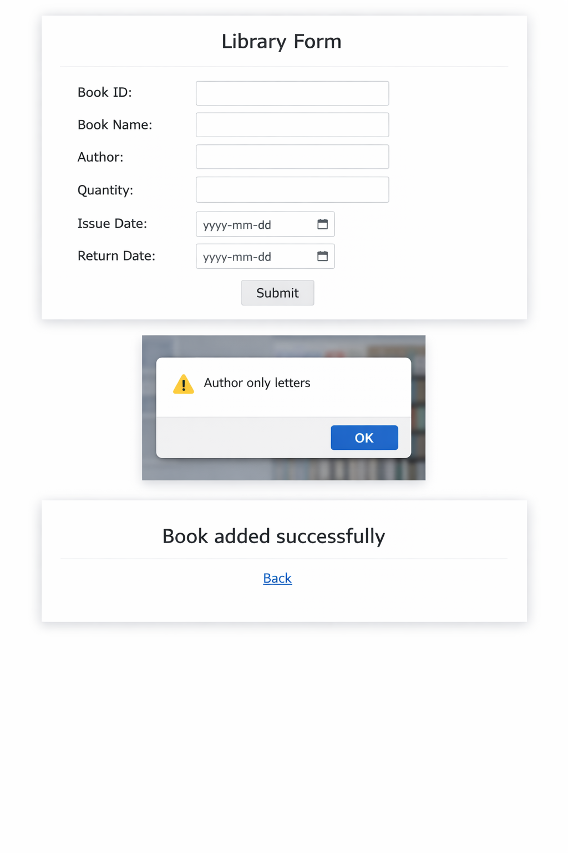
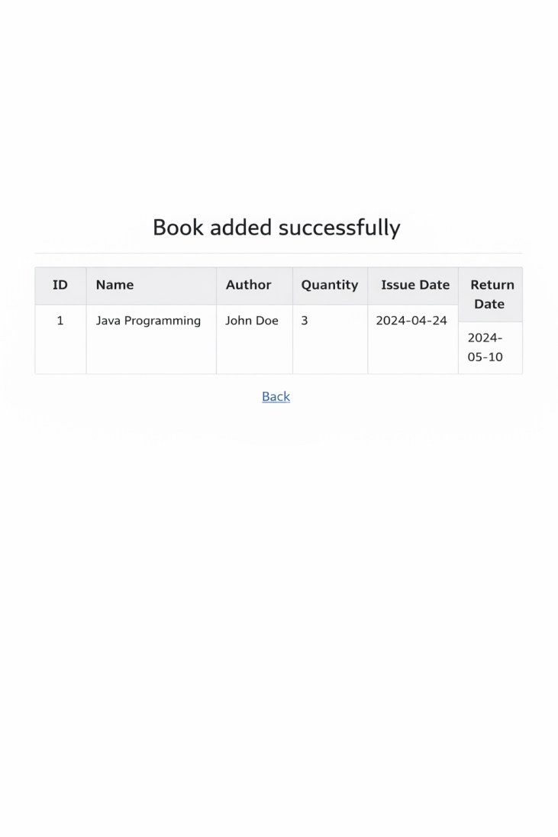

Result:
Thus, the Library Management System with JavaScript validation and database
connectivity using Servlet and JSP was successfully developed and executed.

