EXP.NO: 4 | Create a web form that accepts a user's name and age. Write a Servlet to process the form data and display it back on the browser.
DATE:26/02/2025

AIM:
To create a simple web application that includes a form to accept a user's name and age, and then use a Servlet to process the submitted data. The Servlet will retrieve the form data, process it, and display the values back on the browser.

ALGORITHM:
1. Input:
• The user fills out a web form with their name and age and submits it.
2. Form Handling and Servlet Processing:
1. Create the Web Form:
o Create an HTML form with two input fields: one for the user&#39;s name and one
for the user&#39;s age.
o Add a submit button to the form.
o Set the form&#39;s action attribute to the URL of the Servlet and the method to
POST (or GET).
2. Create the Servlet Class:
o Write a Servlet that processes the form data submitted by the user.
o The Servlet will override the doPost() (or doGet() depending on the form
method) to handle form submissions.
o The Servlet will retrieve the name and age parameters from the request
object using request.getParameter(&quot;name&quot;) and request.getParameter(&quot;age&quot;).

3. Process the Data in the Servlet:
o Extract the name and age values submitted from the form.
o Validate the input (e.g., check if the age is a valid number).
o Prepare a response that will display the user&#39;s name and age back on the
browser.

4. Send Response to the Browser:
o The Servlet will send a response to the browser containing a message like:
▪ &quot;Hello, [name]! You are [age] years old.&quot;
o The response will be displayed to the user in the browser.
5. Deploy the Servlet:
o Compile the Servlet and deploy it to a Servlet container (like Apache
Tomcat).
o Ensure the web.xml file or Servlet annotations are used to map the Servlet to
the URL defined in the form&#39;s action attribute.

6. Test the Application:
o Open the web browser, fill in the form with the name and age, and submit it.
o The Servlet will process the data and display the message back to the user in
the browser.
Code:
Index.html:
<!DOCTYPE html>
<html>
<head>
<title>Alumni Registration</title>
</head>
<body>
<h2>Alumni Registration Form</h2>

<form action="AlumniServlet" method="post">
Name: <input type="text" name="name"><br><br>
Age: <input type="number" name="age"><br><br>
Email: <input type="email" name="email"><br><br>
Department: <input type="text" name="dept"><br><br>
Passed Out Year: <input type="number" name="year"><br><br>

<input type="submit" value="Register">
</form>
</body>
</html>
Userform.java:
import java.io.*;
import javax.servlet.*;
import javax.servlet.http.*;
import javax.servlet.annotation.WebServlet;

@WebServlet("/AlumniServlet")
public class AlumniServlet extends HttpServlet {

protected void doPost(HttpServletRequest request, HttpServletResponse response)
throws ServletException, IOException {

response.setContentType("text/html");
PrintWriter out = response.getWriter();

String name = request.getParameter("name");
String age = request.getParameter("age");
String email = request.getParameter("email");
String dept = request.getParameter("dept");
String year = request.getParameter("year");

if (name == null || name.isEmpty()) {
out.println("<h3>Name is required!</h3>");
return;
}

out.println("<html><body>");
out.println("<h2>Registration Successful</h2>");
out.println("<p>Name: " + name + "</p>");
out.println("<p>Age: " + age + "</p>");
out.println("<p>Email: " + email + "</p>");
out.println("<p>Department: " + dept + "</p>");
out.println("<p>Year: " + year + "</p>");
out.println("</body></html>");
}
}

OUTPUT:
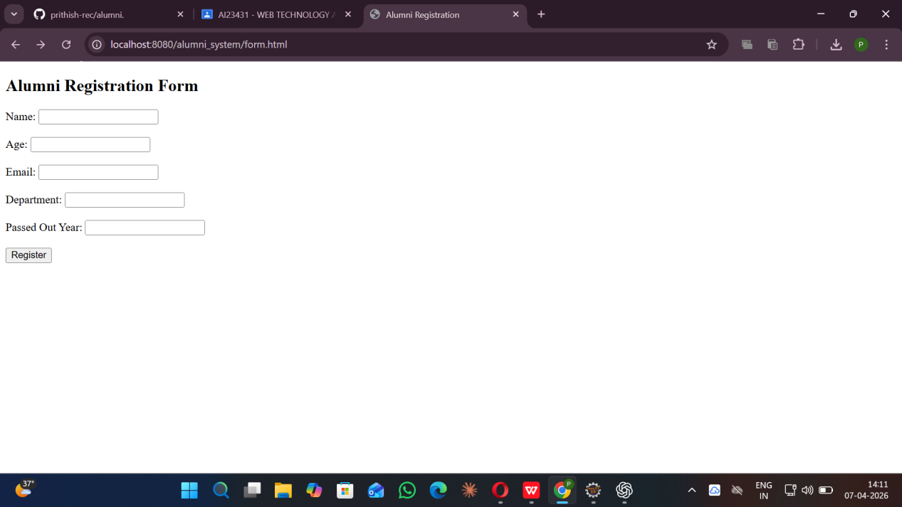
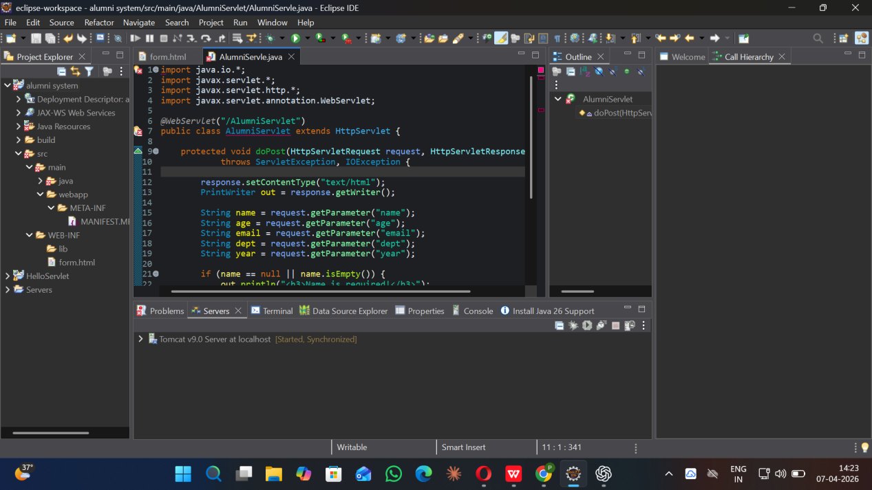

RESULT:
A Servlet is created to demonstrate the difference between HTTP GET and POST methods by creating a form and handling requests accordingly.

