EXP.NO: 6 | Write a Servlet to demonstrate session tracking  using HttpSession.
DATE:24/02/2025

AIM:
To demonstrate session tracking using HttpSession in a Servlet-based web
application. The exercise involves implementing a simple login system where a user can log
in with their username and password, and their session will be tracked throughout their
interaction with the web application.
ALGORITHM:
1. Input:
• The user will enter their username and password in a login form.
• The servlet will validate the credentials and create an HTTP session for the user if
authentication is successful.

2. Steps for Implementing Session Tracking with HttpSession:
1. Create the Login Form (HTML):
o Create an HTML form with two input fields for username and password.
o Provide a submit button to send the data to the servlet for authentication.
2. Create the Login Servlet:
o Write a Java servlet class to handle login requests.
o The servlet will:
▪ Retrieve the username and password from the form.
▪ Authenticate the user by comparing the credentials to a stored value
(e.g., hardcoded or from a database).
▪ Create a new HTTP session for the user if the credentials are valid.
▪ Set session attributes such as the user&#39;s username to track the session.

3. Validate User Credentials:
o In the servlet, check if the username and password match the expected
values.

13

o If valid, create a session and store the username in the session.
o If invalid, redirect the user back to the login page with an error message.
4. Create and Track User Session:
o Upon successful login, use the HttpSession object to store the session data.
o Use the session.setAttribute(&quot;username&quot;, username) method to save the
username.
o Optionally, set session timeout using
session.setMaxInactiveInterval(time_in_seconds) to manage session
expiration.

5. Redirect to a Protected Page:
o After a successful login, the user will be redirected to a protected page (e.g., a
dashboard or home page).
o The protected page should check if the user is authenticated by checking the
session attribute.
6. Logout and Session Invalidation:
o Provide a logout feature that invalidates the session using session.invalidate()
when the user logs out.
o After logout, redirect the user back to the login page.
7. Session Expiration:
o If the session expires or the user manually logs out, the session will be
invalidated, and the user will be redirected to the login page.

Output:

CODE:
<!DOCTYPE html>
<html>
<head>
<title>Alumni Login</title>
<style>
body { font-family: Arial; background: #f0f4f8; display: flex;
justify-content: center; align-items: center; height: 100vh; }
.form-box { background: white; padding: 30px; border-radius: 8px;
box-shadow: 0 2px 10px rgba(0,0,0,0.1); width: 320px; }
h2 { text-align: center; color: #2c3e50; }
input { width: 100%; padding: 10px; margin: 8px 0;
border: 1px solid #ccc; border-radius: 4px; box-sizing: border-box; }
button { width: 100%; padding: 10px; background: #2980b9;
color: white; border: none; border-radius: 4px; cursor: pointer; }
.error { color: red; text-align: center; }
</style>
</head>
<body>
<div class="form-box">
<h2>🎓 Alumni Portal</h2>
<p style="text-align:center; color:gray;">Online Alumni Management System</p>
<form action="LoginServlet" method="post">
<input type="text" name="username" placeholder="Alumni ID / Username" required />
<input type="password" name="password" placeholder="Password" required />
<button type="submit">Login</button>
</form>
<p class="error">${param.error}</p>
</div>
</body>
</html>

package com.alumni;

import java.io.*;
import javax.servlet.*;
import javax.servlet.http.*;
import javax.servlet.annotation.*;

@WebServlet("/LoginServlet")
public class LoginServlet extends HttpServlet {

protected void doPost(HttpServletRequest request,
HttpServletResponse response)
throws ServletException, IOException {

String username = request.getParameter("username");
String password = request.getParameter("password");

// Hardcoded credentials (replace with DB query for real system)
if (username.equals("alumni123") && password.equals("pass123")) {

// ✅ Create Session
HttpSession session = request.getSession();
session.setAttribute("username", username);
session.setAttribute("role", "Alumni");
session.setMaxInactiveInterval(30 * 60); // 30 minutes timeout

// Redirect to dashboard
response.sendRedirect("dashboard.jsp");

} else {
// ❌ Invalid credentials — redirect back with error
response.sendRedirect("login.html?error=Invalid+Username+or+Password");
}
}
}

package com.alumni;

import java.io.*;
import javax.servlet.*;
import javax.servlet.http.*;
import javax.servlet.annotation.*;

@WebServlet("/LogoutServlet")
public class LogoutServlet extends HttpServlet {

protected void doGet(HttpServletRequest request,
HttpServletResponse response)
throws ServletException, IOException {

// Invalidate the session
HttpSession session = request.getSession(false);
if (session != null) {
session.invalidate(); // ✅ Destroys the session
}

// Redirect to login page
response.sendRedirect("login.html?error=You+have+been+logged+out.");
}
}

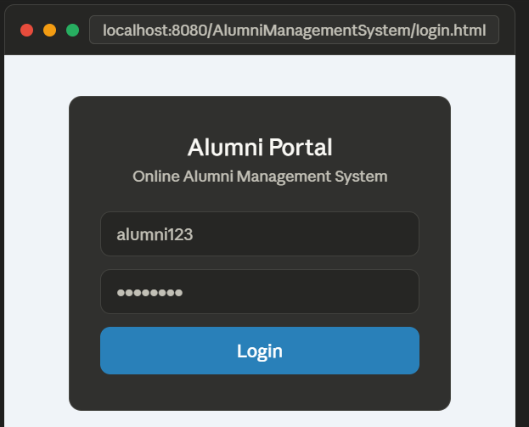

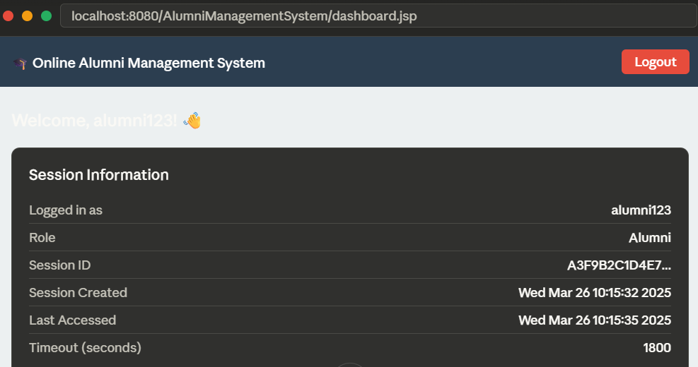

RESULT:
A simple login system is created where the user&#39;s session is tracked by a servlet to
demonstrate session tracking using HttpSession.

