7. Write a Servlet program to store a user's preferences (like theme or
language) using cookies. Retrieve and display these preferences on
subsequent visits.

AIM
To develop a Java Servlet-based web application that stores user preferences (such as theme and language)
using cookies and retrieves them on subsequent visits to personalize the weather information webpage.
ALGORITHM
1. Create a Dynamic Web Project in Eclipse or any IDE.
2. Add Servlet API library (Apache Tomcat server).
3. Create an HTML form to accept user preferences:
Theme (Light/Dark)
Language (English/Tamil/etc.)
4. Develop a Servlet (PreferenceServlet):
Read user inputs from the form.
Store preferences using cookies.
5. Develop another Servlet (DisplayServlet):
Retrieve cookies.
Display saved preferences along with weather info.
6. Configure web.xml (if not using annotations).
7. Run the project on server (Tomcat).
8. Test in browser:
First visit → set preferences.
Next visit → preferences auto-loaded.
SOURCE CODE
1. HTML Page (index.html)
<!DOCTYPE html>
<html>
<head>
<title>User Preferences</title>
</head>
<body>
<h2>Set Your Preferences</h2>

<form action="preferences" method="post">
Theme:
<select name="theme">
<option value="Light">Light</option>
<option value="Dark">Dark</option>
</select>
<br><br>

Language:
<select name="language">
<option value="English">English</option>
<option value="Tamil">Tamil</option>
</select>
<br><br>

<input type="submit" value="Save Preferences">
</form>
</body>
</html>

package com.example;

import java.io.IOException;
import java.io.PrintWriter;
import javax.servlet.ServletException;
import javax.servlet.annotation.WebServlet;
import javax.servlet.http.*;

@WebServlet("/preferences")
public class PreferenceServlet extends HttpServlet {

protected void doPost(HttpServletRequest request, HttpServletResponse response)
throws ServletException, IOException {

String theme = request.getParameter("theme");
String language = request.getParameter("language");

// Create cookies
Cookie themeCookie = new Cookie("theme", theme);
Cookie langCookie = new Cookie("language", language);

// Set cookie expiry (1 day)
themeCookie.setMaxAge(60 * 60 * 24);
langCookie.setMaxAge(60 * 60 * 24);

// Add cookies to response
response.addCookie(themeCookie);
response.addCookie(langCookie);

response.sendRedirect("preferences");
}

protected void doGet(HttpServletRequest request, HttpServletResponse response)
throws ServletException, IOException {

String theme = "Not Set";
String language = "Not Set";

Cookie[] cookies = request.getCookies();

if (cookies != null) {
for (Cookie c : cookies) {
if (c.getName().equals("theme")) {
theme = c.getValue();
}
if (c.getName().equals("language")) {
language = c.getValue();
}
}
}

response.setContentType("text/html");
PrintWriter out = response.getWriter();

out.println("<html><body>");
out.println("<h2>User Preferences</h2>");
out.println("<p>Theme: " + theme + "</p>");
out.println("<p>Language: " + language + "</p>");
out.println("<br><a href='index.html'>Go Back</a>");
out.println("</body></html>");
}
}

OUTPUT
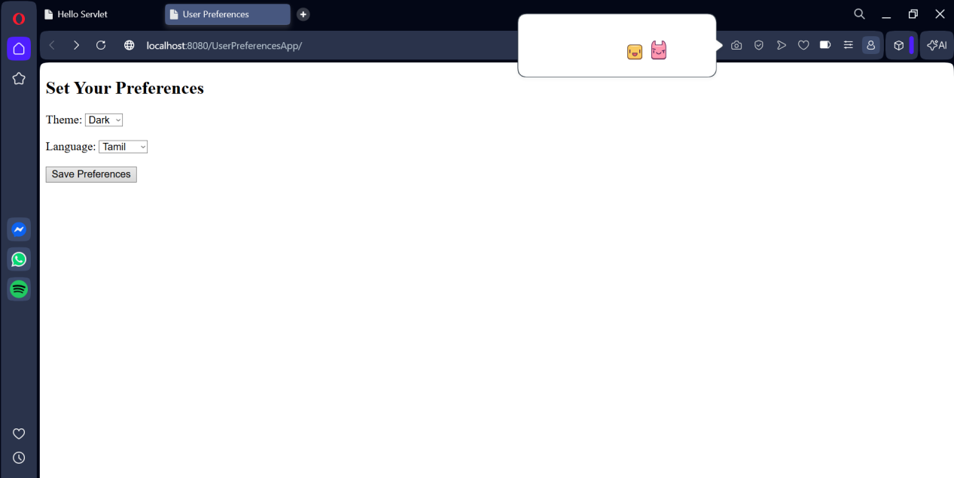

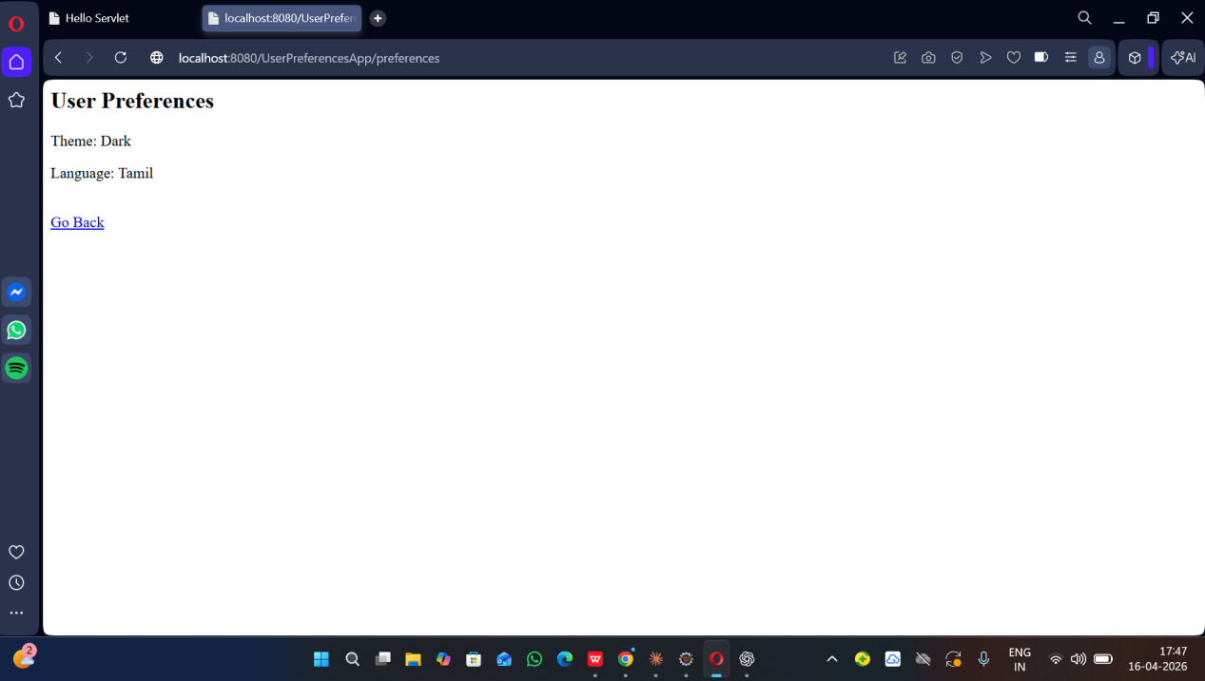

Result:
The experiment was successfully completed.User preferences (theme and language) were stored
using cookies and retrieved on subsequent visits, allowing the weather webpage to provide a
personalized user experience.

