PHASE 7: PROJECT DEMONSTRATION

1. Introduction
The Project Demonstration Phase presents the working flow of AnswerBot through the documented API operations. The demonstration focuses on user registration, user login, FAQ creation, and FAQ search using the REST API. The reference documentation identifies Node.js and Express.js as the backend framework, MongoDB with Mongoose as the data layer, JWT and bcrypt for authentication and password protection, and Google Gemini AI for AI-assisted FAQ generation.

2. Project Details
Project Title | AnswerBot – AI-Powered FAQ and Customer Support Automation
Team Leader | PRITHIKA.V
Mail ID | prithivenkatesan2007@gmail.com

3. Demonstration Objectives
- Demonstrate user registration through the /api/auth/register endpoint.
- Demonstrate user login through the /api/auth/login endpoint and JWT-based authentication.
- Demonstrate creation of an FAQ through the protected /api/faqs endpoint.
- Demonstrate FAQ search through the /api/faqs/search endpoint.
- Provide visual evidence of the API requests and responses used during the project demonstration.

4. Demonstration Environment
The documented project uses Visual Studio Code as the development environment and Postman or
Thunder Client for API testing. The backend is based on Node.js and Express.js, with
MongoDB/MongoDB Atlas and Mongoose for database operations. The documented setup requires Node.js v18 or above and npm v9 or above.

5. Demonstration Workflow
Step 1 – User Registration
Endpoint: POST /api/auth/register
A new user is submitted to the registration endpoint. The demonstration screenshot shows a successful 201 Created response and the registered user data.
Step 2 – User Login
Endpoint: POST /api/auth/login
The registered user's email and password are submitted. The demonstration shows a successful 200 OK response and a returned authentication token.
Step 3 – Create FAQ
Endpoint: POST /api/faqs
An authenticated request creates an FAQ containing a question, answer, and category. The demonstration shows a successful 201 Created response.
Step 4 – Search FAQ
Endpoint: GET /api/faqs/search?q=Node
The search endpoint is used to retrieve matching FAQ records. The demonstration shows a successful 200 OK response containing the matching FAQ. 6. Demonstration Screenshots
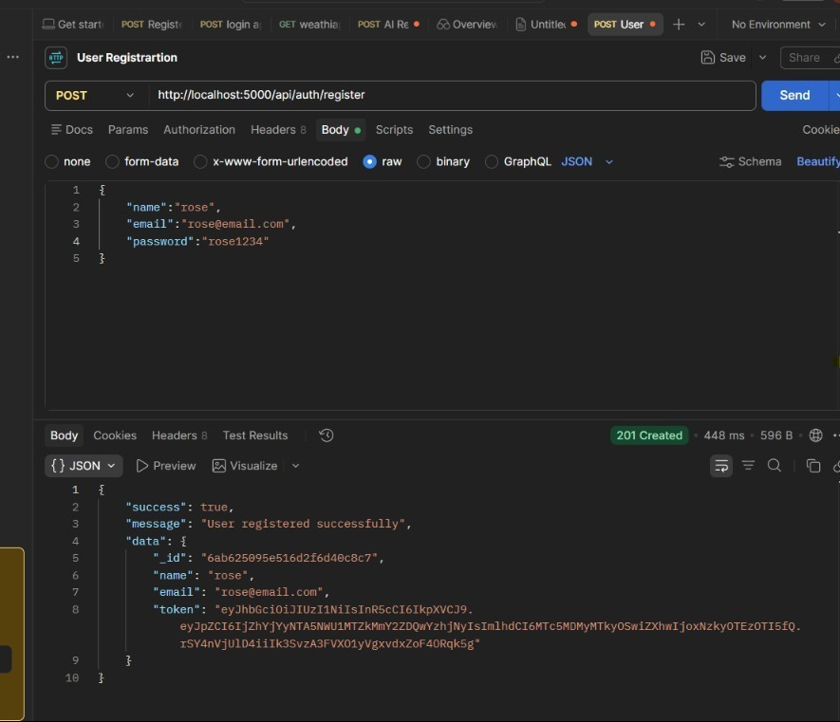
Figure 1. User Registration API request and successful response.
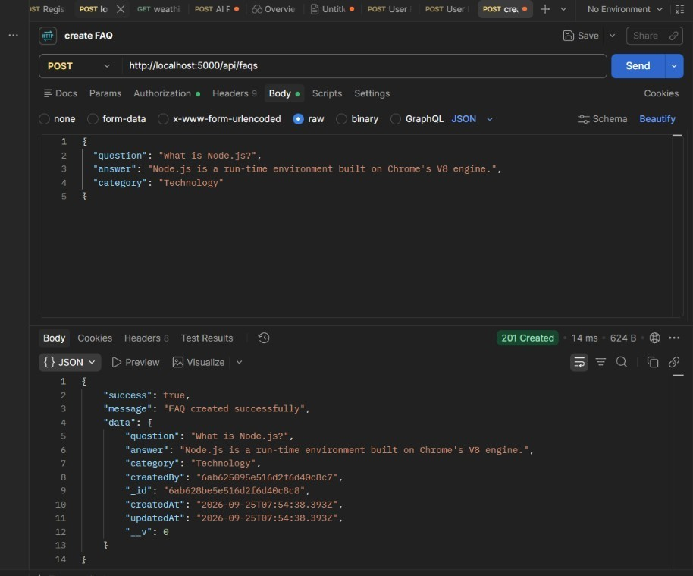
Figure 2. Create FAQ API request and successful response.
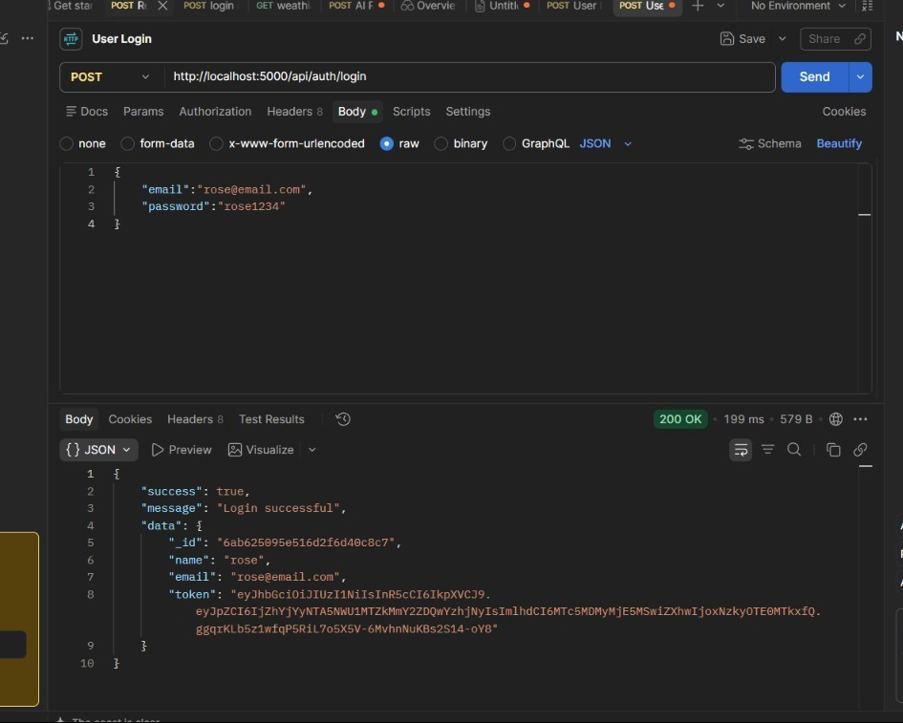
Figure 3. User Login API request and successful response.
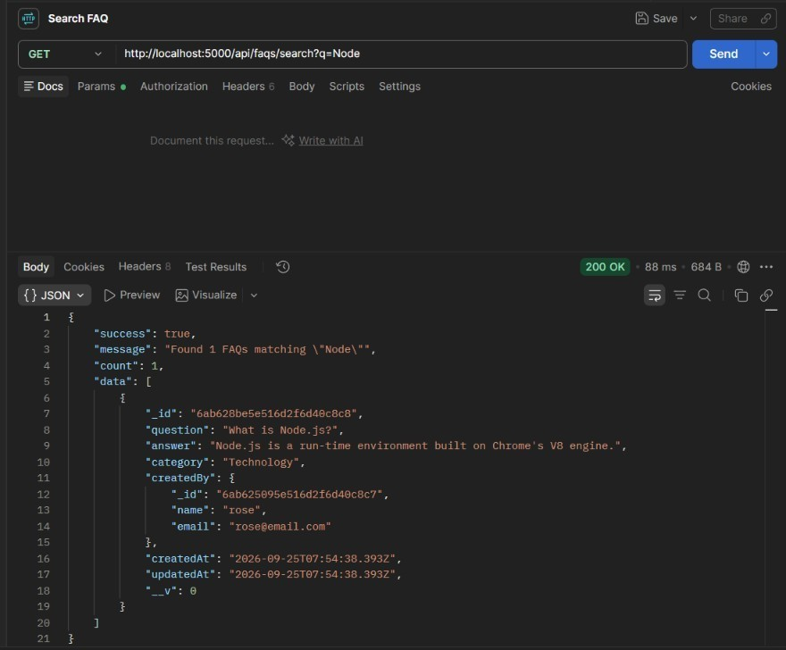
Figure 4. Search FAQ API request and successful response.

7. Demonstration of AI FAQ Generation
The reference documentation also defines an AI FAQ workflow in which the user provides a topic, an authenticated API request reaches the AI controller/service, Google Gemini AI processes the request, and a generated question, answer, and category are returned. The documented endpoint is POST /api/ai/generate-faq. The reference document does not provide a separate screenshot of this AIgeneration operation, so no additional execution result is assumed here.

8. Demonstration Summary
The demonstration provides visual evidence of the core REST API workflow: registering a user, authenticating the user, creating an FAQ, and searching the FAQ collection. These operations correspond to the API documentation in the reference project document. The screenshots are included as demonstration evidence, while the AI generation workflow is described only to the extent supported by the reference documentation.

9. Conclusion
The Project Demonstration Phase shows how the AnswerBot backend can be exercised through API requests and responses. The demonstrated operations reflect the documented authentication, FAQ management, and search capabilities and provide a clear record of the project's working API flow.
10. Demo Video Link
https://drive.google.com/file/d/1j_O-ECfSjJipugInLOSdvpptrX7tZiG1/view?usp=drivesdk

