Absenteeism at Work Prediction – Final Project Report

Abstract
Employee absenteeism significantly affects organizational productivity and workforce planning. This project aims to predict the number of hours an employee is absent from work using machine learning techniques. A dataset containing 8,336 employee records with demographic, organizational, and service-related attributes was used. Four regression models—Multiple Linear Regression, Random Forest Regressor, and their PCA-based variants—were developed and evaluated using Mean Squared Error (MSE), Root Mean Squared Error (RMSE), and R-Square metrics. The results indicate that Random Forest Regressor provides the most accurate predictions, highlighting the effectiveness of ensemble learning methods for HR analytics.

Introduction
Employee absenteeism is a critical issue for organizations as it directly impacts operational efficiency, productivity, and workforce morale. High absenteeism can lead to increased workload for other employees, delayed deliverables, and higher operational costs. With the availability of large volumes of employee data, machine learning techniques can be leveraged to identify patterns and predict absenteeism behavior. This project applies supervised regression models to predict absenteeism hours, enabling organizations to take proactive and data-driven decisions.

Dataset Description
The dataset used in this project contains 8,336 records and 13 attributes. Each record represents an employee and includes demographic information, organizational details, and service-related attributes. The target variable, AbsentHours, represents the total number of hours an employee was absent from work. The dataset provides sufficient diversity and complexity to evaluate multiple machine learning models.

Software and Libraries Used
The project was implemented using Python programming language. The libraries used include Pandas for data manipulation, NumPy for numerical computation, Matplotlib and Seaborn for visualization, and Scikit-learn for preprocessing, model development, dimensionality reduction, and evaluation. These tools are widely adopted in industry and academia.

Exploratory Data Analysis
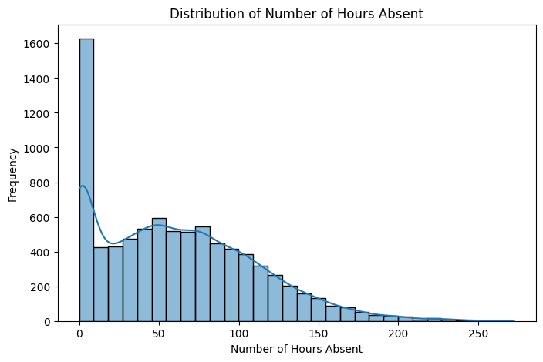
The distribution of absenteeism hours is right-skewed, indicating that most employees have low absence hours, while a small portion exhibits very high absenteeism. This skewness suggests non-normal behavior in the target variable.

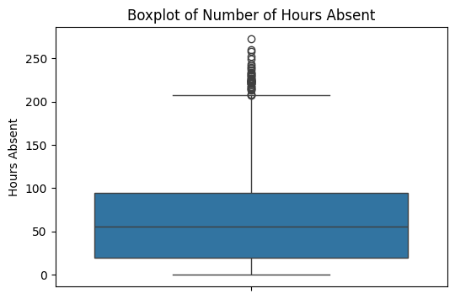
The boxplot reveals several outliers, representing employees with unusually high absenteeism. The presence of these outliers supports the use of robust models such as Random Forest Regressor.

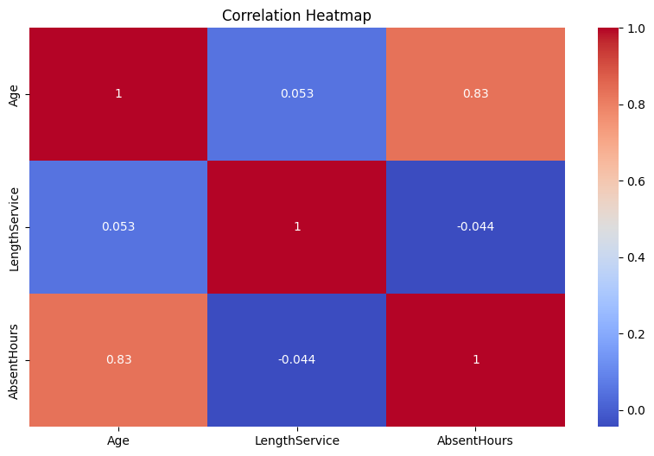
The correlation heatmap shows a strong positive correlation between Age and AbsentHours, while Length of Service shows minimal correlation. This indicates that not all numerical variables influence absenteeism linearly.

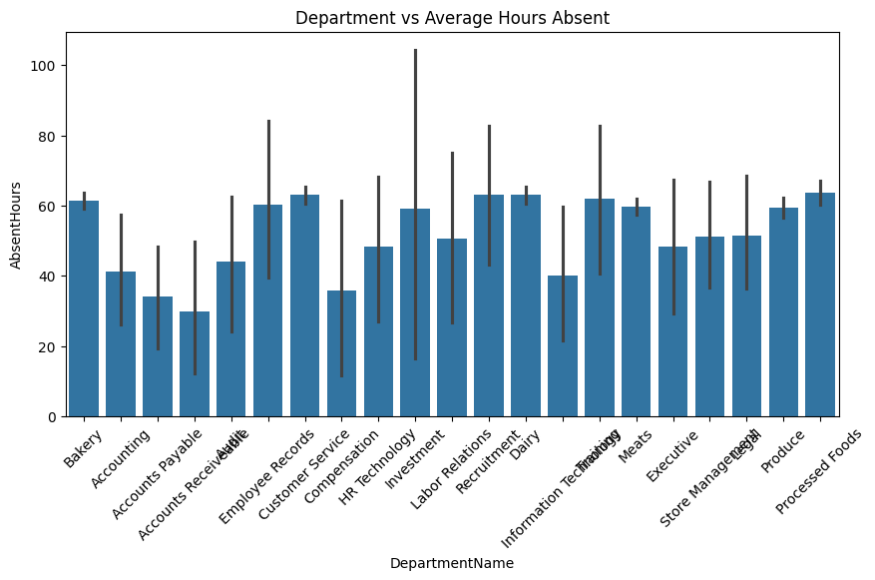
Department-wise analysis highlights variations in absenteeism across different departments, suggesting that role-specific and operational factors influence absence behavior.

Model Evaluation and Comparison
Model | MSE | RMSE | R² Score
Multiple Linear Regression | 777.67 | 27.89 | 0.6574
Random Forest Regressor | 668.75 | 25.86 | 0.7054
MLR with PCA | 683.49 | 26.14 | 0.6989
RFR with PCA | 680.95 | 26.10 | 0.7000

Data Preprocessing
Data preprocessing involved removing non-predictive identifiers, encoding categorical variables using One-Hot Encoding, scaling numerical features, and splitting the dataset into training and testing sets. Separate preprocessing pipelines were maintained for PCA-based models to ensure compatibility and correctness.

Machine Learning Models
Multiple Linear Regression, Random Forest Regressor, Multiple Linear Regression with PCA (using TruncatedSVD), and Random Forest Regressor with PCA. Linear regression served as a baseline, while Random Forest captured non-linear relationships and interactions.

Model Evaluation and Comparison
The models were evaluated using Mean Squared Error (MSE), Root Mean Squared Error (RMSE), and R-Square metrics. Multiple Linear Regression achieved an R² score of 0.657. Random Forest Regressor achieved the best performance with an R² score of 0.705. PCA-based models showed slightly reduced performance due to dimensionality reduction trade-offs.

Inference
The Random Forest Regressor without PCA emerged as the best-performing model. PCA improved the linear model marginally but resulted in slight information loss for ensemble models. Overall, non-linear models proved more effective for absenteeism prediction.

Conclusion
This project successfully applied machine learning techniques to predict employee absenteeism hours. The findings demonstrate the importance of selecting models aligned with data complexity. The developed framework can assist HR departments in workforce planning and absenteeism management. Future work may include feature selection, hyperparameter tuning, and temporal analysis.

