import Enzyme from 'enzyme';

import EnzymeAdapter from 'enzyme-adapter-react-16';

Enzyme.configure({

  adapter: new EnzymeAdapter(),

});

Shallow 🡪 renders parent component without rendering Child component

const wrapper = shallow(<App />);

wrapper.debug(); // debug shows the html like outcome of the component

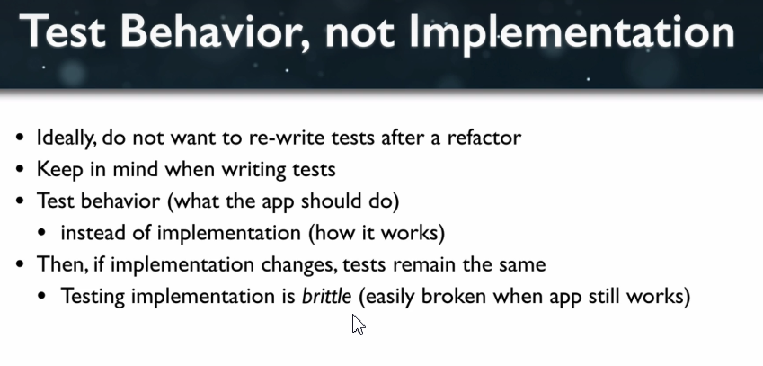

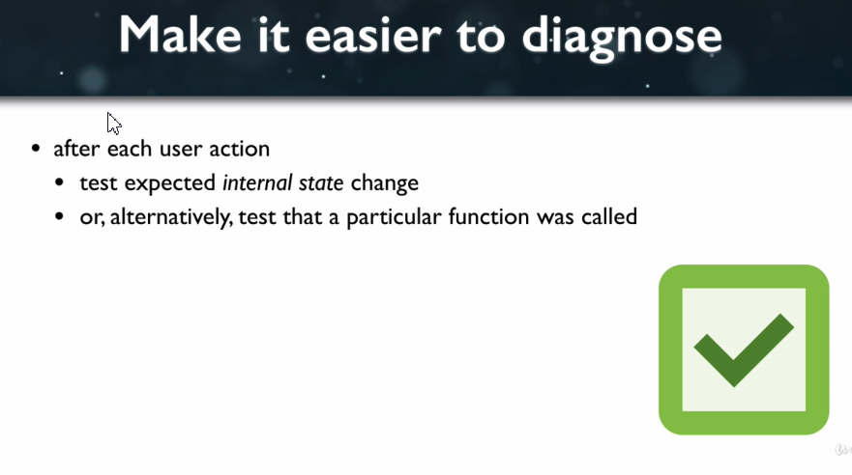

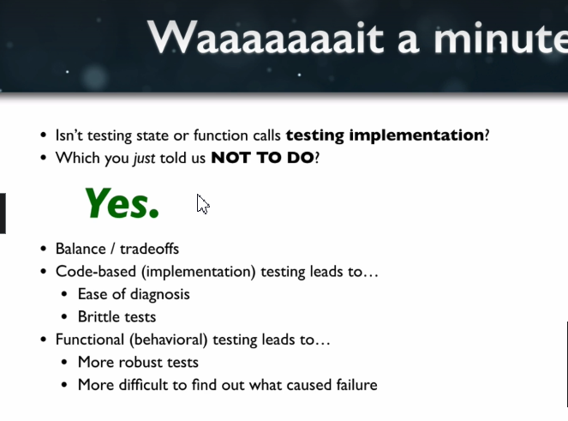

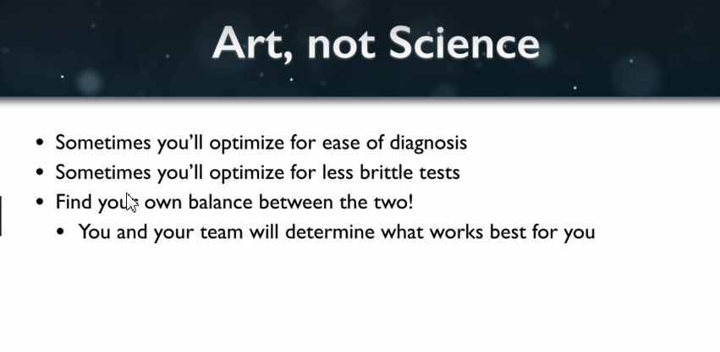

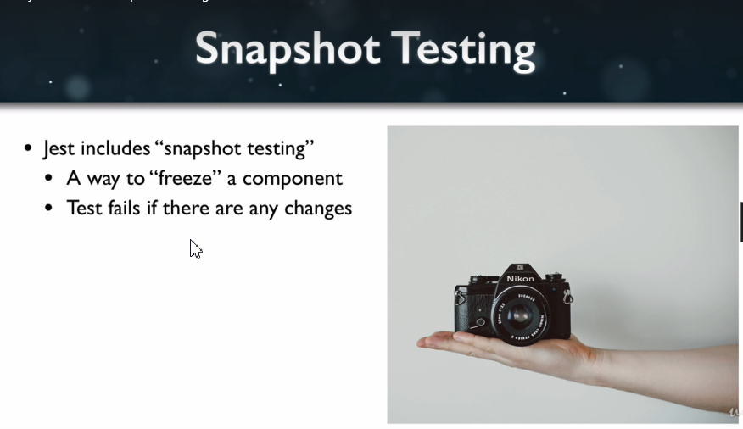

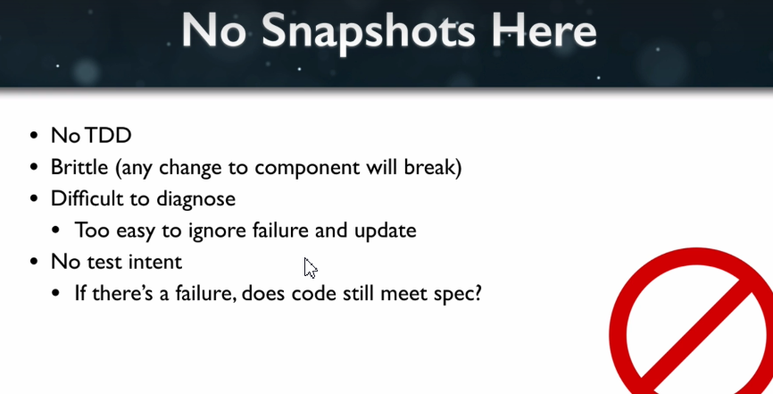

Data-test attributes

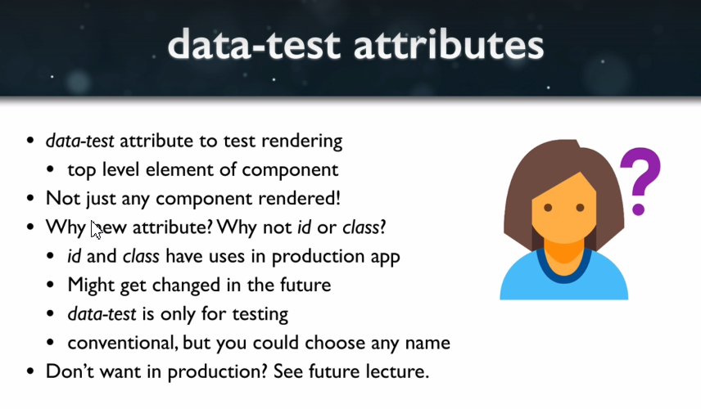

**.find(selector) => ShallowWrapper**

Selector 🡪 can be any valid HTML/CSS attribute

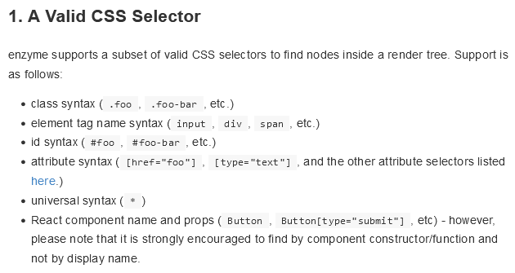

it('renders without error', () => {

  const wrapper = shallow(<App />);

  const appComponent = wrapper.find('[data-test="component-app"]');

  expect(appComponent.length).toBe(1);

});

import App from './App';

import Enzyme, { shallow } from 'enzyme';

import EnzymeAdapter from 'enzyme-adapter-react-16';

Enzyme.configure({

  adapter: new EnzymeAdapter(),

});

const setup = () => shallow(<App />);

const findByTestAttr = (wrapper, val) => wrapper.find(`[data-test='${val}']`);

it('renders without error', () => {

  const wrapper = shallow(<App />);

  const appComponent = wrapper.find('[data-test="component-app"]');

  expect(appComponent.length).toBe(1);

});

it('renders increments button', () => {

  const wrapper = shallow(<App />);

  const button = wrapper.find('[data-test="increment-button"]');

  expect(wrapper.exists()).toBe(true);

});

it('renders counter display', () => {

  const wrapper = shallow(<App />);

});

it('counter display starts at 0', () => {

  const wrapper = setup();

  const count = findByTestAttr(wrapper, "count").text();

  expect(count).toBe("");

});

it('clicking button increments counter display', () => {

  const wrapper = setup();

  const button = findByTestAttr(wrapper, "increment-button");

  button.simulate('click');

  const count = findByTestAttr(wrapper, 'count').text();

  expect(count).toBe("1");

});