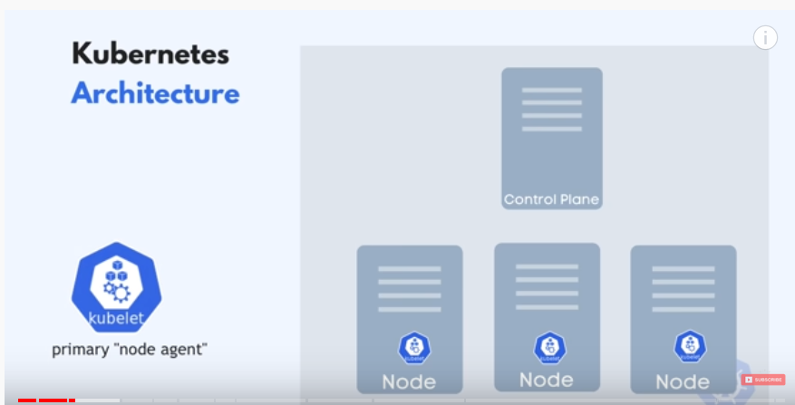

Worker nodes are where the application runs

Master Node:

.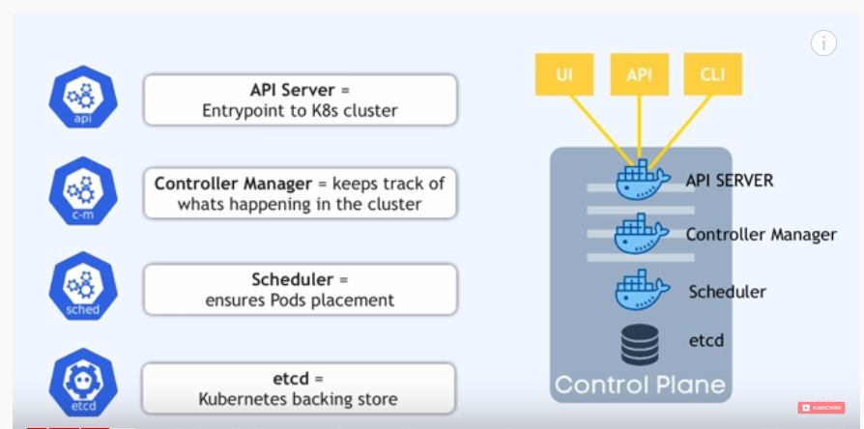

Virtual Network 🡪 is how the nodes communicate with each other

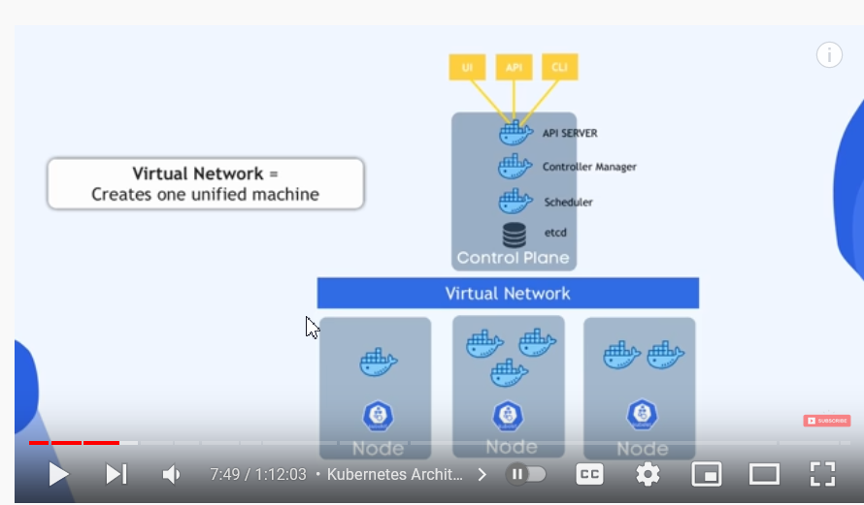

Master Node though small and has less workload it is very important hence there will always be a backup of master node

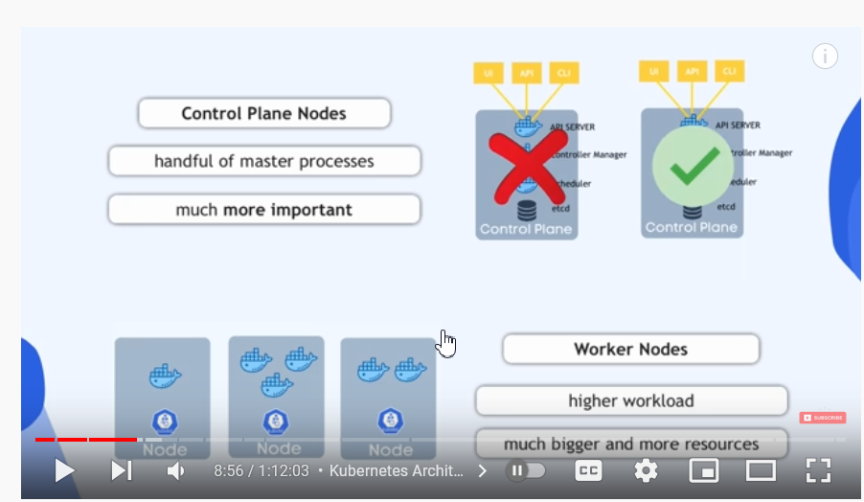

Node 🡪 pod as its own IP permanent address and hence once a new pod is created the IP changes

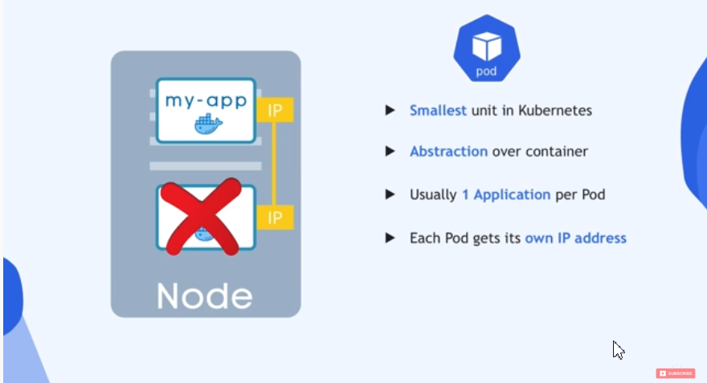

Services