WebSockets

A few ways to implement these:

* Long/short polling (client pull)
* WebSockets (server push)
* Server-Sent Events (server push)

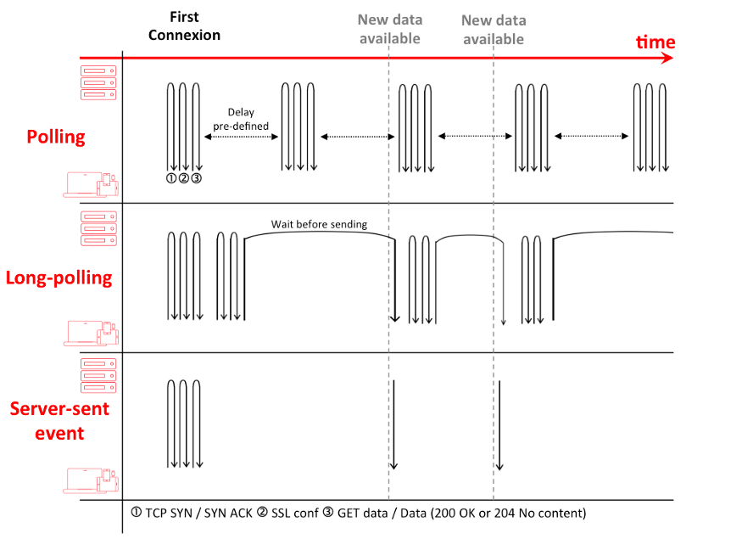

Short polling is an AJAX-based timer that calls at fixed delays

Long polling is based on [Comet](https://en.wikipedia.org/wiki/Comet_(programming)) (i.e server will send data to the client when the server event happens with no delay, One request goes to server and client is waiting for the response to come (its unresolved).

Server Sent Event