Problem 2

.exe files, the mean is 110.06 Kb and the median is 60 Kb.

The equation for the optimal page is = (2x s x e)1/2

Here,

e = 8 bytes

s = pages per process x page number = 28 x 110.06 x 1024

So, optimal page size = (2 x 28 x 110.06 x 1024 x 8)1/2 = 21485.46 bytes

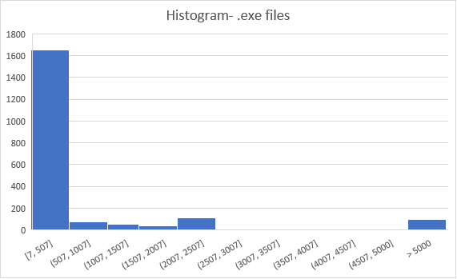

.dll files, the mean is 342.98 Kb and the median is 34.29 Kb.

The equation for the optimal page is = (2x s x e)1/2

Here,

e = 8 bytes

s = pages per process x page number = 28 x 342.98 x 1024

So, optimal page size = (2 x 28 x 342.98 x 1024 x 8)1/2 =37928.38 bytes

