 | Vriddhi Nexus Bus Booking Platform  Short client brief | Current build: mock inventory, mock payment status, mock tracking
Current Scope
The platform is ready for client review using mock bus inventory, mock payment status, scheduled-route tracking, and mock support/refund queues. Real supplier API, real payment gateway, and live GPS data are not connected yet.

What the platform does
Vriddhi Nexus is a web-based bus booking platform for customers, admins, and travel agents. Customers can search routes, compare buses, choose seats with visible prices, enter traveller details, and receive ticket and invoice records. Admins manage operational views such as bookings, invoices, bulk uploads, refunds, support, users, reports, and trust signals.
Customer Experience  Search routes, view fares, select seats, manage bookings, invoices, tracking, saved travellers, wallet rewards, and support. | Admin Operations  Manage bookings, seat prices, bulk booking upload, invoice generation, refund queue, support desk, users, reports, and trust labels. | Access & Safety  Separate customer/admin workspaces, role-based dashboard routing, protected admin pages, and clean navigation for each role.
Diagram 1: Platform overview
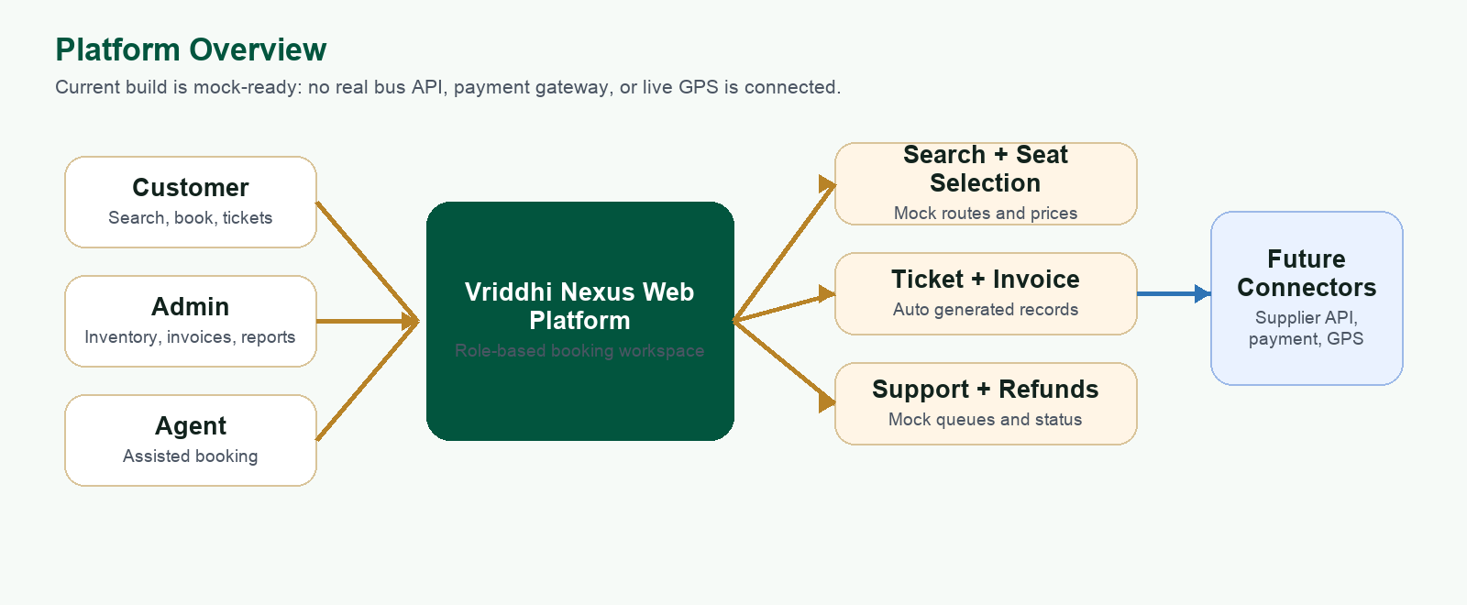

Diagram 2: Customer booking flow
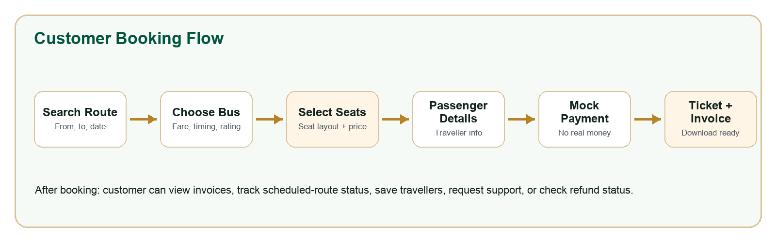
Feature coverage
Module | What client can review now
Route search | Find buses by city, date, timing, type, fare, rating, seats, and tracking filter.
Seat selection | Seat layout supports visible prices, selected seats, booked seats, and gender indicators.
Booking records | Passenger details, ticket view, booking history, cancellation state, and invoice actions.
Customer dashboard | Bookings, invoices, tracking, saved travellers, wallet/rewards, support, and notifications.
Admin dashboard | Bookings, bulk upload, invoice generation, seat price controls, refunds, support, reports, users, and trust signals.
Mock readiness | Safe demo mode with mock inventory, mock payments, mock tracking, and mock support/refund queues.
Not connected in this phase
Live bus API  Pending supplier integration | Real payments  Gateway not connected | Live GPS  Tracking is scheduled preview | Live external data  Mock/demo data only
Recommended next steps
1. Client UAT  Review booking, admin, invoice, refund, and support flows with sample data. | 2. Integration plan  Confirm supplier API, payment gateway, GPS, and notification providers. | 3. Launch hardening  Production DB, monitoring, security review, backups, and deployment checks.

