Instructions on Using the Ember App

1. At first you are greeted with the home screen. Just click next to enter the main interface.



1. In the main interface you have the option of choosing four different features. The top left one scans QR codes. The top right one gives you a current environment reading. The bottom left one gives you a detailed analysis of movement. The bottom right one gives you a list of the spacesuit parts you are currently wearing. The button “Go for a SpaceWalk” prepares you for a spacewalk. When you return from a spacewalk, the button says “Enter Spaceship”

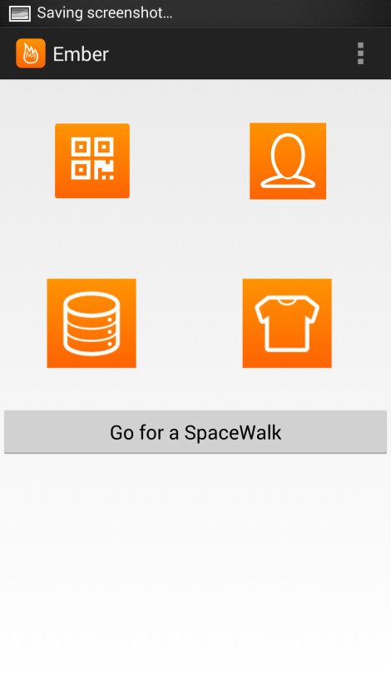

1. On this activity you can click the scan button and scan a QR code. At first it will prompt you to download a QR Code scanner (Make sure to download it). Once you have downloaded it, scan each of the QR Codes present on the respective parts of the suit, then; wear the part you just scanned. Once Scanned this page will give you the QR Codes’ details and the name of the item you just scanned, also it will store this in your phone’s memory.

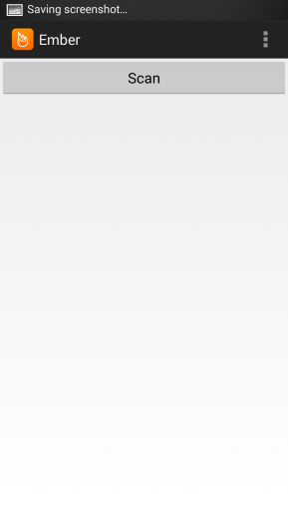

1. This feature tells you your current location (In the ship or spacewalking). It also shows the environments’ air pressure, temperature, brightness, humidity, magnetic field strength, and oxygen and water levels. (Galaxy S4 works best for this part, it contains most of these sensors). In the future, almost every phone will contain each of these sensors. (When you are at a spacewalk this feature can sense these variables in the environment inside of your suit.)

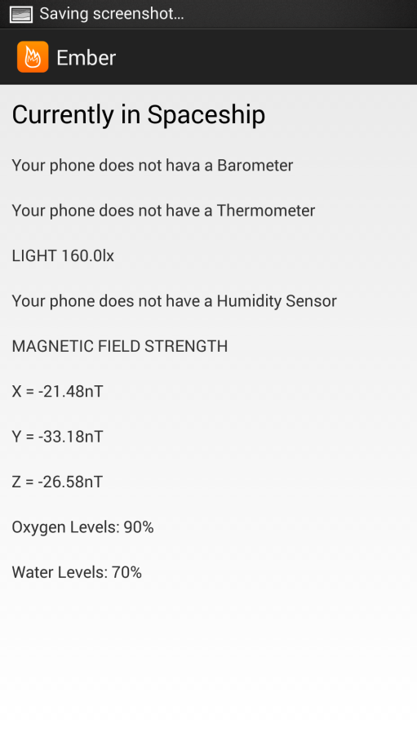

1. This feature uses the accelerometer and the gyroscope (almost every Smartphone has these sensors) to calculate your linear and rotational speed. When you move to fast or rotate to fast it warns you (This comes in handy when you are spacewalking). Its warning system consists of making a noise and changing the text “Your movement is ok now” and “Your rotational movement is ok now” to a message that warns you of your erratic speed.

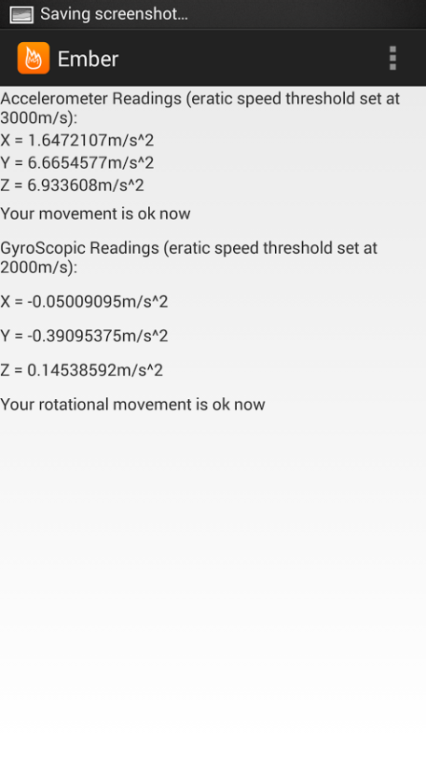

1. This feature lists all of the spacesuit parts you scanned before wearing them. It just shows what you are wearing right now.

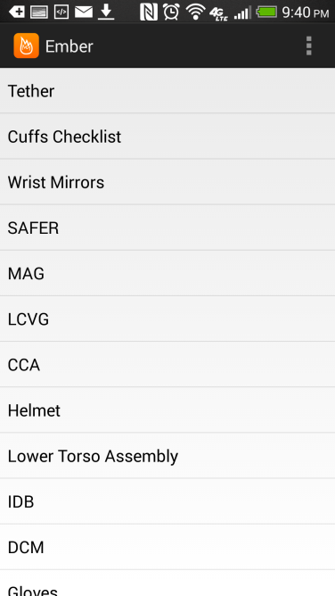

1. When you click “Go for a SpaceWalk” button, it takes you to this activity. In this activity you are prompted to either go or not go depending on whether or not you are wearing all of the parts of the space suit. It checks by looking at all of the parts that have been scanned. (The user has to make sure that they scan the item and then put it on). It instructs you to go if and only if you are wearing all of the parts of the space suit. (This can feature can help a forgetful tourist keep track of what they are wearing. And if they forget anything, this app lists what they are forgetting.)

