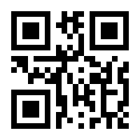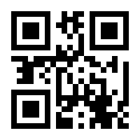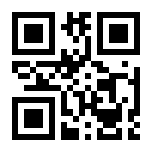

Tether cuffs SAFER

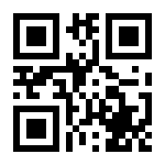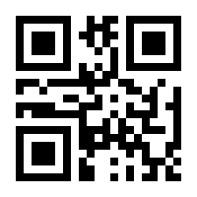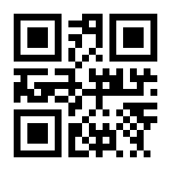

LCVG CCA

MAG

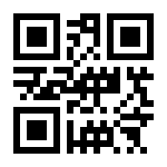 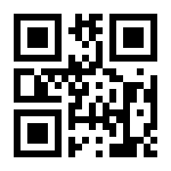

Helmet Lower Torso Assembly

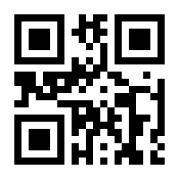 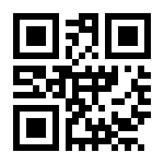 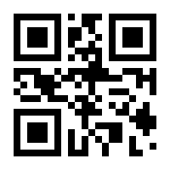

IDB DCM Gloves

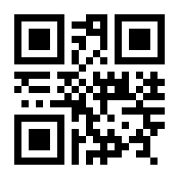 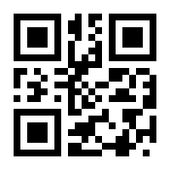 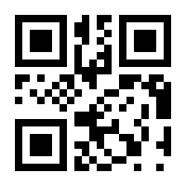

Upper Torso PLSS Arm

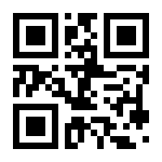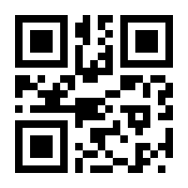

HUT Wrist Mirrors

Codes and Respective Space Suit Parts

4s5e834 - Safety Tethers (special unit for this)

38d52f5 - cuff

232d53e - wrist mirrors

25d25e6 - SAFER

55e84f4 - MAG

235e145 - LCVG

24e11s6 - CCA

548e1s4 - Helmet

654e62s - Lower torso assembly

25e62s6 - IDB

7886s8e - DCM

336s85e - gloves

3s44e4f - upper torso

53484s6 - PLSS

4832se8 - Arm