Experiment No.: 3
Title: Virtual Modeling of Robot Links, Joints, and Coordinate Systems using Open-Source Software

Title

Virtual Modeling of Robot Links, Joints, and Coordinate Systems using Open-Source Software.

Objectives

- To model a robot structure using links and joints (revolute and prismatic).
- To understand coordinate systems and robot motion.
- To analyze Degrees of Freedom (DOF) and workspace.

Software / Resources Required

- Open-source robot modeling / simulation software — RoboAnalyzer, or Python (NumPy, Matplotlib, PyBullet), or ROS with URDF and RViz (any one, as available in the laboratory).
- A computer with the chosen software pre-installed.
- Reference robot link-joint data sheet (link lengths, joint types, and joint limits) for the model to be created.
- Notebook / observation sheet for recording D-H parameters and results.

Theory

Links and Joints
A robot manipulator is built as an open kinematic chain of rigid bodies called links, connected to one another by joints. Each joint permits one independent relative motion between the two links it connects, and is therefore assigned one degree of freedom. The two most common joint types used in industrial robot modeling are the revolute joint and the prismatic joint, illustrated in Figure 1.
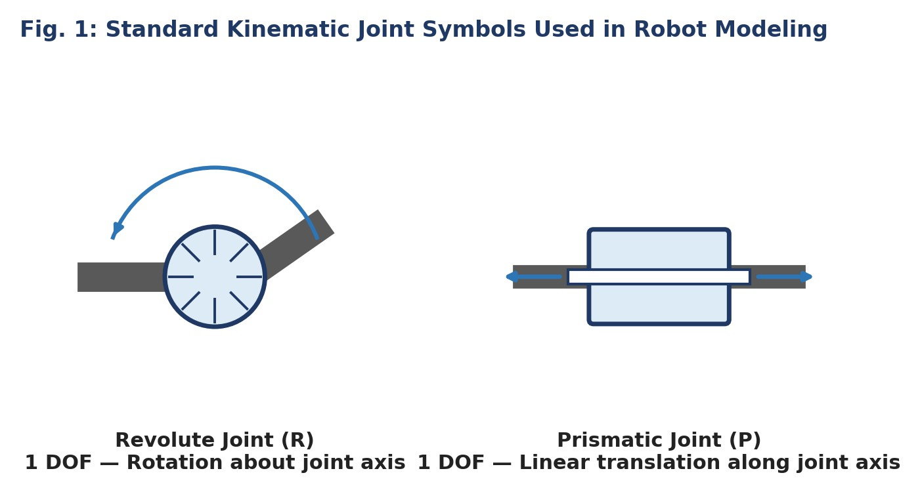
Fig. 1: Standard kinematic joint symbols — revolute (rotational) and prismatic (translational) — used to represent robot joints in a kinematic diagram.

A revolute joint (R) permits pure rotation of one link relative to the next about a fixed joint axis, while a prismatic joint (P) permits pure translation of one link relative to the next along a fixed joint axis. Every industrial robot configuration can be described as a specific sequence of R and P joints — for example, an articulated robot is typically an RRR (or RRRRRR) chain, a SCARA robot is an RRP chain, and a Cartesian robot is a PPP chain.
Figure 2 shows a simple two-link planar robot arm built from two revolute joints and two rigid links, fixed to a stationary base. This is the simplest structure that can be virtually modeled to understand how links and joints combine to produce a kinematic chain.
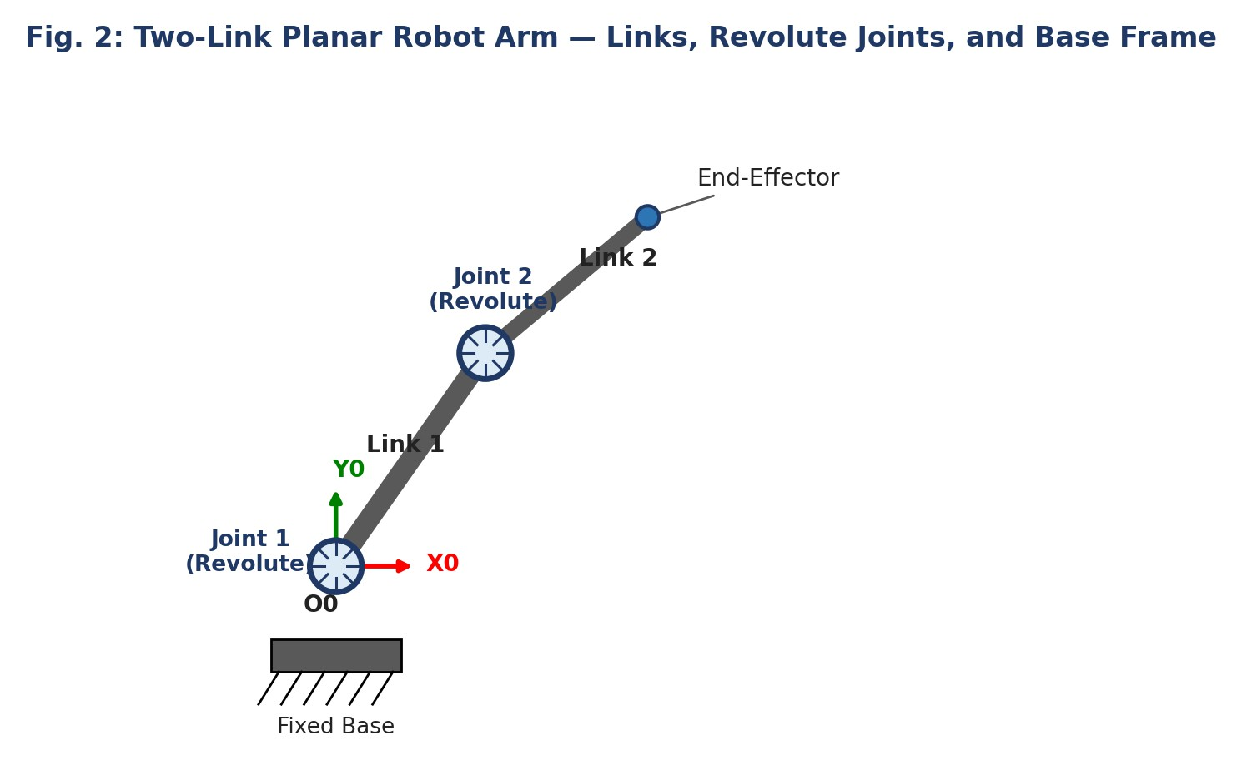
Fig. 2: A two-link planar robot arm showing Link 1 and Link 2 connected in series by two revolute joints (J1, J2), fixed to a base, with the base coordinate frame (X0, Y0) shown at the first joint.

Coordinate Systems and Robot Motion
To describe the position and orientation (together called the pose) of every link in space, a right-handed Cartesian coordinate frame is attached to each link of the robot, as shown in Figure 3. The position of the origin and the orientation of the axes of each frame relative to the previous frame together define the robot's overall geometry and its motion as the joints move.

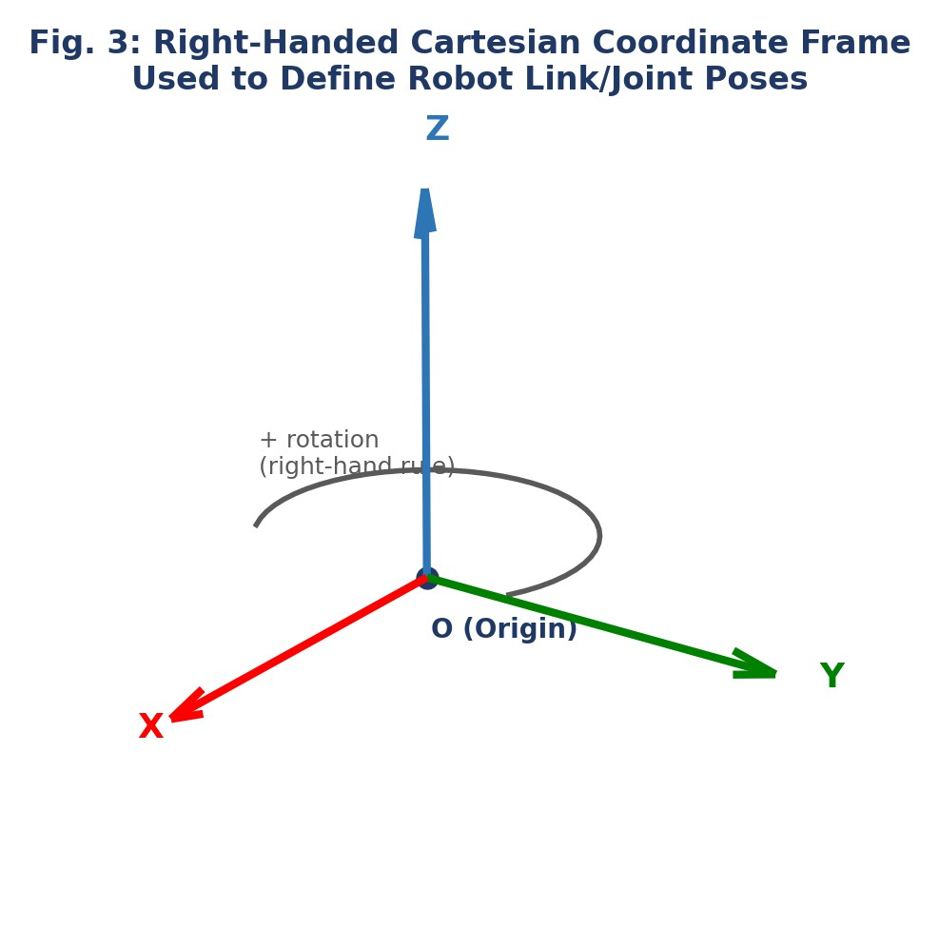
Fig. 3: A right-handed Cartesian coordinate frame (X, Y, Z) is attached to each robot link. Positive joint rotation is defined using the right-hand rule about the frame's Z-axis.
The most widely used systematic method of assigning these coordinate frames to a chain of links is the Denavit–Hartenberg (D-H) convention. In this convention, four parameters are used to describe the geometric relationship between any two consecutive link frames, as illustrated in Figure 4:
    - Link length (aᵢ): the distance between the Z-axes of frame i-1 and frame i, measured along the common normal (X-axis).
    - Link twist (αᵢ): the angle between the Z-axes of frame i-1 and frame i, measured about the X-axis.
    - Link offset (dᵢ): the distance between the X-axes of frame i-1 and frame i, measured along the Z-axis of frame i-1.
    - Joint angle (θᵢ): the angle between the X-axes of frame i-1 and frame i, measured about the Z-axis of frame i-1.

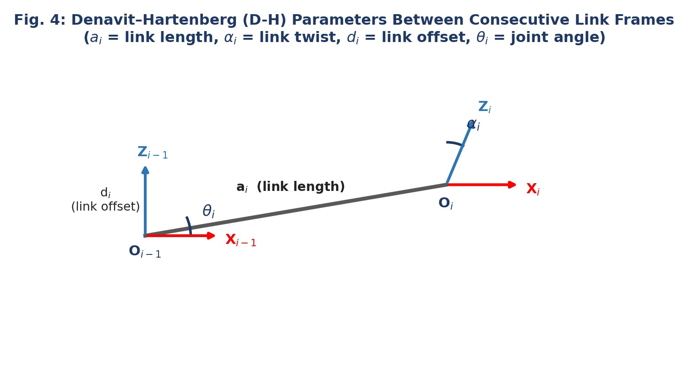
Fig. 4: Denavit–Hartenberg (D-H) parameters that geometrically relate two consecutive link coordinate frames Oᵢ₋₁ and Oᵢ.
For a revolute joint, θᵢ is the variable (joint) parameter while aᵢ, αᵢ, and dᵢ remain fixed by construction. For a prismatic joint, dᵢ is the variable parameter while aᵢ, αᵢ, and θᵢ remain fixed. Virtual modeling software builds a homogeneous transformation matrix from the D-H parameters of each link and multiplies these matrices in sequence to compute the pose of the end-effector for any given set of joint values — this is known as forward kinematics.

Degrees of Freedom (DOF) and Workspace
The degrees of freedom of a robot equal the number of independent joint variables needed to completely specify the configuration of the mechanism — one for every revolute or prismatic joint in the chain. A minimum of six DOF is required for a robot's end-effector to reach any arbitrary position and orientation in three-dimensional space. Figure 5 shows a typical 6-DOF articulated industrial robot arm, with its joints labeled in sequence from the base to the wrist.

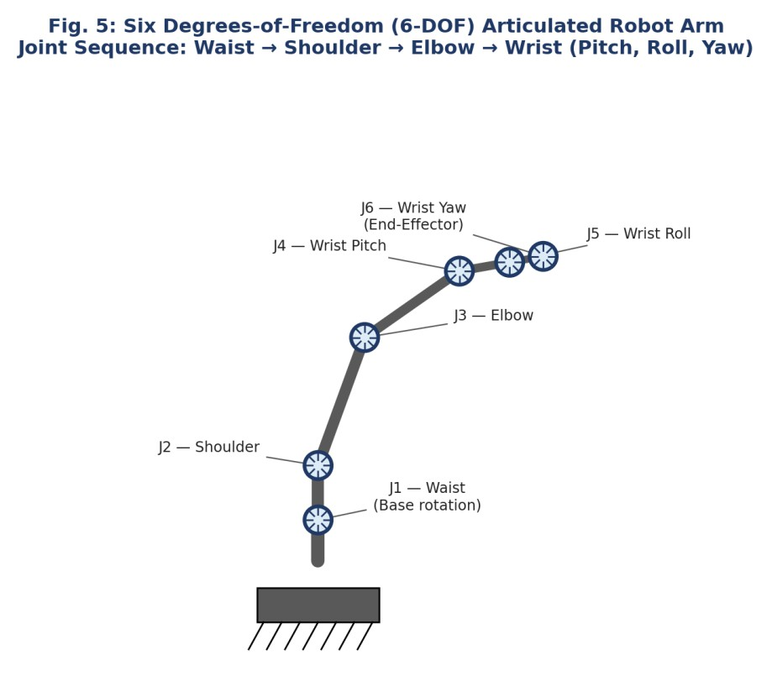
Fig. 5: A 6-DOF articulated robot arm formed from six revolute joints in series — waist, shoulder, elbow, and a three-axis (pitch, roll, yaw) wrist.
The workspace (or reachable volume) of a robot is the complete set of points in space that its end-effector can access, considering the link lengths and the travel limits of every joint. The shape of the workspace envelope depends directly on the type and arrangement of joints used, as shown in Figure 6 for three common configurations.
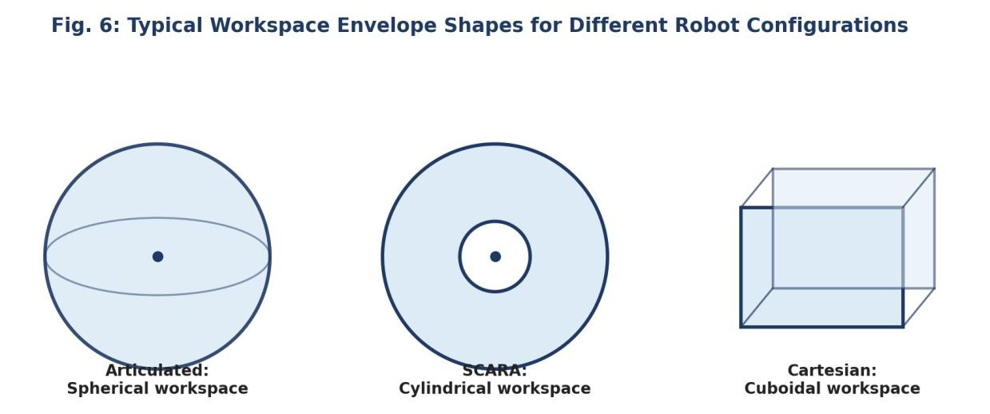
Fig. 6: Typical workspace envelope shapes generated by different joint arrangements — spherical (articulated, RRR), cylindrical (SCARA, RRP), and cuboidal (Cartesian, PPP).

Procedure

- Open the selected open-source modeling/simulation software (e.g., RoboAnalyzer, a Python environment with NumPy/Matplotlib, or ROS + URDF/RViz).

- Define the robot structure to be modeled: decide the number of links and the joint type (revolute or prismatic) connecting each pair of links.
- Assign a coordinate frame to each link following the Denavit-Hartenberg convention, and tabulate the four D-H parameters (aᵢ, αᵢ, dᵢ, θᵢ) for every link, as in Section 6.
- Enter the link lengths, joint types, and D-H parameters into the software to construct the virtual robot model.
- Vary each joint variable (θ for revolute, d for prismatic) within its defined limits and observe the resulting motion of the links and coordinate frames on screen.
- Record the end-effector position obtained for at least three different sets of joint values, using the software's forward-kinematics display.
- Count the number of independent joint variables in the model to determine its total Degrees of Freedom.
- Trace or plot the end-effector positions over the full range of joint motion to visualize the approximate workspace envelope of the modeled robot.
- Save screenshots of the modeled robot in at least two different configurations (poses) for the lab record.

Observation Table — Forward Kinematics

(Record the end-effector position obtained in the software for different sets of joint values.)

Trial No. | Joint Values Set (θ / d) | End-Effector Position (X, Y, Z) | Remarks
1
2
3

7.Conclusion

