Game Design Document

Fill up the following document

1. Write the title of your project.

Escape to nowhere

1. What is the goal of the game?

Not to get caught by the police.Player will try to cover high distances and as the distance increases, speed of the player also increases. The player also has to make sure that they do not touch any of the barriers.If he suddenly touches any of the barriers ,The police starts chaseing after him.

1. Write a brief story of your game.

A rogue scientist made a humanoid creature which is capable of breaking into the highly secure vault of world’s top museum. Before he can launch this humanoid into committing world’s biggest heist police arrests the scientist, but the humanoid escapes . The interpol is after him .How far can he go?

1. Which are the playing characters of this game?

* Playing characters are the ones who respond to the user based on the input from the user.
* Cars, monkeys, dinos, wizards, etc., are the playing characters in the game.

|  |  |  |
| --- | --- | --- |
| Number | Character Name | What can this character do? |
| 1 | Runner/Theif | Run faster than a car |
| 2 |  |  |
| 3 |  |  |
| 4 |  |  |
| 5 |  |  |
| 6 |  |  |
| 7 |  |  |
| 8 |  |  |

1. Which are the Non-Playing Characters of this game?

* Non-Playing characters are the ones that don't have an action or behavior when the user interacts with the game.
* Hurdles, stones, bananas, coins, etc., are non-playing characters in the game.

|  |  |  |
| --- | --- | --- |
| Number | Character Name | What can this character do? |
| 1 | Police | Chase the theif |
| 2 | Barrier | Obstacle for runner(if theif touches it then it alerts the police) |
| 3 | Cone | Obstacle for runner(if theif touches it then it alerts the police) |
| 4 |  |  |
| 5 |  |  |
| 6 |  |  |
| 7 |  |  |
| 8 |  |  |

Draw your imagination of this game. What does this game look like?

* Draw the game either on your computer or on paper.
* Add images of the game scenes to show each of the playing and non-playing characters at least once.

Game picture:

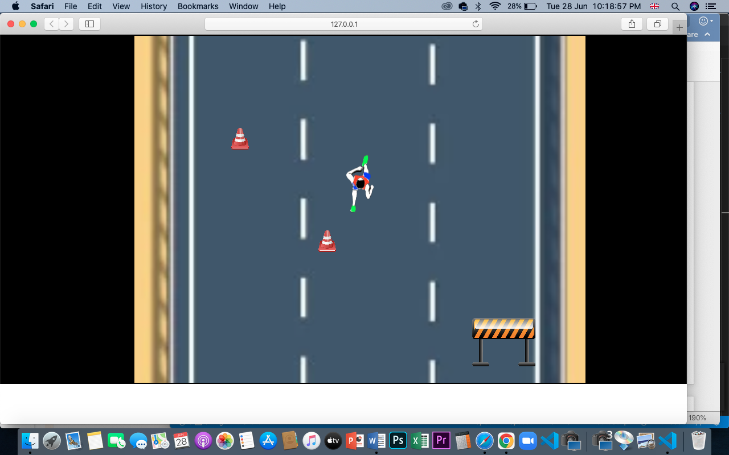

NPC-

Barrier-Cone-Police car-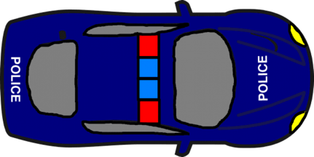

Pc-

Theif(Animation)- 

How do you plan to make your game engaging?

* Player will have to avoid the various obstacles by jumping over them or stepping aside
* Speed of the player increases as distance increases
* Background will change after certain intervals
* Player will have two lives