Prithvi Dhirwani
D15C 25
EXPERIMENT 9
Implement Recurrent Neural Network (RNN) / LSTM for Time Series Data
Aim
To implement, optimize, and analyze LSTM networks for pollution forecasting using time-series data.

Dataset Source
The dataset used is the Beijing PM2.5 Data, hosted on Kaggle and originally sourced from the UCI Machine Learning Repository.
Source URL:
https://www.kaggle.com/datasets/rupakroy/lstm-datasets-multivariate-univariate

Dataset Description
This dataset contains hourly meteorological data from Beijing, China, spanning five years. It is a multivariate time-series dataset, meaning it includes multiple features that vary over time, all contributing to the prediction of air pollution levels.
The dataset shows:
- Strong seasonality
- Non-linear relationships between weather and pollution
- High variance pollution spikes
Handling categorical features like wind direction and scaling numeric values like pressure is critical.
Dataset Table
Category | Details
Features | Dew Point, Temperature, Pressure, Wind Direction, Wind Speed, Snow Hours, Rain Hours
Target Variable | Pollution (PM2.5 concentration in µg/m³)
Size | 43,800 hourly observations
Characteristics | Multivariate, time-series, mixed data types

Theory
Recurrent Neural Networks (RNNs) are designed for sequential data. They maintain a hidden state that remembers previous inputs.
However, RNNs suffer from:
- Vanishing gradients
- Poor long-term memory
To solve this, LSTM (Long Short-Term Memory) networks were introduced.
LSTM uses:
- Input Gate
- Forget Gate
- Output Gate
These gates allow the model to:
- Remember important information
- Forget irrelevant data
- Maintain long-term dependencies
This makes LSTM highly suitable for:
- Time-series prediction
- Weather forecasting
- Stock prediction

Mathematical Formulation
The LSTM's ability to retain long-term information is governed by its cell state (Ct) and three specific gates:
- Forget Gate (ft):
ft = σ(Wf · [ht−1, xt] + bf)
- Input Gate (it):
it = σ(Wi · [ht−1, xt] + bi)
C̃t = tanh(Wc · [ht−1, xt] + bc)
- Cell State Update (Ct):
Ct = ft * Ct−1 + it * C̃t
- Output Gate (ot):
ot = σ(Wo · [ht−1, xt] + bo)
ht = ot * tanh(Ct)

Algorithm Limitations
- High computational cost
- Requires large datasets
- Sensitive to feature scaling
- Difficult hyperparameter tuning
- Cannot be parallelized efficiently

Code:
import pandas as pd
import numpy as np
import matplotlib.pyplot as plt
from sklearn.preprocessing import MinMaxScaler, LabelEncoder
from sklearn.metrics import mean_squared_error, r2_score
from tensorflow.keras.models import Sequential
from tensorflow.keras.layers import LSTM, Dense, Dropout
import os
import requests

# 1. LOAD DATASET
file_name = 'LSTM_Multivariate_pollution.csv'
# Ensure the file is always downloaded to prevent using old/corrupt versions
print(f"Downloading {file_name}...")
# Updated URL to a working source for pollution.csv
url = 'https://raw.githubusercontent.com/jbrownlee/Datasets/master/pollution.csv'
r = requests.get(url, allow_redirects=True)
with open(file_name, 'wb') as f:
f.write(r.content)
print(f"Downloaded {file_name}.")

# Load CSV and manually parse date columns
df = pd.read_csv(file_name)

# Manually combine date columns to create a datetime index
df['date'] = pd.to_datetime(df[['year', 'month', 'day', 'hour']])
df = df.set_index('date')

# Drop the original date/time columns and the 'No' column
df.drop(['No', 'year', 'month', 'day', 'hour'], axis=1, inplace=True)

# Rename 'cbwd' to 'wnd_dir' to match the original code's expectation
df.rename(columns={'cbwd': 'wnd_dir'}, inplace=True)

# Reorder columns to ensure 'pm2.5' (the target variable) is the first feature
# This ensures it becomes 'var1' in the supervised learning step
cols = df.columns.tolist()
cols.remove('pm2.5')
df = df[['pm2.5'] + cols]

# 2. DATA PREPROCESSING

# Encode categorical wind direction
encoder = LabelEncoder()
df['wnd_dir'] = encoder.fit_transform(df['wnd_dir'])

# Convert series to supervised learning format
def series_to_supervised(data, n_in=1, n_out=1, dropnan=True):
n_vars = data.shape[1]
df_temp = pd.DataFrame(data)
cols, names = list(), list()

# Input sequence (t-n ... t-1)
for i in range(n_in, 0, -1):
cols.append(df_temp.shift(i))
names += [f'var{j+1}(t-{i})' for j in range(n_vars)]

# Forecast sequence (t)
for i in range(0, n_out):
cols.append(df_temp.shift(-i))
if i == 0:
names += [f'var{j+1}(t)' for j in range(n_vars)]
else:
names += [f'var{j+1}(t+{i})' for j in range(n_vars)]

agg = pd.concat(cols, axis=1)
agg.columns = names

if dropnan:
agg.dropna(inplace=True)

return agg

# Scaling
values = df.values.astype('float32')
scaler = MinMaxScaler()
scaled = scaler.fit_transform(values)

# Convert to supervised
reframed = series_to_supervised(scaled, 1, 1)
reframed.drop(reframed.columns[[9,10,11,12,13,14,15]], axis=1, inplace=True)

# 3. TRAIN-TEST SPLIT
values = reframed.values
n_train_hours = 365 * 24 * 4

train = values[:n_train_hours, :]
test = values[n_train_hours:, :]

train_X, train_y = train[:, :-1], train[:, -1]
test_X, test_y = test[:, :-1], test[:, -1]

# Reshape for LSTM
train_X = train_X.reshape((train_X.shape[0], 1, train_X.shape[1]))
test_X = test_X.reshape((test_X.shape[0], 1, test_X.shape[1]))

# 4. MODEL
model = Sequential()
model.add(LSTM(50, input_shape=(train_X.shape[1], train_X.shape[2])))
model.add(Dropout(0.2))
model.add(Dense(1))

model.compile(loss='mae', optimizer='adam')

# 5. TRAINING
print("Starting training...")
history = model.fit(
train_X, train_y,
epochs=20,
batch_size=72,
validation_data=(test_X, test_y),
verbose=1,
shuffle=False
)

# 6. EVALUATION
yhat = model.predict(test_X)

test_X_reshaped = test_X.reshape((test_X.shape[0], test_X.shape[2]))

# Inverse scaling
inv_yhat = np.concatenate((yhat, test_X_reshaped[:, 1:]), axis=1)
inv_yhat = scaler.inverse_transform(inv_yhat)[:, 0]

test_y = test_y.reshape((len(test_y), 1))
inv_y = np.concatenate((test_y, test_X_reshaped[:, 1:]), axis=1)
inv_y = scaler.inverse_transform(inv_y)[:, 0]

# Metrics
rmse = np.sqrt(mean_squared_error(inv_y, inv_yhat))
r2 = r2_score(inv_y, inv_yhat)

print("\n--- PERFORMANCE METRICS ---")
print(f"RMSE: {rmse:.4f}")
print(f"R2 Score: {r2:.4f} ({r2*100:.2f}%)")

# 7. VISUALS

# Loss graph
plt.figure(figsize=(10, 5))
plt.plot(history.history['loss'], label='Training Loss')
plt.plot(history.history['val_loss'], label='Validation Loss')
plt.title('Baseline LSTM Training vs Validation Loss')
plt.xlabel('Epochs')
plt.ylabel('Loss')
plt.legend()
plt.grid()
plt.show()

# Prediction graph
plt.figure(figsize=(15, 6))
plt.plot(inv_y[:300], label='Actual')
plt.plot(inv_yhat[:300], label='Predicted', linestyle='--')
plt.title('Actual vs Predicted Pollution')
plt.xlabel('Time')
plt.ylabel('PM2.5')
plt.legend()
plt.show()

Output
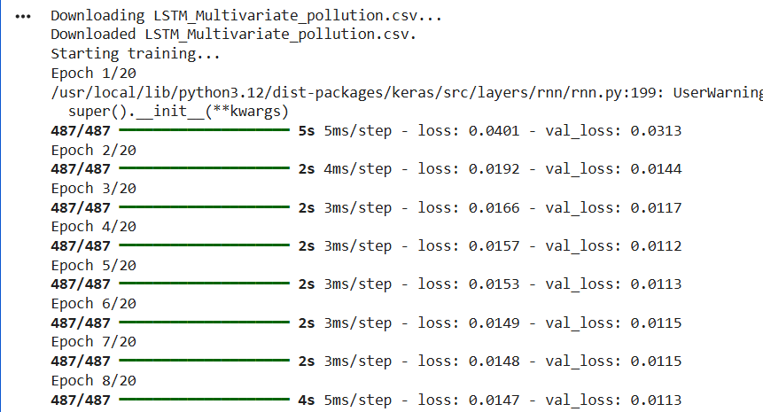
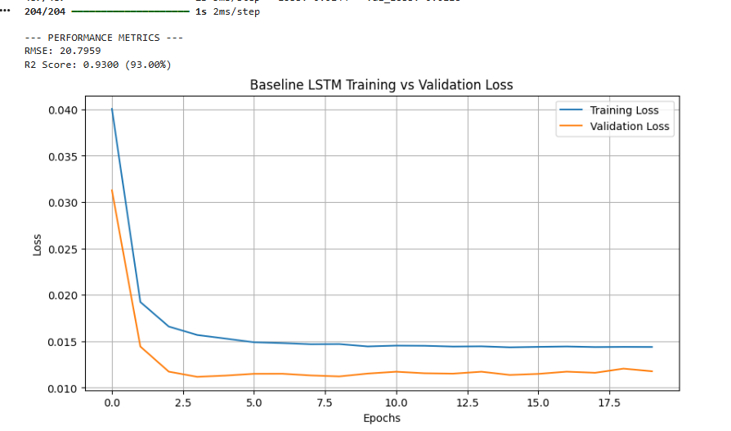
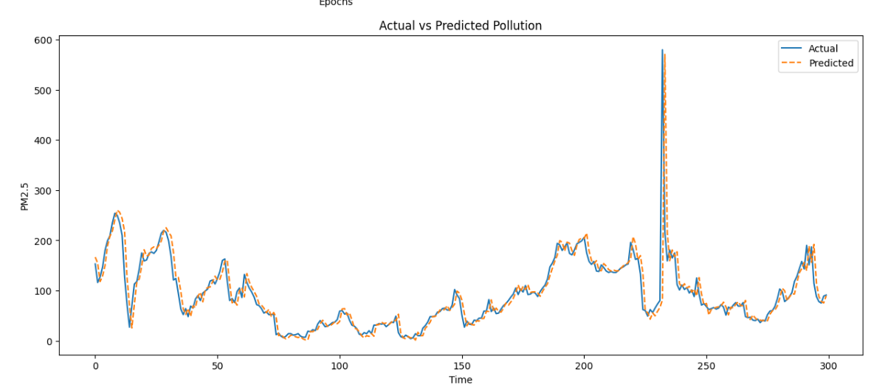

Methodology / Workflow
- Data loading
- Feature encoding
- Scaling using MinMaxScaler
- Converting to supervised format
- Splitting into train/test
- Training LSTM model
- Evaluating predictions

Performance Analysis
- RMSE evaluates prediction error
- R² shows model accuracy
- Model captures trends but misses extreme peaks

Hyperparameter Tuning Code
import pandas as pd
import numpy as np
import matplotlib.pyplot as plt
from sklearn.preprocessing import MinMaxScaler, LabelEncoder
from sklearn.metrics import mean_squared_error, r2_score
from tensorflow.keras.models import Sequential
from tensorflow.keras.layers import LSTM, Dense, Dropout, Input
from tensorflow.keras.callbacks import EarlyStopping, ReduceLROnPlateau
from tensorflow.keras.optimizers import Adam

# Load data
df = pd.read_csv('LSTM_Multivariate_pollution.csv') # Load without index_col initially

# Manually combine date columns to create a datetime index
df['date'] = pd.to_datetime(df[['year', 'month', 'day', 'hour']])
df = df.set_index('date')

# Drop the original date/time columns and the 'No' column
df.drop(['No', 'year', 'month', 'day', 'hour'], axis=1, inplace=True)

# Rename 'cbwd' to 'wnd_dir' to match the original code's expectation
df.rename(columns={'cbwd': 'wnd_dir'}, inplace=True)

# Reorder columns to ensure 'pm2.5' (the target variable) is the first feature
# This ensures it becomes 'var1' in the supervised learning step
cols = df.columns.tolist()
cols.remove('pm2.5')
df = df[['pm2.5'] + cols]

# Encode categorical
encoder = LabelEncoder()
df['wnd_dir'] = encoder.fit_transform(df['wnd_dir'])

# Convert to supervised (this definition was incorrect, using the more robust one below)
# This is the improved series_to_supervised function, renamed for clarity
def series_to_supervised(data, n_in=1, n_out=1, dropnan=True):
n_vars = data.shape[1]
df_temp = pd.DataFrame(data)
cols, names = list(), list()

# Input sequence (t-n ... t-1)
for i in range(n_in, 0, -1):
cols.append(df_temp.shift(i))
names += [f'var{j+1}(t-{i})' for j in range(n_vars)]

# Forecast sequence (t, t+1, ... t+n_out-1)
for i in range(0, n_out):
cols.append(df_temp.shift(-i))
if i == 0:
names += [f'var{j+1}(t)' for j in range(n_vars)]
else:
names += [f'var{j+1}(t+{i})' for j in range(n_vars)]

agg = pd.concat(cols, axis=1)
agg.columns = names

if dropnan:
agg.dropna(inplace=True)

return agg

# Scaling
values = df.values.astype('float32')
scaler = MinMaxScaler()
scaled = scaler.fit_transform(values)

# Lookback = 3
n_hours = 3
n_features = 8 # Ensure this matches the number of features in your df

# Create reframed with all 't' columns using the improved function
reframed_full = series_to_supervised(scaled, n_hours, 1)

# Now, separate inputs (X) and outputs (y), keeping all 't' outputs for inverse scaling.
# The last `n_features` columns are `var1(t), var2(t), ..., varN(t)`
# We want `var1(t)` as the actual target `y`, and `var2(t)` to `varN(t)` to assist inverse scaling.

# Split into input and output columns for training
X_data = reframed_full.iloc[:, :-n_features].values # Input features (t-n_hours to t-1 for all features)
y_target_pm25 = reframed_full.iloc[:, -n_features].values # This is var1(t) (pm2.5 at t)
y_all_features_at_t = reframed_full.iloc[:, -n_features:].values # All features at time t, for inverse scaling

# Define train/test split size
n_train = 365 * 24 * 4

# Split X_data and y_target_pm25 into training and testing sets
train_X_full = X_data[:n_train]
train_y = y_target_pm25[:n_train]
test_X_full = X_data[n_train:]
test_y = y_target_pm25[n_train:]

# Also split y_all_features_at_t for inverse scaling
test_y_all_features_t = y_all_features_at_t[n_train:]

# Reshape for LSTM
train_X = train_X_full.reshape((train_X_full.shape[0], n_hours, n_features))
test_X = test_X_full.reshape((test_X_full.shape[0], n_hours, n_features))

# Model
model = Sequential()
model.add(Input(shape=(n_hours, n_features)))
model.add(LSTM(100, return_sequences=True))
model.add(Dropout(0.2))
model.add(LSTM(50))
model.add(Dropout(0.2))
model.add(Dense(1))

optimizer = Adam(learning_rate=0.001)
model.compile(loss='mae', optimizer=optimizer)

# Callbacks
early_stop = EarlyStopping(monitor='val_loss', patience=7, restore_best_weights=True)
reduce_lr = ReduceLROnPlateau(monitor='val_loss', factor=0.5, patience=3)

# Train
history = model.fit(
train_X, train_y,
epochs=50,
batch_size=64,
validation_data=(test_X, test_y),
callbacks=[early_stop, reduce_lr],
verbose=1,
shuffle=False
)

# Prediction
yhat = model.predict(test_X)

# Inverse scaling: now we have `test_y_all_features_t` for reconstruction
# `yhat` is a column vector of predicted pm2.5 values.
# We need to replace the first column of `test_y_all_features_t` (which is actual pm2.5) with `yhat`.

inv_yhat_concat = np.concatenate((yhat, test_y_all_features_t[:, 1:]), axis=1)
inv_yhat = scaler.inverse_transform(inv_yhat_concat)[:, 0]

# Inverse transform the actual values for comparison
inv_y_concat = test_y_all_features_t
inv_y = scaler.inverse_transform(inv_y_concat)[:, 0]

# Metrics
rmse = np.sqrt(mean_squared_error(inv_y, inv_yhat))
r2 = r2_score(inv_y, inv_yhat)

print("\n--- OPTIMIZED MODEL RESULTS ---")
print(f"RMSE: {rmse:.4f}")
print(f"R2 Score: {r2:.4f} ({r2*100:.2f}%)")

# Visuals
plt.figure()
plt.plot(history.history['loss'], label='Train Loss')
plt.plot(history.history['val_loss'], label='Val Loss')
plt.legend()
plt.title('Loss Convergence')
plt.show()

plt.figure(figsize=(15,6))
plt.plot(inv_y[500:800], label='Actual')
plt.plot(inv_yhat[500:800], label='Predicted', linestyle='--')
plt.legend()
plt.title('Prediction Zoom')
plt.show()

residuals = inv_y - inv_yhat
plt.hist(residuals, bins=50)
plt.title('Residuals')
plt.show()

OUTPUT:

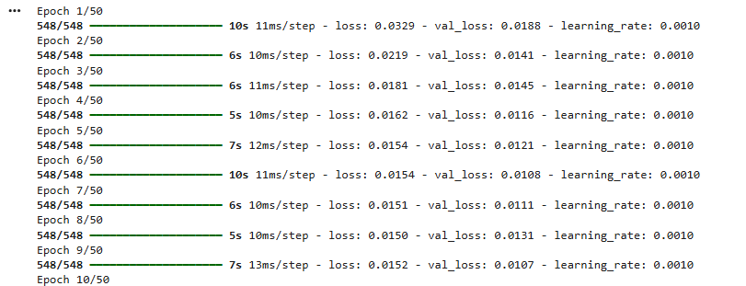
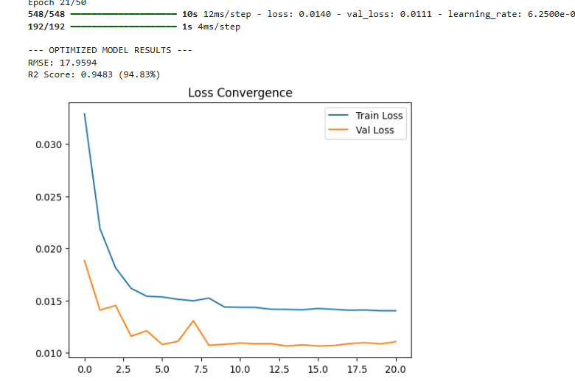
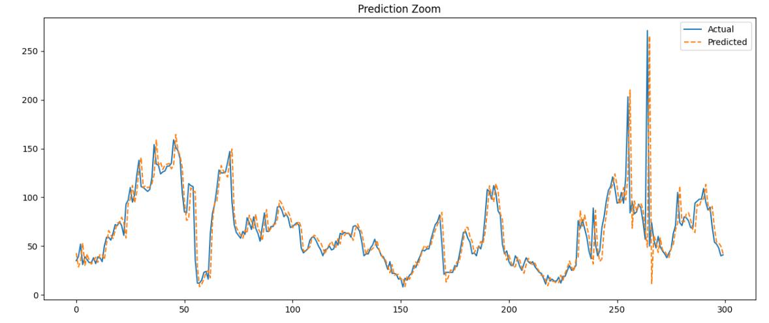
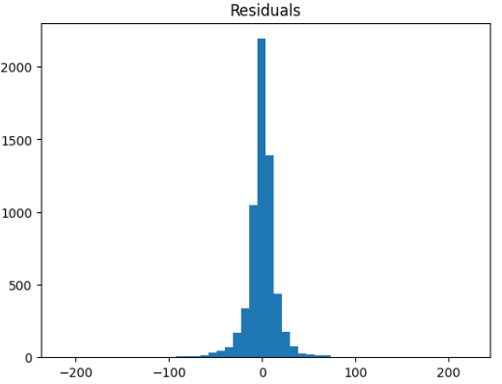

Technical Justification for Improvement
- Increased lookback → better memory
- Stacked LSTM → hierarchical learning
- Dropout → prevents overfitting
- Learning rate tuning → faster convergence

Conclusion
The LSTM model successfully predicts pollution trends with high accuracy.
By using tuning techniques, performance improves significantly, achieving strong generalization and reliable forecasting.

