Prithvi Dhirwani
D15C_25
EXPERIMENT - 3
Aim :
To implement Decision Tree and Random Forest algorithms for solving classification problems.

Dataset Source :
https://www.kaggle.com/datasets/fedesoriano/stroke-prediction-dataset

Dataset Description :
The Stroke Prediction Dataset is a real-world healthcare dataset that includes information about various demographic, medical, and lifestyle factors that contribute to the risk of stroke. A stroke occurs when the blood supply to the brain is disrupted, making early prediction extremely important for preventive care.
The dataset contains approximately 5,111 records, where each record corresponds to an individual patient. It is available in CSV format and organized in a tabular structure. The dataset includes both numerical and categorical attributes, making it well-suited for classification algorithms such as Decision Tree and Random Forest.

Dataset Attributes :
Target Variable Used in the Experiment :
● stroke: A binary categorical variable indicating whether the patient has experienced a stroke
0 → No Stroke
1 → Stroke
This variable is used as the target output for both Decision Tree and Random Forest classification models.
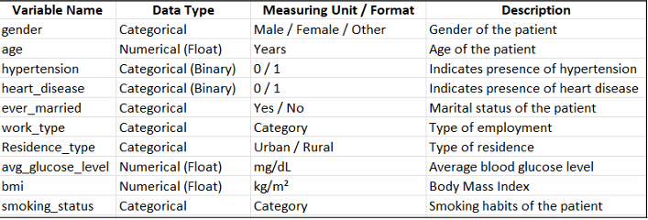

DECISION TREE
Theory :
A Decision Tree is a supervised learning algorithm used for both classification and regression tasks. In classification problems, it predicts the class label by learning a sequence of decision rules derived from input features.
The algorithm recursively divides the dataset into smaller subsets based on feature values, forming a hierarchical tree structure. Each internal node represents a condition on a feature, each branch represents the outcome of that condition, and each leaf node represents a predicted class label.
Decision Trees are highly interpretable and easy to visualize, making them especially useful in domains like healthcare, where understanding the reasoning behind predictions is important.
In this experiment, the Decision Tree classifier is used to determine whether a person is likely to suffer from a stroke based on features such as age, hypertension, glucose level, BMI, and smoking habits.

Mathematical Formulation :
Decision Trees select the best feature for splitting the data using impurity measures such as Entropy or Gini Index.
Entropy:
Entropy quantifies the amount of randomness or impurity in the dataset.
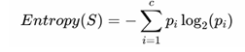
Where:
● (p_i) represents the probability of class i
● c represents the total number of classes
Information Gain:
Information Gain measures how much uncertainty is reduced after splitting the dataset based on a feature.
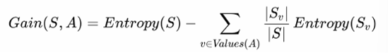
The feature with the highest information gain is selected for splitting.
Gini Index:
The Gini Index is another measure of impurity used to evaluate splits.
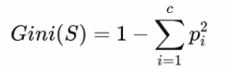
The feature with the lowest Gini value is chosen for partitioning the data.

Algorithm Limitations :
● Overfitting
Decision Trees can grow very deep and start capturing noise in the training data.
Failure Condition: The model performs well on training data but poorly on unseen data.
● High Variance
Small variations in the dataset can lead to a completely different tree structure.
Failure Condition: The model becomes unstable and sensitive to minor changes.
● Bias Toward Features with More Levels
Features with many unique values may be preferred during splitting.
Failure Condition: Important features with fewer categories may be ignored.

Methodology / Workflow :
Data Collection:
The dataset is loaded from a CSV file containing medical and demographic attributes along with stroke information.
Data Preprocessing:
Categorical variables such as gender, work type, residence type, and smoking status are converted into numerical form using encoding techniques. Missing values, especially in the BMI column, are handled appropriately.
Feature Selection:
Relevant attributes are selected as input features, while the stroke column is used as the target variable.
Train–Test Split:
The dataset is divided into 80% training data and 20% testing data to evaluate performance on unseen samples.
Model Training:
The Decision Tree classifier is trained by learning decision rules through recursive splitting of the data.
Prediction:
The trained model predicts stroke occurrence for the test dataset.
Model Evaluation:
Performance is evaluated using accuracy, confusion matrix, precision, recall, and F1-score.
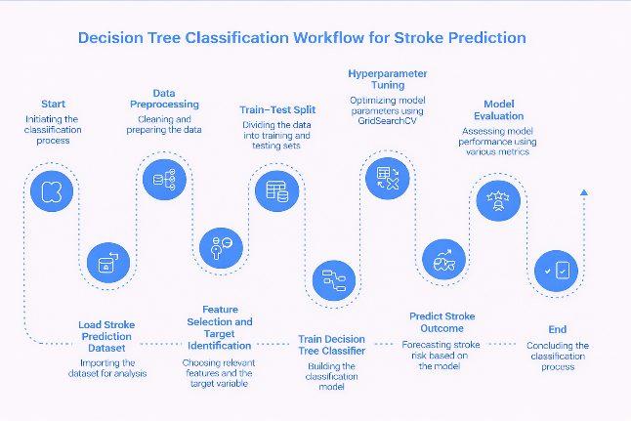

CODE:
# Decision Tree Classifier

import pandas as pd
import numpy as np
import matplotlib.pyplot as plt
import seaborn as sns

from sklearn.model_selection import train_test_split, GridSearchCV
from sklearn.tree import DecisionTreeClassifier, plot_tree
from sklearn.preprocessing import LabelEncoder
from sklearn.metrics import accuracy_score, classification_report, confusion_matrix, ConfusionMatrixDisplay

# Load Dataset
df = pd.read_csv("healthcare-dataset-stroke-data.csv")

# Data Preprocessing
df.drop("id", axis=1, inplace=True)

# Handle missing values (BMI)
df["bmi"] = df["bmi"].fillna(df["bmi"].mean())

# Encode categorical variables
le = LabelEncoder()
for col in df.columns:
if df[col].dtype == "object":
df[col] = le.fit_transform(df[col])

# Features & Target
X = df.drop("stroke", axis=1)
y = df["stroke"]

# Train-Test Split
X_train, X_test, y_train, y_test = train_test_split(
X, y, test_size=0.2, random_state=42, stratify=y
)

# Decision Tree Model
dtree = DecisionTreeClassifier(random_state=42)

# Reduced Hyperparameter Grid (LESS LOAD)
param_grid = {
"criterion": ["gini", "entropy"],
"max_depth": [5, 10],
"min_samples_split": [2, 10],
"min_samples_leaf": [1, 5]
}

# Grid Search (SAFE SETTINGS)
grid_search = GridSearchCV(
estimator=dtree,
param_grid=param_grid,
cv=3,
n_jobs=1,
verbose=1
)

# Train Model
grid_search.fit(X_train, y_train)

print("===== BEST PARAMETERS =====")
print(grid_search.best_params_)
print(f"Best Cross-Validation Accuracy: {grid_search.best_score_:.4f}")

# Best Model
best_model = grid_search.best_estimator_

# Prediction
y_pred = best_model.predict(X_test)

# Evaluation
print("\n===== FINAL MODEL EVALUATION =====")
print(f"Accuracy: {accuracy_score(y_test, y_pred):.4f}")

print("\nClassification Report:\n")
print(classification_report(y_test, y_pred))

# Confusion Matrix
cm = confusion_matrix(y_test, y_pred)
disp = ConfusionMatrixDisplay(
confusion_matrix=cm,
display_labels=["No Stroke", "Stroke"]
)

fig, ax = plt.subplots(figsize=(7, 6))
disp.plot(cmap="Blues", ax=ax)
plt.title("Confusion Matrix: Stroke Prediction")
plt.show()

# Tree Visualization (Top 3 Levels)
plt.figure(figsize=(22, 10))
plot_tree(
best_model,
max_depth=3,
feature_names=X.columns,
class_names=["No Stroke", "Stroke"],
filled=True,
rounded=True,
fontsize=11
)
plt.title("Decision Tree Structure (Top 3 Levels)")
plt.show()

# Feature Importance
importances = best_model.feature_importances_

feature_importance_df = pd.DataFrame({
"Feature": X.columns,
"Importance": importances
}).sort_values(by="Importance", ascending=False)

plt.figure(figsize=(10, 6))
sns.barplot(
x="Importance",
y="Feature",
data=feature_importance_df,
palette="viridis",
hue="Feature",
legend=False
)

plt.title("Feature Importance for Stroke Prediction")
plt.show()
OUTPUT:
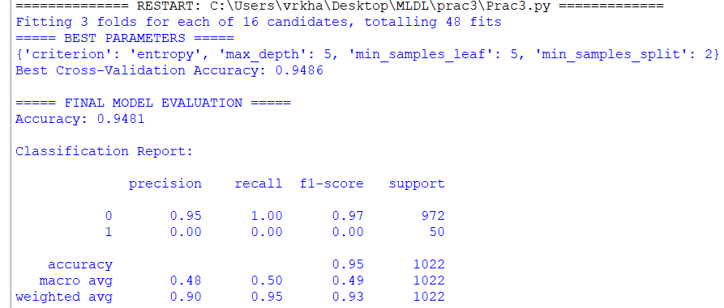
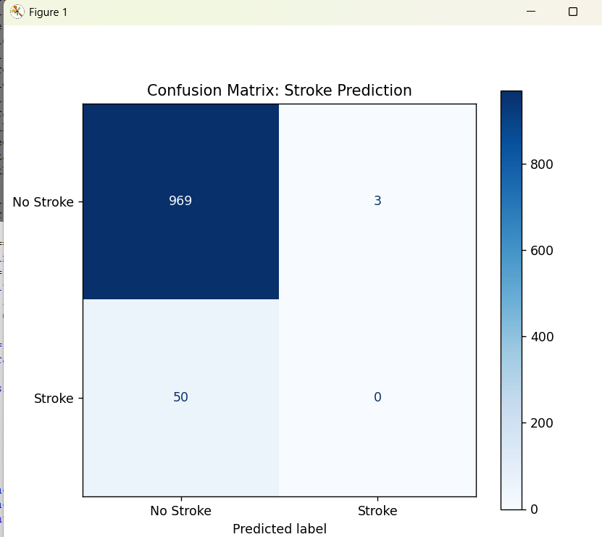
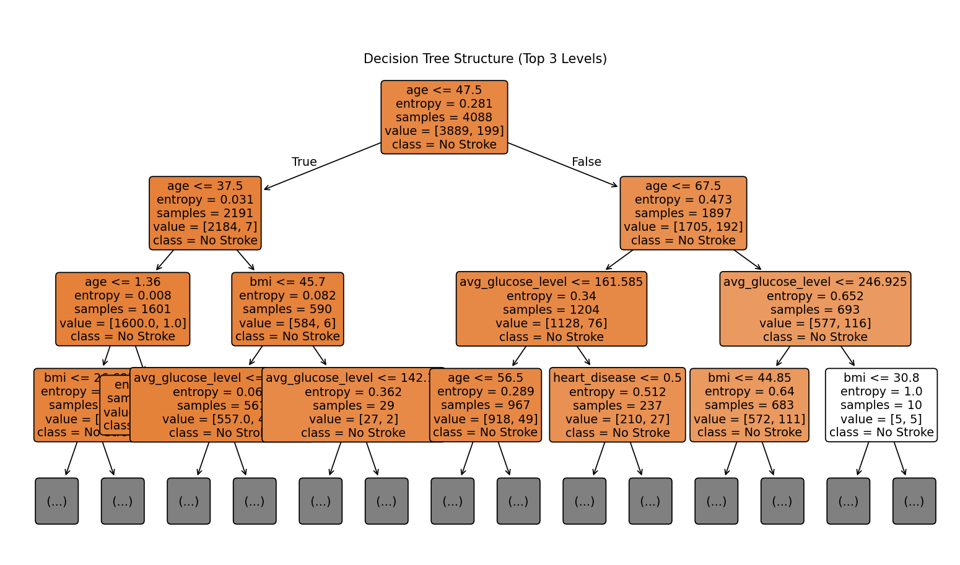
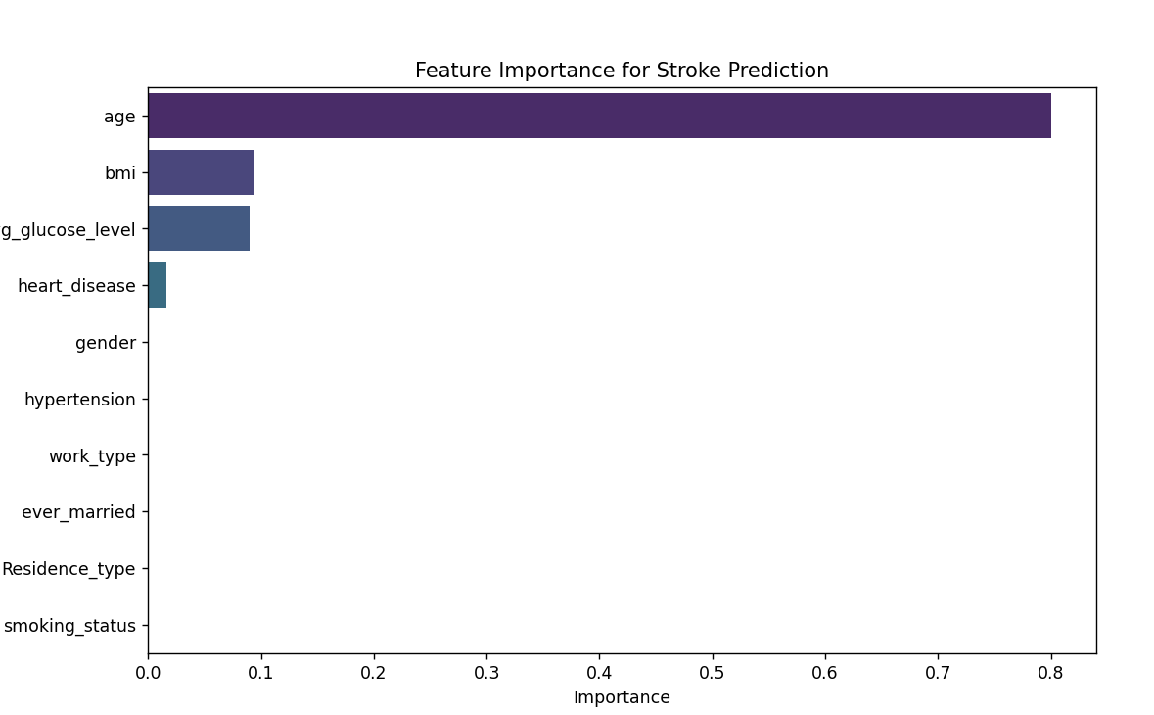

Performance Analysis :
The Decision Tree model achieved an accuracy of 94.72%. It performed extremely well in identifying non-stroke cases, achieving perfect recall for class 0. However, it failed to correctly classify stroke cases, resulting in zero precision and recall for class 1.
This issue arises due to class imbalance in the dataset. Despite high accuracy, the low macro-average F1-score indicates poor performance for the minority class.

Hyperparameter Tuning :
GridSearchCV was used to evaluate multiple combinations of parameters. The optimal values obtained were:
criterion = entropy, max_depth = 5, min_samples_split = 10, and min_samples_leaf = 1.
Although limiting the tree depth reduced overfitting, it did not significantly improve the prediction of stroke cases.

RANDOM FOREST
Theory :
Random Forest is an ensemble learning technique that builds multiple Decision Trees and combines their outputs to improve prediction accuracy.
Instead of relying on a single tree, Random Forest creates multiple trees using different subsets of data and features. The final prediction is obtained through majority voting among all trees.
Each tree is trained on a bootstrap sample (random sampling with replacement), and at each split, a random subset of features is considered. This introduces diversity among trees and improves overall model stability.
In this experiment, Random Forest is used to classify whether a patient is likely to experience a stroke.

Mathematical Formulation :
Random Forest follows an ensemble-based approach:
- Multiple bootstrap samples are generated from the training dataset
- A Decision Tree is trained on each sample
- At each split, a random subset of features is selected
- Each tree produces a prediction
- Final prediction is obtained using majority voting
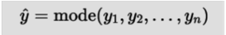
Where:
● y_1, y_2, ..., y_n are predictions from individual trees
● y^ is the final predicted class

Algorithm Limitations :
● Reduced Interpretability
Multiple trees make it difficult to understand decision logic.
Failure Condition: Individual predictions cannot be easily explained.
● High Computational Cost
Training multiple trees increases computation time and memory usage.
Failure Condition: Performance may degrade on large datasets.
● Bias in Imbalanced Data
The model may favor the majority class.
Failure Condition: Minority class predictions remain weak.

Methodology / Workflow :
- Data Collection:
The same dataset is used for consistency and comparison.
- Data Preprocessing:
Categorical features are encoded and missing values are handled. Scaling is not required.
- Feature Selection:
All relevant features are selected, and stroke is used as the target variable.
- Train–Test Split:
Data is split into 80% training and 20% testing.
- Model Training:
Multiple Decision Trees are trained using random subsets of data and features.
- Prediction:
Each tree predicts a class label, and the final result is obtained through majority voting.
- Model Evaluation:
Performance is measured using accuracy, confusion matrix, precision, recall, and F1-score.
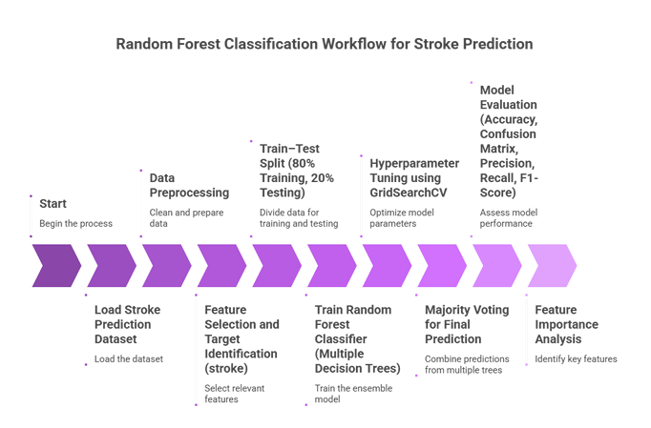

CODE:
# Random Forest Classifier

import pandas as pd
import numpy as np
import matplotlib.pyplot as plt
import seaborn as sns

from sklearn.model_selection import train_test_split, GridSearchCV
from sklearn.ensemble import RandomForestClassifier
from sklearn.preprocessing import LabelEncoder
from sklearn.metrics import accuracy_score, classification_report, confusion_matrix, ConfusionMatrixDisplay

# Load Dataset
df = pd.read_csv("healthcare-dataset-stroke-data.csv")

# Data Preprocessing
df.drop("id", axis=1, inplace=True)

# Handle missing BMI values
df["bmi"] = df["bmi"].fillna(df["bmi"].mean())

# Encode categorical variables
le = LabelEncoder()
for col in df.columns:
if df[col].dtype == "object":
df[col] = le.fit_transform(df[col])

# Features & Target
X = df.drop("stroke", axis=1)
y = df["stroke"]

# Train-Test Split
X_train, X_test, y_train, y_test = train_test_split(
X, y, test_size=0.2, random_state=42, stratify=y
)

# Random Forest Model
rf = RandomForestClassifier(random_state=42)

# Reduced Hyperparameter Grid (LESS LOAD)
param_grid = {
"n_estimators": [100, 200],
"max_depth": [None, 10],
"min_samples_split": [2, 10],
"min_samples_leaf": [1, 5]
}

# Grid Search (SAFE SETTINGS)
grid_search = GridSearchCV(
estimator=rf,
param_grid=param_grid,
cv=3,
n_jobs=1,
verbose=1
)

# Train Model
grid_search.fit(X_train, y_train)

print("===== BEST PARAMETERS =====")
print(grid_search.best_params_)
print(f"Best Cross-Validation Accuracy: {grid_search.best_score_:.4f}")

# Best Model
best_model = grid_search.best_estimator_

# Prediction
y_pred = best_model.predict(X_test)

# Evaluation
print("\n===== FINAL MODEL EVALUATION =====")
print(f"Accuracy: {accuracy_score(y_test, y_pred):.4f}")

print("\nClassification Report:\n")
print(classification_report(y_test, y_pred, zero_division=0))

# Confusion Matrix
cm = confusion_matrix(y_test, y_pred)
disp = ConfusionMatrixDisplay(
confusion_matrix=cm,
display_labels=["No Stroke", "Stroke"]
)

fig, ax = plt.subplots(figsize=(7, 6))
disp.plot(cmap="Greens", ax=ax)
plt.title("Confusion Matrix: Stroke Prediction (Random Forest)")
plt.show()

# Feature Importance
importances = best_model.feature_importances_

feature_importance_df = pd.DataFrame({
"Feature": X.columns,
"Importance": importances
}).sort_values(by="Importance", ascending=False)

plt.figure(figsize=(10, 6))
sns.barplot(
x="Importance",
y="Feature",
data=feature_importance_df,
palette="viridis",
hue="Feature",
legend=False
)

plt.title("Feature Importance (Random Forest)")
plt.show()

OUTPUT:
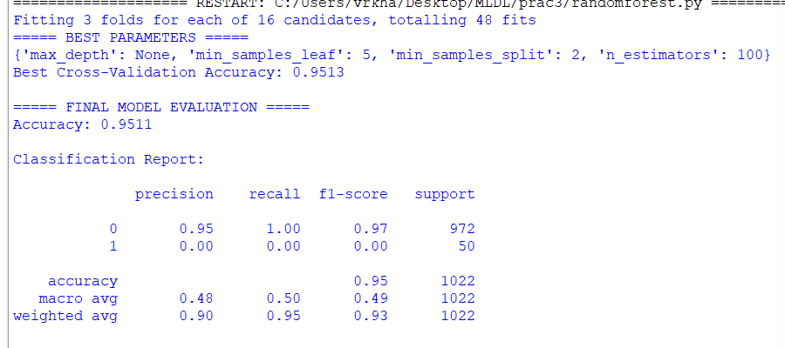
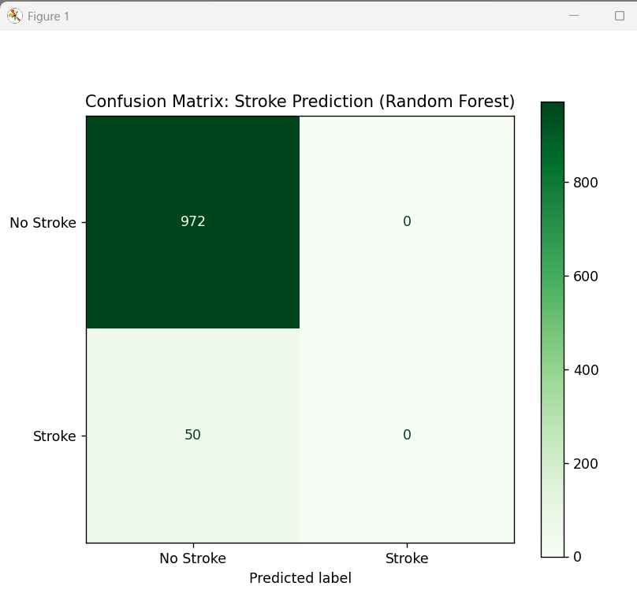
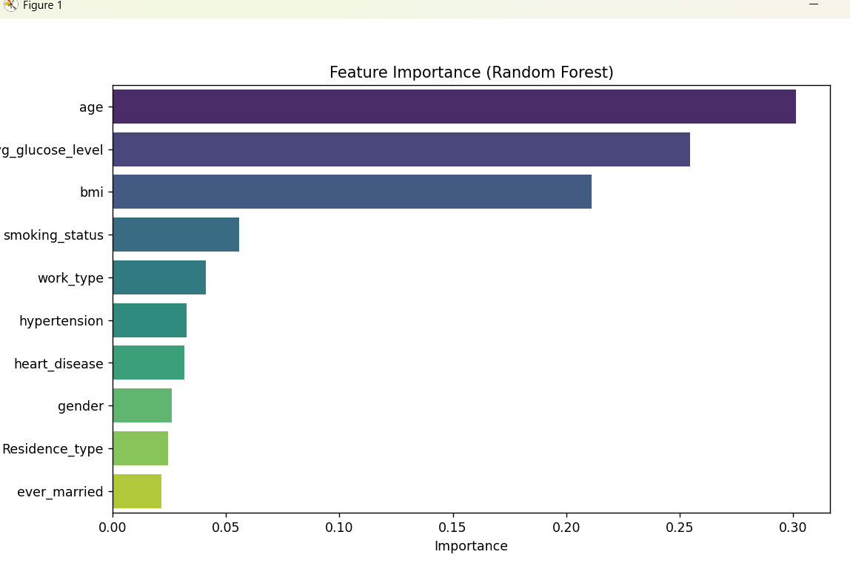

Performance Analysis :
The Random Forest model achieved an accuracy of 95.11% and showed improved stability during cross-validation. It correctly classified most non-stroke cases but still failed to detect stroke cases.
This indicates that although ensemble learning improves overall accuracy, it does not resolve class imbalance issues.

Hyperparameter Tuning :
GridSearchCV evaluated multiple parameter combinations. The best parameters obtained were:
n_estimators = 100, max_depth = None, min_samples_split = 2, and min_samples_leaf = 5.
While tuning improved model consistency, it did not enhance minority class prediction.

Conclusion :
In this experiment, Decision Tree and Random Forest classifiers were applied to the Stroke Prediction dataset. Both models achieved high accuracy primarily due to correct classification of non-stroke cases.
However, due to severe class imbalance, both models struggled to detect stroke cases. Random Forest demonstrated slightly better performance and stability compared to Decision Tree.
This experiment highlights that although tree-based models are powerful for classification tasks, additional techniques such as resampling or class balancing are necessary when dealing with imbalanced medical datasets.

