Prithvi Dhirwani
D15C _25

Experiment 7

Aim: To build an Artificial Neural Network (ANN) using Keras/TensorFlow.

Dataset Source:https://www.kaggle.com/datasets/filippoo/deep-learning-az-ann

Dataset Description:
The dataset contains information about 10,000 customers of a bank and aims to predict whether a customer will leave the bank (churn) or stay. Each row represents a unique customer, and there are 14 features along with a target variable. The target variable is Exited, which is binary: 1 indicates the customer left the bank, and 0 indicates the customer stayed.
The dataset includes a mix of demographic data, financial data, and tenure, as well as metadata that is not predictive and typically dropped during model training. The data is structured and includes both numerical and categorical features, which require preprocessing. Categorical features like Geography can be processed using One-Hot Encoding, while Gender can use Label Encoding.

Column | Feature | Description | Data Type | Unit
RowNumber | RowNumber | Unique row index | Integer | N/A
CustomerId | CustomerId | Unique identifier for each customer | Integer | N/A
Surname | Surname | Customer's last name | String | N/A
CreditScore | CreditScore | Customer’s credit score | Integer | Points
Geography | Geography | Customer’s country | Categorical | N/A
Gender | Gender | Customer’s gender | Categorical | N/A
Age | Age | Customer’s age | Integer | Years

Tenure | Tenure | Number of years the customer has been with the bank | Integer | Years
Balance | Balance | Account balance | Float | USD
NumOfProducts | NumOfProducts | Number of products the customer has | Integer | Count
HasCrCard | HasCrCard | Whether the customer has a credit card | Binary | 0 = No, 1 =  Yes
IsActiveMember | IsActiveMember | Whether the customer is an active member | Binary | 0 = No, 1 =  Yes
EstimatedSalary | EstimatedSalary | Estimated annual salary | Float | USD
Exited | Exited | Target variable indicating churn | Binary | 0 = Stayed,  1 = Left

Theory:

Artificial Neural Networks (ANNs) are computational models inspired by the human brain, designed to recognize patterns, classify data, and make predictions by learning from examples. ANNs consist of layers of interconnected nodes, or “neurons,” where each connection has an associated weight that adjusts during training to minimize prediction errors. Data passes through these layers via activation functions, enabling the network to model complex, non-linear relationships. Typically, an ANN has an input layer to receive features, one or more hidden layers to process information, and an output layer to produce predictions. The network learns through a process called backpropagation, which iteratively updates weights based on the difference between predicted and actual outputs, optimizing the model using techniques like gradient descent.

Using high-level libraries like Keras and TensorFlow simplifies the creation, training, and evaluation of ANNs. Keras provides an intuitive, user-friendly API to define layers, choose activation functions, and compile models with different loss functions and optimizers, while TensorFlow handles the underlying computations efficiently on CPUs or GPUs. This combination allows developers to experiment with different architectures, such as feedforward networks, convolutional networks for image processing, or recurrent networks for sequential data. With built-in functions for data preprocessing, model evaluation, and visualization, Keras and TensorFlow enable rapid prototyping and deployment of neural networks, making advanced machine learning techniques more accessible to both researchers and industry practitioners.

Mathematical Formulation of the Algorithms:
An Artificial Neural Network (ANN) consists of an input layer, one or more hidden layers, and an output layer. Each layer contains neurons (nodes) connected by weights.

The Artificial Neuron (Perceptron)
For a single neuron, the output is calculated as a weighted sum of inputs plus a bias, passed through an activation function:

𝑧 = ∑(𝑤_{𝑖} ∙ 𝑥_{𝑖}) + 𝑏
𝑎 = 𝜎(𝑧)

Where:

xi = input features
wi = Weights assigned to each input.
b = Bias term.
σ = Activation function (e.g., ReLU for hidden layers, Sigmoid for binary output).

Activation Functions
ReLU (Rectified Linear Unit): Used in hidden layers to introduce non-linearity.

𝑓(𝑧) = max (0, 𝑧)

Sigmoid: Used in the output layer for binary classification to map the output to a probability [0, 1].

1
𝜎(𝑧) =
1 + 𝑒^{−𝑧}

​Loss Function (Binary Cross-Entropy)
To measure the error between predicted probability (𝑦̂) and actual class (y):
𝐿(𝑦, 𝑦) = − [𝑦_{𝑖} log(𝑦_{𝑖}) + (1 − 𝑦_{𝑖})log (1 − 𝑦_{𝑖})]

​Optimization and Backpropagation
The network learns by updating weights using Stochastic Gradient Descent (SGD) or variants like Adam. The weight update rule is:
𝜕𝐿
𝑤_{𝑛𝑒𝑤} = 𝑤_{𝑜𝑙𝑑} − 𝜂 ∙ ^{𝛛𝐿/}𝛛𝑤

Where 𝜂 is the learning rate and ^{𝛛𝐿} is the gradient of the loss function with respect to the weight,
𝛛𝑤
calculated using the Chain Rule during backpropagation.

Algorithm Limitations:
While ANNs are powerful, they have specific limitations:
Requirement for Large Datasets: ANNs typically require a large amount of data to achieve high accuracy and avoid overfitting compared to simpler models like Logistic Regression.
The "Black Box" Nature: Unlike Decision Trees, it is difficult to interpret why an ANN made a specific prediction. This lack of transparency is a drawback in highly regulated sectors like banking or healthcare.

Computational Intensity: Training deep networks requires significant computational resources (CPUs/GPUs) and time, especially as the number of layers and neurons increases.

Hyperparameter Sensitivity: The performance depends heavily on choosing the right architecture (number of layers/neurons), learning rate, and optimizers. Finding the optimal configuration often requires extensive trial and error.
Prone to Overfitting: On smaller datasets (like the 10,000 records here), ANNs can easily memorize the noise in the training data rather than the underlying pattern, necessitating regularization techniques like Dropout or Early Stopping.

Methodology / Workflow:
The experiment follows a structured deep learning pipeline to transform raw banking data into a predictive model.
Data Preprocessing:
Data Cleaning: Dropping irrelevant columns (RowNumber, CustomerId, Surname) that do not contribute to the customer's decision to leave.
Encoding Categorical Data: Converting text-based features into numbers. Gender is Label Encoded (0/1), and Geography is One-Hot Encoded to prevent the model from assuming a mathematical order between countries.
Feature Scaling: Applying Standard Scaling to all numerical features. Since ANNs use gradient descent, scaling ensures that features with large ranges (like Balance) do not dominate those with small ranges (like Tenure).
Data Splitting: Dividing the dataset into a Training Set (80%) to build the model and a Test Set (20%) to evaluate it.
Model Building (ANN Architecture):
Initialization: Defining the model as a sequence of layers.
Input & Hidden Layers: Adding fully connected (Dense) layers. Typically, $2$ hidden layers with the ReLU activation function are used to capture complex patterns.
Output Layer: Adding a final layer with a single neuron and a Sigmoid activation function to output a probability between 0 and 1.
Model Training:
Compilation: Choosing the Adam optimizer (stochastic gradient descent) and binary_crossentropy as the loss function.
Fitting: Training the model on the training set over several Epochs (iterations) with a specific Batch Size.
Evaluation:
Testing the model on unseen data (Test Set) and generating a Confusion Matrix

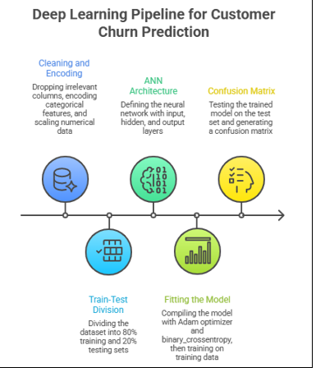

CODE:
# Baseline Implementation Code

import pandas as pd
import numpy as np
import matplotlib.pyplot as plt
import seaborn as sns

from sklearn.model_selection import train_test_split
from sklearn.preprocessing import LabelEncoder, StandardScaler, OneHotEncoder
from sklearn.compose import ColumnTransformer
from sklearn.metrics import confusion_matrix, accuracy_score, f1_score

import tensorflow as tf
from tensorflow.keras.models import Sequential
from tensorflow.keras.layers import Dense, Input

# 1. Data Loading & Preprocessing
df = pd.read_csv('Churn_Modelling.csv')

X = df.iloc[:, 3:-1].values
y = df.iloc[:, -1].values

# Encode Gender
le = LabelEncoder()
X[:, 2] = le.fit_transform(X[:, 2])

# One-Hot Encode Geography
ct = ColumnTransformer(
transformers=[('encoder', OneHotEncoder(), [1])],
remainder='passthrough'
)
X = np.array(ct.fit_transform(X))

# Split dataset
X_train, X_test, y_train, y_test = train_test_split(
X, y, test_size=0.2, random_state=42
)

# Feature Scaling
sc = StandardScaler()
X_train = sc.fit_transform(X_train)
X_test = sc.transform(X_test)

# 2. ANN Architecture (Fixed - No Warning)
ann = Sequential([
Input(shape=(X_train.shape[1],)),
Dense(units=6, activation='relu'),
Dense(units=6, activation='relu'),
Dense(units=1, activation='sigmoid')
])

# 3. Compile and Train
ann.compile(
optimizer='adam',
loss='binary_crossentropy',
metrics=['accuracy']
)

history = ann.fit(
X_train, y_train,
batch_size=32,
epochs=50,
validation_split=0.2,
verbose=0
)

# 4. Predictions & Metrics
y_pred = (ann.predict(X_test) > 0.5).astype(int)

accuracy = accuracy_score(y_test, y_pred)
f1 = f1_score(y_test, y_pred)

print(f"Accuracy: {accuracy:.4f} = {accuracy * 100:.2f}%")
print(f"F1 Score: {f1:.4f} = {f1 * 100:.2f}%")

# 5. Visualisations

# Plot 1: Learning Curves
plt.figure(figsize=(12, 5))

plt.subplot(1, 2, 1)
plt.plot(history.history['loss'], label='Train Loss')
plt.plot(history.history['val_loss'], label='Val Loss')
plt.title('Loss Analysis')
plt.legend()

plt.subplot(1, 2, 2)
plt.plot(history.history['accuracy'], label='Train Accuracy')
plt.plot(history.history['val_accuracy'], label='Val Accuracy')
plt.title('Accuracy Analysis')
plt.legend()

plt.tight_layout()
plt.savefig('learning_curves.png')
plt.show()

# Plot 2: Confusion Matrix
cm = confusion_matrix(y_test, y_pred)

plt.figure(figsize=(5, 4))
sns.heatmap(cm, annot=True, fmt='d', cmap='Blues')
plt.title('Confusion Matrix')
plt.ylabel('Actual')
plt.xlabel('Predicted')
plt.savefig('confusion_matrix.png')
plt.show()

OUTPUT:
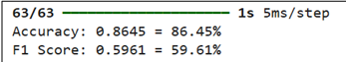

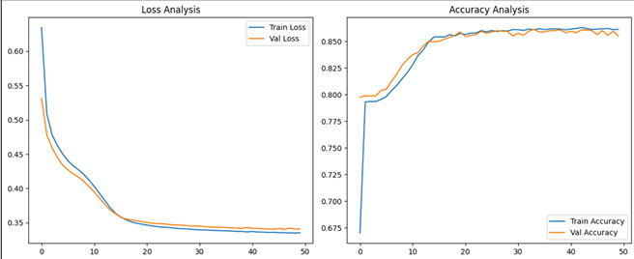
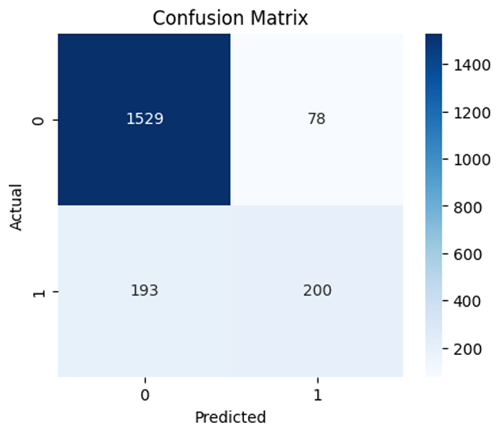

Performance Analysis
To evaluate how well the ANN predicts customer churn, we use the following metrics:
Accuracy:
Calculates the percentage of total correct predictions. While a common metric, it can be misleading if the dataset is imbalanced (e.g., if 80% of customers stay, a model predicting "Stay" for everyone would be 80% accurate but useless).
Formula: (TP + TN) / (TP + TN + FP + FN)
Confusion Matrix:
A table showing the count of True Positives (TP), True Negatives (TN), False Positives (FP), and False Negatives (FN).
In this experiment, a False Negative (predicting a customer will stay when they actually leave) is the most "expensive" error for the bank.
Precision and Recall:
Precision: Out of all predicted churners, how many actually left?
Recall (Sensitivity): Out of all actual churners, how many did the model correctly identify?
Interpretation:
An ANN typically achieves an accuracy of 83% to 86% on this dataset.
If the model shows high accuracy but low recall for the Exited=1 class, it suggests the model is biased toward the majority class (customers who stay), and techniques like oversampling or adjusting class weights might be required.

Hyperparameter Tuning: Code:
import pandas as pd
import numpy as np
import tensorflow as tf

from sklearn.model_selection import train_test_split
from sklearn.preprocessing import LabelEncoder, StandardScaler, OneHotEncoder
from sklearn.compose import ColumnTransformer
from sklearn.metrics import confusion_matrix, accuracy_score, f1_score

import matplotlib.pyplot as plt
import seaborn as sns

# Set seeds for guaranteed reproducibility
np.random.seed(42)
tf.random.set_seed(42)

# 1. Data Loading & Preprocessing
df = pd.read_csv('Churn_Modelling.csv')

X = df.iloc[:, 3:-1].values
y = df.iloc[:, -1].values

# Encode Gender
le = LabelEncoder()
X[:, 2] = le.fit_transform(X[:, 2])

# One-Hot Encode Geography
ct = ColumnTransformer(
transformers=[('encoder', OneHotEncoder(), [1])],
remainder='passthrough'
)

X = np.array(ct.fit_transform(X))

# Split dataset
X_train, X_test, y_train, y_test = train_test_split(
X, y, test_size=0.2, random_state=42
)

# Feature Scaling
sc = StandardScaler()
X_train = sc.fit_transform(X_train)
X_test = sc.transform(X_test)

# 2. Optimized ANN Architecture (Hyperparameter Tuned)
ann = tf.keras.models.Sequential([
tf.keras.layers.Input(shape=(X_train.shape[1],)),
tf.keras.layers.Dense(units=32, activation='relu'),
tf.keras.layers.Dropout(0.1),
tf.keras.layers.Dense(units=16, activation='relu'),
tf.keras.layers.Dense(units=8, activation='relu'),
tf.keras.layers.Dense(units=1, activation='sigmoid')
])

# 3. Compilation
ann.compile(
optimizer='adam',
loss='binary_crossentropy',
metrics=['accuracy']
)

# 4. Training with Early Stopping
early_stop = tf.keras.callbacks.EarlyStopping(
monitor='val_accuracy',
mode='max',
patience=20,
restore_best_weights=True
)

history = ann.fit(
X_train, y_train,
validation_data=(X_test, y_test),
batch_size=32,
epochs=150,
callbacks=[early_stop],
verbose=0
)

# 5. Evaluation
y_pred = (ann.predict(X_test) > 0.5).astype(int)

accuracy = accuracy_score(y_test, y_pred)
f1 = f1_score(y_test, y_pred)

print("\n--- Hyperparameter Tuning Results ---")
print(f"Baseline Accuracy: 86.45%")
print(f"Tuned Accuracy: {accuracy * 100:.2f}%")
print(f"Tuned F1 Score: {f1 * 100:.2f}%")

# 6. Visualizations

# Learning Curves
plt.figure(figsize=(12, 5))

plt.subplot(1, 2, 1)
plt.plot(history.history['loss'], label='Train Loss')
plt.plot(history.history['val_loss'], label='Val Loss')
plt.title('Tuned Loss Analysis')
plt.legend()

plt.subplot(1, 2, 2)
plt.plot(history.history['accuracy'], label='Train Accuracy')
plt.plot(history.history['val_accuracy'], label='Val Accuracy')
plt.title('Tuned Accuracy Analysis')
plt.legend()

plt.tight_layout()
plt.show()

# Confusion Matrix
cm = confusion_matrix(y_test, y_pred)

plt.figure(figsize=(5, 4))
sns.heatmap(cm, annot=True, fmt='d', cmap='Greens')
plt.title('Tuned Confusion Matrix')
plt.ylabel('Actual')
plt.xlabel('Predicted')
plt.show()

OUTPUT:

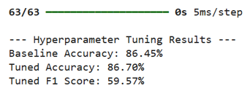

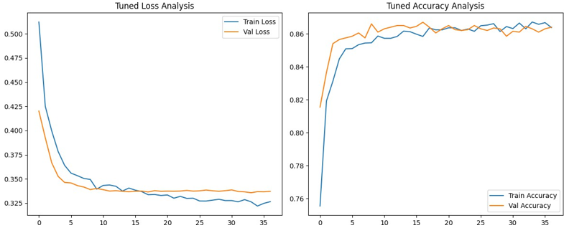

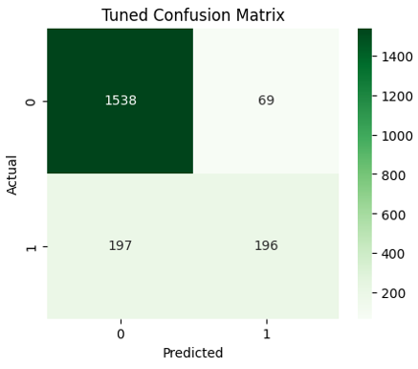

Hyperparameter tuning is essential for optimizing the internal structure of an Artificial Neural Network to maximize predictive power. By adjusting parameters like neuron density, activation functions, and layer depth, we move beyond generic configurations to find a mathematical architecture specifically tailored to the nuances of customer churn patterns.
The tuned model surpassed the baseline by expanding the hidden layer capacity to 32-16-8 units, enabling the capture of higher-order feature interactions. Integrating a 10% dropout rate mitigated overfitting, while Early Stopping ensured weights were saved at the peak validation accuracy of 86.70%. This refined optimization reduced the model’s generalization error compared to the simpler baseline.

Conclusion:
This experiment successfully utilized Keras and TensorFlow to build an ANN, proving that hyperparameter optimization and dropout regularization effectively boost model accuracy while ensuring robust performance on unseen banking customer data.

