**Batch: A2 Roll No.: 1611023**

**Experiment / assignment / tutorial No.__7__**

**Grade: AA / AB / BB / BC / CC / CD /DD**

**Signature of the Staff In-charge with date**

|  |
| --- |
| **Batch: A2 Roll No.: 1611023 Experiment / Assignment / Tutorial No.: 7** |

|  |
| --- |
| **Title: Installation & configuration of SQUID Proxy Server.** |

**Objective:**

1. To install & configureSQUID Proxy Server.
2. To understand the functioning of a SQUID Proxyserver.

**_____________________________________________________________________________**

**Expected Outcome of Experiment:**

CO3. Manage the configurations by using network administration tools.

**___________________________________________________________________________**

**Books/ Journals/ Websites referred:**

1. Linux Lab - Open source Technology :Ambavade –Dreamtech.
2. https://help.ubuntu.com/lts/serverguide/squid.html
3. www.squid-cache.org

**____________________________________________________________________________**

**Pre Lab/ Prior Concepts:**

Basics of computer networks, open source technology.

______________________________________________________________________________

**New Concepts to be learned:**

______________________________________________________________________________

**Introduction:**

Squid is a Unix-based proxy server that caches Internet content closer to a requestor than its original point of origin. Squid supports caching of many different kinds of Web objects, including those accessed through HTTP and FTP. Caching frequently requested Web pages, media files and other content accelerates response time and reduces bandwidth congestion.

A Squid proxy server is generally installed on a separate server than the Web server with the original files. Squid works by tracking object use over the network. Squid will initially act as an intermediary, simply passing the client's request on to the server and saving a copy of the requested object. If the same client or multiple clients request the same object before it expires from Squid's cache, Squid can then immediately serve it, accelerating the download and saving bandwidth.

Squid is provided as free, open source software and can be used under the GNU General Public License (GPL) of the Free Software Foundation. Squid was originally designed to run on Unix-based systems but can also be run on Windows machines.

**Implementation details:**

1. Server Side Configuration

**Setting Squid server to listen on TCP port 8888 instead of the default TCP**

**port 3128:**

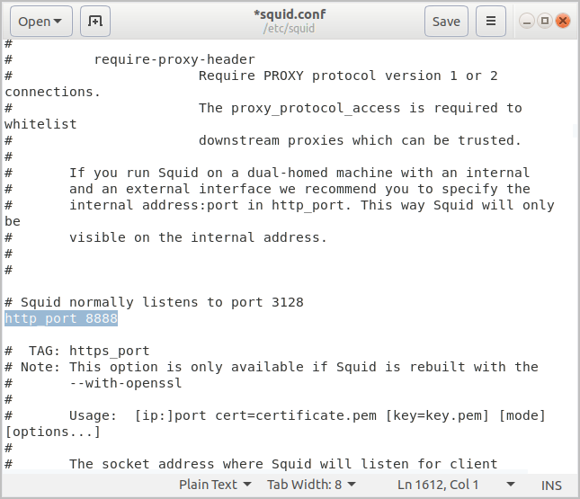

**Changing the visible_hostname directive in order to give the Squid server a specific**

**hostname.**

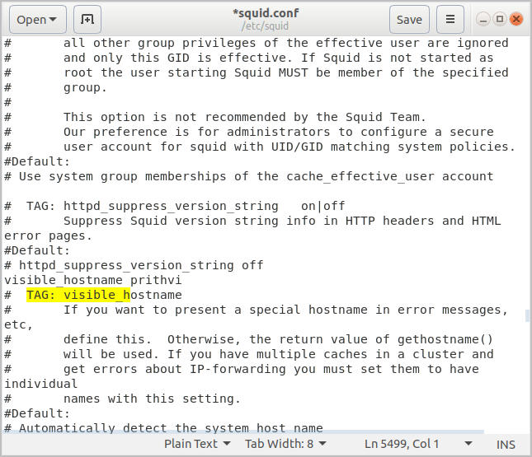

**Giving access to users of the 172.17.15.0/24 subnetwork (our_network) only:**

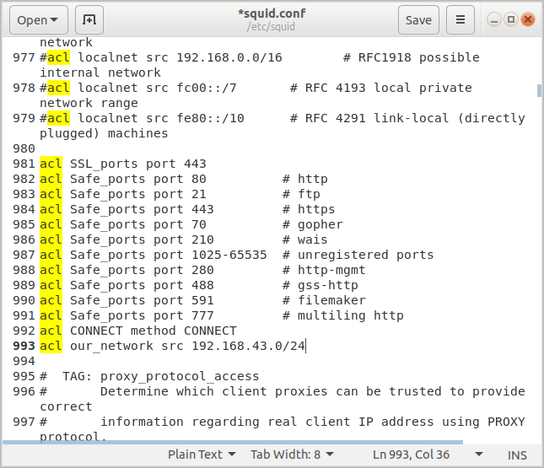

**Allowing access to the subnetwork:**

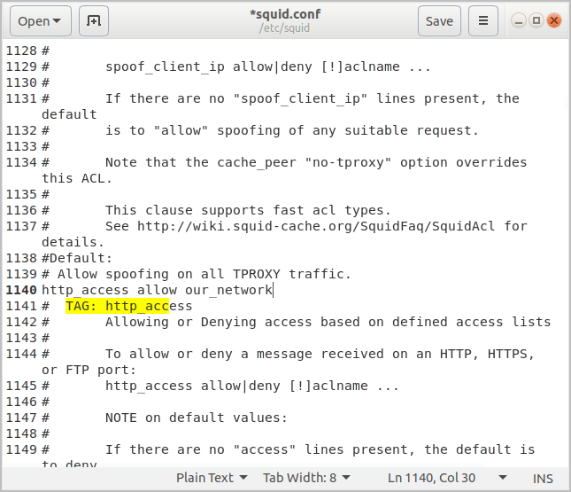

**Restarting server:**

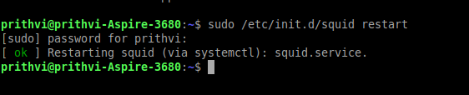

**Accessing net through the allowed subnetwork:**

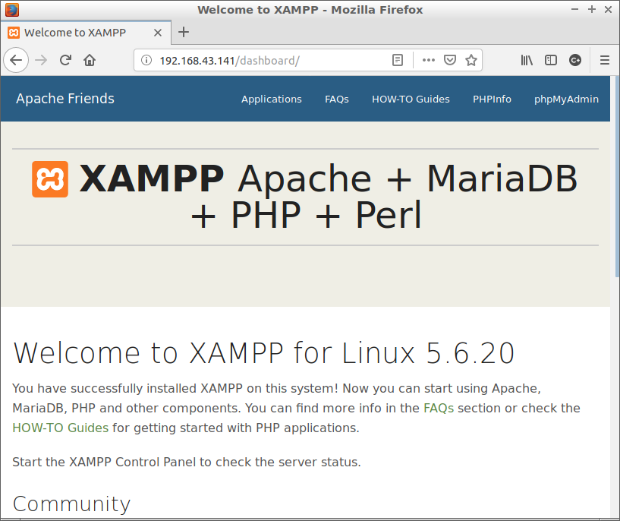

**Denying the access:**

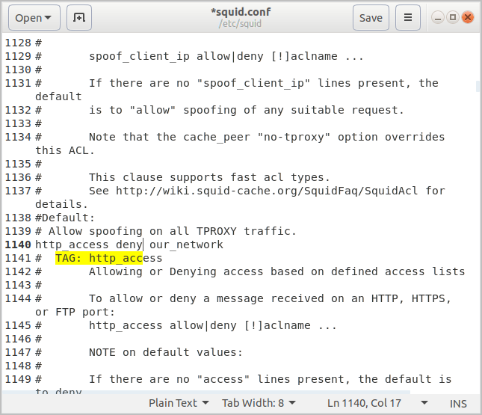

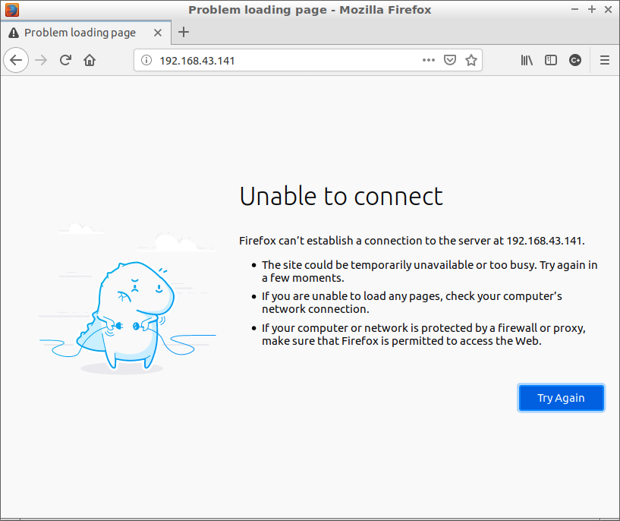

**Allowing access for specified time:**

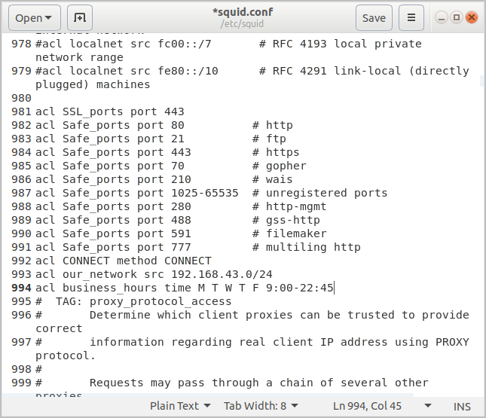

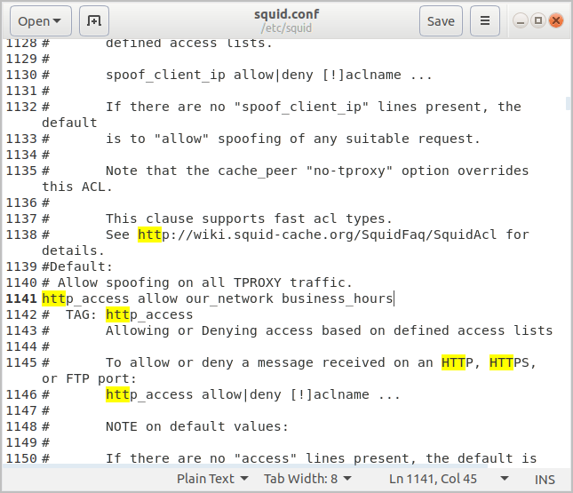

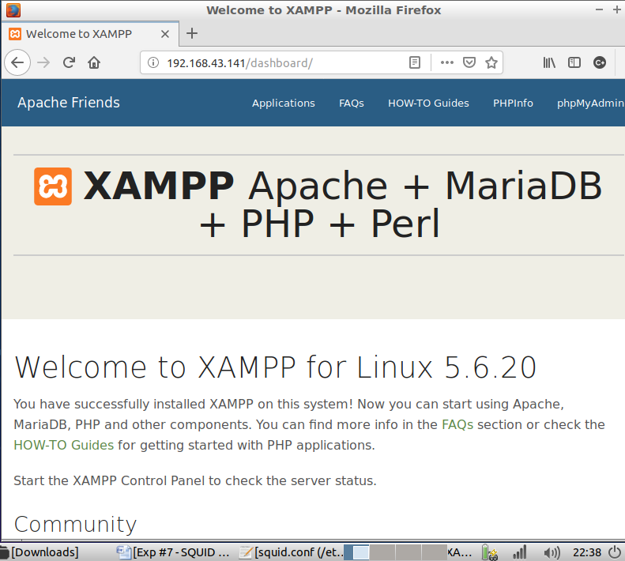

**Conclusion:**

**Thus we have installed & configured SQUID Proxy Server.**