**K. J. Somaiya College of Engineering, Mumbai-77** (Autonomous College Affiliated to University of Mumbai)

**Batch:A2**

**Roll No.: 1611023**

**Experiment / assignment / tutorial No. 08**

**Grade: AA / AB / BB / BC / CC / CD / DD**

**Title:** Installation and configuration of FTP server **(Remote Administration with FTP) .**

**Objective:** To install and configure FTP Server and handle remote operation. **_____________________________________________________________________**

**Expected Outcome of Experiment:**

CO3 : Manage the configuration by using network administration tools.

**_____________________________________________________________________ Books/ Journals/ Websites referred:**

1. *Linux Lab - Open source Technology : Ambavade –Dreamtech* 2. *https://help.ubuntu.com/lts/serverguide/ftp.html* 3. http://www.krizna.com/ubuntu/setup-ftp-server-on-ubuntu-14-04-vsftpd/

4. https://www.cyberciti.biz/faq/linux-unix-ftp-commands/

**___________________________________________________________________**

**Pre Lab/ Prior Concepts:** Computer Network, Web Technologies **__________________________________________________________________ New Concepts to be learned:** Installation of ftp, configurations for ftp, vsftpd,SSHD

**__________________________________________________________________**

FTP is used to transfer files from one host to another over TCP network. This article explains how to setup FTP server on ubuntu 14.04 . There are 3 popular FTP server packages available PureFTPD, VsFTPD and ProFTPD. Consider VsFTPD which is lightweight and less Vulnerability.

vsftpd is an FTP daemon available in Ubuntu. It is easy to install, set up, and maintain.

**Installation of FTP:**

To install FTP server on Ubuntu 14.04(vsftpd ),need to run the following command:

**Step 1 »** Update repositories .

sudo apt-get update

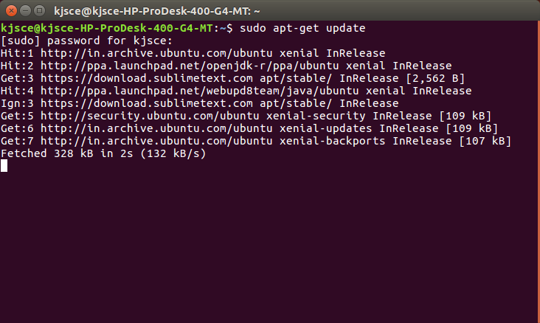

**Step 2 »** Install VsFTPD package using the below command.

sudo apt-get install vsftpd

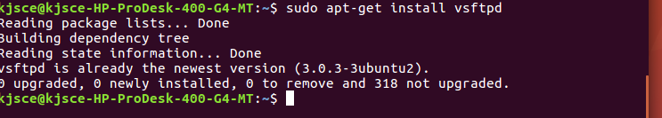

**Step 3 »** After installation open **/etc/vsftpd.conf** file and make changes as follows.

Uncomment the below lines (line no:29 and 33).

write_enable=YES local_umask=022» Uncomment the below line (line no: 120 ) to prevent access to the other folders outside the Home directory. chroot_local_user=YESand add the following line at the end. allow_writeable_chroot=YES» Add the following lines to enable passive mode. pasv_enable=Yes pasv_min_port=40000 pasv_max_port=40100

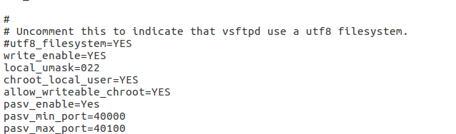

**Step 4 »** Restart vsftpd service using the below command.

sudo service vsftpd restart

https://lh3.googleusercontent.com/aD-yNaDYY7U7l3LtsVDMtrgMZcVbiGO7gtIGwvFCDcDAjvV5TmbpCn0XOZHiRTxa0bDfyjGFBA1kVMpjV3z0g_fSLAqa9KZcHuCfLI-A915lbwKMtHP-vj9OsWutKqDSqi7OYKks

**Step 5 »** Create user with the below command. Ftp server will listen on port 21.

Use shell to prevent access to the bash shell for the ftp users .

**/usr/sbin/nologin**

sudo useradd -m john -s /usr/sbin/nologin

sudo passwd john

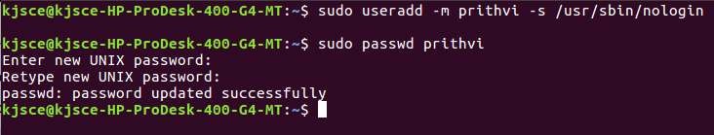

**Step 6 »** Allow login access for nologin shell .

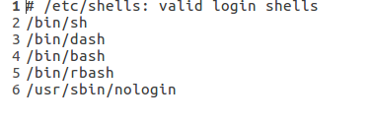

Open **/etc/shells** and add the following line at the end. /usr/sbin/nologin SFTP is called as “Secure FTP” which generally use SSH File Transfer Protocol . so we need openssh-server package installed , Issue the below command if it’s not already installed.

sudo apt-get install openssh-server

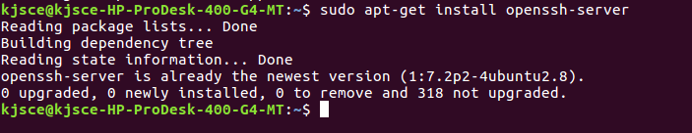

**Step 7 »** Create a new group **ftpaccess** for FTP users.

sudo groupadd ftpaccess

https://lh6.googleusercontent.com/OFOzWnKjPXgxsRna09KO8lA2Yc7VHRO1UgCxynNa3bOocBtZj_fp-uqvxjnEhe-NrIq99XcXK6r2thWoO04BQUlkI-DJ23u8s7j11Wu3j97CjYrD8mNUk3wQzbxW4IIIPKFXj0Cx

**Step 8 »** Now make changes in this **/etc/ssh/sshd_config** file.

» Find and comment the below line

Subsystem sftp /usr/lib/openssh/sftp-server

and

Add these lines at the end of the file.

Subsystem sftp internal-sftp Match group ftpaccess ChrootDirectory %h X11Forwarding no AllowTcpForwarding no ForceCommand internal-sftp

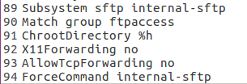

**Step 9 »** Restart sshd service.

sudo service ssh restart

https://lh5.googleusercontent.com/_OIPoTfFrwjvOWSQl5bCdG0WWgmGKNXYHNAiu6ZiKYUfjU-id6auYf60uQvYtWlGfzhX_Dy9uhgDQc9ypSXYN-KxJPegJhx5W52R_YJgB0OKkk09Ifq8krCJgXS-_p1_Fk6nGCi7

**Step 10 »** creating Users for sftp access.

Create user **john** with **ftpaccess** group and **/usr/bin/nologin** shell. sudo usermod -m john -g ftpaccess -s /usr/sbin/nologin sudo passwd john

Change ownership for the home directory. sudo chown root /home/john

Create a folder inside home directory for writing and change ownership of that folder. sudo mkdir /home/john/www sudo chown john:ftpaccess /home/john/www

sudo usermod john -g ftpaccess -s /usr/sbin/nologin sudo chown root /home/john sudo mkdir /home/john/www sudo chown john:ftpaccess /home/john/www

Now john can able to upload files to www folder using FTP as well as SFTP.

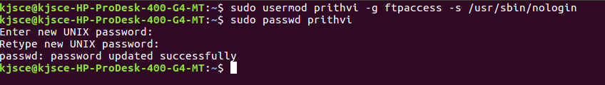

https://lh4.googleusercontent.com/XU56O0ONU_0riYbsaOO_uU3mT9Y3lR-pFyIkH80_DefVM2djkIr-t8oB0wlUeAOYoE95-8Xn-6L03xbpN447YL21wH8mFlAYFP0D3pgGEzGUAcwRnZMveDQp4iB6X-BjYT1XqokT



**Testing FTP:**

To Test FTP server on Ubuntu 14.04(vsftpd ),need to run the following command:

1. **Internet File Transfer Program:**

It does connect to transfer files to and from a remote network ftp site. One must aware ftp username and password for user-based password authentication or with anonymous user access .

a. ftp ftp.example.com b. ftp 1.2.3.4 c. ftp user@ftp.example.com d. ftp ftp.freebsd.org

**2. List Current File:**

This command list the names of the files in the current remote directory

ftp> ls

**3. Change Directory:**

To change directory on the remote machine use cd command:

ftp> cd dirName Example : To change to pub directory, enter:

ftp> cd pub

**4. Download / Copy file:**

a. Download / Copy file o copy one file at a time from the remote ftp server to the

local system use get command:

i. get fileName ii. get fileName newFileName b. In this example, download file resume.pdf in the current remote directory to (or

on top of) a file with the same name, resume.pdf, in your current local directory:

i. ftp> get resume.pdf

**5. Change Local Directory:**

(a) To change directory on your local system: 1. ftp> lcd /path/to/new/dir 2. ftp> lcd /tmp

(b) Print local directory:

(i) The lpwd command prints current download directory for local systems

1. ftp> lpwd

(c) pwd: To find out the pathname of the current directory on the remote ftp

server, enter: ftp> pwd

**6. Download Multiple Files:**

i) To copy multiple files from the remote ftp server to the local system.

ftp> mget *

ii) To download all perl files (ending with .pl extension)

ftp> mget *.pl

**7. Turn On / Off Interactive Prompting:**

The ftp command prompt sets interactive prompting; “on” which enables prompting so that you can verify of each step of the multiple commands, “off” allows the commands to act unimpeded.

ftp> prompt on ftp> mput *.php ftp> prompt off ftp> mget *.py

**8. Delete File:**

To delete a file in the current remote directory use delete command. ftp> delete fileName

ftp> delete output.jpg

**9. Upload One File:**

To copy one file at a time from the local systems to the remote ftp server.

ftp> put filename Upload Image file ftp> put logo.jpg

**10.Upload Multiple Files:**

To copy multiple files from the local system to the remote ftp server use mput command. Again, you may be prompted for a yes/no (y/n) answer before transferring each file. ftp> mput * ftp> mput *.pl Above example, upload all files from the current system.

**11.Create a Directory:**

To make a new directory.

ftp> mkdir dirName ftp> mkdir scripts ftp> cd scripts ftp> pwd

**12.Delete a Directory:**

Purpose is to remove or delete a directory. ftp> rmdir dirName ftp> rmdir images

**13.Set The Mode Of File Transfer:**

The binary mode is recommended for almost all sort of files including images, zip files

and much more. The binary mode provides less chance of a transmission error. The command are as follows: To set the mode of file transfer to ASCII ftp> ascii

To set the mode of file transfer to binary. ftp> binary

**4.Connect To Another FTP Server:**

To open a connection with another ftp server. ftp> open ftp.nixcraft.net.in ftp> open 172.17.15.86

**15.Exit the FTP Session:**

Type quit or bye. ftp> quit OR ftp> bye

**Implementation details:**

Step 1:

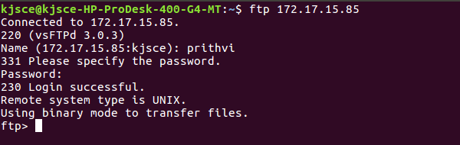

Step 2:

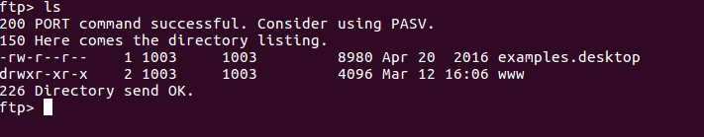

Step 3:

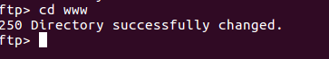

Step  4:

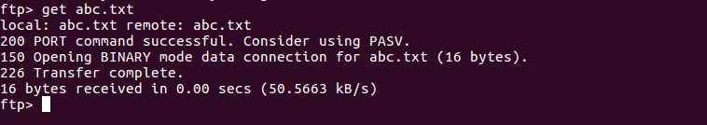

Step 5:

https://lh6.googleusercontent.com/8UTQ7jGbl3OH76c4JUnWaLiZ_CgPe47verFD6XrooVl-1zPlR-g1rCRS_LvxOyF26yv2I8WomQuUX2RzFZqskcDOY7MZvdlYQ8MwSvh2-E46GzFGYMmbMAdrDUmJMdhOI2-wsDVF

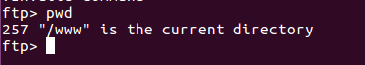

Step 6:

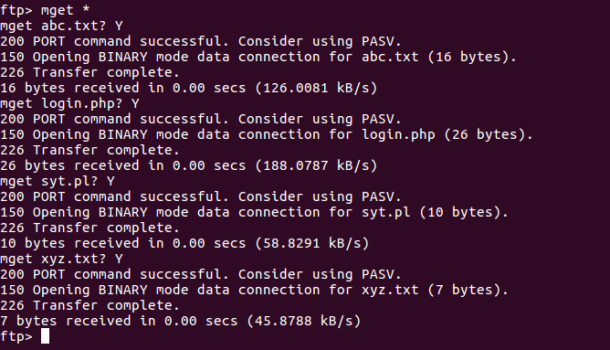

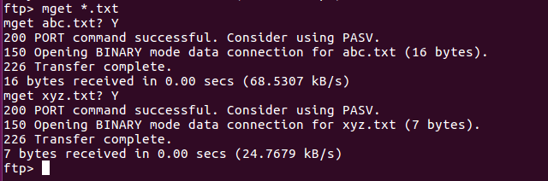

Step 7:

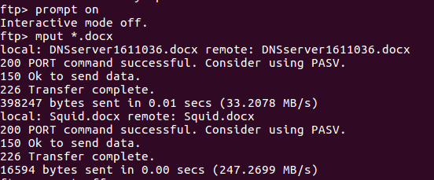

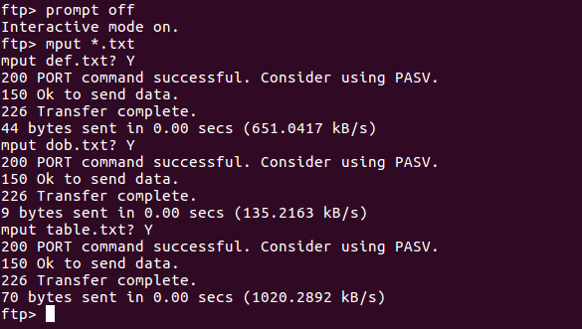

Step 8:

https://lh5.googleusercontent.com/v2huzt_ILGRSOwcG6i_IVfCvCaPSAygLuzjGLX28fSUdFXAVcXE5FwxHqEagG5xw4nwQoOtVgGtd0WBOTYWtI3Hb90zL63nVncLd9GhdNLBy1i78MpYHt0PFJn7OfAoD51Vs0abH

Step 9:

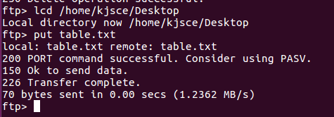

Step 10:

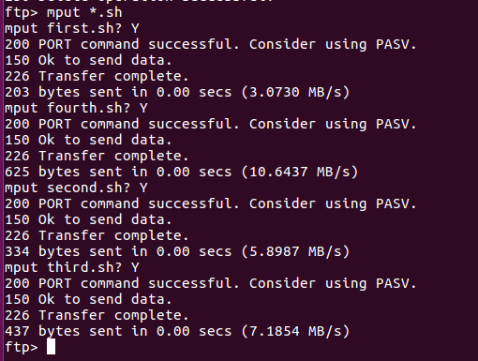

Step 11:

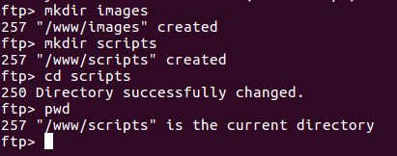

Step 12:

https://lh6.googleusercontent.com/5ZbpaIrkk_uFRPNPHaa2wm3GqYfJiGVN6KCE763spSYpSQmcHhcNSJ2K7u7QasYdcuorrIj2N8pZxQX5ZAoS2kJraZ_5H9WpilHv5sUNIgvpHC2XaCvwvN7TaWuVFZ18enWQsLLM

Step 13:

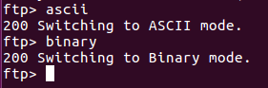

Step 14:

https://lh3.googleusercontent.com/kZKsuvbf8mNkUD6AuzkvQMP12GaKY4QZ2pI8YroGkKHr38nim0RqaztPxw25VeQaST5zCr979sdOvX6qcK6GmUfp86txORUKx60JLe9DkjE7rWqGu6tk7kGjtrOFjQ1cKKGN0hac

Step 15:

https://lh5.googleusercontent.com/GB-HUQPdR09mw9c5B3PAYIwjtktYmSyna0OJdohVERnjjNo2HaIHJtgSb-qRI4KxBPSsruGNgATaPqTVmE9AxYbReRflky5_ih3pOBIjuPgr0COuTRw5dMSAobo7uyuZ1obU7h31

**Conclusion:**

Thus we have installed and configured FTP server properly and implemented the given commands.