Traffic Sign Detection and Reading using MATLAB

Prithviraj Kadiyala
School of Electrical and Computer Engineering
University of Oklahoma, Norman, OK 73069
prithvirajkadiyala@ou.edu

Abstract— The main overview of this paper is to use image processing technique to detect Traffic signs in an Image and Read them to display them to the driver. MATLAB Image Processing toolbox is used in this project. It involves image acquisition, pre-processing such as thresh-holding, grey scale conversion, color and shape analysis for detection of the signs and finally read them to the driver. This project also discusses the problems in which the sign cannot be processed to save the information without white washing it with the background. Work also must be done with the robustness of the system because time is of the essence while driving and the faster the information is provided, the more time the driver must react to the surroundings.

Introduction
Road Signs play a vital role in giving information to the drivers about the surroundings and warnings in case of any dangers. But while driving it is difficult for the driver to focus on the signs than the road. Hence implementing a system which could read the signs and read them to , or display them to driver on his dashboard for safer driving conditions. Using MSER, CC and Stroke Width algorithm we could read and display the correct info to the driver without much distraction.

- Proposed:
Detecting the road signs and reading them to display them to the driver for safer driving conditions without any distractions.

- Traffic signs can be categorized into[1]:

Danger warning signs

Priority signs

Prohibitory or restrictive signs

Mandatory signs

Special regulation signs

Information, facilities, or service signs

Direction, position, or indication signs

Additional panels

- Image Processing to read texts on signs goes in the following steps [2]:

Contrast Enhanced Image

Edge-Enhanced MSER

Geometric Filtering

Finding Stroke Width

Stroke Width Filtering

Letter Pairing

Text-line Formation

Word Separation

Background

Huizhong Chen [2] proposed a novel CC-based text detection algorithm, which employs MSER as our basic letter candidates. Despite their favorable properties, MSER have been reported to be sensitive to image blur. As opposed to texture-based methods, the CC-based approach extracts regions from the image and uses geometric constraints to rule out non-text candidates. The top scoring contestant in applies an adaptive binarization method to find CCs. Text lines are then formed by linking the CCs based on geometric properties. With the extraction of edge-enhanced MSER, we obtain a binary image where the foreground CCs are considered as letter candidates. As in most state-of-the-art text detection systems, we perform a set of simple and flexible geometric checks on each CCs to filter out non-text objects [2].

There are several geometric properties that are good for discriminating between text and non-text regions [3], including:

Aspect ratio

Eccentricity

Euler number

Extent

solidity

Another common metric used to discriminate between text and non-text is stroke width. Stroke width is a measure of the width of the curves and lines that make up a character. Text regions tend to have little stroke width variation, whereas non-text regions tend to have larger variations. To help understand how the stroke width can be used to remove non-text regions, estimate the stroke width of one of the detected MSER regions. You can do this by using a distance transform and binary thinning operation [4]

Abbreviations and Acronyms
MSER - Maximally Stable Extremal Regions
CC - Connected Components

Project Plan
- Progress:
  - Found a new method to incorporate that using the Connected component method [3].
  - Implementing the ‘Scene detection with stroke width method’ [4].
  - Planned to make decent progress in recognizing text but couldn’t due to improper text scanning method.
- Completion plans:
  - Plan on completing the stroke width algorithm first.
  - Apply Connected components to bring together the words and stitch them together.

Preliminary Results
With the MSER text detection, we were able to read a little bit of text from the signs but weren’t completely making sense of what it means. Hence, with the implementation of CCs and Stroke Width algorithm we could be able to read the text as is and display it to the driver.
Image Result
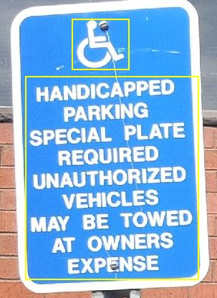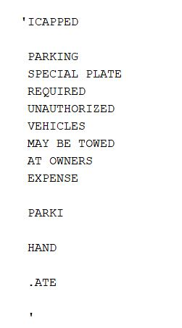

Acknowledgment
The preferred spelling of the word “acknowledgment” in America is without an “e” after the “g”. Avoid the stilted expression, “One of us (R.B.G.) thanks . . .” Instead, try
“R.B.G. thanks”. Put applicable sponsor acknowledgments here; DO NOT place them on the first page of your paper or as a footnote.

References

- https://en.wikipedia.org/wiki/Traffic_sign
- Chen, Huizhong, et al. "Robust Text Detection in Natural Images with Edge-Enhanced Maximally Stable Extremal Regions." Image Processing (ICIP), 2011 18th IEEE International Conference on. IEEE, 2011.
- Gonzalez, Alvaro, et al. "Text location in complex images." Pattern Recognition (ICPR), 2012 21st International Conference on. IEEE, 2012.
- Li, Yao, and Huchuan Lu. "Scene text detection via stroke width." Pattern Recognition (ICPR), 2012 21st International Conference on. IEEE,2012.

