Abstract— Real-time implementation of many digital signal processing (DSP) algorithms and multimedia applications is performance limited by the available speed, energy efficiency, and area requirement of multiplication. This is exacerbated in handheld multimedia devices due to the small size and limited battery lifetimes. In this work, we introduce a novel iterative multiplier structure in which the conversion from 2’s complement to canonical signed digit (CSD) representation is implicitly implemented in real-time. With the CSD representation, the proposed multiplier increases the number of zero partial products to approximately 66.7%. This new design also uses a bypass technique to further reduce the need for devices such as carry save adder (CSA) arrays and adder trees for partial product reduction operations. Therefore, the new structure introduced here greatly improves the multiplier throughput and energy efficiency. Moreover, the number of iterations required to complete a fixed length multiply is data dependent as a result of a novel variable shifting technique; hence there is no energy and time overhead expended for unnecessary iterations as observed in multipliers where the number of iterations is fixed. Our results show that this new iterative structure delivers significant performance improvements with respect to speed, area, and power consumption relative to previous iterative multiplier designs.
Efficient Iterative Multiplier Structure Based on a Novel Real-time CSD Recoding
Yunhua Wang, Linda S. DeBrunner, Senior Member, IEEE, Dayong Zhou, Member, IEEE,
Victor E. DeBrunner, Senior Member, IEEE, and Joseph P. Havlicek, Senior Member, IEEE

Index Terms—Iterative Multiplier, CSD Recoding, Real-time implementation

INTRODUCTION
H ardware implementation of digital signal processing (DSP) algorithms and multimedia applications in technologies such as field programmable gate arrays (FPGAs) and digital signal processors requires a large number of multiplications. Often, the overall performance of the design is limited by constraints on the speed, energy consumption, and area requirements of the available multiplier design options.

This is particularly true for applications centered around modern handheld multimedia devices, where physical size, chip real-estate, power, and battery life are all at a premium. Consequently, intense recent research has been focused on the development of efficient, advanced multiplier techniques to support these demanding applications [1]-[8].
Multiplication involves two basic operations: generation of partial products and accumulation of partial products. Hence, all techniques for speeding up multiplication can be categorized into to two main groups: those that seek to reduce the number of nonzero partial products and those that seek to accelerate the accumulation of partial products. The three main classes of multipliers include parallel multipliers, array multipliers and iterative multipliers [9]. Parallel multipliers generate partial products in parallel and accumulate them using a fast multi-operand adder. With this type of multiplier design, the execution speed is increased (relative to a typical iterative multiplier) at the expense of the increased area that is required for the generation of multiple partial products in parallel. Further speed up can be achieved by using an array multiplier where an array of identical cells generates new partial products and accumulates them simultaneously, such that separate circuits are not required for generation and accumulation. Array multipliers are used widely where high-speed multiplications are required. However, in addition to requiring large area, array multipliers usually do not seek to optimize energy efficiency though exploitation of the specific, data dependent patterns of digits that occur in the multiplier and multiplicand; typical array multipliers are inherently energy inefficient in this regard. These two considerations limit many practical applications of both parallel and array multipliers.
In contrast, typical iterative multipliers utilize a few hardware functional units repeatedly to generate partial products sequentially and add each newly generated product to those previously accumulated. The main characteristics of iterative multipliers are small area consumption; reduced pin count and wire length, and high clock rate. Moreover, by executing a number of iterations that are data dependent, the energy efficiency can be greatly improved relative to array and parallel multipliers. Here, energy efficiency refers to the energy required per operation, e.g., nano-Joules/op [2]. Therefore, the choice between implementing a parallel or array multiplier as opposed to an iterative multiplier in any given design is generally a trade-off of computational speed against area requirement and energy efficiency. In this paper, we introduce a new iterative multiplier design that provides simple structure, high throughput, and high energy efficiency, making it particularly suitable for deployment in low power and low area applications.
In an iterative multiplier, the partial products are generated and added together sequentially or iteratively to obtain the final product using shift/add functional blocks [9]. The number of shift/add operations that occur in a given multiply is directly related to the power consumption of the circuit. Thus, the number of iterations required in a multiply directly impacts both the throughput and the energy efficiency of the multiplier. A variety of techniques have been developed to reduce the number of iterations, thereby increasing the efficiency of the shift/add operations [2], [3], [10]; detailed descriptions of several of these are given in Section II below.
Typically, the shift/add functional blocks implemented in an iterative multiplier shift the operand by a fixed number of bits and a fixed number of iterations are required to produce the final product. With this straightforward approach, the control and energy overhead required per machine cycle are constant throughout the entire multiplication operation. The new iterative multiplier structure proposed in this paper employs a variable number of iterations to convert one operand (the multiplier) from 2’s complement to a Canonical Signed Digit (CSD) representation in real-time by using a new CSD recoding method where the number of iterations is data dependent. This novel real-time CSD recoding is very simple to implement and requires only a few combinational logic gates. In fact, the actual CSD representation of the multiplier operand is never explicitly present in the hardware; rather, only the control signals that are required for accumulation of the partial products based on the value of the multiplicand are generated. By exploiting the inherent properties of the CSD number system, the proposed multiplier increases the number of zero partial products to approximately 66.7%. Each time a zero partial product occurs, the corresponding add (accumulate) operation is automatically bypassed. Consequently, the number of partial product reduction operations, as are often implemented with carry save adder (CSA) arrays and/or adder trees, is greatly reduced. This in turn dramatically reduces the power consumption of the overall multiplier circuit. Compared to a typical iterative multiplier where the number of iterations is fixed, this approach saves energy and time by bypassing iterations that are not required for the generation of the product.
Section II provides some preliminary background about iterative multipliers and CSD number representations. The new real-time CSD recoding multiplier technique and structure are presented in Section III. Performance comparisons of this new multiplier against other existing iterative multipliers are given in Section IV, while conclusions appear in section V.

Background
In an iterative multiplier, partial products are generated and added together sequentially. For the 2’s complement binary
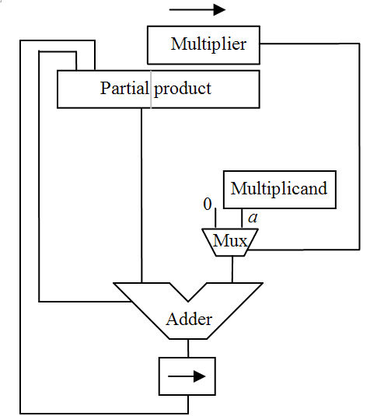
Figure 1 Schematic depiction of a right-shifting 2’s complement iterative shift/add multiplier [9].

number system, the generation and addition of the partial products may be implemented in hardware using simple shift/add techniques as shown in Fig. 1, where right-shifting is employed. For an n-bit by n-bit multiplication, realization using right-shifting requires only an n-bit adder, as opposed to the 2n-bit adder that is required in a left-shifting structure. Note that the multiplier and the lower half of the partial product can share a common register, as shown in Fig. 1, since multiplier bits are shifted out as the partial product grows. This is a common area-optimization method that is applied in the design of iterative multipliers [9]. Typically, the multiplier and partial products are right-shifted one bit in each iteration and the product is completed after n iterations. This approach requires n shift/add operations regardless of the values of the operands. Several methods have been proposed to improve the throughput and power efficiency of the basic multiplier structure shown in Fig. 1, as described below.
Method 1: bypass the adder and multiplexer if the partial product is zero [2], [9]. Clearly, the addition operation can be bypassed in any iteration where a zero bit is encountered in the multiplier operand. When this occurs, the only operations that are required to complete the iteration are a shift right by one bit of the previous partial product and also of the multiplier. This modification can significantly reduce the number of additions, increase throughput, and reduce power consumption, provided that zeros occur frequently in the multiplier operand.
Method 2: increase the number of zero partial products [9], [10]. More zero partial products mean fewer switch operations in the adder; by combining this with Method 1, more adder and multiplexer functions can be bypassed. Booth’s recoding algorithm, as developed for speeding up multiplication in early computers, is an example of one method that belongs to this category [10]. In Booth’s recoding, a string of 1’s is replaced by one 1, one -1 and many 0’s based on

.
Therefore, Booth’s recoding maps words with digit set {0, 1} to those with digit set {, 0, 1}, where is used to denote the digit -1. For example using this recoding, the number “00111110” is represented by “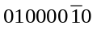”. Therefore, many zero partial products can be generated. However, the performance of the multiplier is improved at the cost of requiring increased circuit complexity. To implement subtraction by adding the two’s complement of the multiplicand, an additional carry-in input is required for the adder, as well as the computation of the one’s complement of the multiplicand. Moreover, the original proposed Booth’s recoding algorithm can only speed up multiplication when a multiplier has many consecutive 1’s, and Booth’s recoding is very inefficient when multiplier has alternating 1’s and 0’s, e.g. the number “010101” is represented by “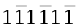”.
Method 3: reduce the number of partial products, i.e. reduce the number of iterations [9]. Clearly, energy efficiency and throughput of an iterative multiplier can be greatly improved by decreasing the number of iterations. Therefore, instead of bit by bit operation, multiple bits can be operated on simultaneously to form the partial product. The Modified Booth’s recoding (MBR) algorithm combines multiple bits in an efficient way that reduces not only the total number of partial products, but also the number of non-zero partial products. Thus, the MBR algorithm actually improves multiplier performance using both Method 2 and Method 3. Radix-4 MBR, for example, has been applied often to take advantage of these performance gains. An iterative multiplier structure based radix-4 MBR is depicted in Fig.2, while the recoding scheme is given explicitly in Table I. By using radix-4 based MBR, the operation takes place 2 bits at a time by converting a 3-bit segment of a 2’s complement number into the digit set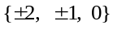. Thus the number of partial products is reduced from n to n/2, and approximately 75% of these n/2 partial products are nonzero. Therefore, the performance of the multiplier can be greatly improved. However, the costs are a complex ‘multiplexer’ with zero, multiplicand, and twice multiplicand inputs, as well as the carry-in input and one’s complement computation required for negative numbers. Higher radix Booth’s recoding can be used to further reduce the number of iterations but requires an even more complex multiplexer [9]. Note that most iterative multipliers based on MBR fail to effectively exploit the operand structure; as a result, they are fixed iteration multipliers.
In addition to the three principal performance enhancement methods enumerated above, there are additional techniques available for improving the performance of an iterative multiplier by decreasing the latency per iteration and by designing efficient structures for performing fast addition, including, e.g., carry-look-ahead and carry select circuitry [9][11].
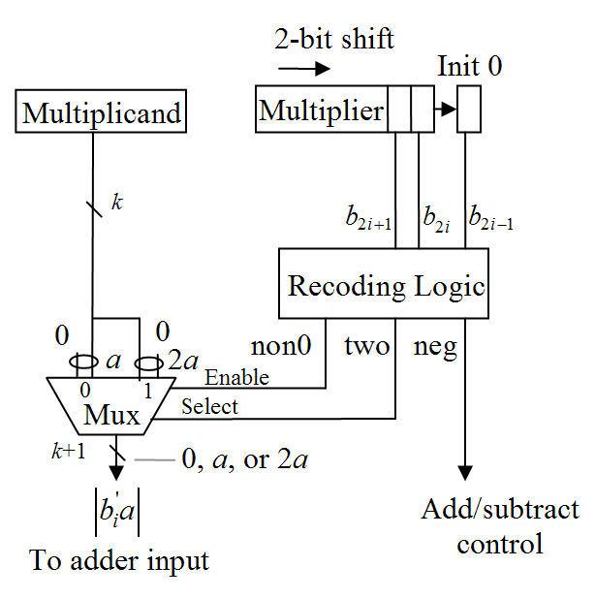
Figure 2 An iterative multiplier structure based radix-4 MBR[9]

Table I. Radix-4 Modified Booth’s recoding [9].
b_{2i +1} | b_{2i} | b_{2i-1} |  | Operation
0 | 0 | 0 | 0 | +0
0 | 0 | 1 | 1 | +a
0 | 1 | 0 | 1 | +a
0 | 1 | 1 | 2 | +2a
1 | 0 | 0 | -2 | -2a
1 | 0 | 1 | -1 | -a
1 | 1 | 0 | -1 | -a
1 | 1 | 1 | 0 | 0

Our proposed new iterative multiplier makes use of the essence of the three methods discussed above based on a novel implementation of Canonical Signed Digit (CSD) recoding. As we noted earlier, Booth’s recoding algorithm introduces some inefficiency for numbers with alternating ones. A more efficient number representation can be achieved by using the CSD number system. As in Booth recoding, the CSD representation [12] is a radix-2 number system using the digit set 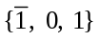 with the “canonical” property that no two consecutive bits in the CSD number are nonzero. For example, the 2’s complement number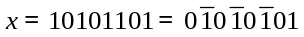, where “” stands for “-1.” This representation replaces the additions arising from a string of ones in a binary number with a single subtraction, so that the “shift-and-add” algorithm becomes “shift-and-add/subtract”, i.e. a multiplier can be realized by incorporating a few adders (or subtractors) and bit shifters. CSD representations have proven to be useful in implementing multipliers with reduced complexity, because the cost of multiplication is a direct function of the number of nonzero bits in the multiplier. Under the assumption that all realizable n-bit operand values are equally likely to occur, the probability that a CSD digit is nonzero is given by [6]
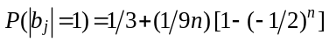.
From , we can see that for an n-bit 2’s complement multiplier, the number of non-zero bits in its CSD representation never exceeds n/2 and can be reduced to n/3 on average, as the wordlength of the multiplier grows. Therefore, if we can incorporate the CSD number representation into our multiplier, we can significantly reduce the number of non-zero partial products, which in turn increases the multiplier throughput and energy efficiency.
The conversion of a 2’s complement binary number to CSD representation can be implemented in hardware using look-up tables [4], a canonical recoding algorithm [13], or complicated digital circuits [7][14], but these all are costly in terms of area and power consumption. As a result, many current applications that utilize CSD representations avoid the issue of real-time 2’s complement to CSD conversion by limiting CSD optimization to a fixed set of operand values that can be converted a priori. This allows the CSD representation to be calculated offline. These approaches can be further improved by the Dempster-Macleod algorithm [15] or similar techniques. Fixed number CSD representation techniques have been applied to efficiently implement the multiplications for fixed-coefficient digital filters, but these techniques are not applicable to adaptive filters [16] and other inner-product computations in which the multipliers are not know a priori.

Real-time CSD Multiplier Structure
In this section, we will introduce our iterative multiplier structure, which is based on a novel real-time CSD encoding technique. Instead of converting a binary number into its CSD representation, the CSD recoder in our design only generates the corresponding control signals. Based on these control signals, the multiplier actually operates using CSD generated logic. In order to introduce this novel CSD encoding method, we first present a new way to convert a 2’s complement binary number to its CSD representation.
To reduce the many additions arising from a string of ones, we use the simple concept that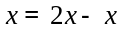to convert x to another form we refer to as the difference form signed (DFS) number [14]. In the DFS representation, a number may contain instances of the digit pairs “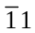” and “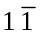,” but sequences of two consecutive ones or two consecutive negative one digits cannot occur. DFS conversion is illustrated in the following example:
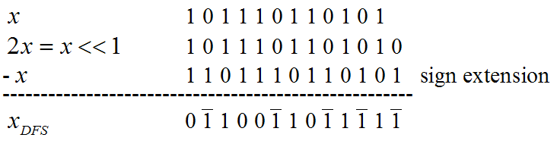A closer look at the DFS number reveals that the DFS representation of x exactly coincides with the Booth’s recoding representation of x. However, the notation in our discussion here will be simplified by the use of the term DFS. Additionally, the concept of the DFS representation provides a new insight into Booth’s recoding [10]. We now summarize some of the key properties of the DFS number representation.
Property 1: No two consecutive nonzero bits in the difference form of have the same sign.
Proof: If two consecutive nonzero bits in a DFS number,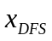, have the same sign, i.e. “11” or “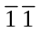”, then the corresponding positions of 2x and x should be either “11” and “00” or “00” and “11”. However since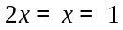, then the (i+1)^{th} bit of 2x must be the same as the i^{th} bit of x, which contradicts with previous statement. Hence, the difference form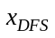 cannot contain a sequence “11” or “”.⁪ 
Property 2: To convert a 2’s complement number x to the CSD representation, we only need to replace occurrences of the bit pair “” with “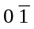” and/or the bit pair “” with “01” in the DFS representation of x starting from the least significant bit (LSB).
Proof: Let be a DFS number and let be the number of sequences of two or more consecutive nonzero digits that occur in, where 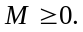 If 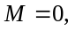then is already a valid CSD representation. Therefore, it is sufficient to consider only cases where 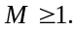 Let 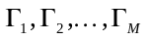denote the sequences of two or more consecutive nonzero digits that occur in in order of decreasing length (so that 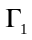is the longest such sequence) and let 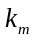denote the length in digits of the sequence 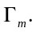 It follows immediately from Property 1 that 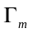is an alternating sequence of occurrences of the digits “1” and “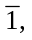” where 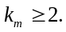 If the low-order digit pair of is “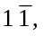” then it may be replaced by the equivalent digit pair “01”; alternatively, if the low order digit pair is “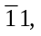” then it may be replaced by the equivalent pair “.” This replacement converts from a sequence of consecutive nonzero digits to a sequence of 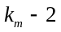 consecutive nonzero digits and may be repeated until the length of is reduced to zero. The desired result follows immediately by repeating this argument for all 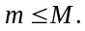⁪ 
Therefore, if we scan a DFS number in 2-bit segments from right to left, whenever a pair of nonzero digits is encountered, we convert the bits based on property 2. Whenever there are 2-bit segments which begin with a ‘0’ bit (such as “”, “00” or “01”), we leave them unchanged; whenever the 2-bit segments end with a ‘0’ bit (such as “10” or “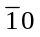”), we leave the ‘0’ bit unchanged and continue scanning the remaining digits in 2-bit segments. In this way, we obtain the CSD representation of the number. The following example illustrates this algorithm for conversion of a DFS number to its CSD representation:
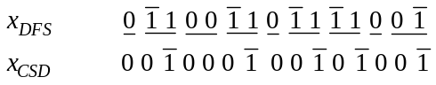
Real-time circuits have been designed to convert a two’s complement number into its CSD representation [7], [14]; however, the proposed circuits add overhead in terms of area requirements and energy consumption. In our proposed multiplier structure, we do not convert a number explicitly into the DFS or CSD representations. Instead, based on the relationship between the two’s complement number and its DFS representation, as well as Properties 1 and 2, we obtain the digit-set relationships between a two’s complement number, its DFS representation and its CSD representation, which provides us with the corresponding signals that are needed to control the accumulation of partial products in the multiplier. These relationships are shown in Table II, where , and are control signals based on CSD number conversion. Signal is used to control the add or subtract operation, i.e. addition is performed if 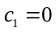 and subtraction is performed if 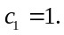 Signal is used to control the number of bits that are shifted in each iteration, i.e. 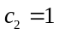 indicates a right shift by 1 bit and 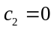 enables right shifting by 2 bits. Finally, is the bypass control signal, where 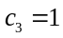 enables the bypass operation. These signals (defined in Table II) are given by and may be efficiently implemented in hardware using the circuits shown in Fig. 3.
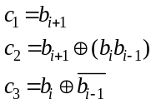
The block diagram of our proposed iterative multiplier structure based on this novel CSD encoding is given in Fig. 4. The corresponding signal flow chart is provided in Fig 5. From the flow chart, it is clear that this encoder generates directly in hardware the control signals required to realize a multiplier based on the CSD representation.
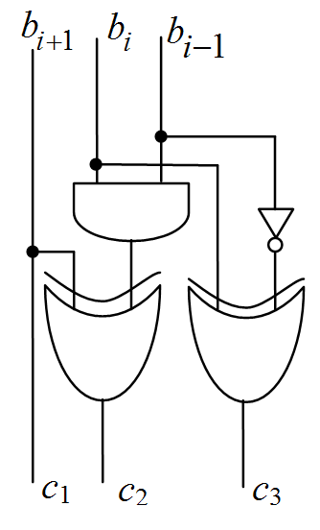
Figure 3 Implementation of multiple generations and shift control part of CSD recoding multiplier in logic gates

Table II. Recoding Scheme of CSD Algorithm.
2’s Complement |  |  | DFS |  | CSD |  | Control Signals*
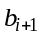 |  | 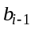 | 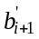 |  | 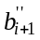 | 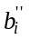 | 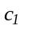 | 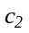
0 | 0 | 0 | 0 | 0 | 0 | 0 | × | 0 | 1
0 | 0 | 1 | 0 | 1 | 0 | 1 | 0 | 0 | 0
0 | 1 | 0 | 1 |  | 0 | 1 | 0 | 0 | 0
0 | 1 | 1 | 1 | 0 | # | 0 | × | 1 | 1
1 | 0 | 0 |  | 0 | # | 0 | × | 1 | 1
1 | 0 | 1 |  | 1 | 0 |  | 1 | 0 | 0
1 | 1 | 0 | 0 |  | 0 |  | 1 | 0 | 0
1 | 1 | 1 | 0 | 0 | 0 | 0 | × | 0 | 1
* “×” means don’t care. “#” in CSD column means no CSD bit is generated and wait till next bits come.

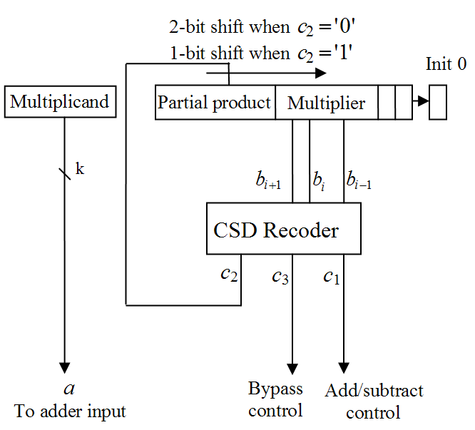
Figure 4 Real-time CSD multiplication based on our novel CSD recoder

The question of how to convert 2’s complement numbers to the CSD representation efficiently has received increasing interest recently. Several approaches have been proposed from the point of view of reducing computational complexity [17][18], but these are not suitable for direct hardware implementation. Other approaches have been proposed which seek to improve the implementation efficiency by limiting the area and power consumption [7][8], but these can introduce errors into the final product. Compared to existing techniques of varying complexity, the new approach considered here successfully reduces the implementation overhead by avoiding the need to explicitly represent the CSD number in hardware altogether; only the control signals derived from the DFS number concept are explicitly present in the hardware.

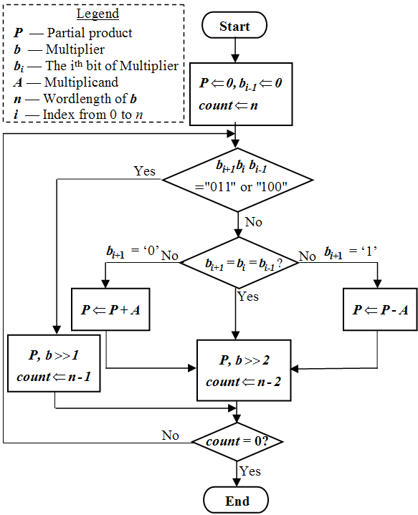
Figure 5 Real-time CSD recoder block diagram.

From Figs. 4 and 5, it can be seen that the number of iterations required by our multiplier is data dependent and uses shifting by a variable number of bits. Usually, shifting by a variable number of bits means that a register-based shifter is needed, which adds to the time and energy consumption for each iteration; in contrast, shifting by a constant number of bits can be conveniently implemented by direct wire connections and requires very low cost of in terms of energy and chip area. However, the design we are proposing here does not in fact require arbitrary shifts, but only shifts by one or by two bits. Thus, the design can be implemented simply with a pair of hardwired shifts, where shifting by one bit or by two is selected by the control signal. This implementation enables us to achieve the advantages of variable shifting at the cost of constant shifting. Note that the computation speed of the proposed multiplier structure can be further improved through the use of advanced adders and asynchronous circuit techniques.

Comparison with Booth Recoding and Other CSD Recoding Techniques
Iterative multipliers with radix-4 based MBR are most commonly used in modern hardware design due to the low area requirement, low energy consumption and high throughput [9][11]. As we discussed earlier, using a modified Booth algorithm, sequential 3-bit segments of a 2’s complement number are converted into the digit set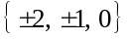. For an n by n bit multiplication, this technique reduces the number of partial products by 50% as compared to straightforward 2’s complement based multiplication, where, moreover, approximately 25% of the partial products are zeros. In practice, a radix-4 MBR based multiplier generates on average 0.375n non-zero partial products. However, after the partial products are generated, they are typically all passed on to the accumulator, including those partial products that are zero. In this way, the number of arithmetic operations in the carry-save structure is not reduced. So, the zero partial products are not fully exploited to improve the multiplier performances.
Compared with a radix-4 MBR based iterative multiplier, our proposed structure is simpler and faster. Instead of computing the five required multiples of the multiplicand a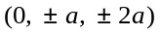 required for radix-4 Booth’s recoding, only 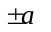are required for our multiplier. Consequently, a complex multiplexer is not required. Furthermore, unlike the multiplier based on radix-4 MBR, once the zero bits in our CSD number are detected, there is no accumulation required – only shifting is required and there is no carry propagation whatsoever. Thus, approximately two thirds of the time on average, the accumulation process is bypassed. Therefore, our algorithm reduces the latency of the operation, as well as the power consumption of the circuit.
Compared with other CSD recoding techniques, such as the self-timed CSD multiplier in [7], our structure is much simpler and faster. In [7], the computational complexity is calculated to be even greater than that of Booth’s recoding because of the need to propagate the carry in the CSD recoder. Also, five multiples of the multiplicand given by a are required – the same as in Booth’s recoding – in addition to carry-in and carry-out signals.
Efthymiou, et al. [2] proposed a variable iteration multiplier based on the original Booth’s recoding algorithm. However, variable bit shifters are required which greatly reduce system throughput. Furthermore, the scan logic used to reduce the inefficiency of Booth’s recoding by half further complicates the system design and reduces throughput. Most significantly, the inefficiency of the original Booth’s recoding means that this multiplier is not competitive with the structure proposed here in terms of energy efficiency and throughput.
On average, the real-time CSD recoding multiplier proposed in this paper eliminates 66.7% of the partial product generation operations that would be required for straightforward two’s complement multiplication. The quantitative performance comparison with other multipliers in terms of the number of partial products, non-zero partial products, non-zero multiples, and bypassed null partial products are listed in Table III. These data indicate that the proposed multiplier structure is capable of delivering superior performance in terms of low area requirement, high energy efficiency and high throughput. Moreover, it may be conveniently implemented using either synchronized circuits or asynchronous circuits [2].

Table III. Complexity Comparison on Average Percentage of Data in the Traditional Multiplier, Radix-4 Booth’s Recoding Multiplier, Self-timed CSD Recoding Multiplier and Proposed CSD Recoding Multiplier
 | Total partial products | Nonzero partial products | Nonzero Multiples generated | By-passed null partial products
Traditional Multiplier | 100% | 50% | 50% | 0%
Radix-4 Booth’s recoding | 50% | 37.5% | 75% | 0%
Self-timed CSD recoding | 50% | 33.3% | 66.7% | 33.3%
Proposed CSD recoding | 33.3% | 33.3% | 33.3% | 66.7%

Conclusions
We have presented an efficient iterative multiplier structure based on a novel real-time CSD recoding circuit. To the best of our knowledge, this structure is the first iterative multiplier based on real-time CSD recoding. Because of the iterative multiplier nature, the proposed design requires lower area compared with array multipliers. Furthermore, the CSD number property ensures that this multiplier has the minimum number of nonzero partial products among all radix-2 number representation based multipliers. The number of add/subtract operations is further reduced through the use of bypass techniques. On average, 66.7% of the partial product generation operations are replaced with a simple bypass to the shifting structure and carry propagation is totally eliminated as well. Thus, the complexity of the hardware implementation is dramatically reduced as compared to conventional methods, including modified Booth recoding and competing CSD recoding techniques. This approach achieves an overall speed-up as well as reduced power consumption which is particularly critical in mobile multimedia applications. Finally, unlike other CSD number based multipliers, the structure proposed here uses real time CSD recoding, and does not require a fixed value for the multiplier input to be known a priori; as a result, the proposed multiplier can be used for the efficient implementation of digital filters with non-fixed filter coefficients, such as adaptive filters [16].

References
- J. Kang and J. Gaudiot, “A simple high-speed multiplier design,” IEEE Trans. Comput., vol. 55, No. 10, pp. 1253-1258, Oct. 2006.
- A. Efthymiou, W. Suntiamorntut, J. Garside, and L.E.M. Brackenbury, “An asynchronous, iterative implementation of the original Booth multiplication algorithm,” in Proc. 10th IEEE Int’l. Symp. Asynchronous Circuits, and Syst., Crete, Greece, Apr. 19-23, 2004, pp. 207-215.
- J. Hensley, A. Lastra, and M. Singh, “An area- and energy-efficient asynchronous Booth multiplier for mobile devices,” in Proc. IEEE Int’l. Conf. Comput. Design, San Jose, CA, Oct. 11-13, 2004, pp. 18-25.
- M.A. Soderstrand, “CSD multipliers for FPGA DSP applications,” in Proc. IEEE Int’l. Symp. Circuits, Syst., vol. 5, Bangkok, Thailand, May 25-28, 2003, pp. V-469 – V-472.
- C.-L. Chen, K.-Y. Khoo, and A.N. Willson, Jr., “A simplified signed powers-of-two conversion for multiplierless adaptive filters,” in Proc. IEEE Int’l. Symp. Circuits, Sys., vol. 2, Atlanta, GA, May 12-15, 1996, pp. 364-367.
- G.K. Ma and F.J. Taylor, “Multiplier policies for digital signal processing,” IEEE ASSP Mag., vol. 7, no. 1, pp. 6-20, Jan. 1990.
- G.A. Ruiz and M.A. Manzano, “Self-timed multiplier based on canonical signed-digit recoding,” IEE Proc.: Circuits, Devices, Syst., vol. 148, no. 5, pp. 235-241, Oct. 2001.
- S.-M. Kim, J.-G. Chung, and K.K. Parhi, “Design of low error CSD fixed-width multiplier,” in Proc. 2002 IEEE Int’l. Symp. Circuits, Syst., vol. 1, Scottsdale, AZ, May 26-29, 2002, pp. I-69 – I-72.
- B. Parhami, Computer Arithmetic: Algorithms and Hardware Designs, Oxford Press, London, 1999.
- A.D. Booth, “A signed binary multiplication technique,” Quartly J. Mechanics, Appl. Math., vol. 4, no. 2, pp. 236-240, Jun. 1951.
- M.D. Ercegovac and T. Lang, Digital Arithmetic, Morgan Kaufmann, Los Altos, CA, 2003.
- P. Pirsch, Architectures for Digital Signal Processing, John Wiley & Sons, West Sussex, UK, 1998.
- I. Koren, Computer Arithmetic Algorithms, 2nd ed., Prentice Hall, 2001.
- Y. Wang, L.S. DeBrunner, D. Zhou, and V.E. DeBrunner, “A novel hardware implementation method for adaptive filter coefficients,” in Proc. IEEE Int’l. Conf. Acoust., Speech, Signal Proc., Honolulu, Hawaii, Apr. 15-20, 2007, to appear.
- A. G. Dempster and M. D. Macleod, “Constant integer multiplication using minimum adders,” IEE Proc.: Circuits, Devices, Syst., vol. 141, no. 5, pp. 407-413, Oct. 1994.
- S. Haykin, Adaptive Filter Theory, 4th ed., Prentice Hall, Upper Saddle River, NJ, 2001.
- F. Xu, C.-H. Chang and C.-C. Jong, “HWP: a new insight into canonical signed digit,” in Proc. IEEE Int’l. Symp. Circuits, Syst., vol. 5, Vancouver, BC, May 23-26, 2004, pp. V-201 – V-204.
- R. Hashemian, “A new method for conversion of a 2's complement to canonic signed digit number system and its representation,” in Proc. 30th Asilomar Conf. Signals, Syst., Comput., vol. 2, Pacific Grove, CA, Nov. 3-6, 1997, pp. 904-907.

 Manuscript received May 24, 2007. This work was supported in part by the U.S. Office of Naval Research under grant N000140710405 and by the U.S. Army Research Office and U.S. Army Research Laboratory under grant W911NF-04-1-0221. Yunhua Wang, Dayong Zhou, and Joseph P. Havlicek are with the School of Electrical and Computer Engineering, the University of Oklahoma, Norman, OK 73019 USA. (e-mail: {xiao9,dayong,joebob}@ou.edu). Linda DeBrunner and Victor DeBrunner were with the School of Electrical and Computer Engineering, the University of Oklahoma, Norman, OK 73019 USA, and are now with the Department of Electrical and Computer Engineering, Florida State University, Tallahassee, FL 32310 (e-mail: {linda.debrunner,victor.debrunner}@eng.fsu.edu).

