MATH 4753 Project Template

Wayne Stewart

15 February, 2018

This project is all about applications of SLR to real data using R

Table of Contents

# Introduction

Here you should introduce the data and the problem you wish to solve. Use your own subheadings. Fill with informative sentences and pictures and links. You may inclucde sub-sub headings. You can cite from your bibliography (see Millar 2011 and Crawley (2012))

## What are the variables?

data(mtcars)  
head(mtcars)

## mpg cyl disp hp drat wt qsec vs am gear carb  
## Mazda RX4 21.0 6 160 110 3.90 2.620 16.46 0 1 4 4  
## Mazda RX4 Wag 21.0 6 160 110 3.90 2.875 17.02 0 1 4 4  
## Datsun 710 22.8 4 108 93 3.85 2.320 18.61 1 1 4 1  
## Hornet 4 Drive 21.4 6 258 110 3.08 3.215 19.44 1 0 3 1  
## Hornet Sportabout 18.7 8 360 175 3.15 3.440 17.02 0 0 3 2  
## Valiant 18.1 6 225 105 2.76 3.460 20.22 1 0 3 1

names(mtcars)

## [1] "mpg" "cyl" "disp" "hp" "drat" "wt" "qsec" "vs" "am" "gear"  
## [11] "carb"

### Sub sub headings can be useful

### Plot data

library(ggplot2)  
g = ggplot(mtcars, aes(x = disp, y = mpg, color = cyl)) + geom_point()  
g = g + geom_smooth(method = "loess")  
g

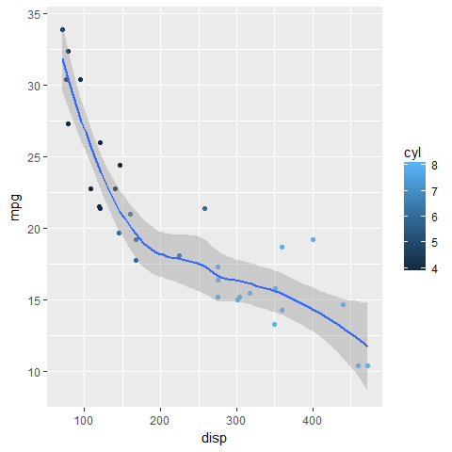

MTCARS

## How were the data collected?

## What is the story behind the data?

## Why was it gathered?

## What is your interest in the data?

### Include pictures ![](jpeg)

## What problem do you wish to solve

# Theory needed to carry out SLR

## Main result 1

## Main result 2

## Main result 3 etc

# Validity with mathematical expressions

## Checks on validity

### Straight trend line

#### Use trendscatter

### Errors distributed Normally

$$ϵ_{i}∼N(0,σ^{2})$$

#### Shapiro-wilk

### Constant variance

#### Residual vs fitted values

#### trendscatter on Residual Vs Fitted

### Zero mean value of $ϵ$

### Independence of data

# Analysis of the data

## Make sure you include many great plots

## Add the trend to the data

## Summary lm object

### Interpretation of all tests

### Interpretation of multiple R squared

### Interpretation of all point estimates

## Calculate cis for $β$ parameter estimates

### Use of predict()

### Use of ciReg()

### Check on outliers using cooks plots

Remember to interpret this plot and all other plots

# Conclusion

## Answer your research question

## Suggest ways to improve model or experiment

# References

Crawley, Michael J. 2012. “Regression.” In *The R Book*, 449–97. Chichester, UK: John Wiley & Sons, Ltd.

Millar, Russell B. 2011. “Latent Variable Models.” In *Statistics in Practice*, 202–32. Chichester, UK: John Wiley & Sons, Ltd.