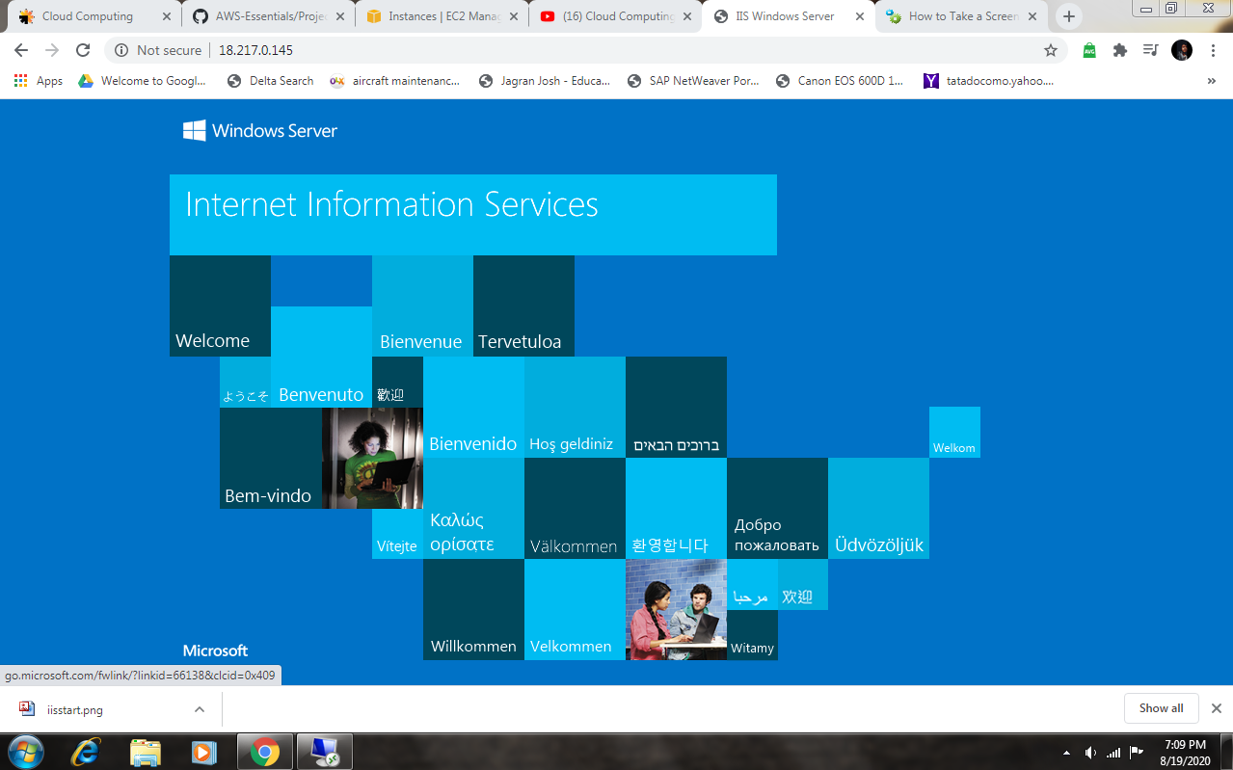**CREATING AND LAUNCHING WINDOWS INSTANCE**

**WINDOWS INSTANCE WITH PUBLIC IP**

