**CREATION OF WEB SERVER IN WINDOWS INSTANCE**

**1. UBUNTU SERVER**

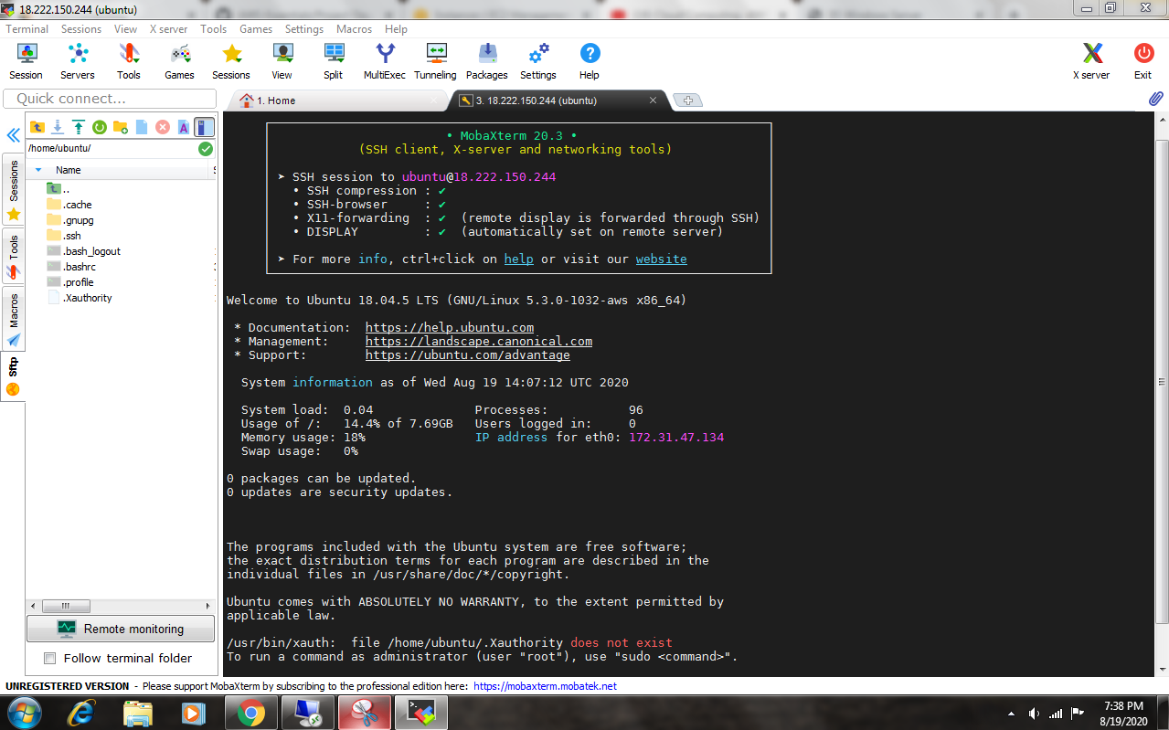

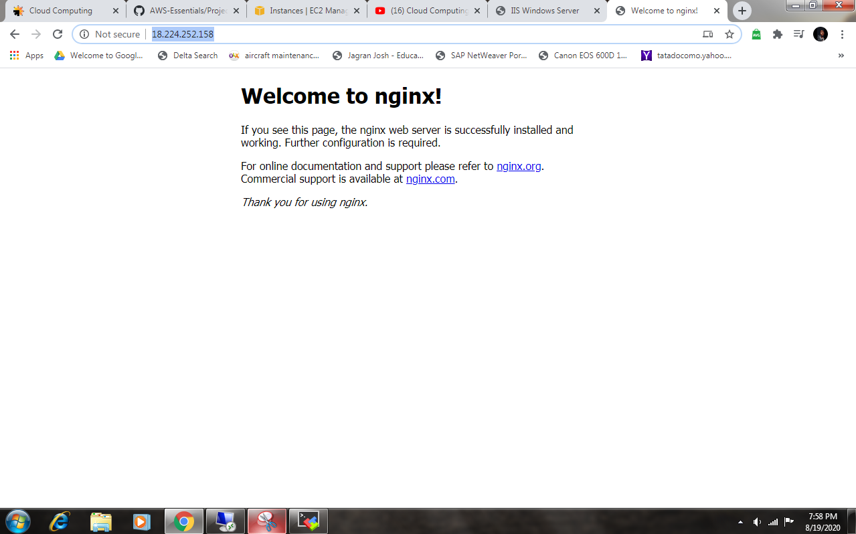

**NGINX WITH PUBLIC IP**

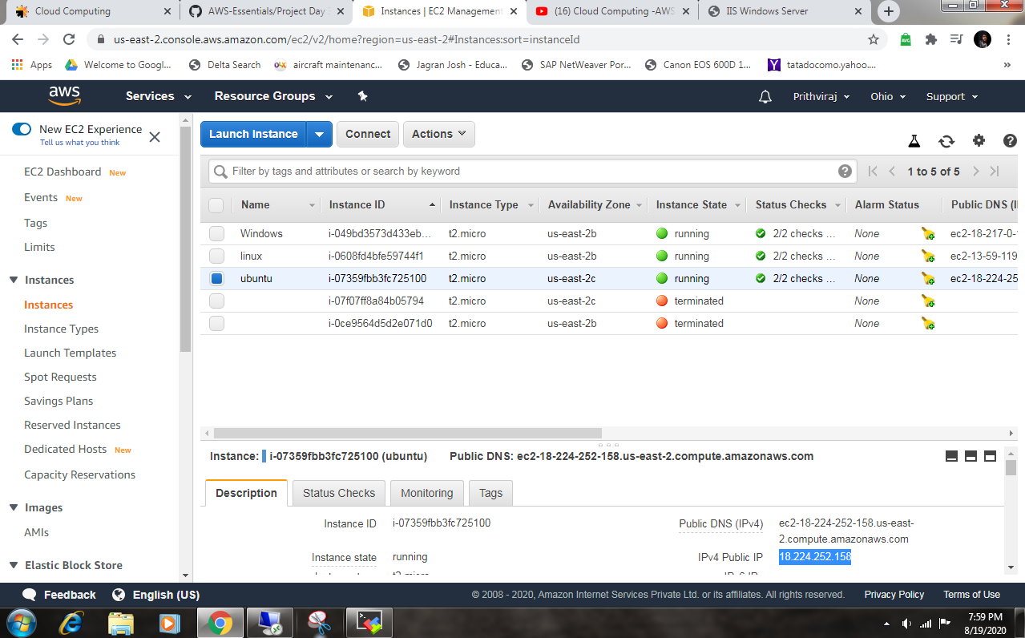

**2. LINUX SERVER**

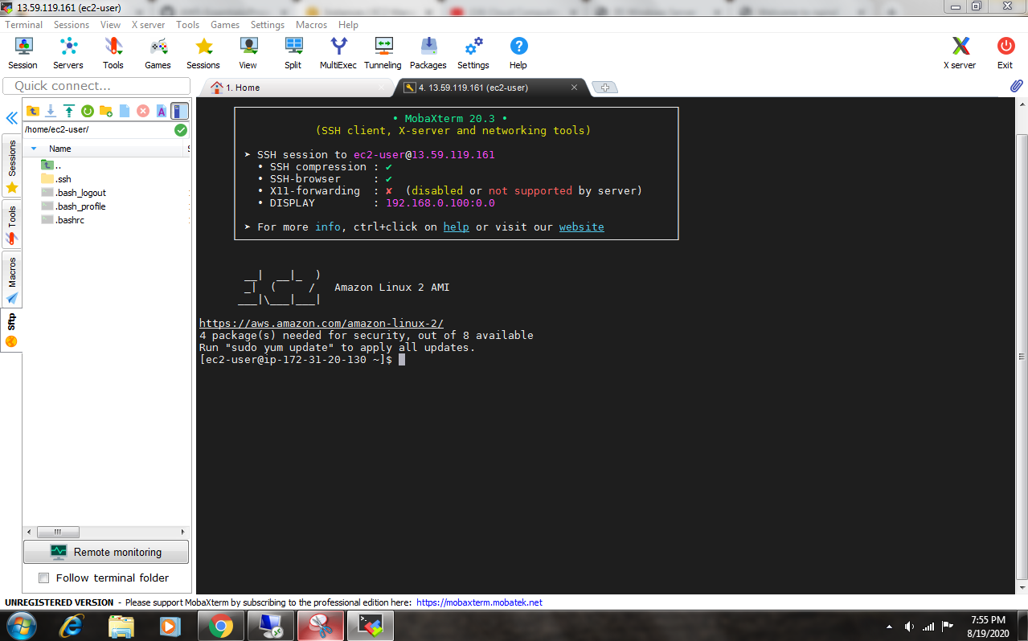

**LINUX INSTANCE WITH PUBLIC IP**

