**Project Name: KidsZone**

**Project Members:**

**Prithviraj Pawar 220343120085**

**Siddharth Patil 220343120075**

**Prithviraj Sonalkar 220343120086**

**Mangesh Cheke 220343120056**

**Guided By:**

**Mrs.** Harshita Maheshwari

**Abstract:**

The transformations in educational sector is one of the most worthwhile gifts of the World Wide Web. The primary goal of a KidsZone site is to make quiz online thus saving time, efforts and resources.

This project deals with developing an quiz for Online Education and learning. It allows the user to register on the site and take quiz of the subject of their choice. The system is implemented using a 3-tier approach, with a backend database, a middle tier of Spring Tool, and web browser as the front end client.

In order to develop a kids quiz website, a number of Technologies must be studied and understood. These include multi-tiered architecture, server and client side scripting techniques, implementation technologies such as Spring Tool, programming language (such as Core Java, Advance Java), relational databases (such as MySQL).

This is a project with the objective to develop a basic website where a students are provided with a quiz application. Where the Admin will be given the administrative powers. Teachers will be able to add or delete questions in the quiz.

**Implementation Technologies:**

1. **Spring Framework:**

Spring Framework is a Java platform that provides comprehensive infrastructure support for developing Java applications. Spring handles the infrastructure so you can focus on your application.

Spring enables you to build applications from “plain old Java objects” (POJOs) and to apply enterprise services non-invasively to POJOs. This capability applies to the Java SE programming model and to full and partial Java EE.

**1.1 Features of Spring Framework:**

**1. Lightweight**

Spring is modular lightweight framework which allows you to selectively use any of its modules on the top of Spring Core.

**2. Inversion of Control (IOC)**

This is another top feature of Spring framework where application dependencies are satisfied by the framework itself. Framework creates the object in runtime and satisfies application dependencies.

**3. Aspect Oriented Programming (AOP)**

Aspect Oriented Programming (AOP) is very popular in programming world and in Spring it is well implemented. Developer can use Aspect Oriented Programming (AOP feature of Spring to develop application in which business logic is separated from system services.

**4. Container**

Spring provides their own container for managing the bean lifecycle.

**5. MVC Framework**

Spring MVC Framework is used for developing MVC based web applications.

**6. Transaction Management**

Spring framework provides generic Transaction Management layer which can be used with or without J2EE(JEE) environment.

**7. JDBC Exception Handling**

Spring provides their own abstraction of JDBC exception which further simplifies the exception handling in program.

**1.2 Advantages of Spring Framework:**

**1. Solving difficulties of Enterprise application development**

Spring is solving the difficulties of development of complex applications, it provides Spring Core, Spring IoC and Spring AOP for integrating various components of business applications.

**2. Support Enterprise application development through POJOs**

Spring supports development of Enterprise application development using the POJO classes which removes the need of importing heavy Enterprise container during development. This makes application testing much easier.

**3. Easy integration other frameworks**

Spring designed to be used with all other frameworks of Java, you can use ORM, Struts, Hibernate and other frameworks of Java together. Spring framework do not impose any restriction on the frameworks to be used together.

**4. Application Testing**

Spring Container can be used to develop and run test cases outside enterprise container which makes testing much easier.

**5. Modularity**

Spring framework is modular framework and it comes with many modules such as Spring MVC, Spring ORM, Spring JDBC, Spring Transactions etc. which can used as per application requirement in modular fashion.

**6. Spring Transaction Management**

Spring Transaction Management interface is very flexible it can configure to use local transactions in small application which can be scaled to JTA for global transactions.

1. **The JDBC Template**

The central class of the Spring JDBC abstraction framework is the **JdbcTemplate** class that includes the most common logic in using the JDBC API to access data, such as handling the creation of connection, statement creation, statement execution, and release of resource. The**Jdbc-Template**class can be found in the **org.springframework.jdbc.core**package.

The **JdbcTemplate** class instances are thread-safe once configured. A single **JdbcTemplate** can be configured and injected into multiple DAOs.

We can use the **JdbcTemplate** to execute the different types of SQL statements. **Data Manipulation Language** (**DML**) is used for inserting, retrieving, updating, and deleting the data in the database such as **SELECT**, **INSERT**, or **UPDATE** statements

**2.1** **MySQL**

MySQL, the most popular Open Source SQL database management system, is developed, distributed, and supported by Oracle Corporation.

**Features of MySQL:**

* **MySQL is a database management system.**

A database is a structured collection of data. It may be anything from a simple shopping list to a picture gallery or the vast amounts of information in a corporate network. To add, access, and process data stored in a computer database, you need a database management system such as MySQL Server. Since computers are very good at handling large amounts of data, database management systems play a central role in computing, as standalone utilities, or as parts of other applications.

* **MySQL databases are relational.**

A relational database stores data in separate tables rather than putting all the data in one big storeroom. The database structures are organized into physical files optimized for speed. The logical model, with objects such as databases, tables, views, rows, and columns, offers a flexible programming environment.

* **MySQL software is Open Source.**

Open Source means that it is possible for anyone to use and modify the software. Anybody can download the MySQL software from the Internet and use it without paying anything.

* **The MySQL Database Server is very fast, reliable, scalable, and easy to use.**

MySQL Server was originally developed to handle large databases much faster than existing solutions and has been successfully used in highly demanding production environments for several years. Although under constant development, MySQL Server today offers a rich and useful set of functions. Its connectivity, speed, and security make MySQL Server highly suited for accessing databases on the Internet.

* **MySQL Server works in client/server or embedded systems.**

The MySQL Database Software is a client/server system that consists of a multithreaded SQL server that supports different back ends, several different client programs and libraries, administrative tools, and a wide range of application programming interfaces (APIs).

1. **Hardware and Software Requirements (Minimum):**

**Hardware:**

1. Intel i3 processor 3rd generation or later / AMD Ryzen 200 2nd generation or later

2. 2 GB ddr3 ram.

3. Windows 7 Home edition or later.

4. 200 GB Sata HDD Space

5. Data Connection 200 kbps

**Software:**

1. Spring Tool Suite
2. MySQL 5.7 with Workbench 8.0
3. Google Chrome version 79.0
4. Apache Tomcat Server 8.5
5. Maven Dependencies
6. **ER Diagram**

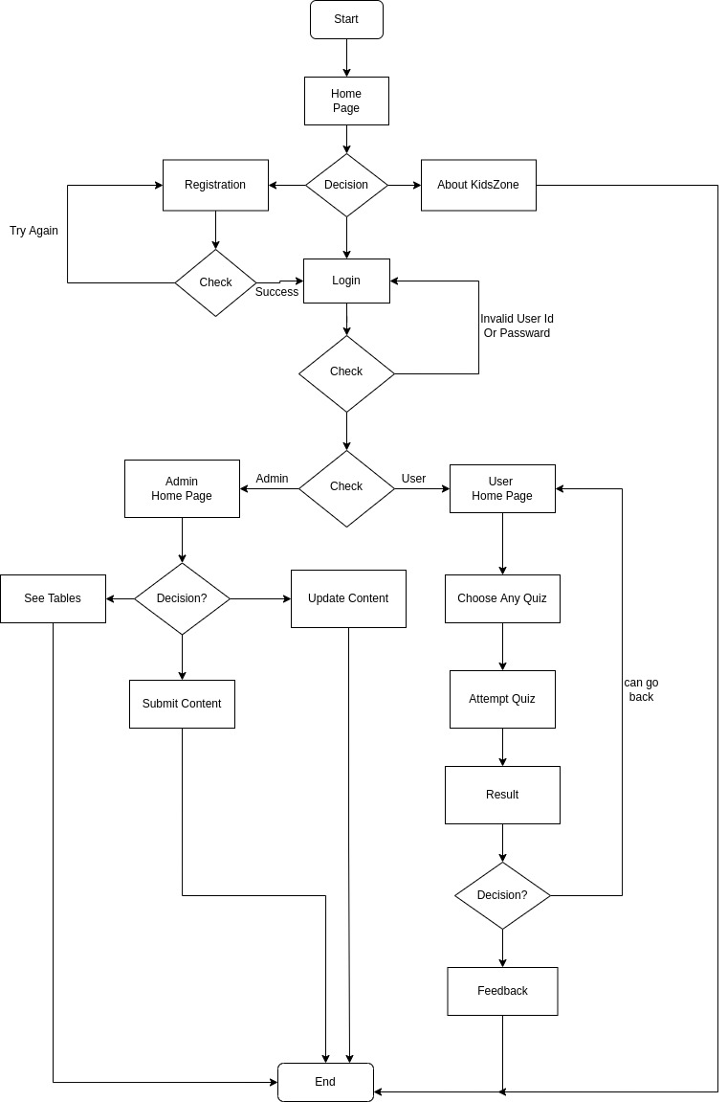

Figure 1: ER Diagram

1. **Table Structures:**
2. **Table name:administrators**

**Column name Type**

Id_bigint int(20) PRI auto_increment

first_name varchar(255)

last_name varchar(255)

password varchar(255)

username varchar(255)

user_role varchar(255)

1. **Table name:Students**

**Column name Type**

Id int (20) PRI auto_increment

first_Name varchar(255)

last_name varchar(255)

Password varchar(255)

User_role varchar(255)

1. **Table name:Questions**

**Column name Type**

Question_id int(20) PRI auto_increment

Question_title varchar(255)

Quiz_id int(20)

Subject varchar(255)

Option_correct varchar(255)

Option_chosen varchar(255)

1. **Table name:sesions**

**Column name Type**

Id int (11) NO PRI auto_increment

End_time varchar (255)

score int(20)

start_time varchar(255)

session_id BIGINT

student_id BIGINT

user_role varchar(255)

correct_student_id varchar(255)

student_name varchar(255)

1. **UML Diagrams:**

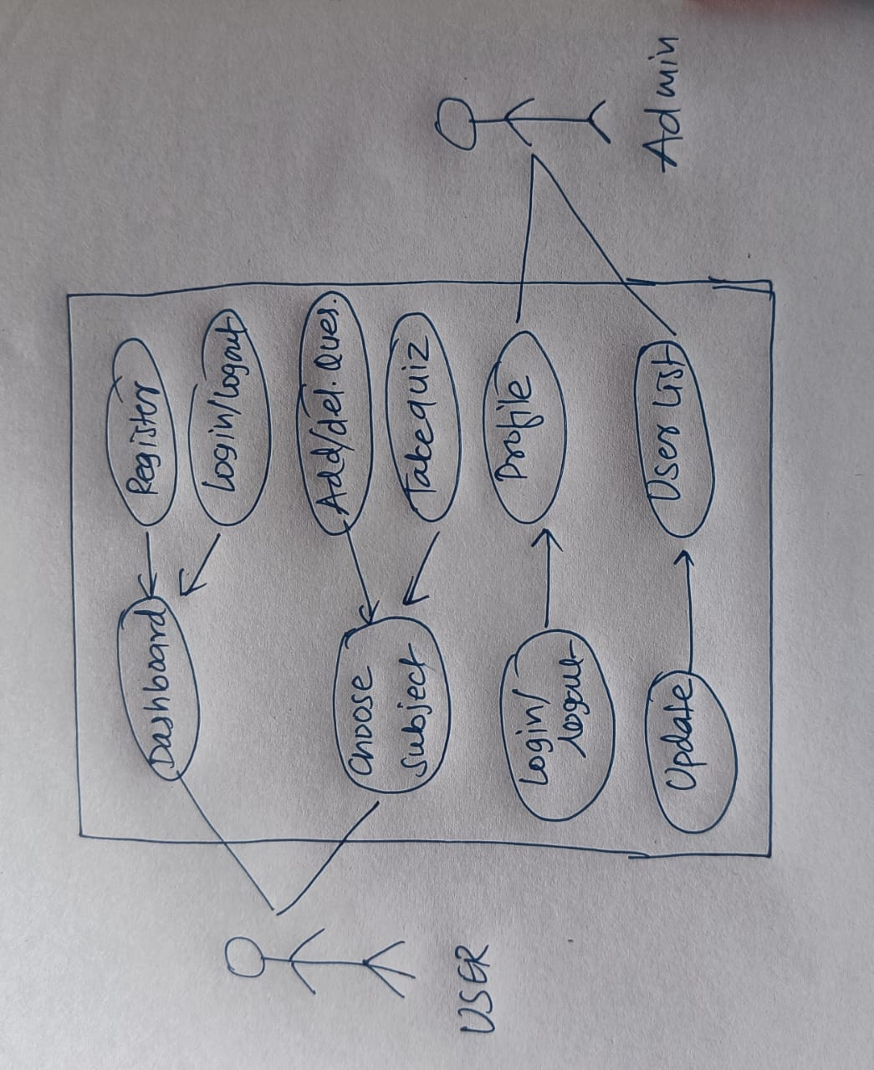

Figure 2: Use Case

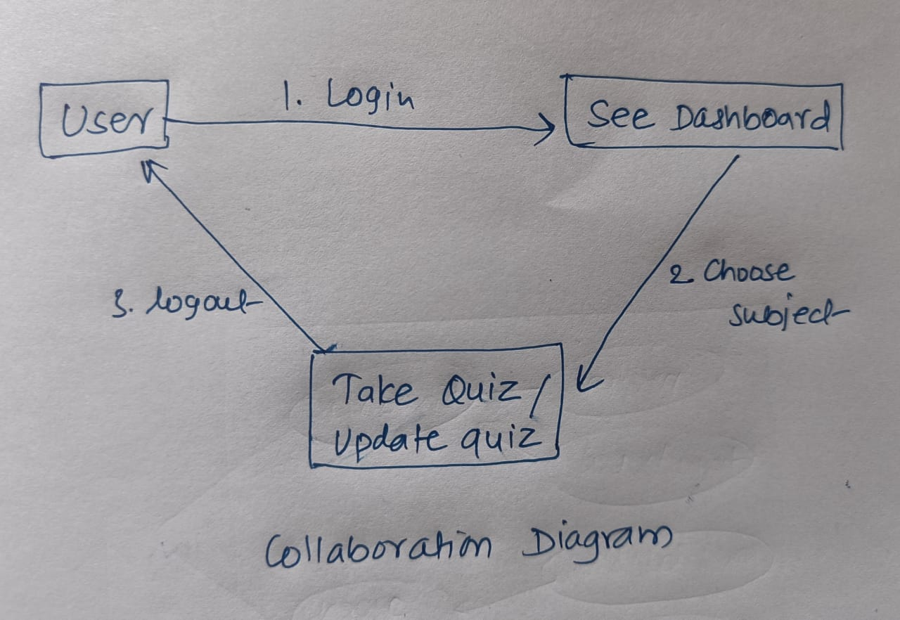

Figure 3: Collaboration Diagram

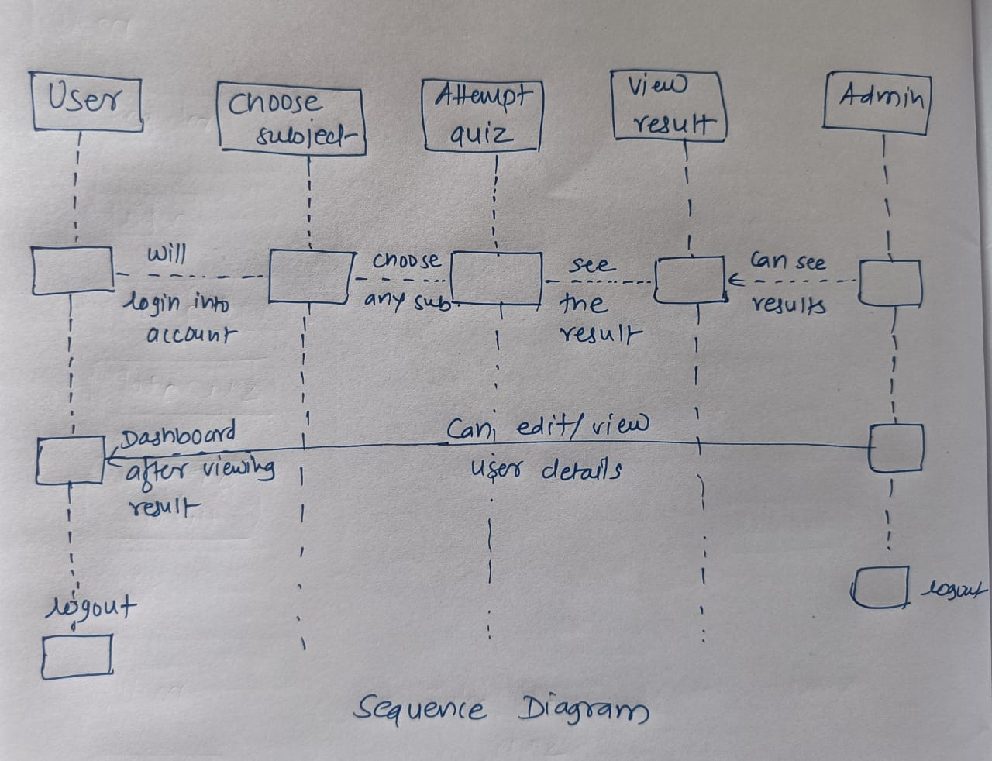

Figure 4: Sequence Diagram

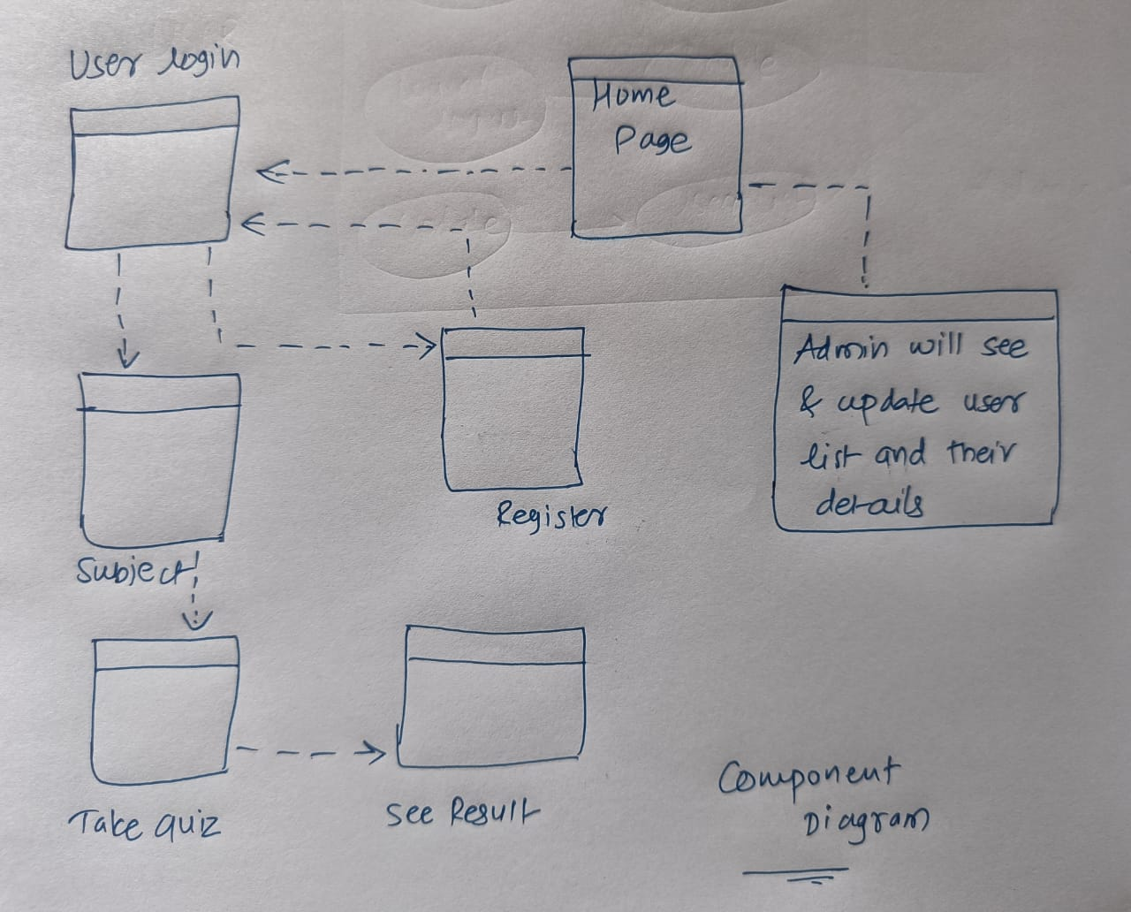

Figure 5: Component Diagram

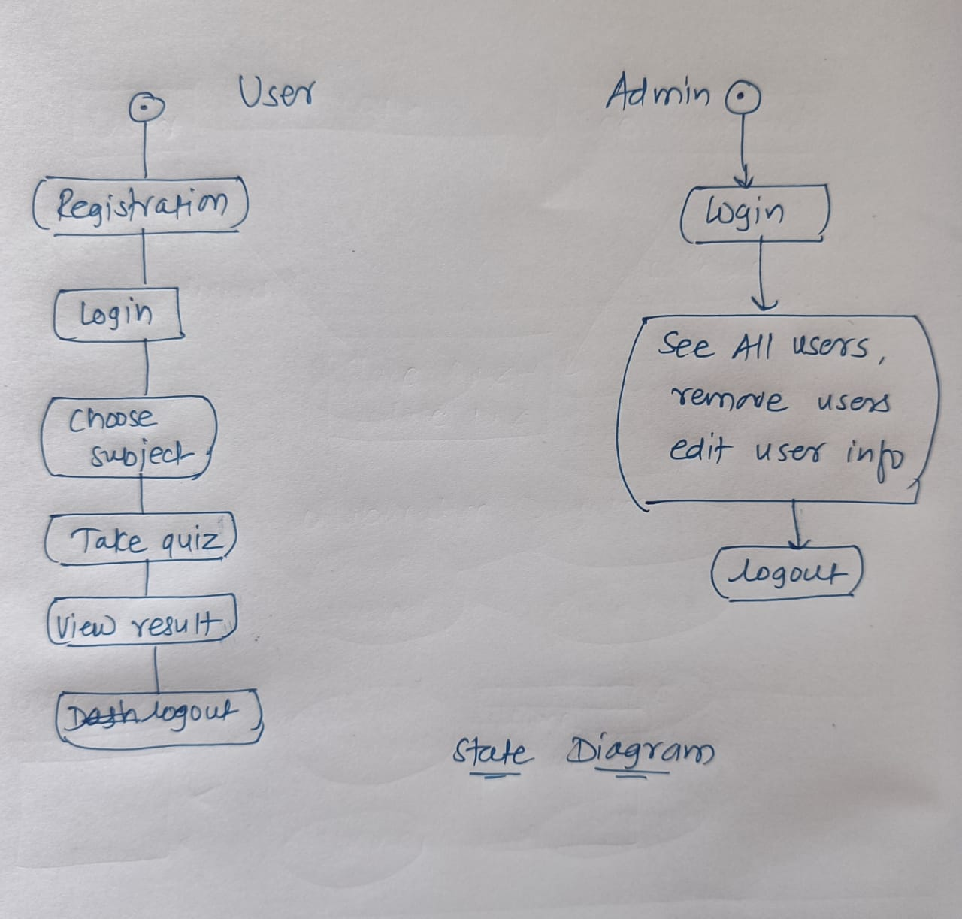

Figure 6: State Diagram

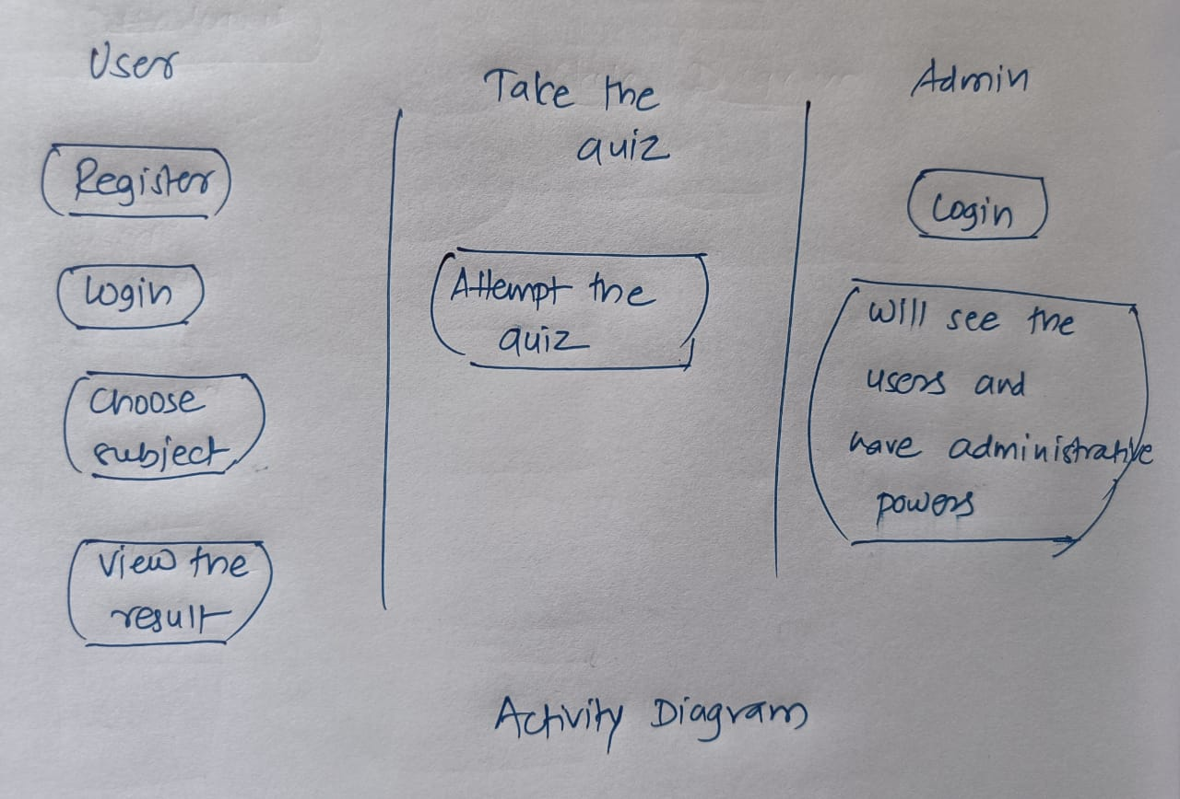

Figure 7: Activity Diagram

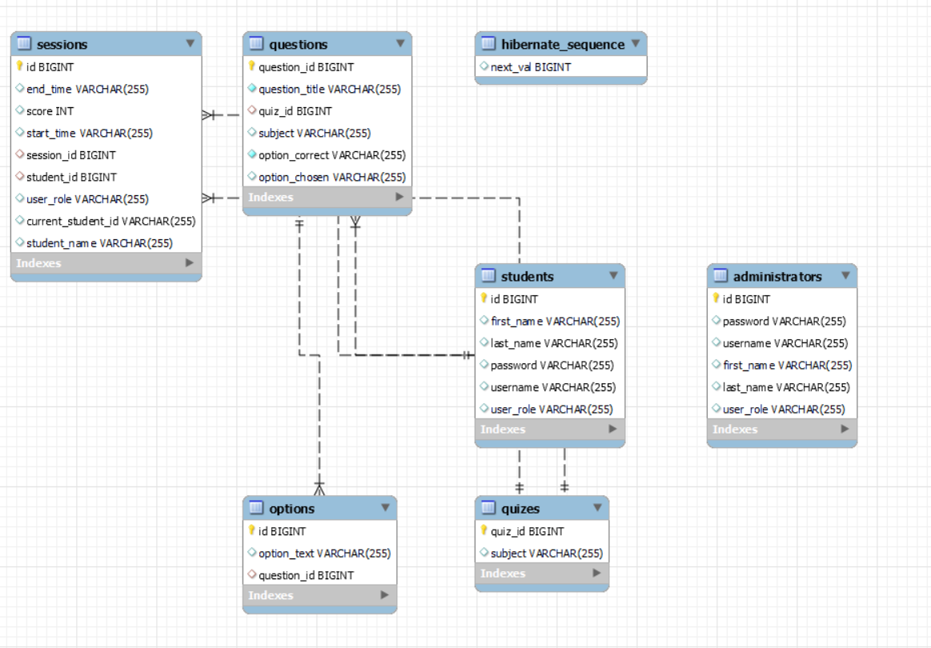

Figure 8: Class Diagram

1. **End to End Flow of Application:**

**User:**

* 1. User will login to the portal or will have to register if he is not a registered user.
  2. After registration User will login and Dashboard page will be displayed to him which will display the subjects list.
  3. From that page can User can click on the different subject button and the quiz will start.
  4. The timer and webcam will also begin.
  5. The quiz will end when time ends.
  6. User will only be able to see his score as the quiz ends.

**Admin:**

1. Admin will login as Admin by providing his/her correct credentials. He will be able to edit the user details and can also add or remove the users.
2. Admin can Review the user list.
3. It is the job of Admin to administer the website.
4. After checking and making any changes if needed, admin will logout from the website and come back to the login dashboard.
5. Future Scope of Project
6. Study Materials can be provided for the kids which will help them to study and refer whenever needed.
7. By analyzing the previous results of student, a detailed analysis can be provided to students based on subjects which will help kids to focus more on the subjects they lack in.

**Thank You!**