./

Learning Report – GENESIS

Course Code: <CODE>



|  |  |  |  |  |  |
| --- | --- | --- | --- | --- | --- |
| **Ver. Rel. No.** | **Release Date** | **Prepared. By** | **Reviewed By** | **Approved By** | **Remarks/Revision Details** |
| 1.0 | 03/12/2020 | Group 4-Believers | Group1 | Srinivas K |  |
| 1.1 | 05/12/2020 | Group 4-Believers | Group3 | Srinivas K |  |
| 1.2 | 07/12/2020 | Group 4-Believers | Group2 | Srinivas K |  |

# 

Table of Contents

Activity and Tasks 5

Activity 1– System Development 5

PRODUCT SELECTED: Automatic Wheel Chair 5

AGEING 5

COST AND GRADATION 5

DEFINITION OF PRODUCT 5

SWOT ANALYSIS 5

REQUIREMENTS 6

TESTING 7

ACTIVITY 2: Agile aspects 13

REQUIREMENT TRACEABILITY MATRIX: 14

PRODUCT BACKLOG: 14

GANTT CHART: 15

REFERENCES 16

**Table of figures**

Figure 1: Block Diagram 8

Figure 2: Use Case Diagram 9

Figure 3: Activity Diagram 10

Figure 4: Component Diagram 11

Figure 5: Agile Aspects 12

Figure 6: Gantt Chart 14

List of tables

Table 1: SWOT Analysis 5

Table 2: High level Requirements 6

Table 3: low level requirements 6

Table 4: Test plan 7

Table 5: Requirement Traceability Matrix 13

Table 6: Backlogs 13

# 

# Activity and Tasks

# Activity 1– System Development

## **PRODUCT SELECTED**: Automatic Wheel Chair

## **AGEING**

* First traditional wheel chair was invented in Germany in 1665
* It required an attendant with the patient all the time.
* Different kinds of automatic wheel chairs were being developed.
* Sip and buff wheelchair, head control wheel chair, Voice activated wheelchair.
* It was still a problem for patients with complete immobility of hands.

## **COST AND GRADATION**

* 8,000-10,000 traditional wheel chair.
* 45,000-50,000 Automatic wheel chair.

## **DEFINITION OF PRODUCT**

Tongue motion controlled automatic wheel chair can be used in patients with severe immobility of hands and legs. It should send signals to the motor driver of the wheel chair to move into the desired direction.

## **SWOT ANALYSIS**

|  |  |
| --- | --- |
| **STRENGTHS**   * Easy to operate and requires minimum effort * System is small in size * Low cost * Disabled people can start being independent and can move to desired location without others help | **WEAKNESSES**   * Requires maintenance from time to time * Power supply is needed all the time * Manual support is required when there are steps |
| **OPPORTUNITIES**   * Can be used in NGO for helping the needful people * Hospital management system becomes more flexible * Most of the works of nurse and ward-boys can be automated | **THREATS**   * Maintenance is required from time to time * When the power supply is disabled there is chance of system to collapse |

Table 1: SWOT Analysis

## **REQUIREMENTS**

High level requirements:

|  |  |
| --- | --- |
| **ID** | **Description** |
| HL_01 | Part of system must be installed inside mouth |
| HL_02 | System inside the mouth must communicate with wheelchair |
| HL_03 | System must be deactivated during eating or sleeping |
| HL_04 | Battery life must be long |
| HL_05 | Motors inside wheelchair must run simultaneously with movement of tongue. |

Table 2: High level Requirements

Low level requirements:

|  |  |
| --- | --- |
| **ID** | **Description** |
| LL_01 | Permanent magnet and hall effect sensors must be attached inside the mouth |
| LL_02 | Wireless communication must be established between 2 parts of system |
| LL_03 | Sensors must be externally controlled to activate or deactivate |
| LL_04 | Operating voltage must be low |
| LL_05 | Motors with low reaction time must be used |

Table 3: low level requirements

## **TESTING**

|  |  |  |  |  |  |
| --- | --- | --- | --- | --- | --- |
| ID | Description | Precondition | Expected input or State | Expected output or State | Actual output |
| H_01_L_01_T_01 | Hall effect sensors must detect the magnet | Sensors are switched OFF | Magnetic field near hall effect sensor | Sensors are switched ON |  |
| H_02_L_02_T_02 | GSM module should detect signals from sensors | GSM is switched OFF | Signals from hall effect sensors | GSM is switched ON |  |
| H_03_L_03_T_03 | Microcontroller should detect signals from GSM module | Microcontroller does not receive signal | Signals from GSM module | Microcontroller gets activated and detect signals |  |
| H_04_L_04_T_04 | Microcontroller should interpret signals from GSM module | Microcontroller is not processing | Signals from GSM module | Microcontrollers should enable DC motor driver |  |
| H_05_L_05_T_05 | DC motor driver should detect signals from Microcontroller | DC motor drivers does not receive signals | Instructions from microcontroller | DC motor driver receives signals |  |
| H_05_L_05_T_06 | DC motor driver should start the DC motors | DC motors are not started | Instructions from DC motor driver | DC motors started working |  |
| H_05_L_05_T_07 | DC motors should rotate in desired direction | DC motors are not rotating | Signals from DC motor driver | DC motors are rotating |  |
| H_05_L_05_T_08 | Deactivate the permanent magnet | Magnet is in active mode | Signal from microcontroller | Magnet is in deactivated mode |  |

Table 4: Test plan

**DIAGRAMS:**

**Block Diagram**

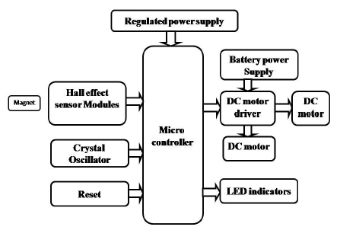

Figure 1: Block Diagram

**Behavioral diagram:**

* Use case diagram

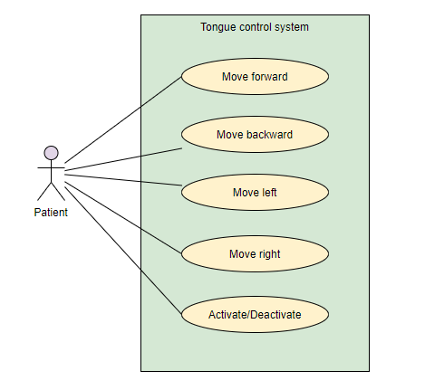

Figure 2: Use Case Diagram

* Activity diagram

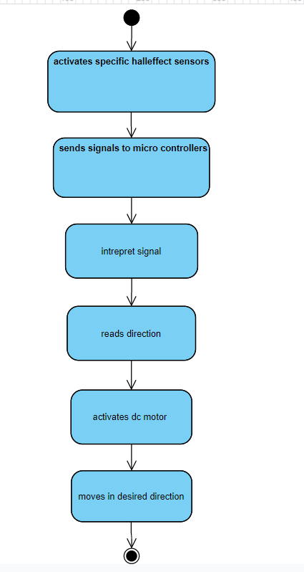

Figure 3: Activity Diagram

**STRUCTURAL DIAGRAM**

* + Component diagram

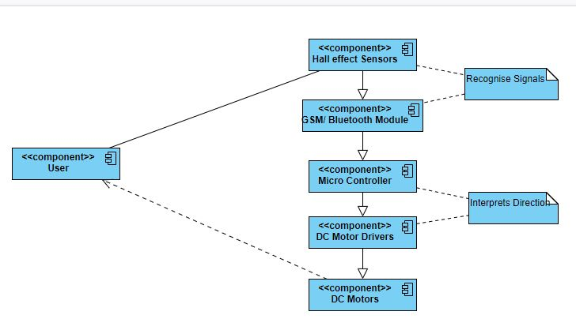

Figure 4: Component Diagram

# ACTIVITY 2: Agile aspects

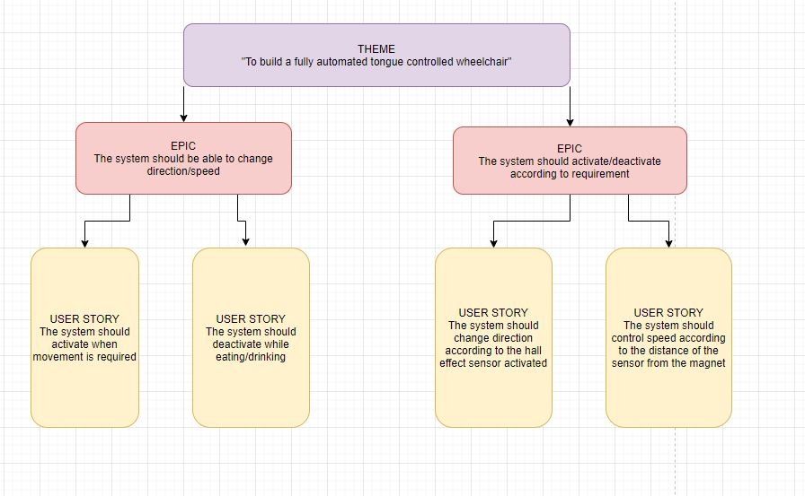

Figure 5: Agile Aspects

## REQUIREMENT TRACEABILITY MATRIX:

|  |  |  |  |  |
| --- | --- | --- | --- | --- |
| **Requirement No** | **Requirement Description** | **Testcase ID** |  |  |
| RN_01 | System should change direction | TC_01  TC_07 |  |  |
| RN_02 | System should change speed | TC_01  TC_07 |  |  |
| RN_03 | System should activate according to requirement | TC_08 |  |  |
| RN_04 | System should deactivate according to requirement | TC_08 |  |  |

Table 5: Requirement Traceability Matrix

## PRODUCT BACKLOG:

|  |  |
| --- | --- |
| **ID** | **Description** |
| B_01 | Installation of system inside mouth |
| B_02 | Wireless communication within the system |
| B_03 | Battery operating power |
| B_04 | Reaction time of motor |

Table 6: Backlogs

## GANTT CHART:

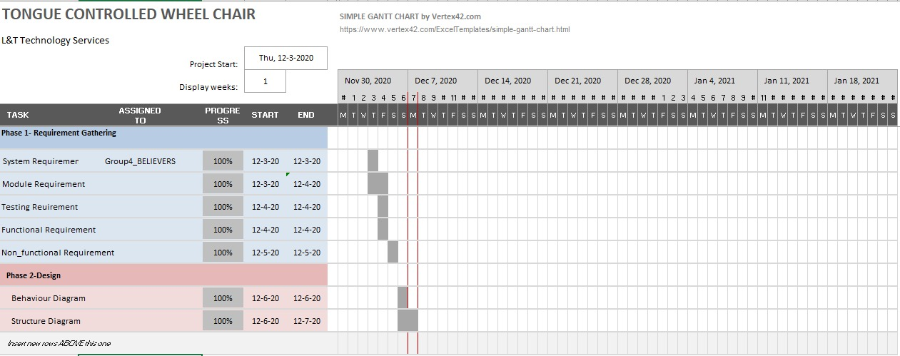

Figure 6: Gantt Chart

# REFERENCES

# Wireless control of powered wheelchairs with tongue motion using tongue drive assistive technology

AUTHORS: Xueliang Huo; Jia Wang; Maysam Ghovanloo

# Android Based Automated Wheelchair Control

Authors: R. Josephine Leela; A. Joshi; B. Agasthiya; U. K. Aarthiee; E. Jameela; S. Varshitha

1. Electric powered wheelchairs

Authors: D. Ding; R.A. Cooper

1. Sensors based automated wheelchair

Authors: Ch. Vijayakumar; M. Pavan Kumar; S. Sivaji; Sk. Sadulla; J. Prathiba; K. Vijay Kumar

1. https://www.tutorialspoint.com/uml/uml_standard_diagrams.htm
2. What is Requirements Traceability Matrix (RTM)? Example Template

https://www.guru99.com/traceability-matrix.html

1. Gantt Chart Template

https://templates.office.com/en-in/simple-gantt-chart-tm16400962