**USE CASE DIAGRAM FOR CALCULATOR:**

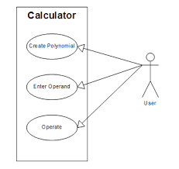

**FLOW CHART FOR SUBTRACTION:**

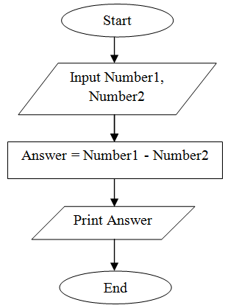

FLOW CHART FOR HEX TO DECIMAL:

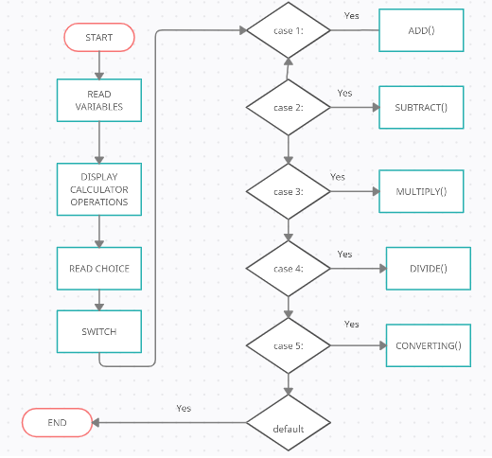

CLASS DIAGRAM:

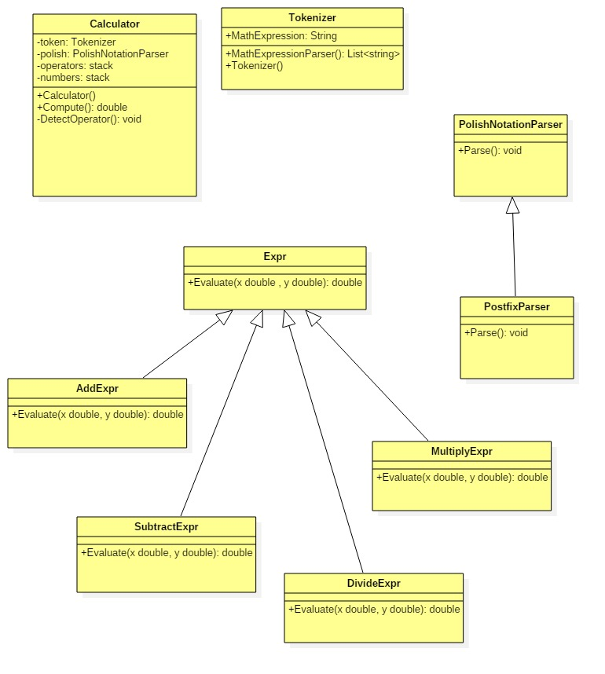

FLOW CHART FOR HEX TO DECIMAL CONVERTION:

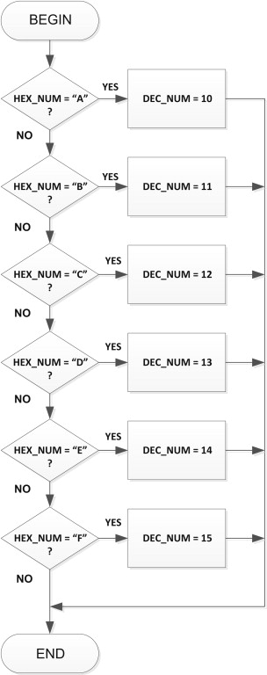

HEX TO DECIMAL CONVERSION

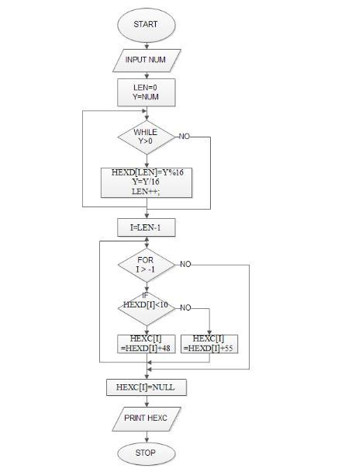

**USE CASE DIAGRAM FOR CURRENCY**:

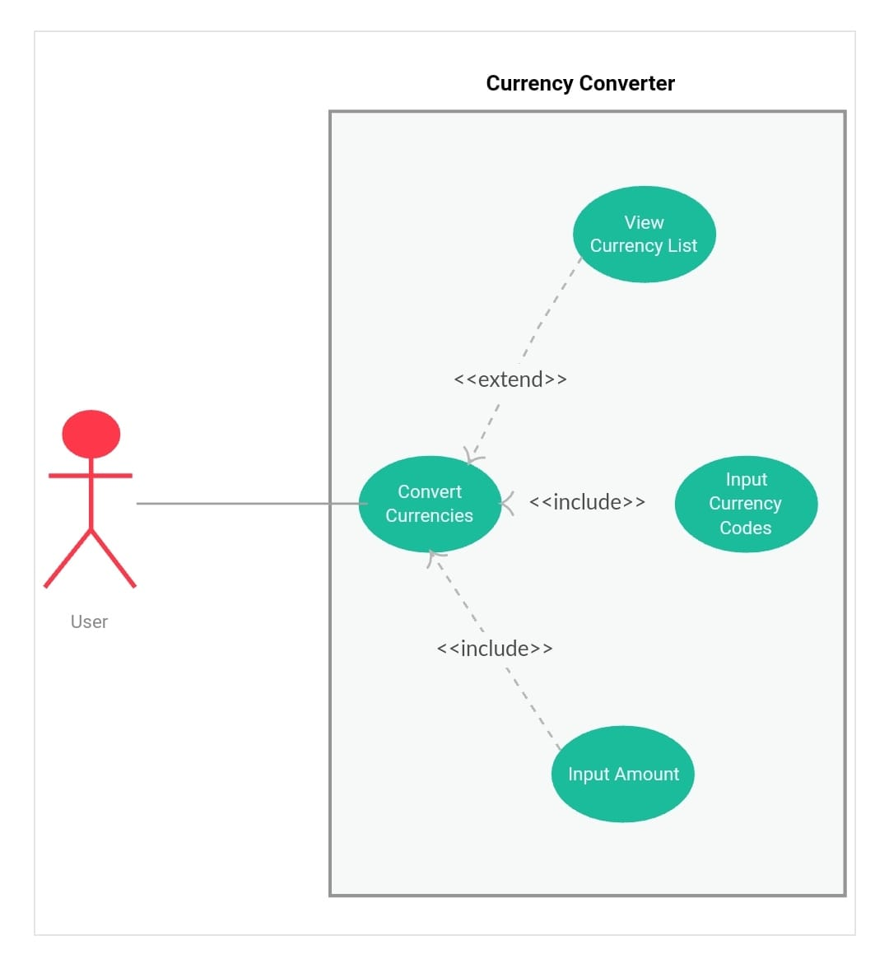

**FLOW DIAGRAM FOR CURRENCY:**

