Practical No: 01

PROBLEM STATEMENT: Perform the following operations using Python on any open
source dataset (e.g., data.csv)
1. Import all the required Python Libraries.
2. Locate open source data from the web (e.g. https://www.kaggle.com). Provide a
clear description of the data and its source (i.e., URL of the web site).
3. Load the Dataset into the pandas data frame.
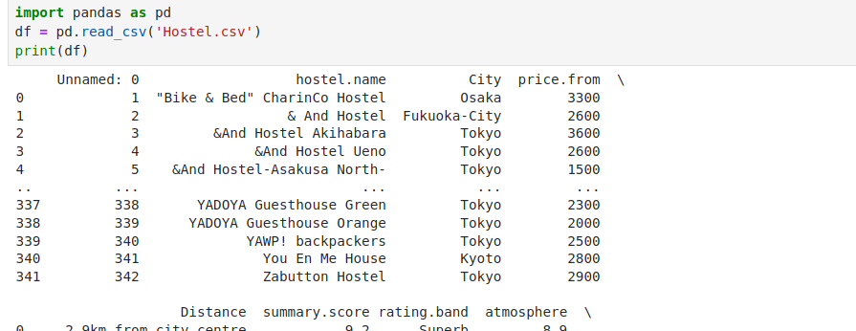
4. Data Preprocessing: check for missing values in the data using pandas insult(),
describe() function to get some initial statistics. Provide variable descriptions. Types of
variables etc. Check the dimensions of the data frame.

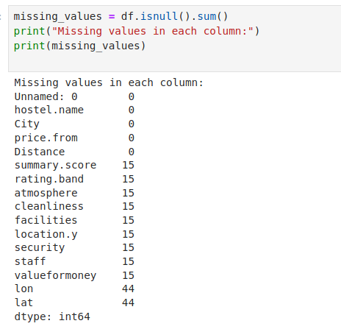

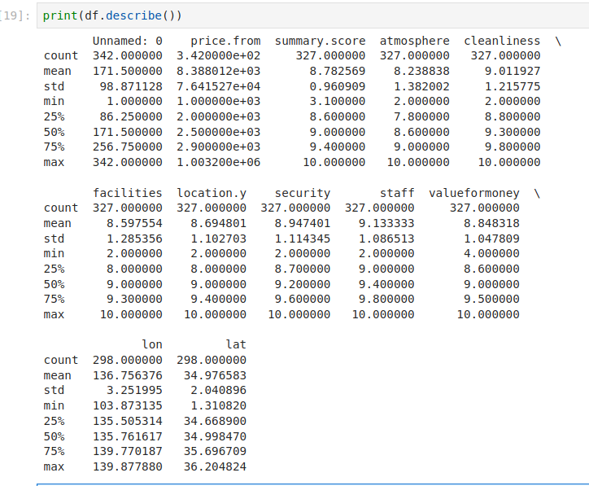
5. Data Formatting and Data Normalization: Summarize the types of variables by
checking the data types (i.e., character, numeric, integer, factor, and logical) of the
variables in the data set. If variables are not in the correct data type, apply proper type
conversions.

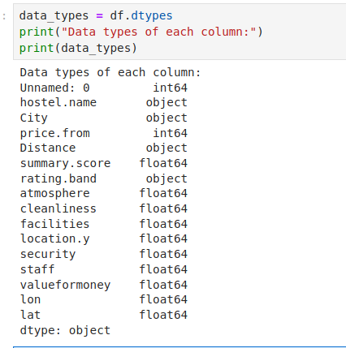

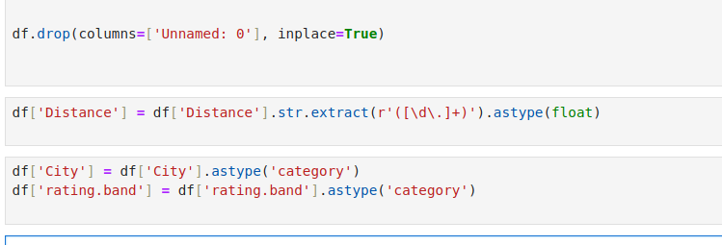

6. Turn categorical variables into quantitative variables in Python.
In addition to the codes and outputs, explain every operation that you do in the above steps
and explain everything that you do to import/read/scrape the data set.

