Output Screens 1: It returns all employees list.

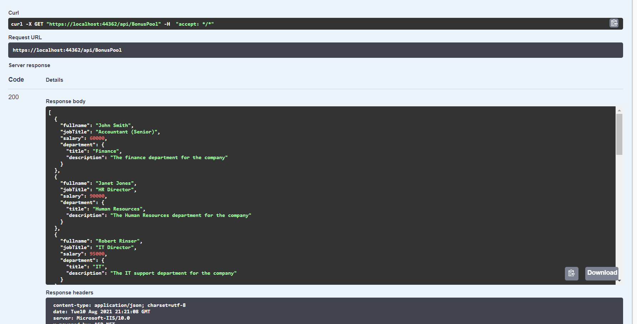

Output Screens 2: It returns a bad request when SelectedEmployeeId is not specified, or the employee is not found.

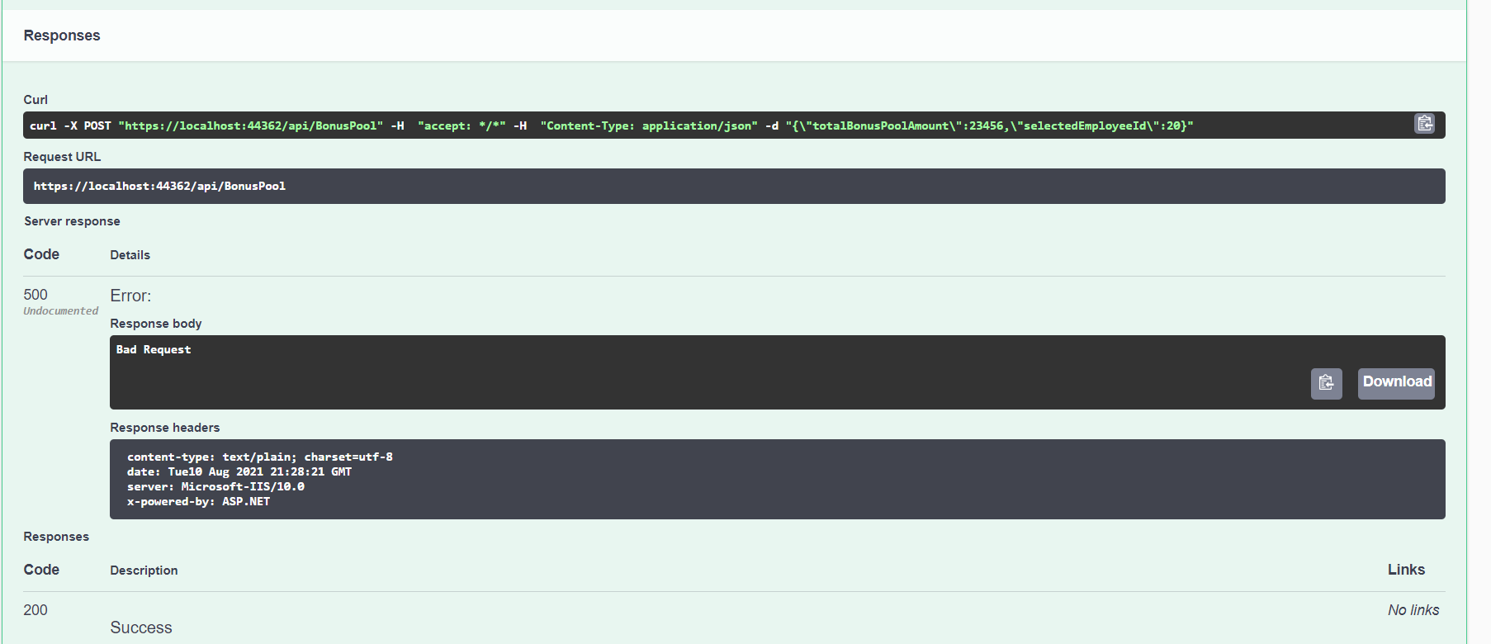

Output Screens 3: It returns bonus amount of SelectedEmployeeId.

